**Step by step guide to add translations to youtube video**

1. Login to youtube
2. Select video you want to add translation to
3. Click three dots and select ‘Add translations’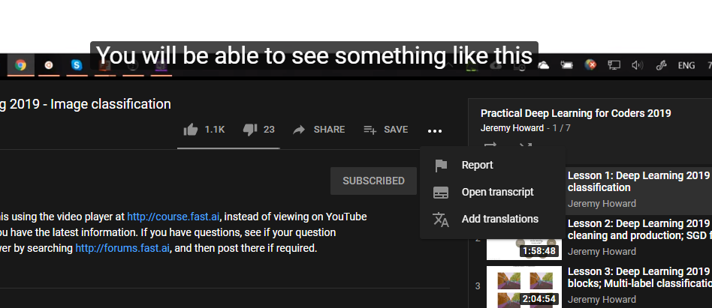
4. Click on `Switch language’ and select language you want to add translation for

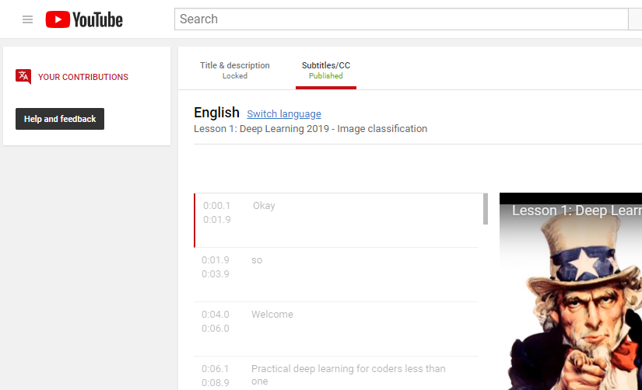

1. Autotranslate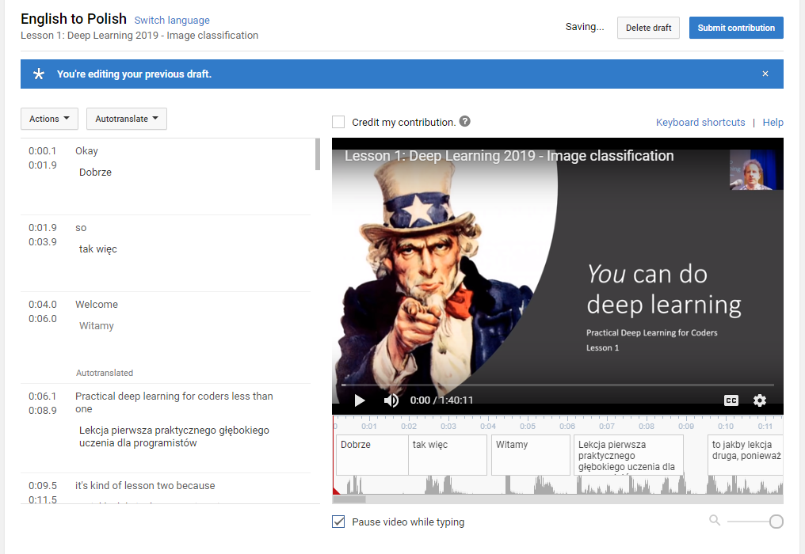
2. Option: Check `credit my contribution` if you would like your name to be associated with the translation

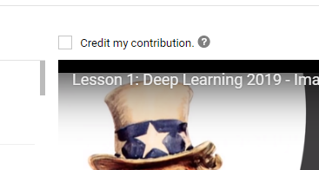

1. Play stop edit subtitles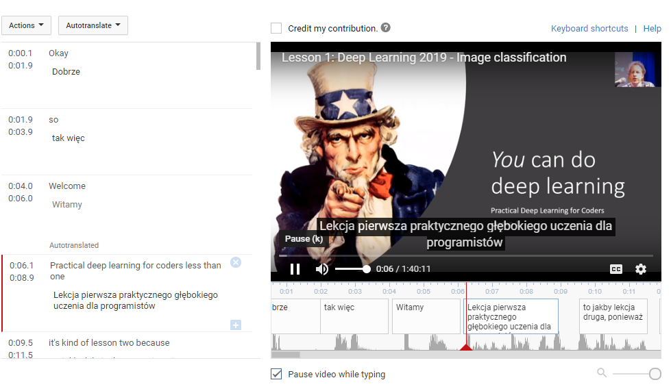
2. Come back to it later as draft is saved for you
3. If you want to correct auto translation just click on the cell with text and type