Steps to add translation to a youtube video

## Login to youtube

## Select a video you want to add translation to

## Click three dots and select ‘Add translations`

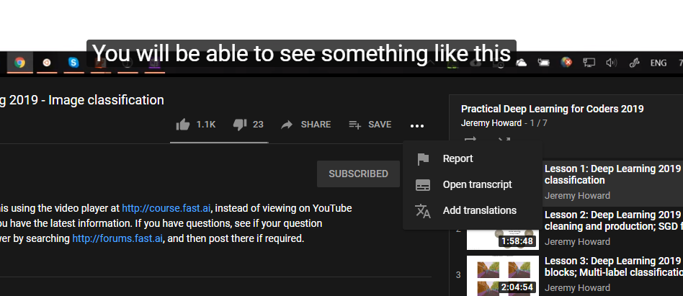

## Click on `Switch language’ and select a language you want to add the translation for

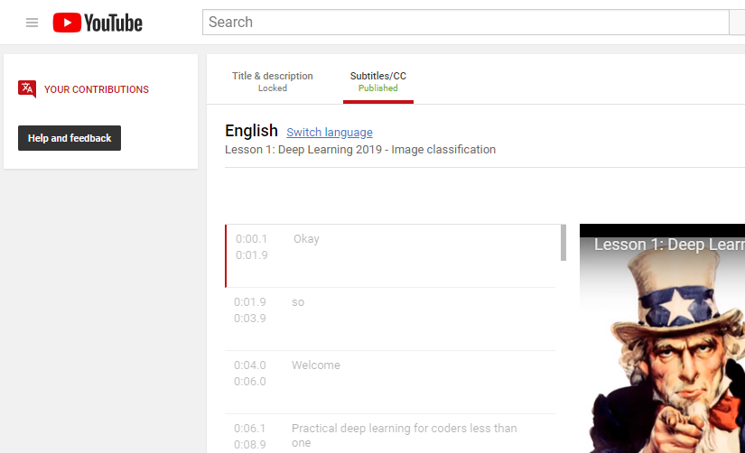

## Auto translate is a good starting point

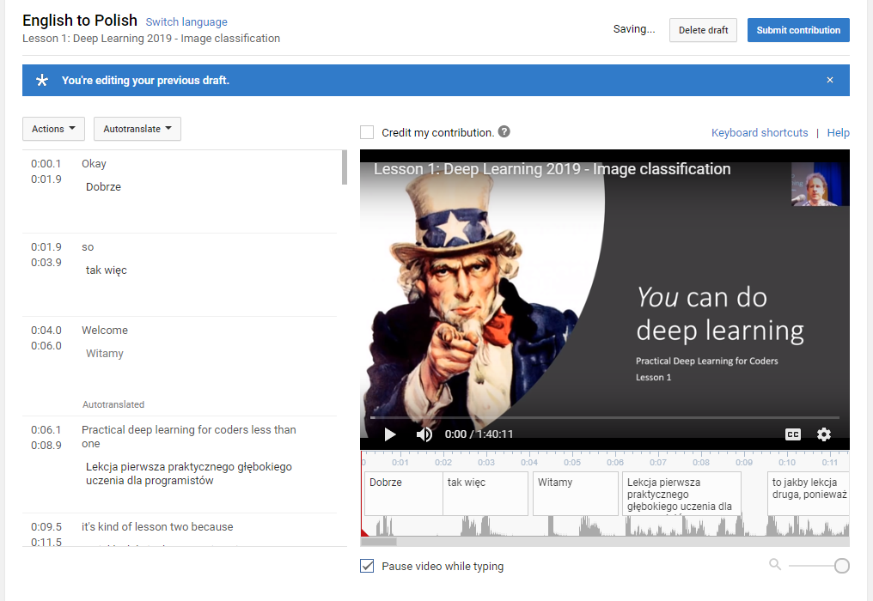

## Option: credit my contribution



## In the editor you can play, stop the video and edit subtitles (a draft is auto-saved so you can come back later to finish the translation)

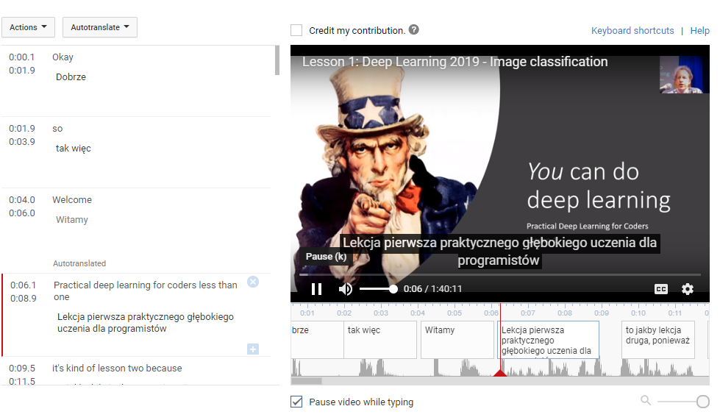

## Once finished, submit the translation to the owner of the video for approval. Congratulations!