# 



**School of Computer Science and Engineering**

Lovely Professional University

Phagwara, Punjab (India)

Gym Website

A gym website for fitness enthusiasts

**──────**

Syed Mustafa Naqvi

Advance Web Development

11704828

RKM012A07

Submitted To : Miss Neha Sharma

# Github Repo

https://github.com/miwsyed/websitegym.git

# Overview

Gym Website is can be used for any gym I can modify it later and can sell it to my local gym it has everything a fitness freak needs to know

# Goals

1. To get more customers to enroll
2. Easy navigation

# Specifications

This project is made with nodeJs and Express as backend framework, handlebars as templating engine and MonogoDb as database. Apart from these, I used a number of various js modules to make it working. Website is mobile friendly as well.

NodeJs

Node. js is primarily used for non-blocking, event-driven servers, due to its single-threaded nature. It's used for traditional web sites and back-end API services, but was designed with real-time, push-based architectures in mind.

ExpressJs

Express is a minimal and flexible Node.js web application framework that provides a robust set of features for web and mobile applications.\

MongoDB

MongoDB is a cross-platform document-oriented database program. Classified as a NoSQL database program, MongoDB uses JSON-like documents with optional schemas.

Morgan

Morgan is a HTTP request logger middleware for Node. js. It simplifies the process of logging requests to your application.

# Screenshots

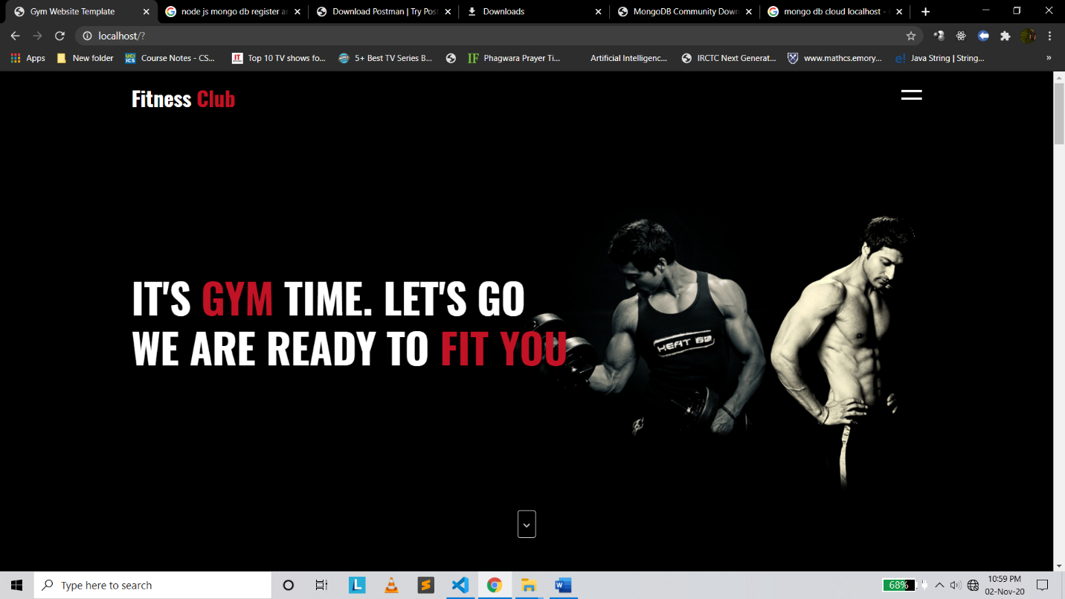

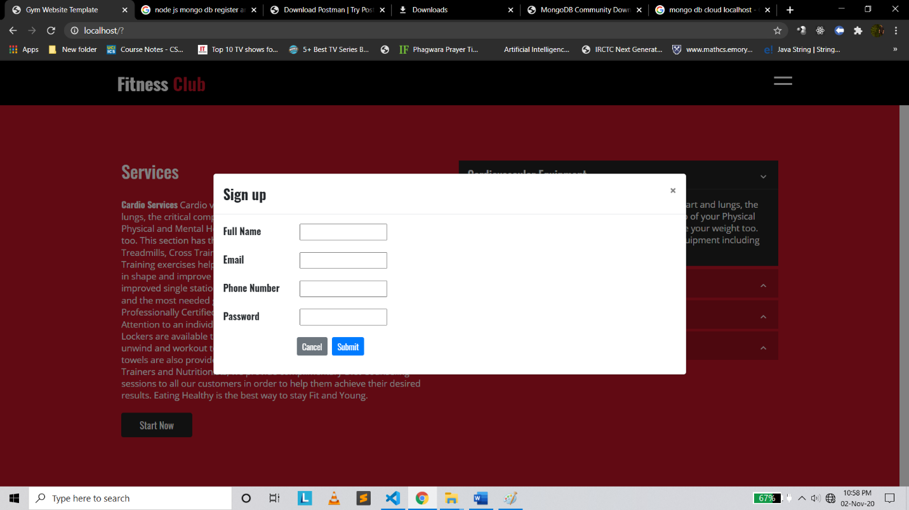

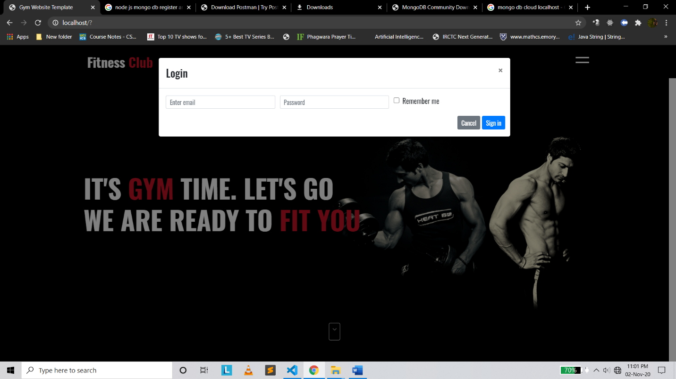

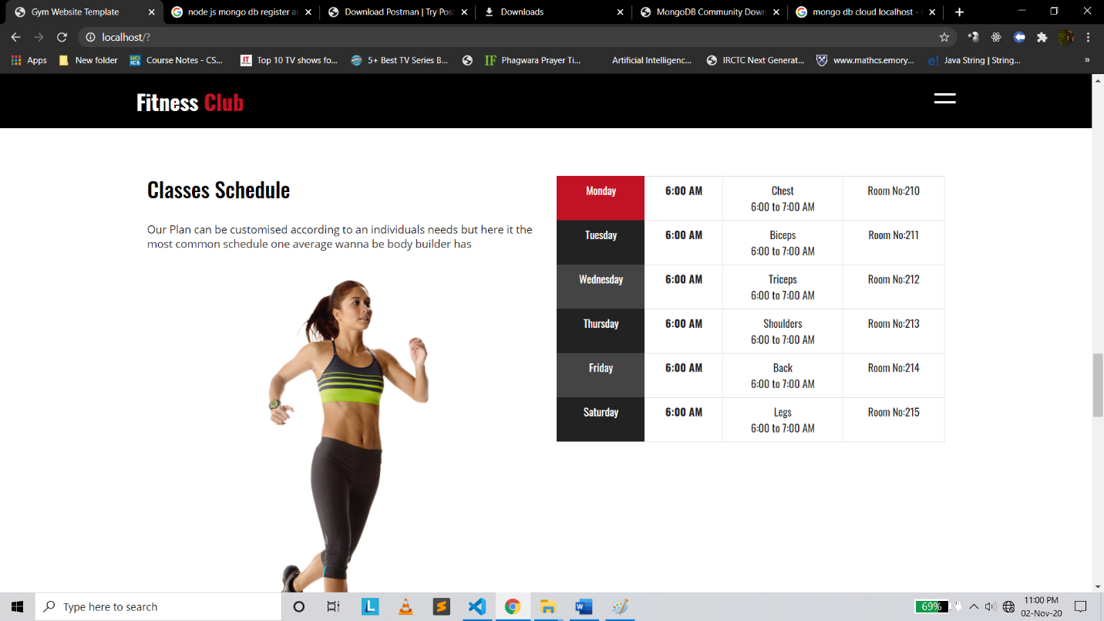

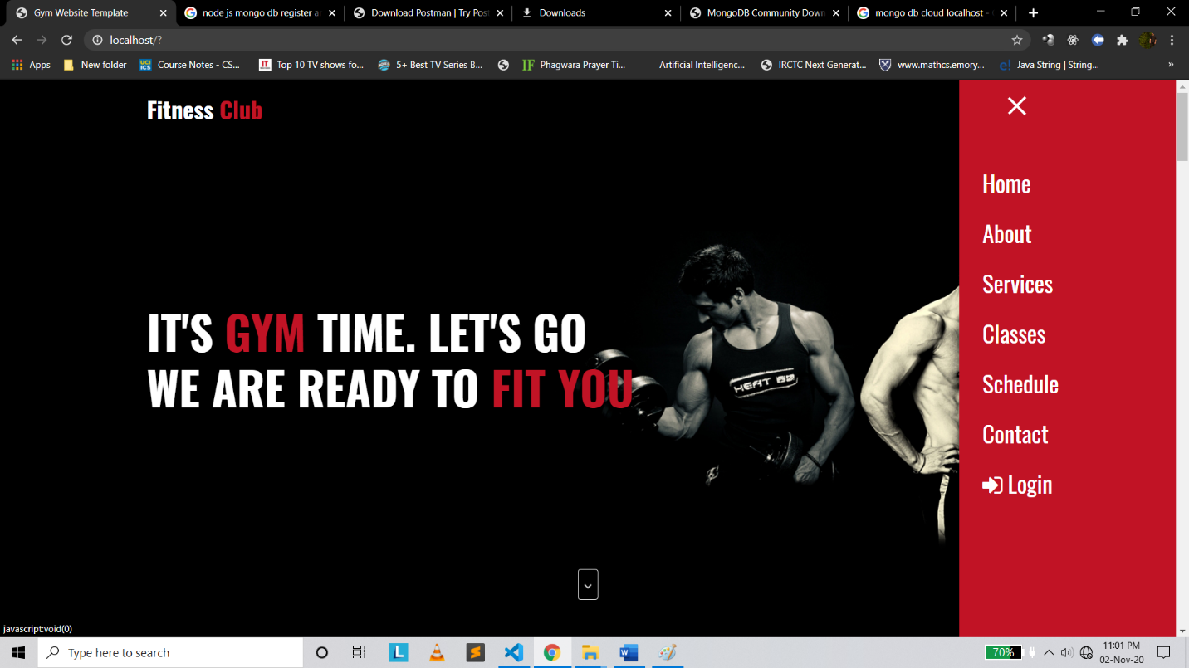

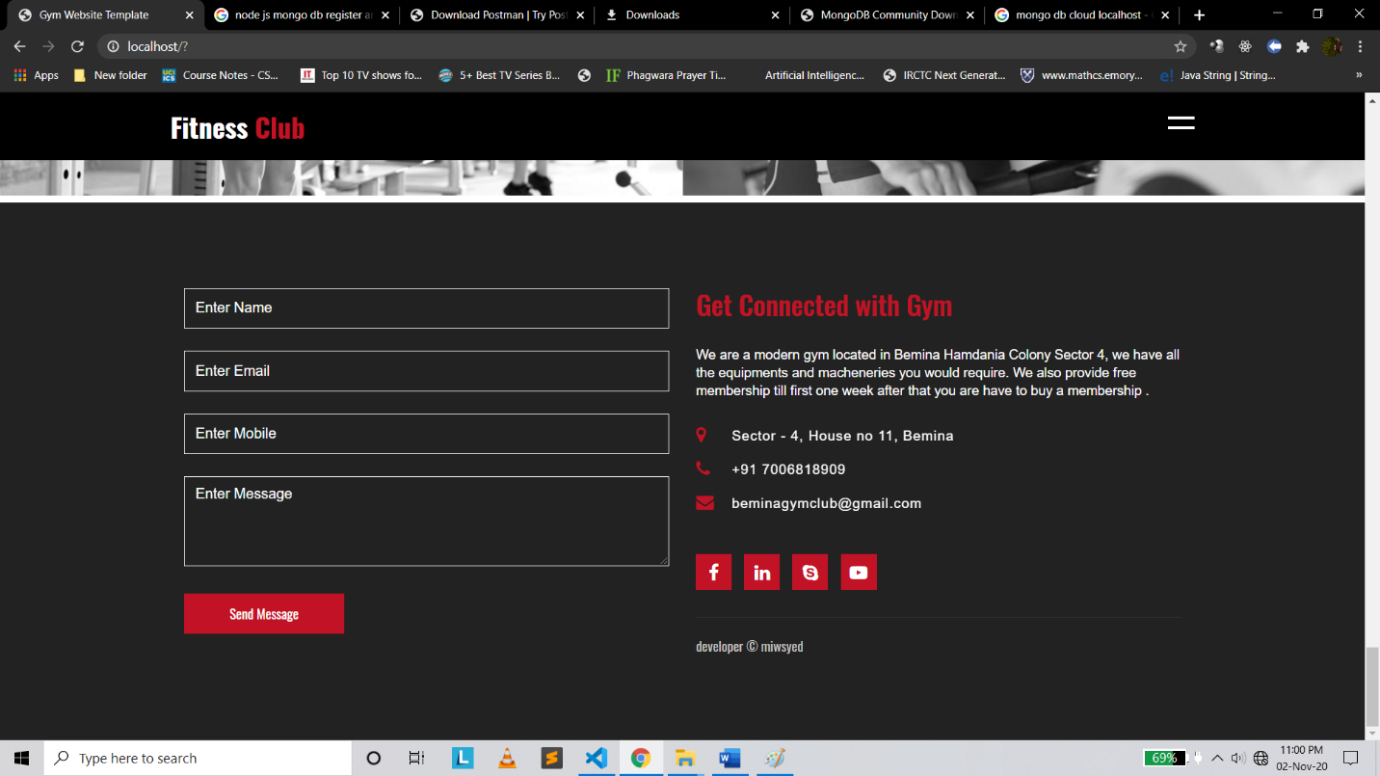

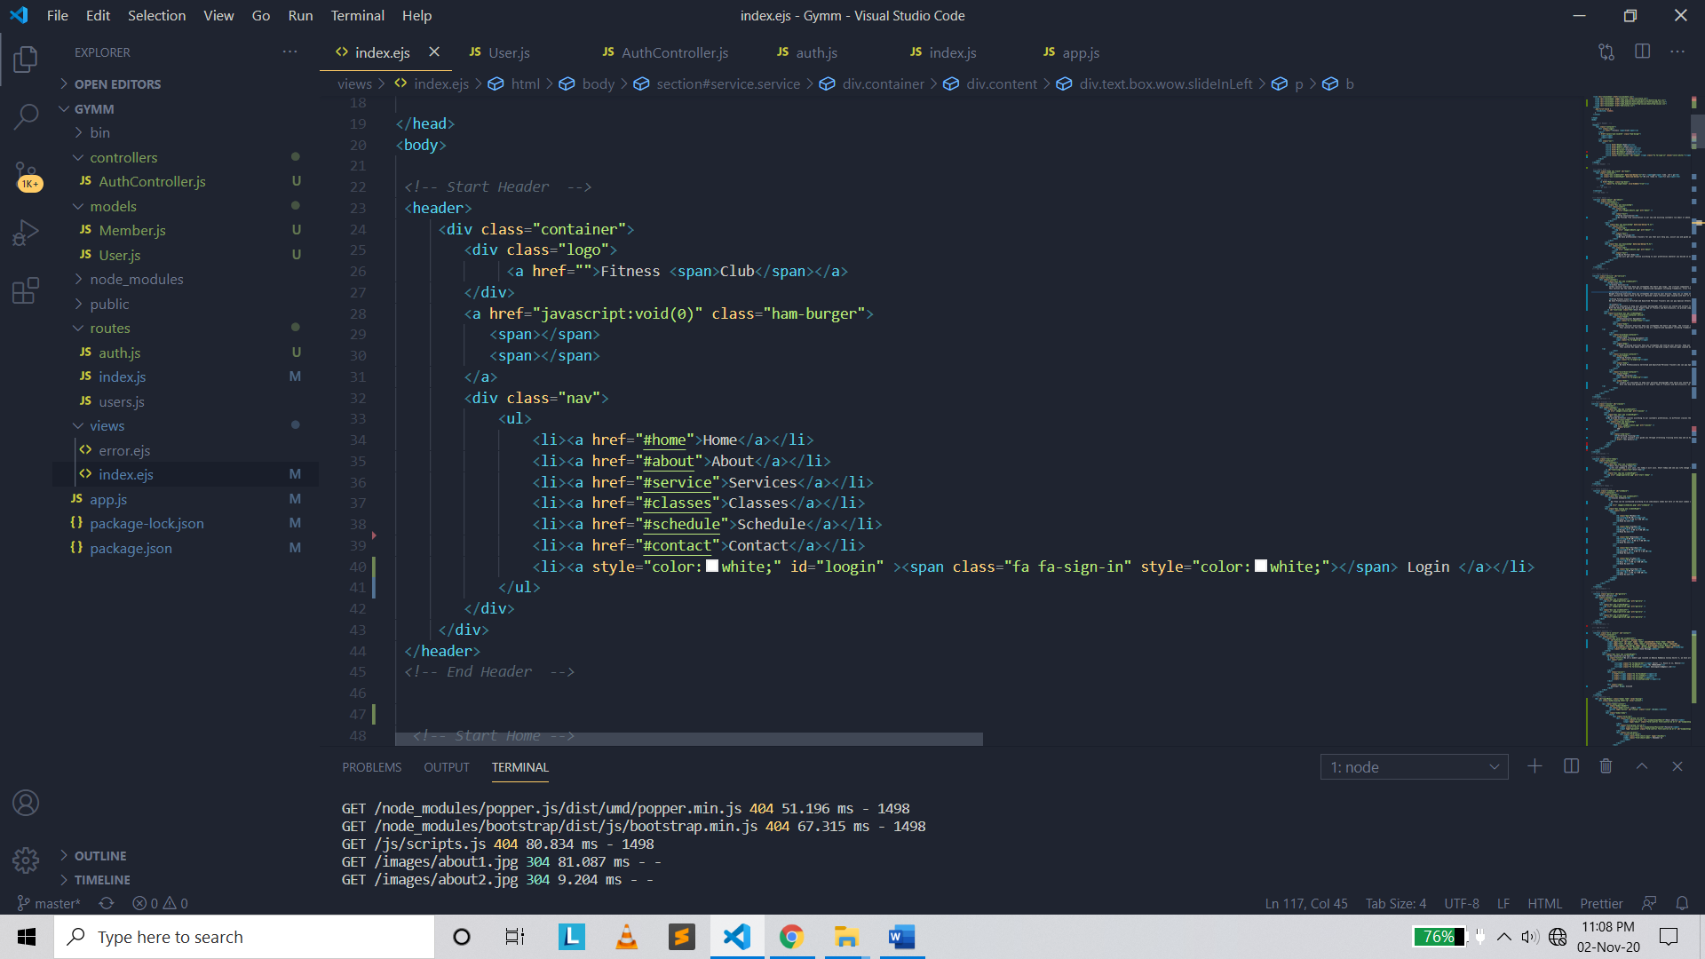

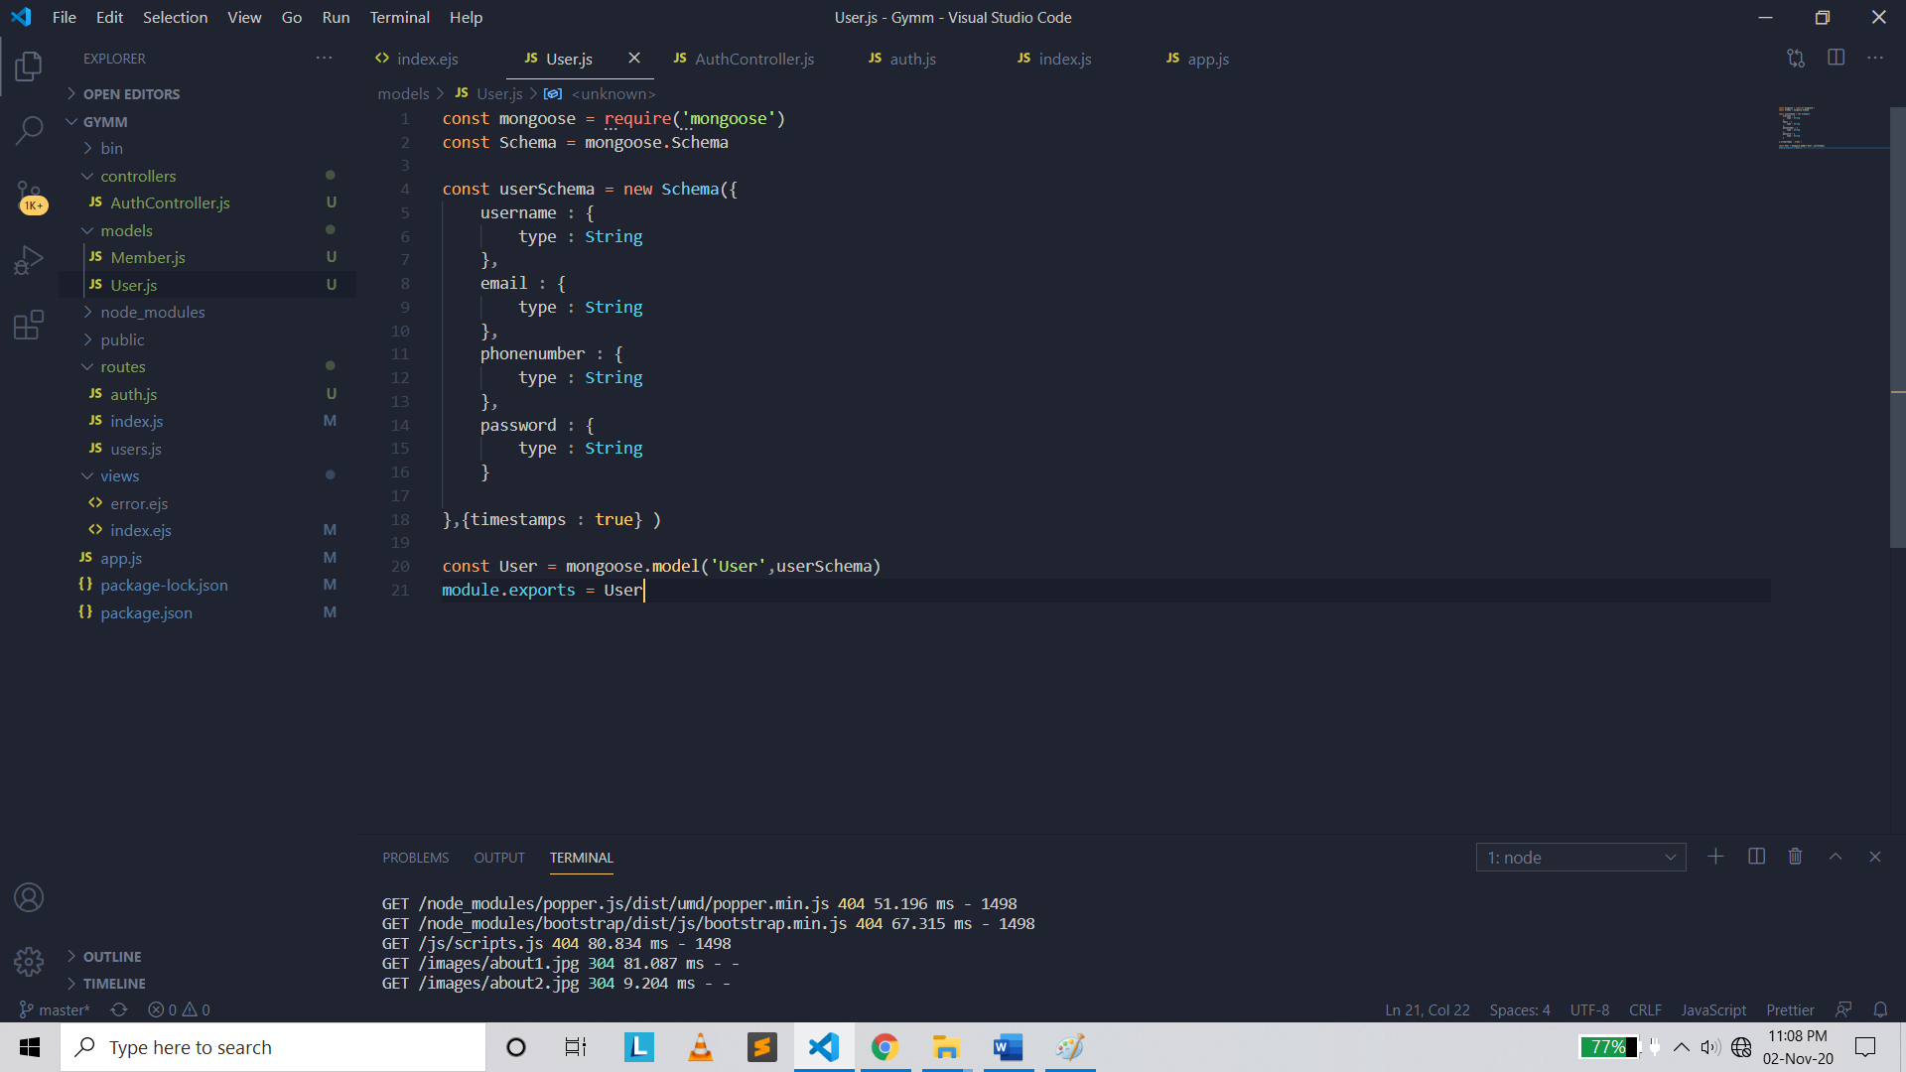

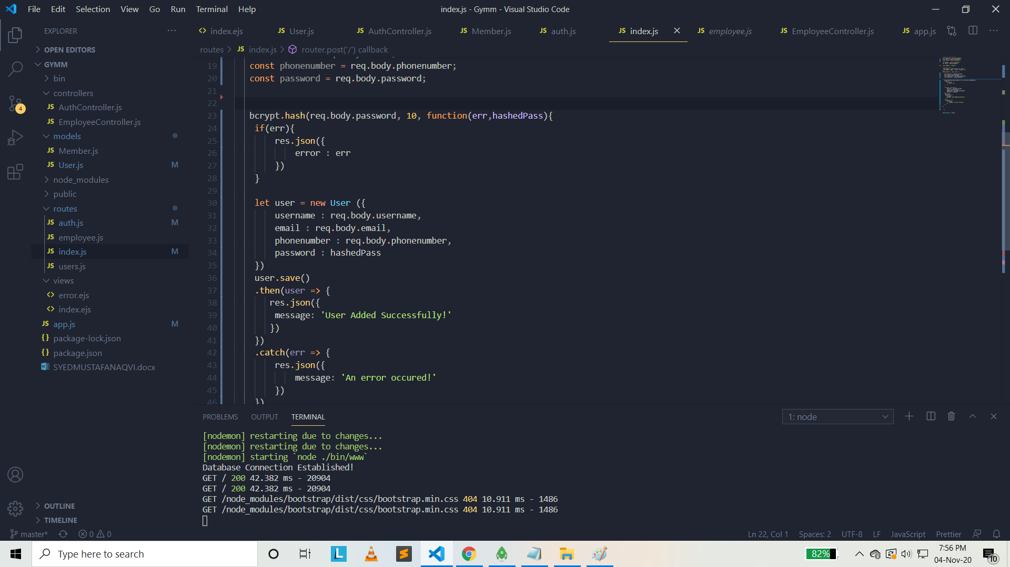

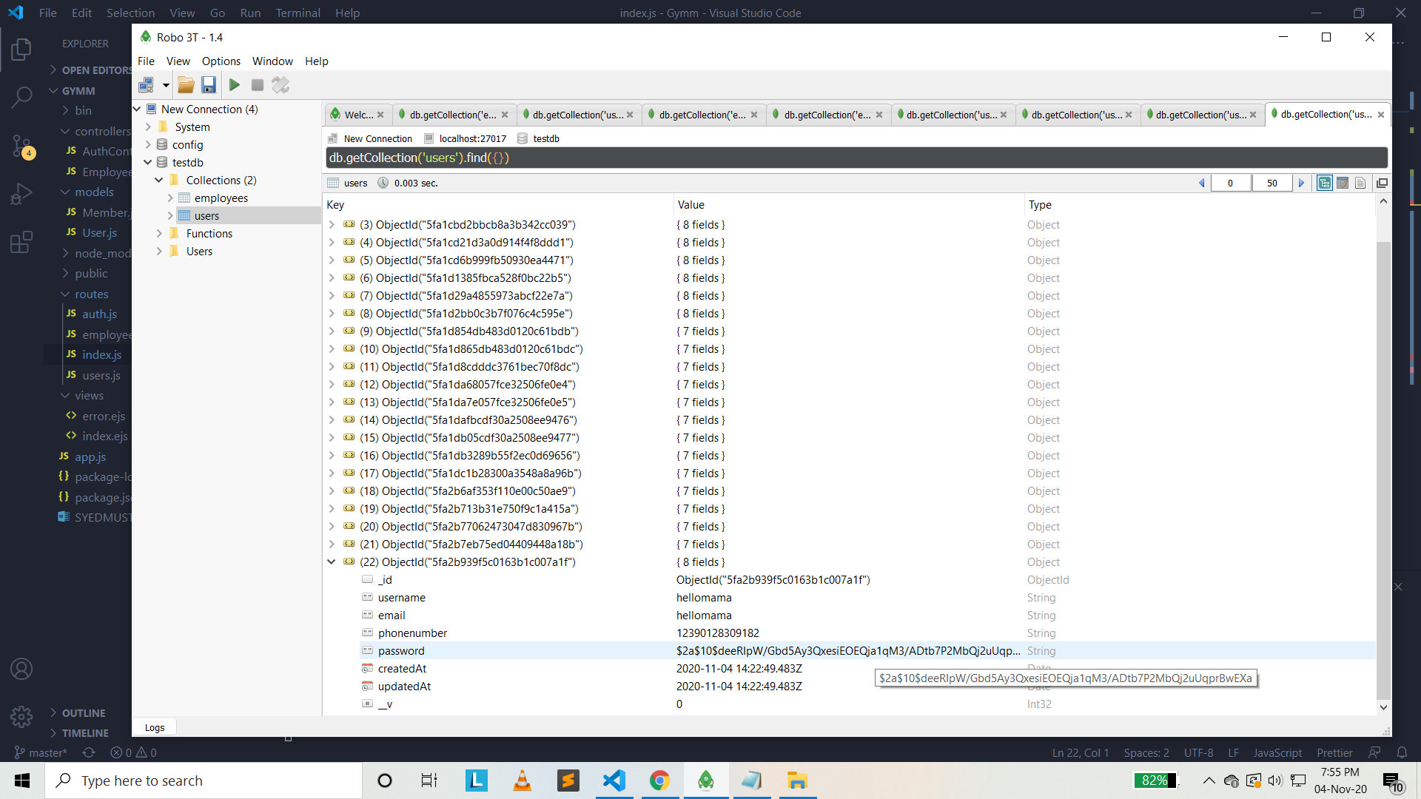

Encrypted Password for Registered User