SMS-HTTP Bridge
Software Requirements Specification
For Geocell Services

Revision History
Date | Version | Description | Author
16.11.2005 | 1.0 |  | Maia Khmaladze

Table of Contents
1 Introduction 3
1.1 Purpose 3
1.2 Scope 3
1.3 Definitions, Acronyms and Abbreviations 3
1.4 Overview 3
1.5 Requirements 4
2 Functionality 5
2.1 Protocol Messages 5
2.2 Configuration Table 6

Introduction

Purpose
The purpose of this subsystem is to support interaction between some company or financial institution and Subscriber via SMS. For this purpose system will implement external service provider interface.

Scope
The document is indented for internal use by co-working company and Geocell staff.

Definitions, Acronyms and Abbreviations
CC – Customer- company: Financial Institution or another co-working company.
SMS – Short Message Service
Subscriber – Geocell or Lai-Lai subscriber
Short Number – the permanent phone number, using which the Subscriber can send request to or get response from the CC.
SMStoHTTP – the type of protocol messages, is used for redirecting the SMS from the Subscriber to the CC. Sometimes this abbreviation is used as a direction name from Subscriber to CC.
HTTPtoSMS - the type of protocol messages, is used for redirecting the SMS from the CC to the Subscriber. Sometimes this abbreviation is used as a direction name from CC to Subscriber.

Overview
The SRS is divided in two parts, first gives general overview of the system, the second contains specific information for implementing Geocell SMS interchanging service.
The goal of this project is to define protocol for information exchange with one specific Service Provider – Geocell. This protocol will be used by CC and will allow Geocell Subscribers and CC to interchange with information. In other words Subscribers will have possibilities to buy service from CC using SMS.

Requirements
- The HTTP is selected as the network protocol for information exchange between CC and Geocell.
- The VPN connection will be established between Geocell and CC. There won’t be any specific encryption on protocol (HTTP) or application level. Security will be handled on lower level. Both sides may assume that communication channel is secured.
- Geocell should define the unique Short Numbers for each CC.
- SMStoHTTP direction: Geocell gets SMS from Subscriber and redirects it to the CC. If redirecting failed the SMS should be placed in the queue and resend later (the next attempt processes in 30 minutes) until the SMS reaches the CC successfully. The redirecting is considered as successful when the CC returns to Geocell response in the predefined time (see Configuration Table: Timeout for Response). If Timeout is expired the SMS will be placed in the queue. Response has two purposes – notifies Geocell about successful redirecting and contains the SMS text that will be delivered to the Subscriber immediately.
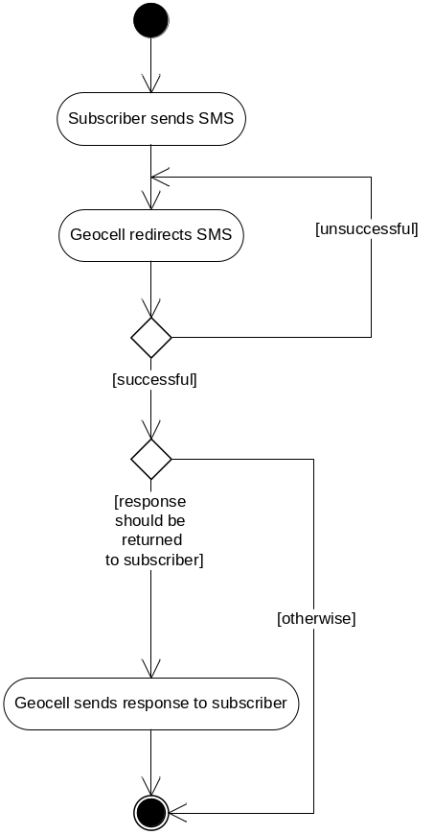
Figure 1

- The SMStoHTTP message should contain the Subscriber number and SMS text as parameters.
- HTTPtoSMS direction: Geocell gets request from CC as HTTP message, redirects to the Subscriber and returns Response “Y” – in case of successful delivering of SMS or “N” otherwise.
- The HTTPtoSMS message should contain the Subscriber number, SMS text and ID of CC-Requester as parameters.
- Geocell should be informed about falling of channel by e-mail. (Recipient’s e-mail was specified later: adevdariani@geocell.com.ge, and some additional e-mails can be specified later)

Functionality

Protocol Messages
HTTP message (post or get – type is not restricted) is used to send either message (SMStoHTTP or HTTPtoSMS) to Geocell or CC servers. Samples of messages are shown below:
SMStoHTTP:
source=995593917070&destination=4004&smstext=some_text&date=20051115102144&smsid=6489&flag=Y

The message body is encoded with ASCII encoding.
Below is the list of parameters (parameter’s names can be change at will; see the Configuration table) for high level protocol:
Name | Description
source | Subscribers GSM number in format (995577######, 995593######,995555######)
destination | unique short number for each CC
date | SMS receiving time in format yyyymmddHHMMSS (24-hour format)
smstext | SMS text
smsid | Unique identifier - is useful for determining whether the sms was sent repeatedly by error.
flag | Indicates whether the sms was placed in the queue and resent.

Response is of two types:
  - “By Full Text” – Geocell without any changes delivers the text to the Subscriber
  - “Nothing” – Geocell does not sends response to the Subscriber

HTTPtoSMS:
src=2516&dst=995593917070&txt=some_text

The message body is encoded with ASCII encoding.
Below is the list of parameters for high level protocol:
Name | Description
Src | Unique identifier of CC (is provided by Geocell)
Dst | Subscribers GSM number in format (995577######, 995593######,995555######)
Txt | SMS text

Response is “Y” or “N”. In case of response= “N” the request will not be resent after some time.

Configuration Table

The Configuration Table contains detailed information about parameter names, timeout interval and other options and has to be prepared for each CC separately.

The Excel file with “Configuration Table” is attached.

