Erythema nodosum

1. Give an overview of the disease, it’s diagnosis, and management

Erythema nodosum

An inflammatory disease featuring characteristic panniculitis, joint pain, and malaise that occurs both as a primary disease and as a secondary phenomenon.

# Incidence, Age, Sex, & Geography

It is a disease of young adults mainly, but no ages are completely spared.

It is uncommon. Women are affected more than men (ratio approx. 1:4). Geography influences the likely aetiology.

# Aetiology

The possible aetiologies of EN are numerous, but three causes make up the vast bulk of cases: (frequencies are approximate):

1. 30% Primary
2. 30% Sarcoidosis
3. 30% Infection (mostly Strep throat)

The remaining causes are all an order of magnitude rarer and can be grouped somewhat systematically:

|  |  |
| --- | --- |
| Drugs | Oral contraceptives  Sulfonamide antibiotics  Sulphonylureas |
| Pregnancy |  |
| Systemic inflammatory disease | Crohn’s disease/Ulcerative colitis  Behcet’s disease |
| Other infections | TB  Various gastro-intestinal infections  Various fungi |

# Pathology & Pathogenesis

It is presumed to be a form of hypersensitivity reaction.

The skin disease is a panniculitis; it is described as a septal panniculitis without vasculitis.

# Symptoms & Signs

Patients typically present with the triad of:

1. Characteristic rash
2. Joint pain
3. Generalised malaise/flu-like symptoms

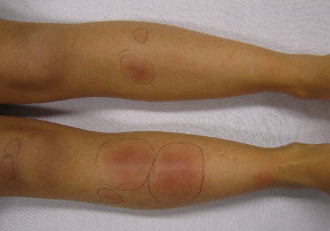

# Tests

EN is usually a clinical diagnosis. A biopsy may confirm the diagnosis but is not usually required.

Further testing depends on the history and risk factors but a reasonable starting point might include:

|  |  |
| --- | --- |
| Streptococcal infection | Throat swab (if active symptoms)  ASO titre (if infection in recent past) |
| Sarcoidosis | Chest XR  +/- serum ACE (*controversial*) |
| Pregnancy | Beta HCG |

# Management and Prognosis

Prognosis is good, but depends of aetiology; surprisingly, primary disease is often more persistent than secondary disease:

1. Infection-induced disease usually clears in 1-2 months
2. Primary disease may last 6 months or more

Treatment is minimal:

1. Treatment of any precipitating cause
2. Symptomatic relief, usually with NSAIDs

# References

1. Erythema nodosum: the underlying conditions. Psychos et al. Clin Rheumatol. 2000; 19(3):212-6. (<https://reference.medscape.com/medline/abstract/10870657>; accessed 1/6/18)
2. Erythema nodosum. Medscape. (<https://emedicine.medscape.com/article/1081633-overview>; accessed 1/6/18)
3. Davidson’s Principles and Practice of Medicine; 22nd Edition; p1303