James’ Guide to Software Rendering

Episode 1: Why does dividing by z make 3d graphics?

I’m going to try and explain how to convert a 3d object into a 2d shape that we can actually draw. This is probably the most basic yet fundamental step in 3d graphics and I didn’t understand it properly for ages.

# The Basic Concept

Imagine the scene: you are sat in front of a window. Behind the window is the scene. You want to draw the scene on the glass. The point of this article is to calculate where to draw on the window.

# Step 1: Some basic definitions

My 3d world is made up of shapes. The various bits of those shapes are defined by their coordinates in the world. Those coordinates are 3d Cartesian coordinates; that is, they have an x, a y, and a z part.

I call the space in which my shapes live “World Space”.

My screen is a 2d world. The physical screen on the laptop on which I’m writing this 1920 units wide, by 1080 units tall. My virtual screen has no limits however. It’s still 2d, and coordinates on it are defined by an x and a y part, but there are no limits on how big the numbers can be. My physical screen just shows a little window onto this.

I’m going to call this flat space “Screen Space”.

I want to draw my world on my screen. The question I’m going to address today is a very basic one: if I have a coordinate in “World Space”, how to I figure out where it goes in “Screen Space”.

# Step 2: a picture of where my two worlds meet

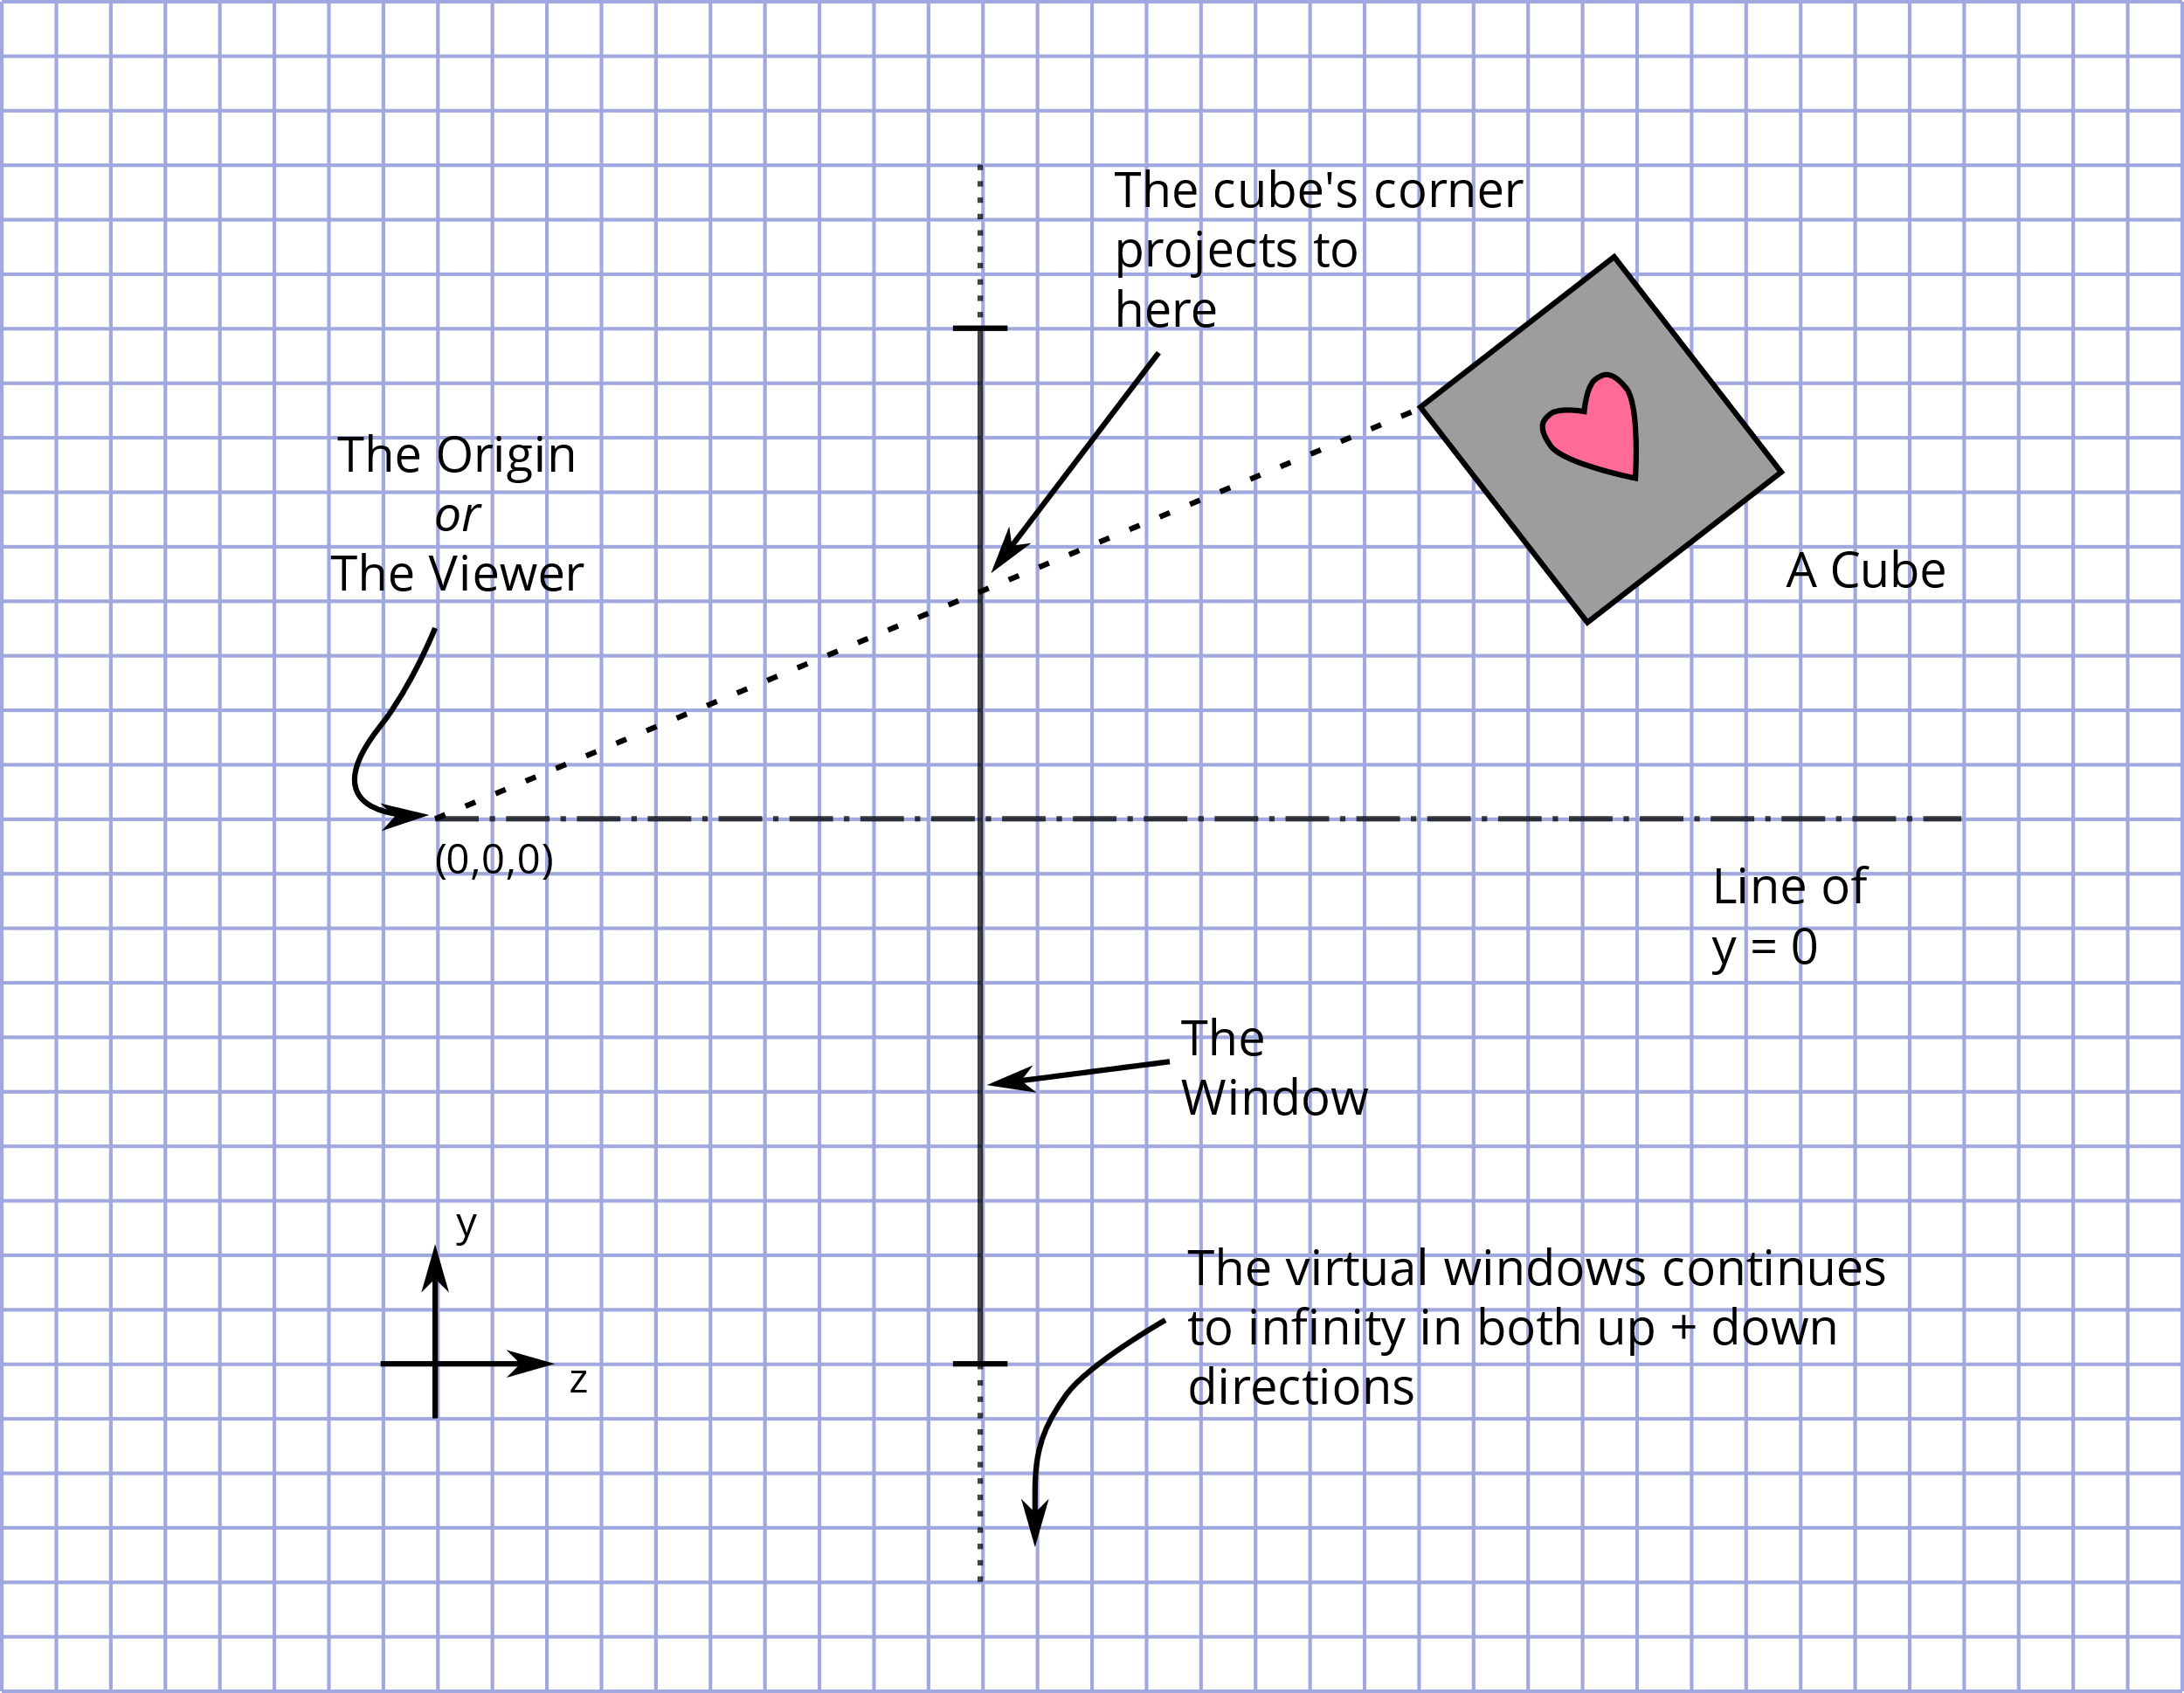

This picture shows my “World Space” from a side-on view. The y-axis is upwards and rightwards is the z-axis. The origin (y = 0, z = 0) is where the eye is. The window is exactly 1 unit in front of the eye.

If you draw a line between any point in 3d space and the eye, that will give you the y coordinate of where to draw that point on the window. You could do the same thing from a top-down view to get the x coordinate.

This next picture shows two triangles overlaid on the original image. The big triangle connects the point on the shape to the origin. The smaller triangle connects the point on the screen to the origin. These triangles are *similar* – they have the same angles but different lengths. Because the angles are the same, the ratios of the lengths must be equal.

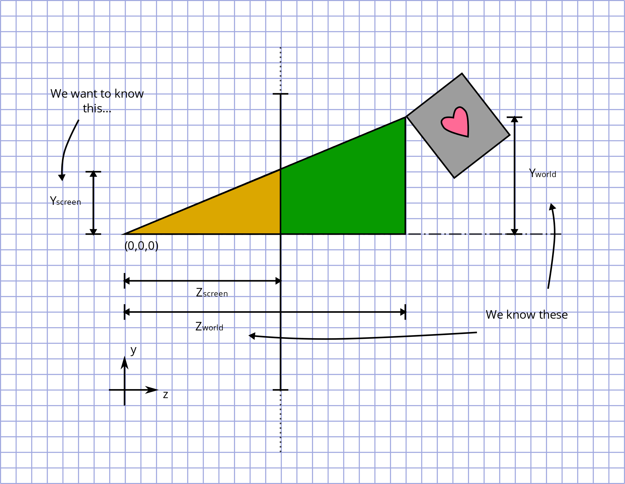

From this we can say:

$$\frac{Y_{screen}}{Z_{screen}}=\frac{Y_{world}}{Z_{world}}$$

And because we have put the screen at z=1:

$$Y_{screen}=\frac{Y_{world}}{Z_{world}}$$

And that’s all there is to it. To project a 3d object onto our screen, simply divide the x and the y coordinates in 3d space by the z coordinate.