Testing sticky elements

The beginning of the sticky section
This is the pre-amble.
  - 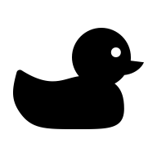
Figure 1A sticky duck!
And this is some text that will appear after the sticky duck.

A further section, this time with a parallax background
Some subtitle

Another section
Some more text.

