This is the page title
  - This is a subtitle
And now some simple text. We include bold, underlined, italic, _{subscript}, ^{superscript}, and strike-through.
Now for some more text and this text has a custom paragraph style and has a run of a custom character style.

Tables
We also need to support tables…
Table 1My little table
Column 1 | Column 2 | Column 3
The | First | Row
The | Second | Row

Images
This is a PNG file…
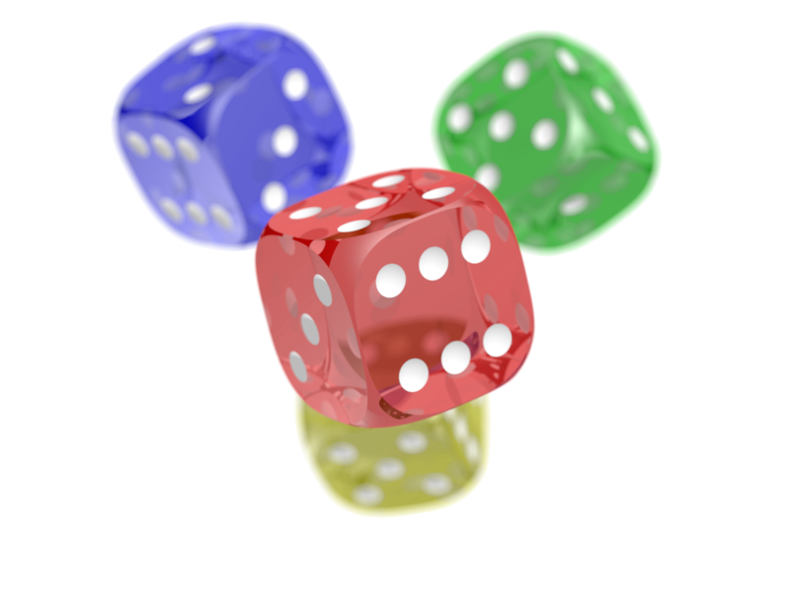
And this is an SVG file…

Figure 1- A caption
And now some equations…
$$E=mc^{2}$$

And now some other stuff…
- A numbered list
- A second item
  - A sublist

Similarly…
- A bullet list
- Two

And this is a footnote
This is an endnote!

