Fig 1.4 General behavior of an nMOS (a) Cutoff mode (Vgs<Vtn) (b) active mode (Vgs > Vtn)

Fig 1.5 Electronics of the MOS system, MOS structure and voltage plot

Fig 1.6 Depletion in the MOS structure

Fig 1.7 Inversion mode of operation in an MOS system

1.1.2 Body Bias

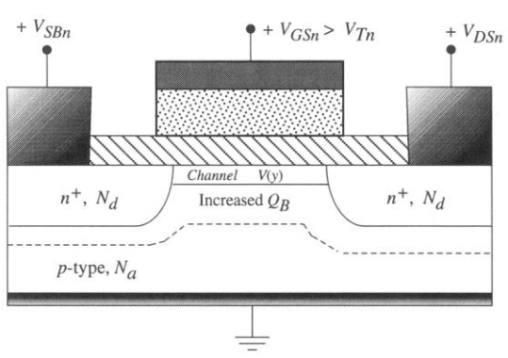

Fig 1.8 Body bias increased Qb