Brave triangle

- Install Construct 2
- Install plug-ins and behaviors
- Open the *.capx file
- How to play: Touch or any press key
- Gameplay
- Very easy reskin sprite
- Export to html5
- Export to android
- Change sound and music
- admob
- facebook and twitter

Installing Construct 2

Construct 2 is a powerful ground breaking HTML5 game creator designed specifically for 2D games. It allows anyone to build games — no coding required! If you haven't already, grab a copy of the latest release of Construct 2 here. The Construct 2 editor is for Windows only, but the games you make can run anywhere, such as Mac, Linux or iPad.

Installing plugins and behaviors

The plugins them into the
'/Exporter/HTML5/plugins' folder on your
Construct 2 installation path.

Open the *.capx file

DogiBallShooter.capx

Run the demo (hot key for start project F4 )

Click on View and on to Project Bar
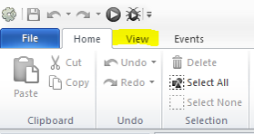
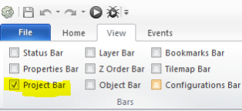

Open double click layout menu
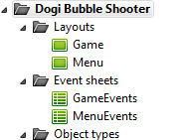
Start selected layout hot key F5 or button play to the quick access toolbar
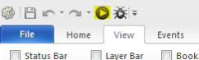

How to play:
Tap on left or right side of screen to move player left or right also you can use left and right arrow on keyboard.

Gameplay
Open event sheet GameEvents to Project Bar, folder Event sheet
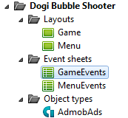

To change ball move speed edit follow line
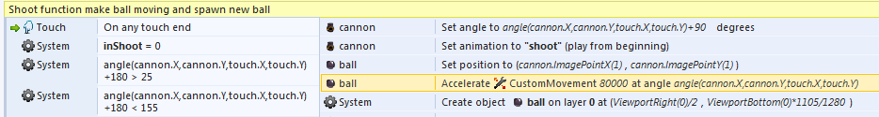
To change number of shots after add line edit follow line
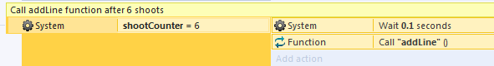
And in this place
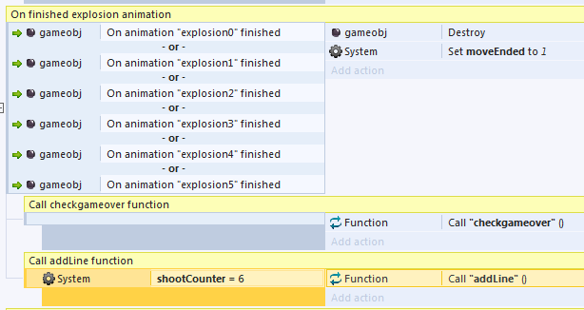

Very easy reskin sprite

Double click for object Sprite (info in Properties Bar) for open editor image. More info
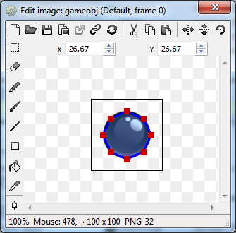

Export to html5

https://www.scirra.com/tutorials/43/making-an-ios-web-app-with-construct-2

https://www.scirra.com/tutorials/58/how-to-make-a-facebook-game

and more

Export to android

You need a Personal License!!! Buy Construct 2

https://www.scirra.com/tutorials/71/how-to-export-to-mobile-with-phonegap

Change sound and music

Project bar, folder Sounds
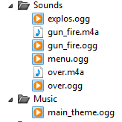
Right click on folder, import
And import sound with same name for ex. Sound with name menu.wav will replace all menu sounds in game.

Admob
Admob work via intel xdk and disabled by default. If you want use admob then toggle disabled follow lines. On start of layout in menuEvents
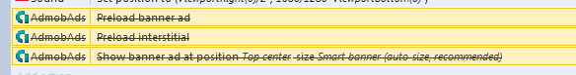
And in GameEvents at gameover function
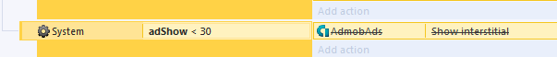
Don’t forget enter your banner id and interstitial id in admob properties.

Facebook and twitter
To change twitter message edit this line at MenuEvents.
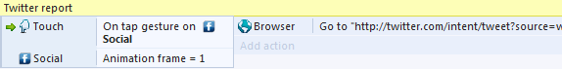
To change facebook message you need to edit shareBS.php as you want, then upload it on your host. I’m use free 000webhost and edit follow line to your link.

Thanks for purchase
Support and suggestion: alexandr-91@bk.ru

