Reading Guide
Huien Mi Yordanova
Version 3 – 18/05/2025

Content
Table of Contents
Reading Guide 1
Branding 1
Mood boards 2
Research & Ideation Phase 2
Styles cape 2
Brainstorming for design zest 3
Logo 3
Step 1: Inspiration for the Logo 3
💻 Step 2: Digital Design 4
👂 Step 3: Feedback 4
🔁 Step 4: Iteration & Validation 4
✅ Step 5: Finalization 5
Posters 5
Website Low fidelity prototype 5
Website coding 5
Trello 6
Notion 6
Team Chart 6
After Effects 7
Night of the nerds 7
Target audience - research 7
Survey and report 7
Empathy map – 7
POV 8
Persona 8
HMW questions 8
Lotus brainstorming 8
Moscow Table 9
Concept poster 9
Customer journey 9
User flow diagram 10
Figma prototype 11
Figma Low fidelity prototype 13
High fidelity prototype 14
Mobile design research 14
Personal project 14
Project Overview – A New Kind of Tamagotchi 14
That’s what inspired me to create this app. 15

Branding project

Project introduction
Our first group project was a branding one. My team and I had to create a completely new brand identity . At the beginning, we didn’t know each other very well, so we decided to set some group rules and penalties to keep things fair and organized. We also created a WhatsApp group to stay in touch and share updates easily.
To understand each other’s strengths and weaknesses, we made a team chart. This helped us see what each person was good at and what they might need help with. Thanks to the chart, we were able to divide the tasks in a way that made the project run more smoothly. It helped us work better as a team and made sure everyone had a role that suited them.

Proof • Team Charter • Brand Guide • Logo • Posters • Website
Reflection Working on this project was a good experience that helped us develop both our design and teamwork skills. At first, coming up with a name and brand identity took some time, but once we had a clear direction, everything started to come together. What I learned during the project was that it is important to communicate ideas clearly. Working on the logo, brand guide and posters taught me a lot about branding and consistency. This project showed me how different elements of a brand identity connect and how teamwork plays a big role in making everything work smoothly.
Logo

Mood boards

Research & Ideation Phase
I began by exploring themes that reflect energy, bold creativity, and a modern design identity. The name “Design Zest” inspired me to incorporate ideas of freshness, vibrancy, and a punchy personality. My focus was on bright, bold imagery using yellow, navy, and citrus tones to convey a sense of positivity and liveliness. The visuals were carefully chosen to express creative freedom, joy, and individuality—core values we want our brand to embody. Throughout the process, we were guided by keywords such as bright, colorful, playful, and professional.

Styles cape
• Color Palette:
- Yellow – for zest, joy, innovation.
- Navy blue – for stability and professionalism.
- White and beige – for clean and minimal backgrounds.
• Typography:
- Bold sans-serif for clarity and impact.
- Elegant serif for a refined contrast.
• We chose a simple but clear visual system that can be easily adapted across print, digital, and social platforms.

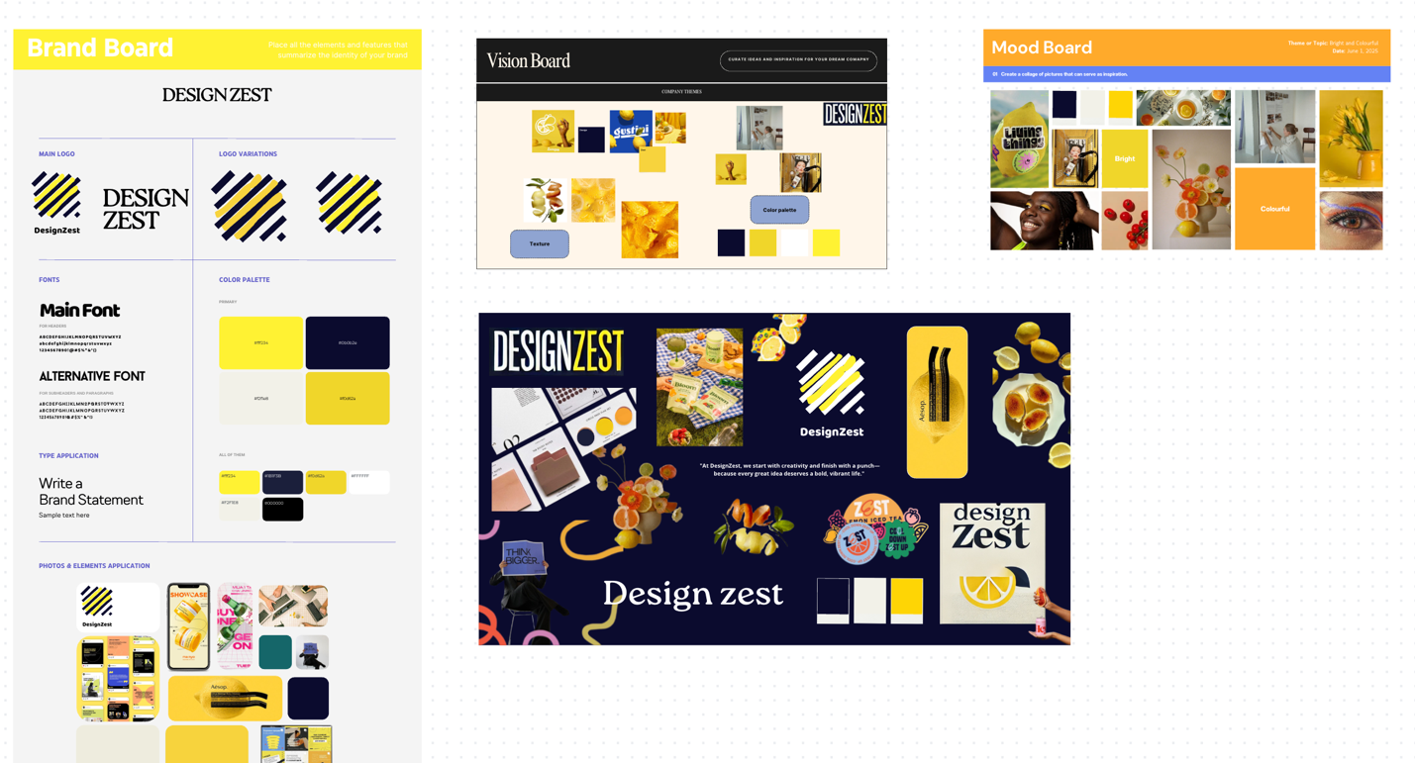

Brainstorming for design zest
  - That day, we had a lecture with Chris, and he told us to start brainstorming on a whiteboard. We wrote the name “Design Zest”, and everyone contributed their ideas. Our goal was to show people how we work and express our identity. We wanted to use the ideas from this brainstorming session to create a poster.

Logo

Step 1: Inspiration for the Logo
The initial idea for the brand “Design Zest” was to visually represent the word zest—as in lemon zest—to convey freshness, energy, and creative sharpness.
At first, I wanted to make the letter "Z" formed from a lemon and a zester tool. While playful and detailed, the early versions were too intricate for scalable use.
After feedback from our teacher Dirk, I researched modern logo trends. I noticed that current logos are:
- More minimal
- Use simple geometric shapes
- Prioritize readability at all sizes
I also looked at inspiration boards and visual references, including a graphic artwork with bold diagonal blue stripes and gradients. This helped me move toward an abstract yet conceptually strong direction.

💻 Step 2: Digital Design
Taking the inspiration further, I explored ways to symbolize a zester tool without literally drawing one. The solution was a series of diagonal lines, inspired by:
- The cutting grooves of a zester
- The motion of zesting a lemon
I paired black/navy diagonal stripes with yellow shapes underneath to represent the zest shavings or lemon layer, while keeping everything abstract and bold.

👂 Step 3: Feedback
Once I created multiple logo variations, I shared them with the group. We all agreed the striped logo was the strongest—it felt modern, memorable, and flexible.
To test it further, I asked teachers Mikael and Kadian for user feedback. Without me explaining the logo, Mikael mentioned:
“I see the idea—the black lines are like a zester and the yellow feels like lemon zest.”
This was a key moment of validation, because the concept was understood visually, without explanation.

🔁 Step 4: Iteration & Validation
Based on feedback:
- I refined the spacing and thickness of the lines
- I experimented with different yellow hues to find the right balance between vibrancy and readability
- I tested the logo in black & white, inverted, and on mockups (like posters and social media)
Every version maintained clarity and impact even at small sizes, which confirmed the strength and scalability of the design.

✅ Step 5: Finalization
The final logo is a bold, abstract mark that captures the essence of Design Zest:
- Diagonal lines = energy, movement, creativity
- Yellow = lemon, freshness, joy
- Balanced structure = professional and trustworthy
It's flexible, memorable, and communicates our brand without being overly literal—perfect for both print and digital use.

Posters
Inspiration
Digital Posters
Validation

Website Low fidelity prototype
Me and my team wanted to make a website that will be for out company “design zest”. Because I coded the website alone and didn’t have time for high fidelity prototype I made a competitive analysis and then a low fidelity prototype. I wanted to be one page website and to have the main information there. I looked at other companies that are media design ones and then because most of them already had clients and projects and we didn’t I decided to just put our work throughout the semesters. With the website I wanted to show the clients how we work and what we can provide I wanted them to see how we are different from the other companies and why they should hire us

Website coding
. The first section is animation drew by Alexandru and then we have the layout page with all our projects and then we have a small section about “what we can provide” page, I got the idea from another company but because they used animations and Lottie I decided to try and recreate it with css and js. It did turned out pretty similar and I made all the sections clickable so when you click them you can see a further process about our work. I wanted the Zest Area to be shaped like a lemon and tried different ways but didn’t succeed I believe if I finish the website and try more I can do it but I decided to leave it with a yellow colour representing our brand. The next section is just teammates and the last one is a 3d gallery that I got from tik tok and decided to put our posters there.

Brand Guide

Trello
I created a trello that helped us with the branding our company part so that we have a clear idea what we need to do and what is done. It helped us also by assigning roles and putting deadlines on each task. But we decided to continue with notion because my group was in a group together before and found notion working more efficient than Trello.

Notion
Notion is better if you want to keep everything in one place—notes, research, wireframes, moodboards, task lists, and documentation. It's flexible and visually clean, great for full project planning.
Trello is better for just task tracking with boards and cards. It’s simpler but not as good for storing detailed design work or writing.
Personal Use:

Team Chart
The team charter is a document that showcases the group members, roles, norms and rules. We decided to have a couple of roles (team lead, contactperson, quality master and note taker) within the group to make sure these tasks will be done. Every group member also had to write down their strengths and weaknesses, which helped us eventually divide tasks within the project.
I made a file with the template for the team charter so we can all fill our own part, then this way it was easier to see and decide the roles for the projects
My part was more of the coding part and documentation but now I am doing still the coding part and the designing part

After Effects

Night of the nerds

Target audience - research
When we got assigned for the project night of the nerds me and my team started doing research on the target audience. We did interviews, surveys etc. Our target audience age was between 14 and 20 so its basically high school and university. I decided that this will be two different target audience because high school people are feeling lonely about another reason and university students have also different reasons. So I made a report of my research: (picture)
Interview:
Then from the interviews which were 31 we saw that most of the people are feeling lonely and are ready to socialize but doesn’t want to do it alone. Our next step was to do a design thinking process in figma and from there to start brainstorming once we know everything for our target audience.

Survey and report

Empathy map –
Using an empathy map helped me better understand the users I’m designing for. By visually organizing what the user says, thinks, does, and feels, I was able to step into their shoes and uncover deeper insights beyond just basic needs. It encouraged me to think about their emotions, frustrations, and motivations, which ultimately influenced my design decisions in a more human-centered way. The insights I got from interviews and survey also from little bit research and mostly the user is willing to take action but is afraid to do it alone.

POV
I had a lecture with Penny, and I was learning about POV and how important it is to define the real problem from the user’s perspective. It turns what I learned from empathy and research into a clear focus. My Point of View for the project is based on young people aged 14–20 who are into creativity and tech. They want to connect with others and are willing to take actions but not alone. Our app aims to support them by offering a fun, low-pressure space for interaction and self-expression.

Persona- These personas help me understand who I’m designing for. Amara and Luca are two types of users who want meaningful, low-pressure digital interactions. Their goals, behaviors, and frustrations guide my design decisions, so the app actually solves problems they face. Me and my group decided to make two personas because our target audience age gap is big so the first type will be mostly people in high school facing problems with connecting with people or having problems at home and the other type is students in university that maybe moved to another country or city and have e difficulties connecting and balancing work life, university life and their personal one.

HMW questions

These HMW questions helped me turn what users are struggling with into ideas I can actually design for. They let me explore different ways to make the app fun, creative, and supportive, especially for young people who feel lonely or awkward socially. They helped me later with brainstorming because basically I was brainstorming solutions and answers for those questions. The questions I and my group asked are based on interviews, surveys and research we did before that.

Lotus brainstorming - We had a lecture about the lotus brainstorming and we kind of did that for the branding our company but now we decided to make it more serious and on paper. First, we started by making not the lotus method but just a brainstorming on a paper and we wrote everything for 5 minutes that we can think of and then showed it to our teacher Kadian, she told us that the ideas were good, but we should confirm with the clients.
After that day we started on the lotus brainstorming. Using the Lotus Blossom brainstorming method really helped me, and my group break down a broad idea into smaller, more manageable concepts. It provided a structured way to expand my thinking by starting with a central theme and branching out into related ideas, each of us got a marker and started filling all the sections then later on it helped us having a clear vision of everything knowing we won’t miss any idea that we had on mind and later on we used it for our Moscow table.

Moscow Table

Concept poster
For the concept poster when i did a research online I saw that mostly people put a lot of text also in annoucment i saw that the teacher sent us a website but all this was with a lot of text something like presentation poster and when I asked my teacher Dirk he said to avoid a lot of text but to make sure still that the concept is clear, so first I did a really simple poster that i asked if its okay and my teacher said that its okay but not a lot detailed and that its not really understandable for who is the app made, so then I decided to give everyone from the group a role. hristiyan did the stylescape for the poster and also the charachter creation (which later on we didn't use because it was minimal and not really matched with the poster) Alexandru was looking for fonts and Lizzy did the insights.
I started doing the poster and put details that will be key things in our website so i basically started with the landing page prototype and then on top Lizzy came up with the name, she made the QR code that goes to her insight and I did a character customization shop that will match the poster, Lizzy also helped me to structure the poster so the first picture is with my structure and the second Lizzy's. After everything was done hristiyan and Alexandru printed the poster. Mostly the inspirations we got are from pinterest and dribble looking how the others make their concept poster.

Customer journey
I initially started the customer journey first and decided to finish it after when we already have the concept.

User flow diagram
So, this is the user flow me and Lizzy worked on, and it really helped us structure our idea better. Basically, a user flow shows all the steps a person would take when using the app — from the moment they open it to the different actions they might take, like signing up, choosing hobbies, or joining events.
Me and Lizzy used different colors to categorize each page.
The reason we made a user flow before jumping into prototyping is because it gives us a clear picture of the entire experience. We get to see how everything connects, what screens we need, where users might get stuck, and even where errors might happen — like we showed with the school email error.
It also helped us think logically about the features. For example, when we added the event section, we realized it wasn’t just “make an event” — users also need to add a location, pictures, and maybe even set a max number of people. All of that came from mapping it out in the flow first.
So overall, it’s a helpful step for organizing our ideas and making sure the app is usable before we spend time designing or coding anything.

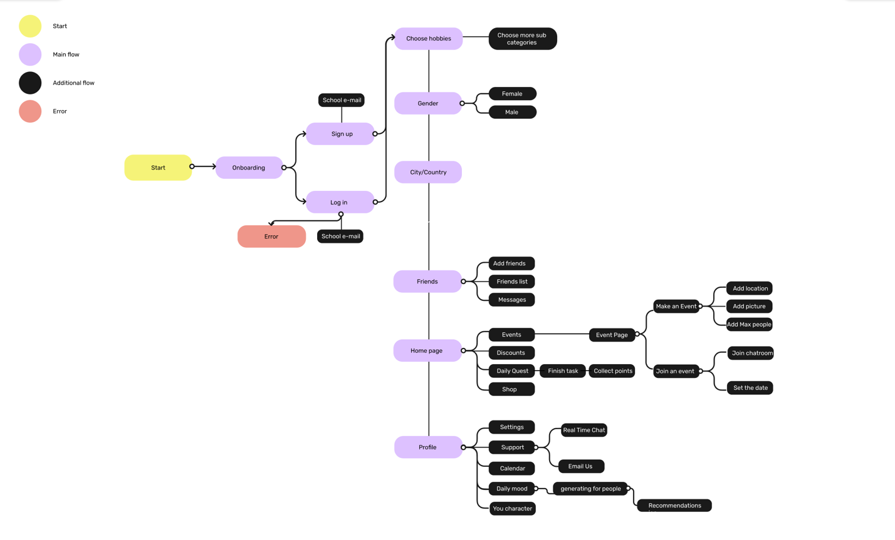

Figma prototype
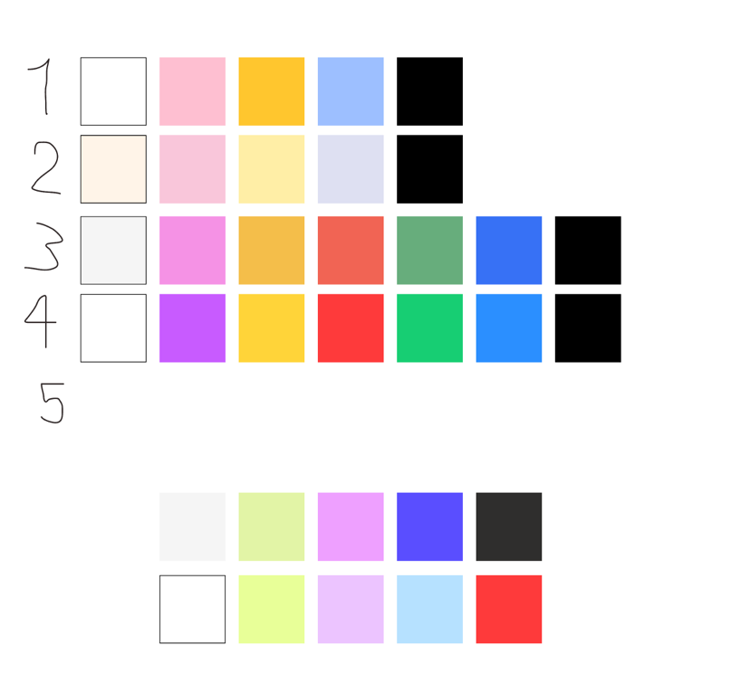
After we finished the user flow, Lizzy worked on a few different colour palettes. To figure out which one worked best, I tested them with a few people just to get their reactions. Most of them said that the fifth one really stood out the most — they described it as more energetic and friendly, which is the kind of vibe we wanted for the app.

Once we chose that palette, we moved on to creating the UI sheet. That’s where we started putting together all the design elements like fonts, sizes, button styles, and things like that. Having this UI sheet is helping us a lot, because it keeps everything consistent throughout the app. So, no matter what screen we’re working on, we can make sure the design feels the same — same colors, same style, same tone. It’s made the whole process feel more organized and professional, and it's easier to prototype now because we’re not making design decisions from scratch each time.
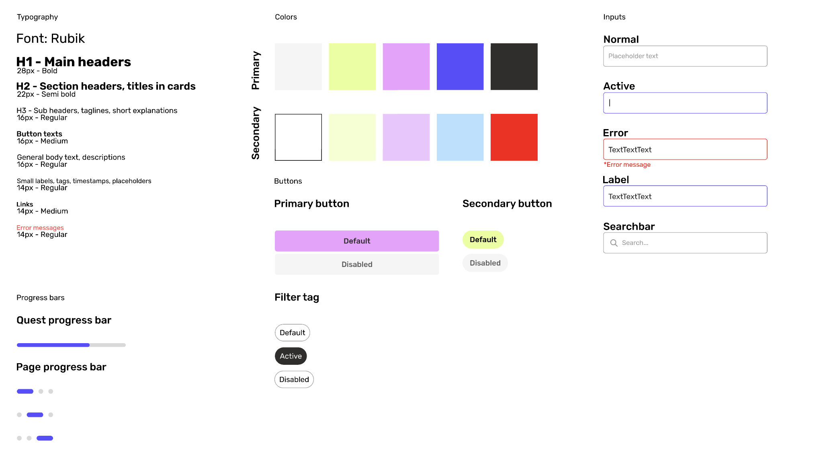

After that I started off thinking for different ways of making the pages, I was assigned to do everything connected with the event page, the home page, discount page and quest page. I was looking at Pinterest and dribble for most recent designs and what people use most. I had for most of the pages several options and listed pros and cons for each of them so at the end I choose the one that the target audience chose.

Validation:

Figma Low fidelity prototype
To design a better high-fidelity prototype, I started by creating a low-fidelity version first. I began with the home page, following the user flow, and included all the main elements to see if the structure made sense. From there, I tested the layout by imagining it as a real app—clicking through each button and interaction in my mind to make sure all the necessary pages were present and connected.
Since the first section of the homepage featured events, I continued by building out everything related to the event page. For the sake of consistency, I then reused certain elements and layouts for other pages like the discount page, ensuring a cohesive design throughout the app.

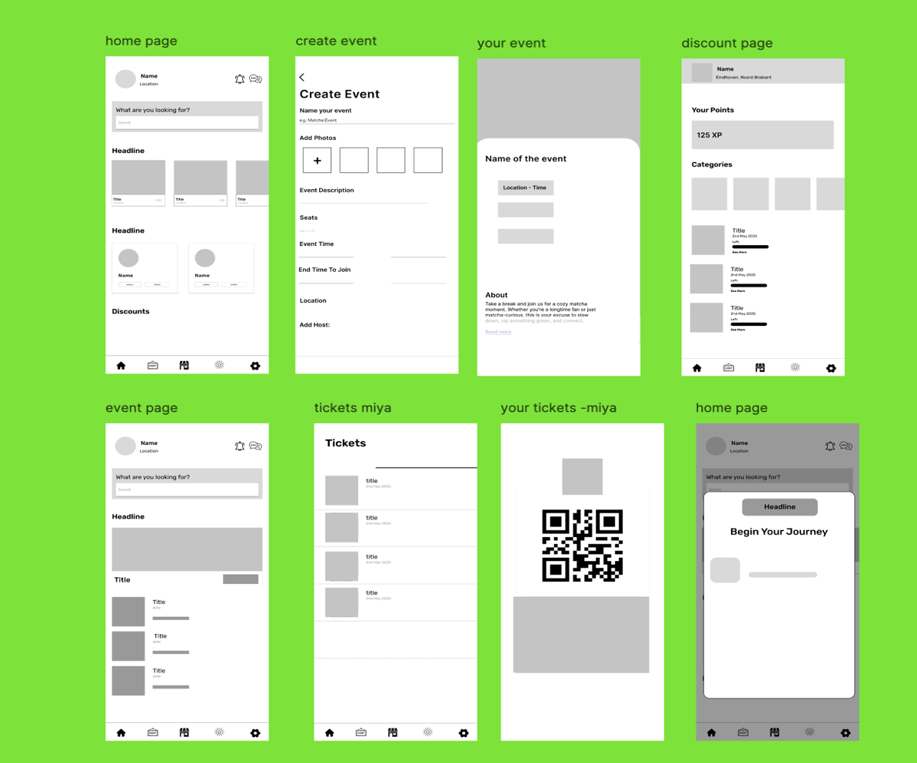

High fidelity prototype
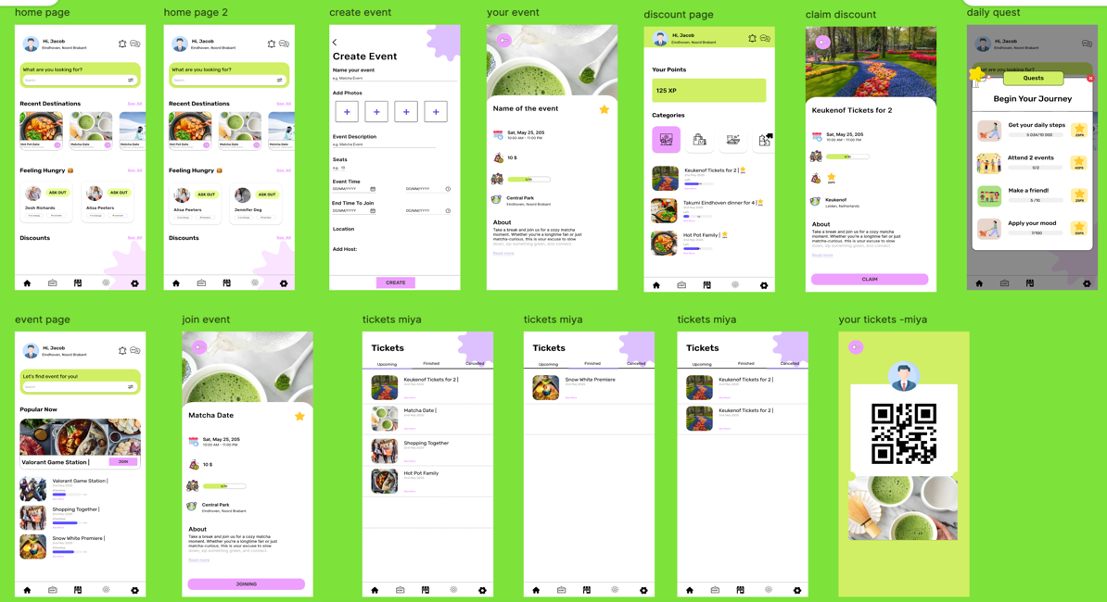

Mobile design research

Personal project

Project Overview – A New Kind of Tamagotchi
I’ve decided to start a small personal project inspired by Tamagotchi, but with a different purpose and features tailored for people like me—and my team at Takumi.
One day, we had a conversation about burnout—from university, work, and the constant stress of thinking about the future. As international students in the Netherlands, we often feel alone. We're trying to save money, stay on top of studies, and keep everything together. But sometimes, all that pressure leads to overthinking, burnout, and losing focus on university or life in general.

That’s what inspired me to create this app.
This app will feature a virtual companion—a modern Tamagotchi—that mirror you. It lives alongside you and reacts to how you manage your day.
- If you miss a task, skip a meal, or don’t study, your Tamagotchi will show signs of being sad, unmotivated, or tired. It might let out a small "aghhh" sound of disappointment.
- If you complete tasks, eat well, or take care of yourself, your Tamagotchi will cheer up and get a little sweet treat or reward.
It’s not about working constantly. It's about balance—between work, university, and personal life. The Tamagotchi helps you recognize when to push forward and when to take a break.
I did make some Canva page- prototype and started coding it because I never worked with apps so I wanted to see how long it will take me how it will be what I need etc. Once I got the idea, I started with defining and interview the target audience, brainstorming and then making a Moscow table because I know that I can’t make everything finished till the end of semester. After the Moscow table I started making the prototype (not finished) by first making a user flow, Ui sheet and then low fidelity prototype. I looked for inspirations and got many from Pinterest.

