4D Summit 2012

Playing the Examples

With TNV (v14)

WARNING: Doc. written in november 2012. To be updated if needed depending on how v14 is ready

Important information
- Examples are run on Mac, because:
  - We’re using native grammar checking (not available on Windows)
  - We’re using the iOS Simulator for the Wak-4D example
- One single example database: REKE (Real Estate Keynote Example)
- Code for REKE is mainly hard-coded everywhere. Avoid giving it to external people. And if you give it to somebody (internal/external), make sure he/she understands things are hard coded and built for playing the examples. For example, in the ListBox cell formatting demo, once in the spreadsheet demo, it’s not possible to go back to page #1. Also, only click in “price” and “city” headers are handled. Etc.
- Need an internet connexion

Pre-preparation
Some days before:
- Download the latest version of TNV and try it with REKE. With a copy of REKE actually ;-)
- Download latest Wak4 (dev. channel as of today) version
- Test everything
- Cleanup everything
  - In iOS SImulator
    - In preferences/Safari, clear history and cache
    - Remove the shortcut in the home screen if any (we should have one)
  - REKE
    - Delet trigger in [House]

Preparation
- Start REKE with v14
  - Close all windows
  - Display structure
- Start Wakanda Studio (dev. channel, Wak 4)
- Start iOS Simulator
- Put each application in a different desktop

Example #1 - ListBox - Cell formating
Note: this is the project form “HouseOutput_sliderAndSheet”. Feel free to change it, enhance it to fit your needs, change keyboard shortcuts if needed, etc.

Briefly explain the structure.
Run the “Example_RE” method.

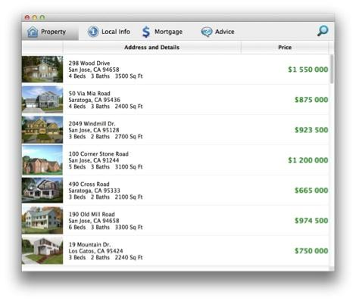
Explain we want to query (click the magnifier button)...

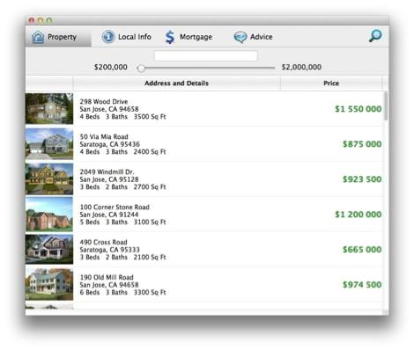
...we want to query using this slider (do not use the slider until explanations are given)
We want to query for a houses of a certain price. But we want to highlight 3 informations. We want to query using an interval of pricing, plus or minus 100 000 dollars. SO, if we choose 500 000 for example, then houses between 4-600 000 are in green, beyond 600 000 are in red and lower than 400 000 in yellow.
And here we are
(move the slider slowly)
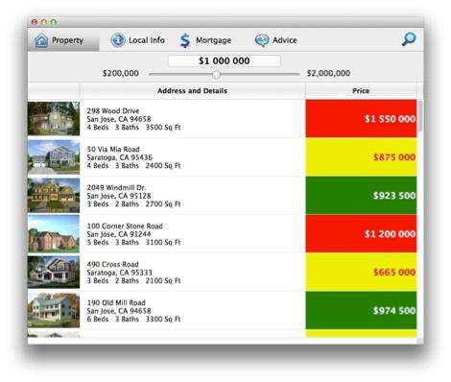
Explain the new feature. Move up to the max (so everything is in red), then leave the slider on 1 000 000.
Speaker continues explanations.

Now another example.
Move to next page by just hitting the right-arrow

We have a spreadsheet like listbox

Explain we want to display a red gradient depending on the price.

Hit right-arrow key once more to display the red gradient
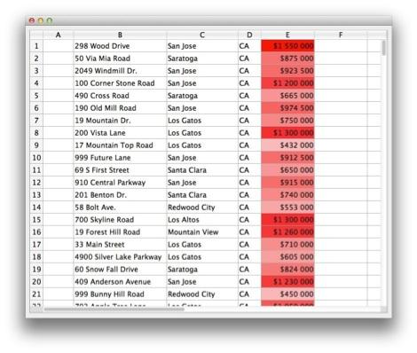
Click the “price” header to show it’s ordered and “nice”. Scroll vertically to show it really is a spreadsheet like listbox

Then, order by the city

WARNING: the code of the listbox only handle ordering by price or city. This is a manual sort to handle the spreadsheet-like listbox, with empty lines after the data.

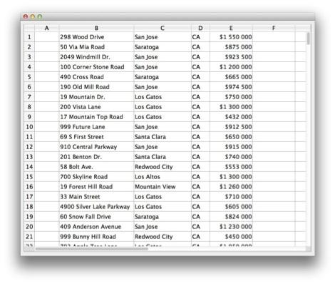
Explain we’re going to show an extreme use of the feature by simulating a spreadsheet cell-clic.
command-click on a cell IN THE CITY COLUMN (not in another because the City column is ordered now, and a click in a clele does not highlight the columns header).
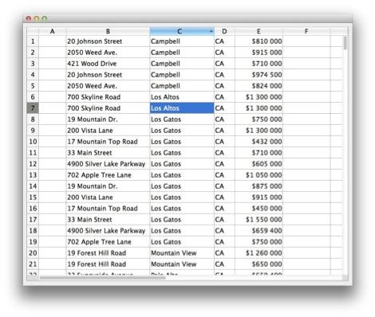
Explain we’re changing the background of 2 cells (the one clicked and the one with the line number)

Example #2 - New Text Object in form

This example is just a support to explain the job done with this new object.
Run the “Example_TextArea” method (NOTICE: It runs the “RichText” project form)

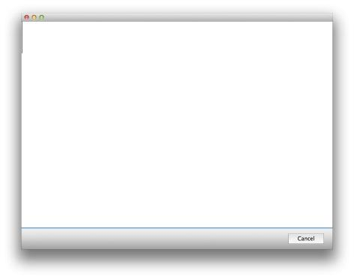

Say something about the act the player of the example is writing some english.
Write “I are hapy to be here.” (with the errors)

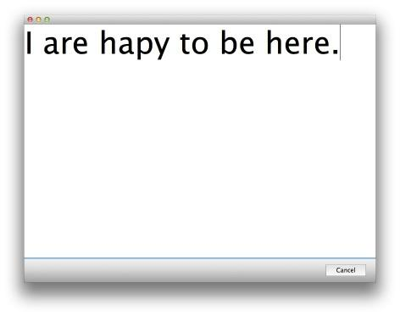

Hit command-right arrow to move to next page (a page with auto spell check activated)

Explain we have the spell checking, as usual.Fix the problem with “hapy”

But what we also have is an access to the native Mac OS grammar speller:

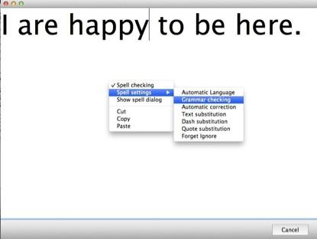

See the green line that highlights the error?

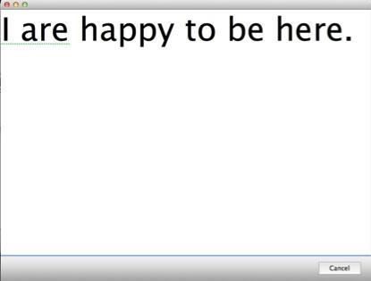

We can fix it
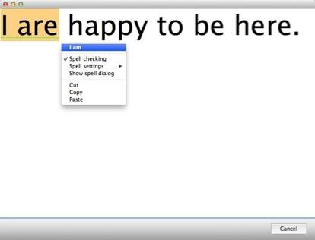

[Switch to slides, explanations about the new object]
While speaker explains text object + JSON, close this example, run “Example_JSON”]

Example #3 - JSON
2 examples here. one use internet and is how to get tweets about real estate, and another example about using C_OBJECT to save/load preferences from a file on disk (saved as JSON)

JSON and Tweets
FORM USED: “JSON_FORM”
Run the “Example_JSON” method

Form did open with the “Realty showcase” agency.
Click the “US Real Estate News” to show different tweets

Hit the capslock key (used for TRACE)
Back to “Realty showcase” => trace mode is open

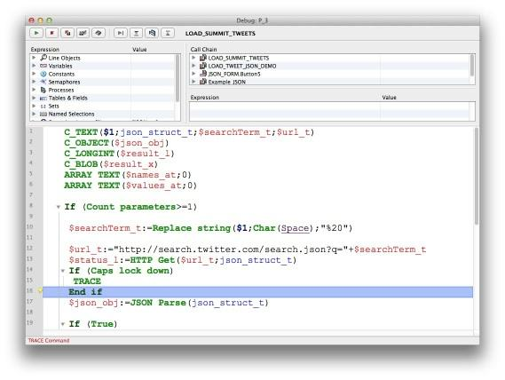

Follow speaker.

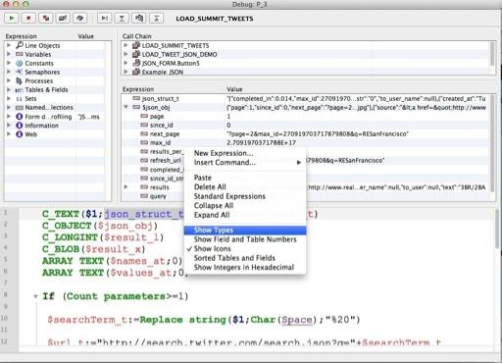

Basically:
- Highlight HTTP Get
- Put the json_struct_t variable in the debugger
Zoom to show the value (ctrl-scroll)
- Move to the JSON Parse line
- Run the line
- Put $json_obj in the debugger
Zoom (ctrl-scroll) to show value
- Expand the object
- At some point right-click and “show variable types”

Run the code, close the window

C_OBJECT
Let capslock down
Open the “run method” dialog, run “Example_RE”

Show the query settings are not displayed.

Move the window to top-left of screen
Display slider (click the magnifier button)
Set the slider to 1 000 000

Set capslock on
Maintain shift down
Click the close window
NOTE: because capslock + shift => TRACE

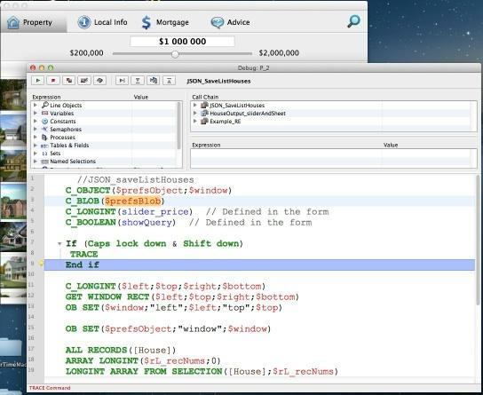

Follow code, show $prefsBlob in debugger.
Here, we are saving preferences via a C_OBJECT, saving window position, saving the whole selection (rec. numbers) and the query settings of the window

Once the code has run, show file on desktop, open it with a text editor

The explain we’re gonna use the settings
Open the “run method” dialog
Select (not dble click, just select) the “Example_RE” method
Hold shift key and click the run button
NOTE: because capslock + shift => TRACE in On load of the form)

Navigate, explain

Example #4 - Web Inspector

Form used: “WA_CoverFlow”

Run method “Example_CoverFlow”

Display the coverflow, navigate a bit
WARNING: check you have the “hand” cursor before clicking a picture or moving the thumb of the horizontal scrollbar

Here, it’s about displaying the WebInspector (right click in the web area) and
-> Change the size of boxes
-> Debug JavaScript

RIght click in he webarea and “Inspect element”
=> This opens the web inspector

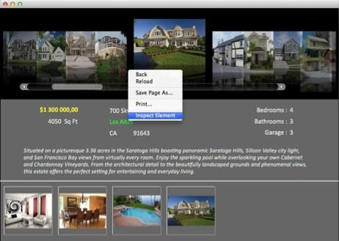
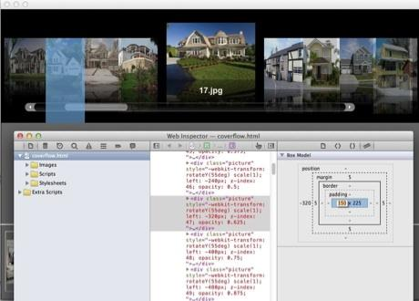

Click on some “DIV” items => the corresponding element is highlited by the WebInspector
Then click on the “box” item (top right) and change a width

Then open the coverflow.js script and setup a brakpoint

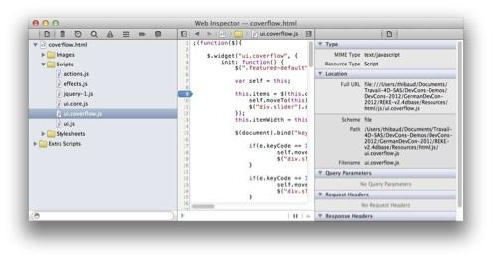

Right-click the webarea and “reload page”
=> The web area stays blank (this is normal)
=> The webinspector shows, js being executed and stoped

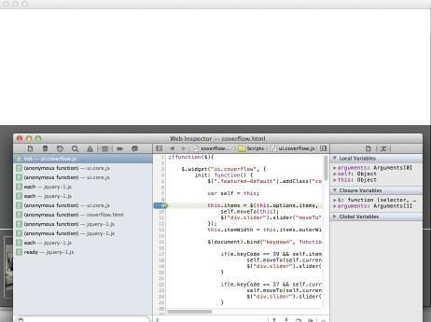

Run 2-3 lines.
Follow speaker (show objects, show values, ...)

Example #5 - Wakanda - 4D
(until it’s written: see the movie sent by Omid)

2 parts in this example: (1) Build an iPhone interface and (2) Show data modification + lock

IMPORTANT: speaker follows the demo, not the reverse. Some time, nothing is said, just let people see how things are done (no need to say “he is moving a widget”. Everybody can see he is moving a widget)

Building iPhone interface
4D: REKE application is open (since beginning of the session)

Start web server.

Let speaker insist on the fact it’s the only thing we do 4D side.

Wakanda: if not done, start Wakanda studio.

Create a new solution. Name it whatever you want. “Reke-web” for example [Make sure you removed a previous solution with the same name you could have created during rehearsals].

Show the model (click “Model” toolbar button)...



It contains the default “DataClass1” by default.

Move to “unguided” mode: click the button, accept the dialog (speaker says nothing or just a word, no explanations)

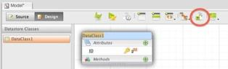
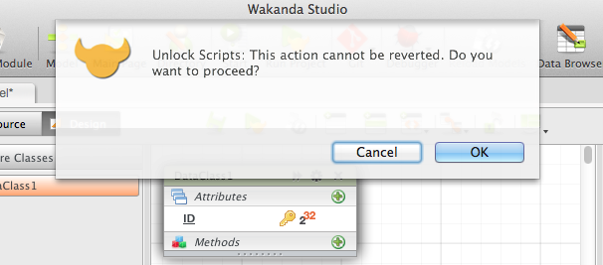

Open the script of the model...

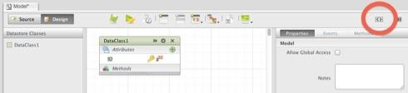

If not already done, increase size of font: command-+ (WARNING: this is the “+” of the numeric keyboard, not shift +. CHECK THIS BEFORE)

Have the following code available somewhere (we used to have TextWrangler open and to open a file on the desktop), and copy/paste it in the .js of the model:

model = new DataStoreCatalog();
model.addOutsideCatalog("reke", "http://127.0.0.1:8050")

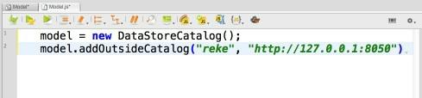

Save the script. Close the tab.
Move the “Dataclass1” some centimeters. Save the model. Close it
NOTICE: this must be done because of a bug in the Model Designer. The model designer does not load 4D table if we don’t modify a bit the model - here, the position of the class.
=> Please, play it quickly. No comment will be done by the speaker

NOTICE #2: Also, check with latest version of Wakanda if everything just don’t work as expected: once the .js is saved, the tables must be visible in the MOdel Designer

Now, expand the “Model” line in the solution explorer to display 4D table. Zoom (ctrl scroll) so attendees can see them

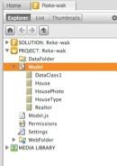

speaker explains 4D data can be handled as it was local, etc. etc.

Build the iPhone interface

Click New Page toolbar button. Select “Smartphone” in the “Create view for” popup
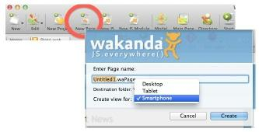

The GUI designer opens, with an iPhone background picture.
Double-click the Tab title to use all the available room in the sutio (collapse the solution explorer)

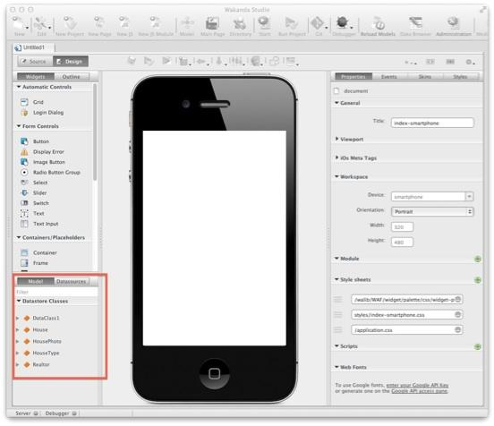

Show the “Datastore classes” part (zoom on it), while speaker explains we also have the 4D tables available in the GUI Designer

Expand “House”
command clic on Address, City, State, Listing Price and Photo
Drag-drop the attributes to the drawing area in the iPhone

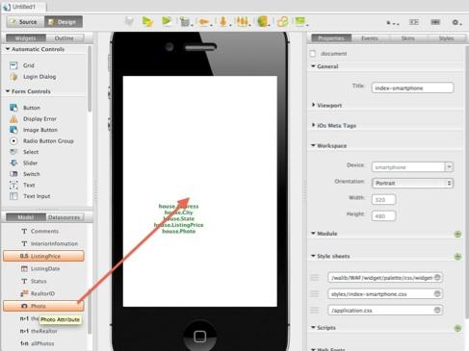

In the “” dialog:
Remove all labels
Change all “Text Input” with “Text”

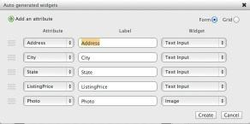
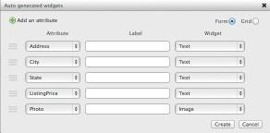

Validate the dialog

Move the create container to the left border, then increase the width:

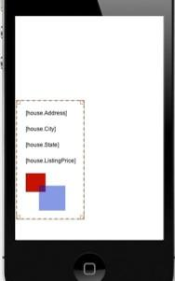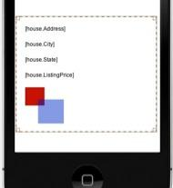

Move all text widgets on the right, so you’ll can move the picture top-left. You can select them with command-clic
VERY IMPORTANT:
- DO NOT RESIZE THE PICTURE WIDGET
- DO NOT MOVE IT OUTSIDE THE CONTAINER, EVEN PARTIALLY
- (while bugs are not fixed)

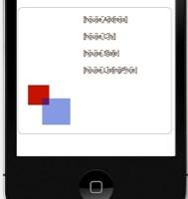

Move the picture widget top left.
Put the state near the city
Move the price below
Organize things so they look almost good (use alignment tool if needed)
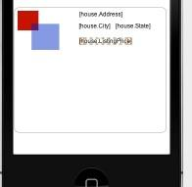

Resize the container (also reduce its width) and move it at the bottom (so we can use the Matrix easily)
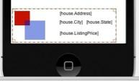

Now, drag-drop a matrix at the top of the iPhone drawing area.
Unless the bug of the default size if fixed, let the matrix selected, move to the “Styles” tab and change width and height to 200x200

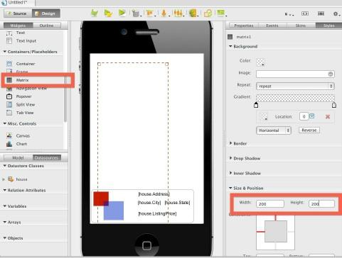

Position the matrix on the left. Let room on the top (we’ll be adding a text input widget for query later). Give it more width.

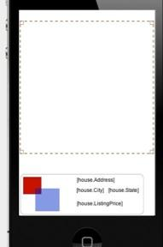

Now, put the container into the matrix and make the matrix higher so we can see 4 containers

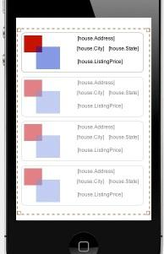
Save the form.
Start the server.

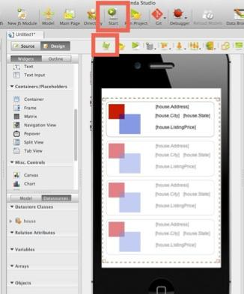

Move to iOS Simulator.
Make sure the hardware is set to iPhone (no Retina, it’s too big for screen)
Launch Safari
Enter the URL of the page: 127.0.0.1:8081/YOUR TITLE HERE
Note: remember the name of the page you created. Do not add “.html” at the end


So cool!

Scroll with the mouse to display the smooth scrolling of iPhone

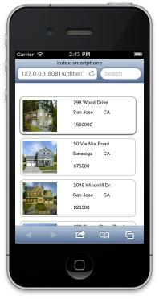

Back to Wakanda, add a text input widget at the top of the form
Then add a button near it.
Give a label to the button: “Query”

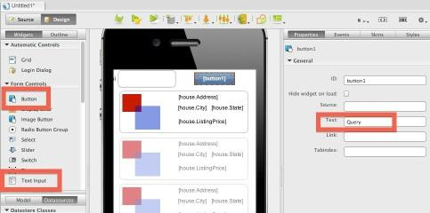

Select the TextInput widget, and copy it’s id in the “Properties” tab

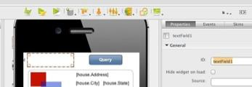

Select the button, move to “Events” tab; click the “On click” script

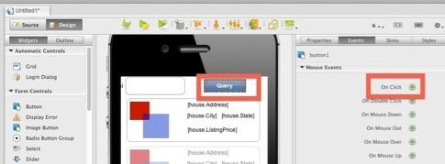

In the JS, type the code:

WAF.sources.house.query('City = ' + $$('textField1').getValue());

(paste the name of the Text Input widget)
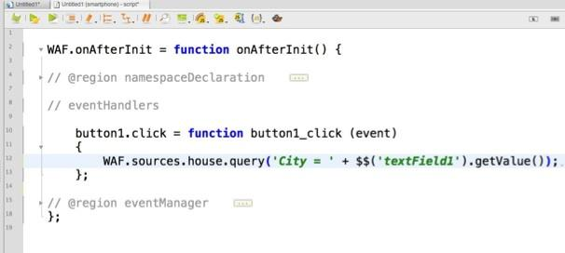

Save.
Back to iSO Simulator, reload the page.
Enter Campbell as query string.
Click the “Query” button
We see the awesome result

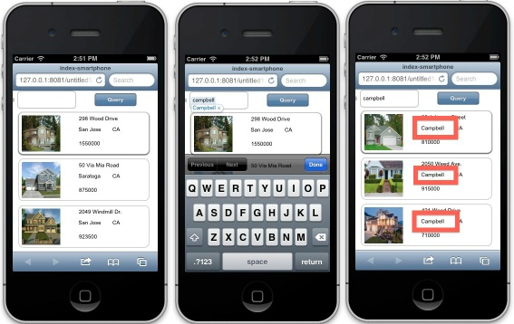

Last example: creating a home-screen button.

Back to GUI Designer, select “nothing” in the drawing area (ie click near the “Query” button.
Display “Properties” tab
Expand “iOS Meta Tag”
Check “Web App Capable”
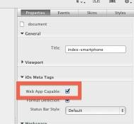

Save.
Back to iOS simulator, reload the page
Click the “Send” button

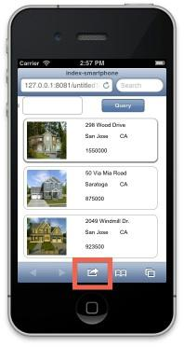

Select “Home screen” in the dialog. May need to swap to next page to see this button.
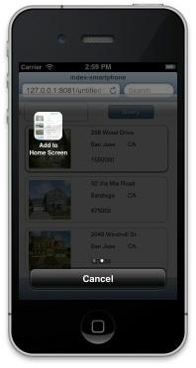

Name the page whatever you want “Reke” is ok)
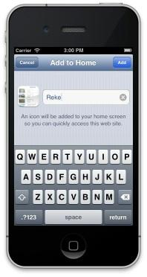
Click add.


Then click on this new home screen button.
Show we have a Native look: no search bar, no status bar of Safari.

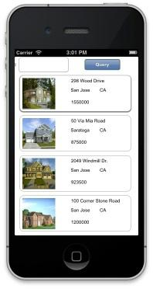

Quick data exchange with 4d
After the waow demo, we just quickly shows data modification is available both side.

Create a new page, select “For desktop”( not tablet or Smartphone)

Drag a grid.
Select Address, City, State and Listingprice, photo => drop on the grid
Resize the grid so we see attributes.
Run. Make things bigger in the browser so people can see data.
(speaker explain we’re doing demo about data, so we don’t create a complicated interface)

Show 4D, House table
Show (with the mouse) the prices of the 2-3 first houses.
Double click the second house, change the price, save.
Go to Safari, reload the page => we have the new price
Double-clic in the price to edit it, change it
Back to 4D, refresh( click on line) => we see the price as set in wakanda

Open the 3d record (so it is locked)

Safari => edit the 3d line, change the price. Click somewhere in a blank part of the page (just to validate data entry)
=> We have an alert in the browser saying the entity could not be saved

[We don’t show triggers. Does not work. And will not work before some time - just talked with LR about this today 2012-11-21]

// End of “PLaying the Examples”

