4D Summit 2012

Technical Keynote

Theme: Modernization
Future Proofing
Deployment
Automated Deployment
New Data Package
Improved Client Experience
Reliability
Enhanced Diagnostics
Real-Time Monitoring
Theme: Productivity
Query Editor
List Box
Augmented Text Area
JSON
Theme: Information Everywhere
SQL Views
Web Area
Theme: Information EVERYWHERE
Future-proofing
Reliability
Scalability
Power
Even more developer tools
Even Better User Experience
Richer web access to existing 4D apps
Conclusion

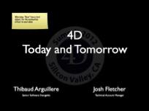
Thibaud’s Introduction

Josh’s Introduction

Welcome to the 4D Summit 2012 technical keynote! Thibaud and I are going to take you on a journey looking at how 4D has grown to be the product it is today, and what we are working on to bring you the 4D of the future.

4D Today
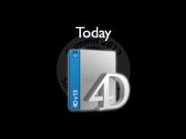
"The future starts here” is the slogan for this year’s Summit. But actually, as Tom mentioned, it really started 25 years ago when 4D came to the US and a couple of years before that when the company was founded. Now I’m not saying this purely out of ego; the fact is when you developers made the choice to use 4D, and for some of you you’ve been using it for a long time, you made it a good choice. It was the smart choice. 4D is the tool that has allowed your business to thrive. If it wasn’t, we would not be here!

So let’s take a look at the recent history of the 4D you have today...

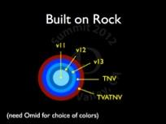
First I want to talk about how we are building the 4D of today. In order to continue to make 4D the smart choice, we laid a new foundation with 4D v11 SQL.
[First animations of the circles]
This gave a solid kernel to build from. Each subsequent layer, each new release of 4D has not been a revolution, but rather an evolution of this core. We’re increasing stability, while still adding awesome features.

We will continue for the next version...And the version after the next version

[next slide]
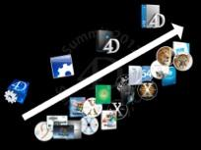
Another important piece is we make compatibility a big deal in 4D. Each new release of 4D must maintain compatibility.
[First animation, migration 2004->v13]
Your applications have smoothly evolved from version to version. We're not saying there were no significant changes, but imagine any other software products that are more than 25 years old! Most of them no longer exist! But you moved from v1 to v13 and you will be able to continue with the next versions.

And also, you moved...
[Second animation, all systems]
...from Mac OS 6 to Mountain Lion, from Windows 98 to Windows 8.
Your business survived to all system changes.

We walked this path together!

It’s really important for us to say that, just as you have work to do to migrate your databases from version to version, we are there to make sure 4D works from OS to OS.

We are invested in this along with you.

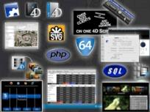

You have now in v13a lot, a lot of gréât features,, ready to be use, and used by hundred of applications all over the world.

Another way to put this into perspective is looking at the number of new commands added to 4D.

Since 2004, there have been hundreds of new commands, and hundreds of enhanced commands, as well dozens of brand new features. And don’t forget about all those pre-enhanced commands

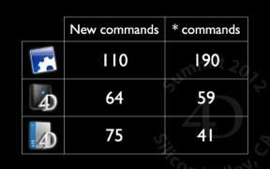
Remember last year’s Summit. A pre-enhanced commands is when a command already has a star when it was born.

You - I mean you as developer, or your company - probably don’t use all of these features, of course. But they are here. If you need them, they are available.
Does your application needs to display some html? Just use the web area!
Do you need Web session management? It’s here, since v13. I could continue with many many other features, but that’s not the point...

[Next slide - conclusion]
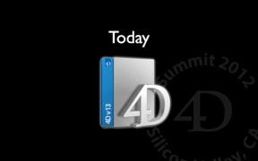
...the point is you made the choice of 4D in the past. And you were right.

We’re moving forward, and we’re moving forward with you. We’re making sure your applications run despite Operating System or hardware changes. And we continue to improve the product.

That’s why the future starts here!
GOOSEBUMPS!

Now, let’s talk about the future.

4D Tomorrow
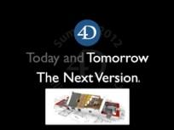

What are we working on today, to bring you the next version of 4D for tomorrow?
For the rest of this keynote, we’ll be talking about the next version. Actually, about the next versionssss. I mean, this is work in progress, we are not launching a product today but, rather giving you a glimpse at the coming features.

We could show you everything but then Thibaud would be fired. It’s a good thing he’s already quitting...

Theme: Modernization
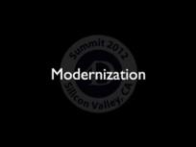
We will start by talking about some of the important improvements we are making to the foundations of 4D. These changes really strive to continue 4D’s growth into the future.

Future Proofing
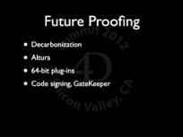
[Bullet points animation]
“Future-Proofing” is the work we have to do because the underlying platforms that 4D runs on are constantly changing. The new foundations (new Web server, new network layer) of 4D make this kind of work easier than it’s ever been before.

This work may not always seem important on the surface; it doesn’t necessarily bring big new features and yet it is absolutely critical to making 4D a successful product and, therefore, making you successful developers.

Decarbonization is super important for moving 4D forward on OS X. We keep talking about this and you might be wondering why. Recall that this work is necessary because Apple has deprecated Carbon so, in the same way we might deprecate and remove an out-dated 4D feature, Apple does the same thing to us. We absolutely need this change to have a 64-bit server on OS X. As Laurent Esnault VP of R&D explained last year this is a big job, spanning multiple man-years. We have refocused this effort to complete this job within two versions.

[Next bullet]
We need to remove Altura. Recall that Altura is the layer in 4D that made cross-platform execution possible. But Altura is simply not modern enough. Now we are targeting the OS API’s directly.

[Next bullet]
In TNV, all 4D-published plug-ins, like 4D Write or 4D ODBC Pro, will be available in 64-bit on Windows. You will be able to use all 4D plug-ins from 4D Server 64 bits.

[Next bullet]
Operating systems are constantly improving application-level security. The fact is to move forward with 4D you must have support for “code signing”. This prevents those annoying pop-ups like on Windows when you get a UAC prompt saying the author is unknown, or with Gatekeeper on OS X where the application simply refuses to run. In the next version you will be able to “sign” your merged applications and avoid these issues.

(say this as if we forgot)
And we almost forgot the next version is Retina-ready! In fact the change for Retina support was relatively easy thanks to the work on decarbonization. It required all of this other investment we have made in the past years to make it happen.

(maybe we will get applause for this?)

Deployment
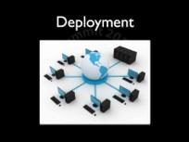

Automated Deployment
(Question to the audience, show of hands)
How many of you need to deploy updates to your 4D applications?

(To Thibaud)
Thibaud do you have to deploy updates? What update mechanism do you have?

(tell this in a joking fashion)

I have an amazingly efficient algorithm...

- Well first my alarm rings in the middle of the night...
- ... because of course I’m doing the update for the customer...
- ...and I don’t want to bother him during working hours....
- ... well. His working hours....
- Connect to the customer VPN...
- Upload the new files to FTP...
- Download from FTP...
- Unzip the files...
- Copy and paste the new files...
- and...
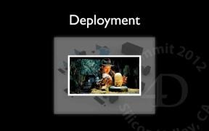
- We wait for a call from the customer saying everything is ok...

That sounds really easy Thibaud! I hope everyone in the audience has a technique that is equally efficient. But in all seriousness for the next version of 4D we want to deliver the tools for a fully-automated deployment solution.
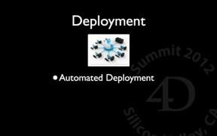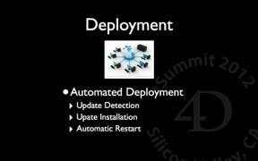
The next version has new commands for:

- Update detection.
- Update installation: download the archive, extract it.
- Automatically shut down the server and clients.
- Deploy the update.
- Re-launch the server.
- Re-launch the clients?

The point is, for merged applications, you will be able to schedule the update ahead of time and not need a human present to do it. You will be able to automate the update using 4D commands.

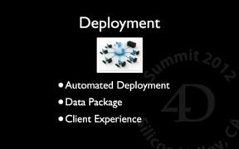

New Data Package
You already have a package for the application (.4dbase). Now we’re adding a package for everything related to the data:

- Data file
- Data index file
- Journal file
- Match file
- Logs
- Etc.

Everything can be placed in .4ddata and this makes the update process even easier. You will be able to specify this path at build time, of course.

Improved Client Experience
Another small but effective change improves the client experience when connecting to a busy server. By “busy” I don’t mean the server has a lot of users or is non-responsive but, rather, I’m talking about the normal circumstances where the server cannot accept a client connection like during a backup or if the database is restarting. The current mechanism gives a standard 4D error dialog complete with stack trace and so on. The next version will have something more user-friendly and clear, so users are not confused about what’s happening.

Reliability
The last thing we want to talk about in this theme of Modernization is reliability.
Reliability is when something works as you want.
Reliability in software is about building something you can rely on. It seems obvious but it is super important.

One of the parts of making something reliable is finding the weakest link in the chain and fixing it.
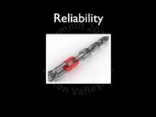
If your customers can’t get their problems fixed, well, you know what happens...
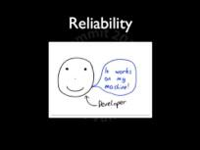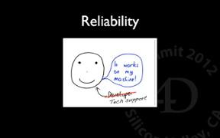
Now that the joke is done, let’s get serious.

Josh?

Over the last few years we’ve had a tremendous growth in reliability tools available to us. Not only that but we have had huge success using them and therefore made our customers more successful.

The next version brings with it a renewed focus on reliability.

Enhanced Diagnostics
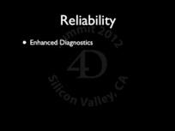

You are probably already aware of the diagnostics currently available in 4D. They come in two forms:

- Built-in tools. These are features built into the product. We’re talking about logs (debug, request, web, etc.)
- And we have custom Tech Support tools, like the Information Components, the Cache Log Recorder, so we can see what’s going on in the database as it executes during the day. Cache usage, number of processes, memory usage and so on.

These are powerful tools to be sure. They have proven themselves useful time and again. But they are disparate. The log formats are all different, they are all enabled in different ways using different UI. They are powerful, but relatively complex to use.

Thanks in large part to Thomas Maul ( Managing Director, Northern Europe), if you were at the pre-class last year you saw Thomas demonstrate just how powerful these kinds of diagnostics are, he really helped the team focus on this area, in the next version, we are consolidating and integrating these diagnostic tools into one cohesive package.

You will have one common to enable various tools and a shared log format.

Real-Time Monitoring
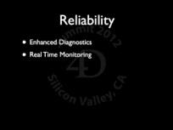

Diagnostic tools are great, but they are only effective after a problem has occurred and they consume valuable time.
What if we could catch problems as they occur, and prevent them, investigate in real-time?

So for example, it’s when your customer calls you and say “hey, everything is slow right now”. What would you have done in the past? Well, everything you could, which may lead to activate logs (that would slow down the whole thing even more actually) and so. The fact is, whatever you chose to do is not really the point, what’s important is that it was very difficult and time consuming (PITA).

What did you have before?

“Josh, what is that?”

“Did the slides break? I have no idea, what is it?”

“It’s a black box!”
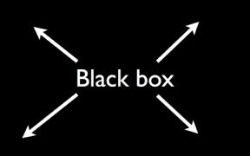

What you had before was nearly a black box. If a backup is running, yeah you have a dialog but you don’t know who started it, what is the status. And if you’ve got a long sequential query running, then you get a sequential search dialog, but you don’t know who started the query, you don’t know which fields, you don’t know which parameters, and so on.

What you will be able to do in the next version is...
[NEXT SLIDE]
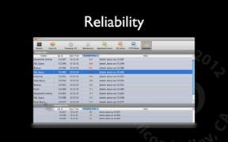

...real time monitoring. So you will be able to check what’s going on on the server now. Not from looking at log files, not after the fact but at runtime. You’ll have the appropriate tool to do real time monitoring. And you will be able to immediately see which operation running on the server is slow, and why it is slow.

So, for the next version, we’re talking about white box. If the user is running a slow sequential query, you’ll be able to see who is running it, which table, which fields, which parameters and make a decision on how to fix it. Do you need to index the field? Perhaps. But the thing is: you will be able to find what’s going on now and to figure out how to fix it in real-time.

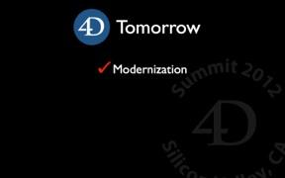

So Modernization is a really important part of keeping 4D relevant and making you successful.

Theme: Productivity
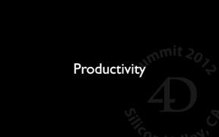
Productivity is a boring word.

We struggle every year to come up with an “exciting” term for these features. Last year, we called it the Language Fiesta and we did a little dance. Maybe Thibaud has some new dance this year (spoiler alert!).

But the fact remains productivity is a huge part of what makes 4D successful. These are those features, some big, some not so big that, when taken altogether are a big part of what 4D is about. Making your lives easier as developers, making your development faster, smoother, and your products richer and more successful.

This is part of why choosing 4D is a smart choice.

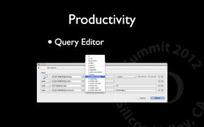

Query Editor
So here is a simple example of this. We are working on a new Query editor for the next version. This will have a modern interface with new features like:

- Filtered constraints (“contains” for text, “is equal” for numbers)
- Query history

[Next bullets, all in on shot]
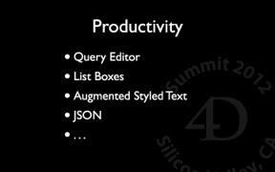
Today we’re are pleased to be able to actually show you some of the new features we are working on, I’m going to ask Thibaud to take us on this journey.

- List Boxes
- Augmented Text Area
- JSON

See « PlayingTheExamples»

[Switch to slides]
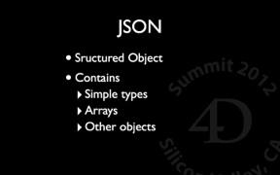

JSON
For those who may not be familar, JSON stands for “JavaScript Object Notation”. Now despite the fact that “JavaScript” is in the name, and JSON really is valid JavaScript code, JSON is actually a data abstraction. It is a simple way to express data. It is hierarchical much like XML but lacks the over-bearing baggage that XML adds to the data (elements, attributes, etc.).

If you think about it in a programming context, where 4D has simple types and c++ has classes, JSON is very much like STRUCT in C. It’s a collection of simple data types (numbers, text, arrays), but it doesn’t support behavior (member functions, methods, what have you). JSON objects can also contain other JSON objects.

The important thing to understand right now is JSON is extremely popular as a data interchange format. Tom mentioned to me a statistic that over 45% of cloud-based services are using JSON today and it’s rapidly growing. JSON works so well because it plays very well with HTTP. It is text-based and easily compressible. It is often used as the reply for REST services so, by using the new HTTP client added in 4D v13 for example, you could call a REST service and receive a JSON response (but it was up to you to parse it).

In the next version 4D can read/write JSON; the parsing will be done for you automatically by 4D and you’ll be able to access the JSON data via 4D commands. But that’s really only the surface of this feature.

In fact we’ve taken it a step further. JSON becomes the foundation for a completely native 4D OBJECT. An object made up of properties, whose properties could be other objects. In fact you don’t need to even know anything about JSON to use this!

[Switch to JSON Demo]

SEE « PLAYINGTHEEXAMPLES »

[Switch to JSlides]
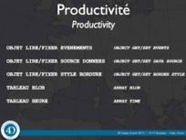
[[Each bullet with drama]
[Finish on the scrolling list of 67 commands]

So, to conclude our section on Productivity, we are still invested in making your development easier/faster/better.

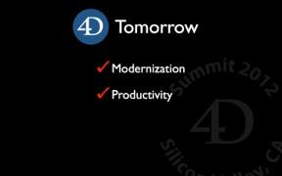

Theme: Information Everywhere
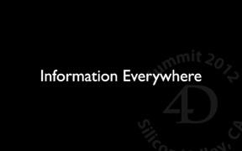
Tom talked earlier about information everywhere. Information everywhere is about this idea that information is no longer locked in one location but distributed all over the place. To stay relevant in this space, you need to be able to connect to services as well as offer services yourself. This is an important theme in the next version of 4D. Here are some things we are working on...

Web Area
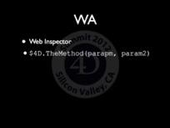

Information everywhere has mash-ups written all over it and yet, until today, truly developing in Web Area could be a bit of a chore. Debugging Web Area content was not always easy. All of that changes in the next version, we have a really great feature that Thibaud is going to show you.

Demo - Web Inspector

SEE « PLAYINGTHEEXAMPLES »

(back to slides)

Another exciting feature is a new callback mechanism. You will be able to call directly back into 4D code from within the Web area by referencing the object “$4D”.

So these are some of the features we are putting in the next version to help 4D latch on to this concept of “information everywhere”.

No no no no Josh! I’m not talking about information everywhere...

I’m want to talk about information EVERYWHERE [Animation with sound]

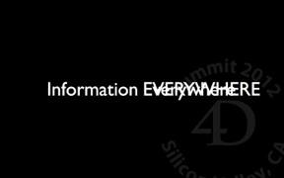

Theme: Information EVERYWHERE

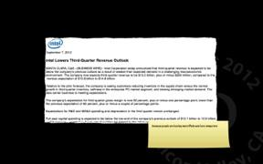

A month ago, Intel sent a press release. They were saying they are forecasting a decrease. And AMD is not doing well either.

And this is because people are buying more iPads and less computers.

Analyst and specialists think it’s because people no longer expect to be stuck at their desk doing their job. They want to do their job from everywhere. They no longer expect to be chained at their desk.
And even if this is not the main explanation, even if there are probably other reasons why people are buying more iPads and less computers, somehow, we don’t care why. We have just a fact. The fact is, whatever the reasons, people are buying more iPads and less computers.

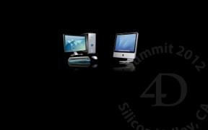

You are developing business apps. You have incredible skills in what you’re doing, and you’re building very rich desktop business applications. And your customers are super happy with what you’re doing, they’re asking for features, they pay your bills, everything is fine.
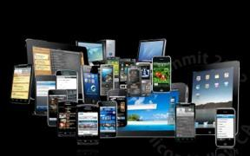
But now they are asking to webify your application. And actually, not only webify, but [pretend you’re inventing the word] even hum, mobil-ify or mobi-fy your application.

And it’s ok, you can do it. But what’s probably the most important to you is that you don’t want to start over with new technologies. You did develop all thr logic, all the business logic in this 4D application you wrote, and you sure don’t want to rebuild it from scratch with another tool, another language another database.


Wouldn’t it be cool if you could take the most powerful Web application development product..and what is it Josh?

Wakanda!

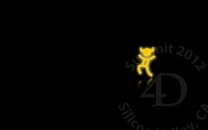

And what is the most powerful desktop application environment...

4D!

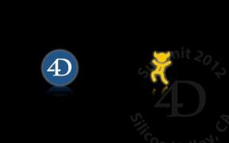

Wouldn't it be great to combine them together into an incredible combination?!

Well? You CAN!



[pause]

You can and in fact today we’re gonna show you how to do it!x

[EXAMPLE]
SEE « PLAYINGTHEEXAMPLES »

[BACK TO SLIDE]
You have seen that you had to do on the 4D side has been to, well, activate the REST server. You did not had to change anything else. here is the architecture of this communication.
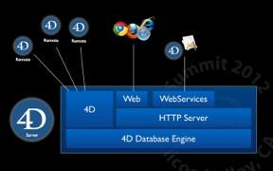
4D has its database engine. On top of it, we find the 4D application server. This is your usual environment, with 4D clients connecting to the server.
4D also has an HTTP server on top of which you find a web server and a web services server.
Abnd for the next version, we have added...
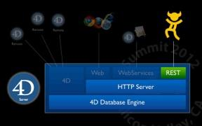
..a REST server to 4D.

That’s how Wakanda can access 4D data live.

We just made this amazing example. We want to make it clear you build ytheour web interface while keeping all the logic in 4D. If you have trigger and the user is modifying the data, the trigger si run. If a record is locked and can’t be save, you’ll get the error in Wakanda. Everything is handled, including access rights for example.

This is the main point: You will be able to keep all the logic in your 4D applicaiton, and to create a mobile interface for your customers!

And we did not dig into details, because Laurent himself is doing a full session on Saturday. He will be explaining all the details, how it works, how to use it and so on.

[End of Keynote]
