**Project Proposal**

**For**

Movin’ Out

|  |  |
| --- | --- |
| **Instructor:** | Dr. Pirmann |
| **Team Members:** | Andrew Shoffler, Michael Wyda, Harrison Beerley, Miyo Imai |
| **Cycle:** | 1 |
| **Date Submitted:** | 2/1/2019 |

**Grading Rubric – Project Proposal**

This rubric outlines the grading criteria for this document. Note that the criteria represent a plan for grading. Change is possible, especially given the dynamic nature of this course. Any change will be applied consistently for the entire class.

|  |  |  |  |  |
| --- | --- | --- | --- | --- |
| **Achievement** | **Minimal** | **Exemplary** | **Pts** | **Score** |
| **Content** | Section(s) missing, not useful, inconsistent, or wrong. | Provides all relevant information correctly and with appropriate detail |  |  |
| Project |  |  | 30 | 30 |
| Team |  |  | 10 | 10 |
| Timeline |  |  | 30 | 30 |
| **Grammar and Spelling** | Many serious mistakes in grammar or spelling | Grammar, punctuation, and spelling all correct | 10 | 10 |
| **Expression** | Hard to follow or poor word choices | Clear and concise. A pleasure to read | 10 | 10 |
| **Tone** | Tone not appropriate for technical writing | Tone is consistently professional |  |  |
| **Organization** | Information difficult to locate | All information is easy to find and important points stand out | 10 | 10 |
| **Layout** | Layout is inconsistent, visually distracting, or hinders use | Layout is attractive, consistent, and helps guide the reader |  |  |
| **Late Submission** |  |  |  |  |
| **Total** |  |  | 100 | 100 |

**Project Proposal**

This report documents the initial definition of the project. It includes an abstract and project overview. It also includes a summary of issues related to the project and to the team.

**Project**

## **Project Name: M**ovin’ Out

## **Abstract:**

Movin’ Out is a platform for university students in University City, Pennsylvania to sell and acquire items. At the end of each quarter or semester, most students typically have unwanted furniture that they either throw away or have to store for a large amount of money. We plan on creating a platform to solve this issue and allow students to profit off of their unwanted items while also benefiting someone else. We value quality, efficiency, and reliability, and want to provide our users with an aesthetically pleasing, user friendly intuitive interface that allows for quick and easy listings and peer-to-peer transactions.

A problem we anticipate with this model is the seasonal nature of our platform. The peak period of usage will occur at the beginning and end of each quarter or semester due to the number of students moving in and out of dorms and apartments. We plan on incorporating other quality services to Philadelphia-area university students such as item requests, tutoring, peer academic help, advice forums, and social features to encourage users to come back, meet new people, and start real friendships.

Coming to university, especially in a city like Philadelphia, can be overwhelming and confusing, even for upperclassmen. Certain aspects of our product can let those with experience help the inexperienced. There will be a platform for students to ask questions, where those answered will be displayed for everyone. There will also be a method for students to request personal help with homework, projects, and research they are conducting.

The largest tasks our project will endure are getting users to use our service and developing a good website that is functional but also looks good. We plan to make our product stand out and show that this is clearly the best option to sell your items if you are a University student. We will also work tirelessly to bring our users the best looking web design that we can make. Another challenge we will face is setting up a website that is able to handle all of our users, being a small start up, we don’t have the funding to access large server arrays.

Another aspect of this product is that it should only be available to university students in the Philadelphia area. To ensure this we will have verification methods such as location checking, and a way to verify through either email or user ID that a user is, in fact a university student when they sign up for their account.

Our product is going to rely on revenue from advertisements, so our main goal is to create an experience users deem worthy of spending their time and attention on. We plan on achieving this by making a useful, intuitive product that users continue to use. In addition to this, we will dedicate much time towards making the look of the app/website pleasing. A combination of passion and respect for our users will drive the product and help us create a great user experience worthy of our user’s time.

## **Project Deliverables**

We plan on creating a platform upon which students in the University City area can converse, sell and buy items, and find friends. We will be doing this in the form of a mobile-friendly website. We also intend to set up a server to host our website.

At the end of the project, our website will have several functions: a way for students to list items they want to sell, a way for students to buy or obtain items others are selling, a Q&A platform for students to ask and answer each other’s questions, and a friend-finding system for students to find and meet new people.

By the end of the first week of April, we intend to complete the initial creation for the content of our website, including but not limited to graphics, information about the website, and instructions for posting various types of content on the website. We will also complete creating storage for our user base. By the middle of the second week, we plan to have finished setting up the server and connectivity for our website. By the end of the third week, we will create storage for the content and posts on our website as well as finish coding the basic functionality of the site itself. From the end of April through the deadline for our project, we will be coding and refining the site’s aesthetics, navigation, and user interface.

## **Resources**

We will need to set up a server to host our website.

## **Expertise**

In order to complete this project we will need web development skills, database management, and back end web management. Currently we possess the skills to create the front end website but we are still learning and growing our knowledge on back end servers and managing databases.

**Team**

## **Team Members and Roles**

## Figure 1, below, identifies all the team members and the initial role assigned to each person.

|  |  |
| --- | --- |
| **Name** | **Role** |
| Miyo Imai | Manager |
| Harrison Beerley | Web Designer |
| Andrew Shoffler | Application Developer |
| Michael Wyda | Application Developer |

**Figure 1 - Team Members and Roles**

**Timeline**

The figure below shows the initially identified set of activities for this cycle.

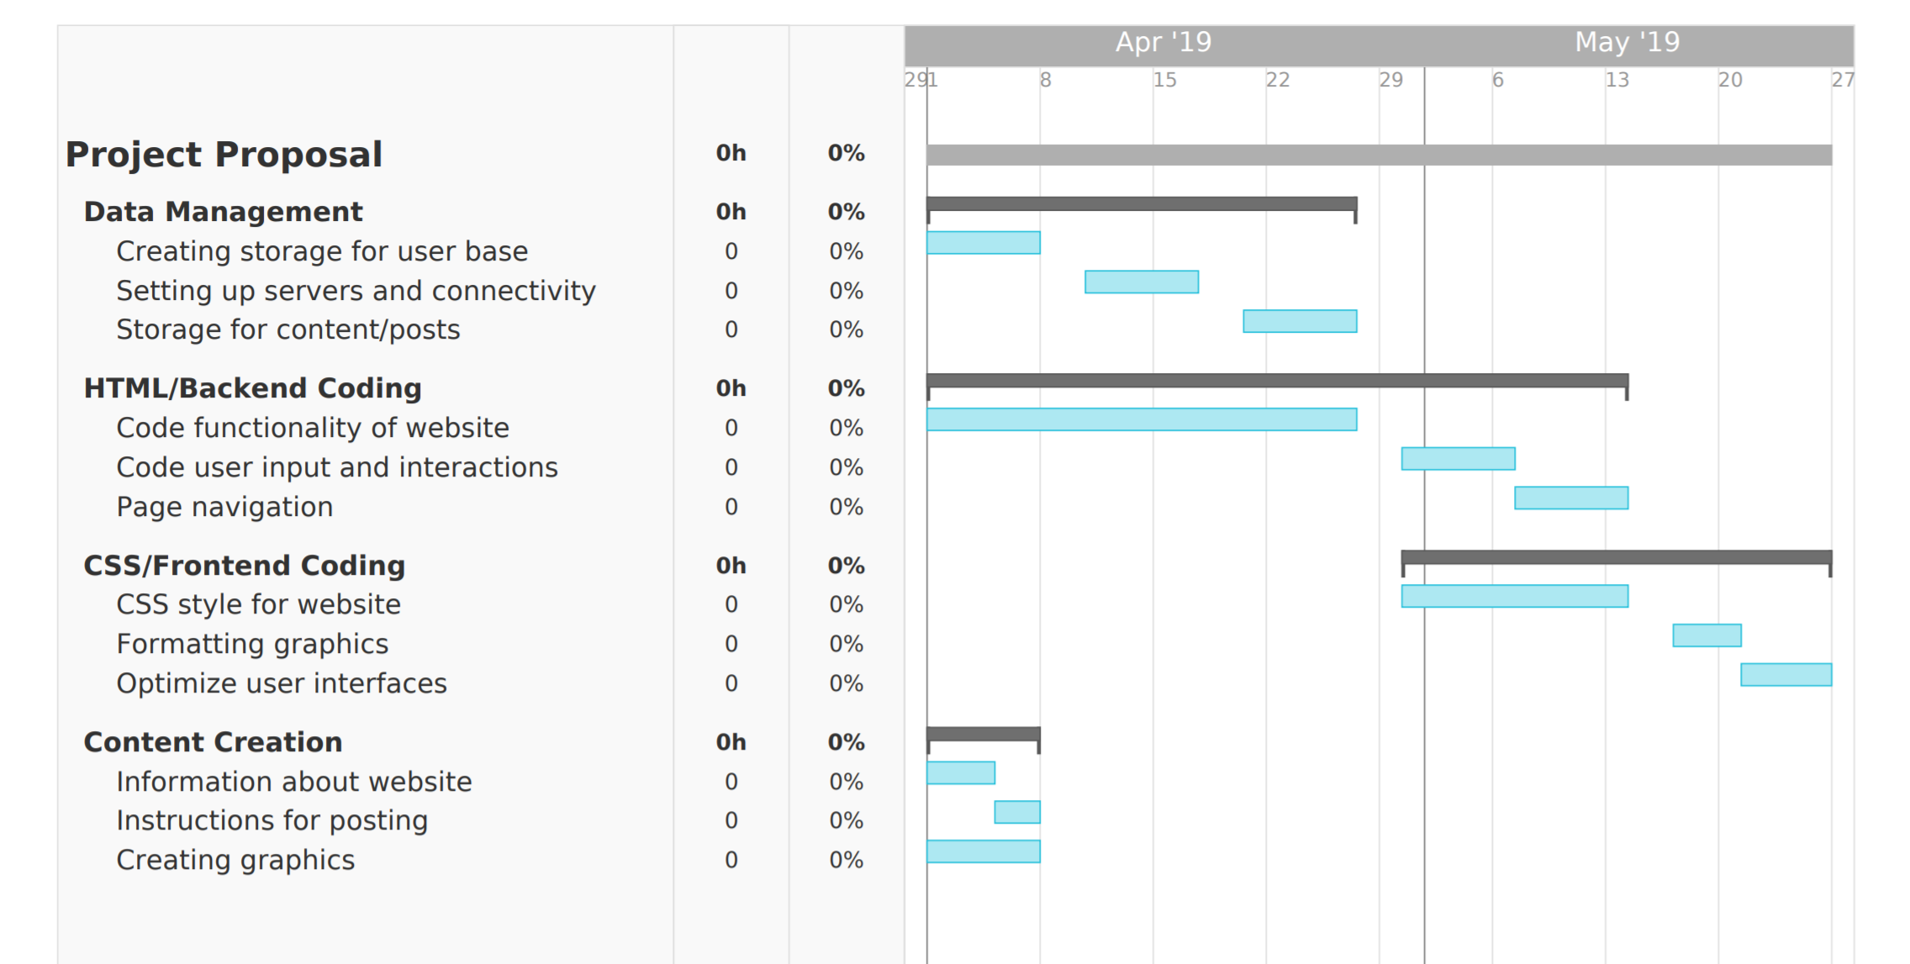

**Figure 2 – Project Timeline**