Project Brief

**Client:** Palovina

**Brief Summary:**

Palovina was established in 2009 in Palestine by a female. It was the first Palestine company specializing in the manufacturing of natural personal care products from extra virgin oil from the holy land of Palestine. Now, they want to focus on e-commerce to make more sales. Also, they want to have a WordPress site instead using the current website.

**Primary Objectives:**

* Create a new WordPress site
* Update some of UX designs
* Appropriate photo updates

**Target Audience and Primary Stakeholders:**

* Influencer
* Local customers
* Foreign customers
* Distribution business
* Dermatologist

**Deliverables:**

* Multi page website

**Key Features & Functionality:**

* Responsive design
* User-friendly
* E-commerce

**Assets needed:**

* Logo
* Photography
* Fact-based Copy
* Map

**Visual Precedents:**

<https://palovina.com/>

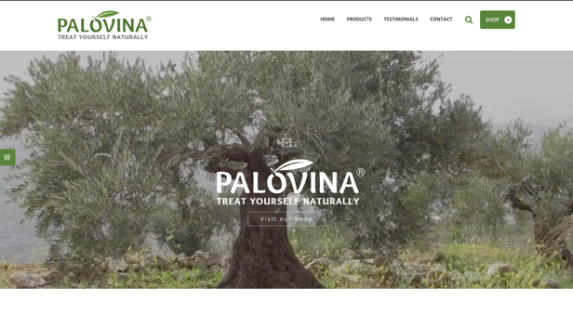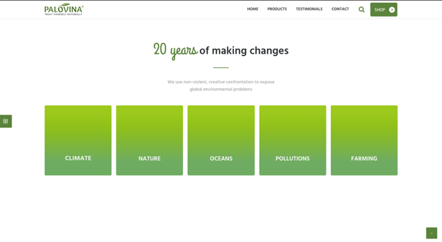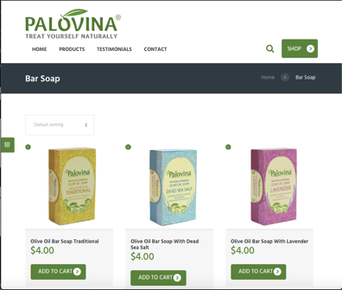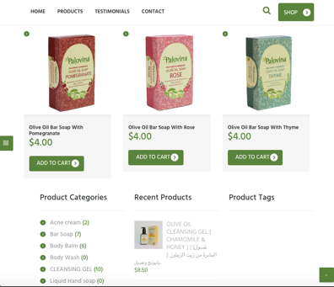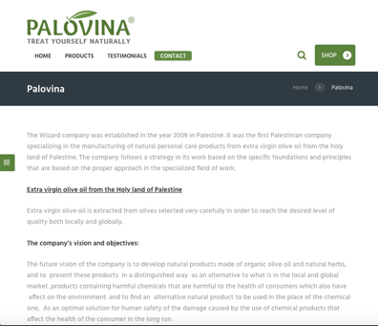

**Competitive Analysis:**

* L’Occcitane (France): <https://www.loccitane.com/en-us/>

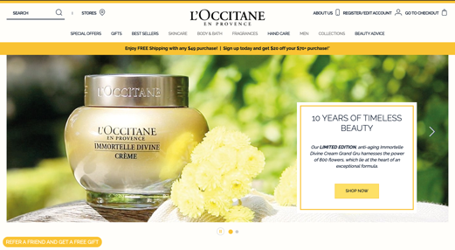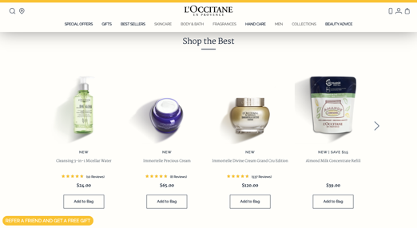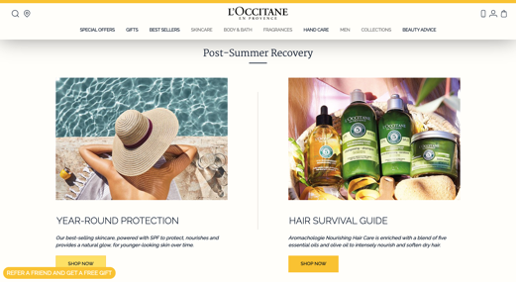

Inspired by the Provence lifestyle (Rosemary essential oil)

Hight-quality natural raw materials

Eco-Recycling Program

“Protecting” and “Passing on to future generations”

* Malie Organics (Kauai Island): <https://www.malie.com/>

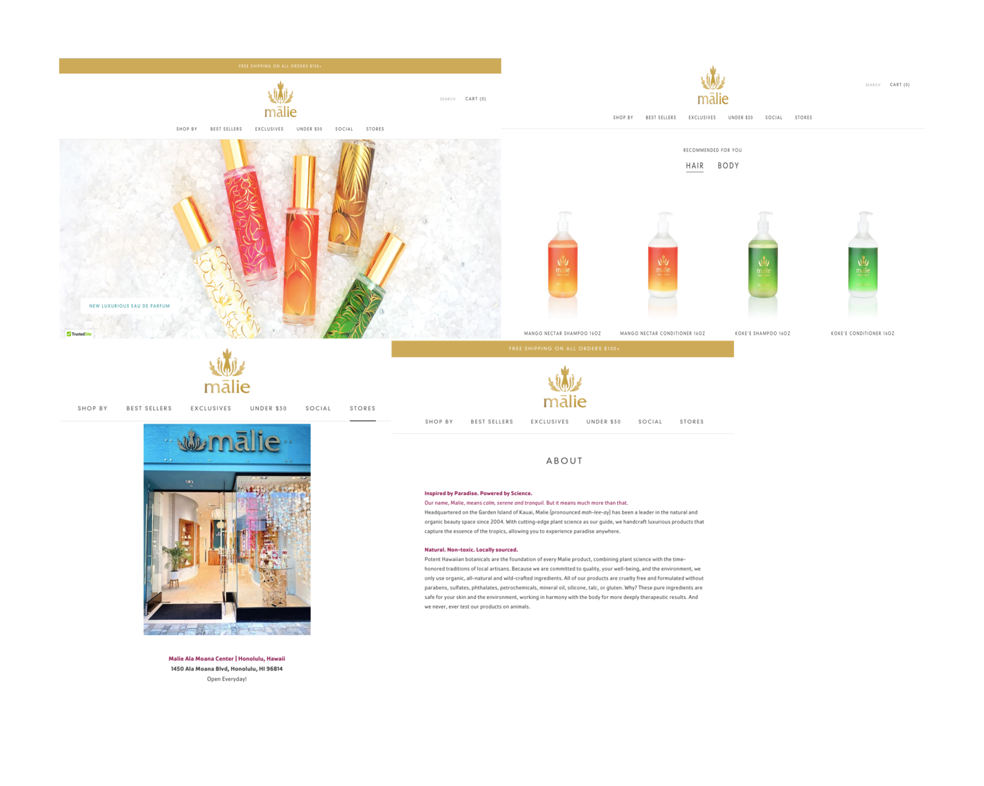

Natural. Non-toxic. Locally sourced.

Hawaiian Hydrosols (handcrafted aromatic flower waters)

Essence of the tropics

Support local society

**User Profiles:**

