Software Requirements Specification

for SmartEdu (E-learning System), Release 1.0
Version 1.0 approved
Prepared by Antigravity
Date: May 18, 2026

Table of Contents
1. [Introduction](#1-introduction)
2. [Overall Description](#2-overall-description)
3. [System Features](#3-system-features)
4. [Data Requirements](#4-data-requirements)
5. [External Interface Requirements](#5-external-interface-requirements)
6. [Quality Attributes](#6-quality-attributes)

1. Introduction
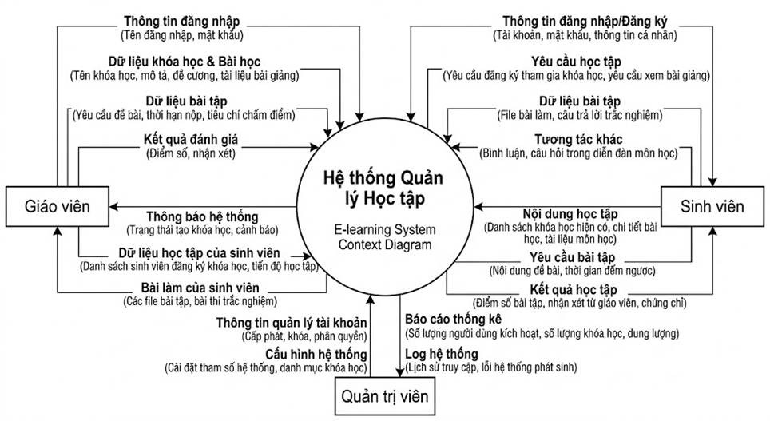

1.1 Purpose
This SRS describes the functional and nonfunctional requirements for software release 1.0 of the SmartEdu E-learning System. This document is intended to be used by the members of the project team who will implement and verify the correct functioning of the system. Unless otherwise noted, all requirements specified here are committed for release 1.0.

1.2 Document Conventions
No special typographical conventions are used in this SRS. Features are prioritized as High, Medium, or Low to indicate their implementation order.

1.3 Project Scope and Product Features
The SmartEdu E-Learning System is a new digital platform designed to replace the current manual, paper-based, and fragmented classroom processes for course registration, content delivery, and student assessment. The system acts as a centralized hub for educational interactions, initially serving internal students and faculty. As the platform evolves over future releases, it is expected to integrate with external academic databases, global payment gateways for premium certifications, and third-party video conferencing APIs to support fully remote, synchronous learning environments.
Key features scheduled for full or partial implementation in this release include:
- User authentication and profile management.
- Course creation and enrollment.
- Exam generation and grading.
- Reporting and analytics for student performance.
- System administration and semester settings.

1.4 References
- Cafeteria Ordering System Vision and Scope Document (Base Template)
- SmartEdu Repository (`c:\Users\Thinh Phat\Documents\UIT\SE104_E-learningSystem`)

2. Overall Description

2.1 Product Perspective
SmartEdu is a standalone desktop application built using Windows Presentation Foundation (WPF) and C# .NET. It connects to Firebase for cloud database and authentication services and Cloudinary for media asset management. It is designed to scale and handle various types of user interactions seamlessly.

2.2 User Classes and Characteristics
- Student: A user who takes courses, completes exams, and tracks their own progress. They will frequently log in to view their classes, check notifications, and view exam reports.
- Teacher: A faculty member who creates courses, builds exams, and tracks student performance across their classes. They need tools for scheduling and course management.
- Admin: A system administrator responsible for overarching system configuration, managing semester settings, maintaining system health, and resolving user issues.

2.3 Operating Environment
- OE-1: The SmartEdu system shall operate correctly on Windows 10 and Windows 11 desktop environments.
- OE-2: The application requires a stable internet connection to communicate with Firebase and Cloudinary services.
- OE-3: The backend data will be hosted on Google Firebase, utilizing Firebase Authentication and Firestore/Realtime Database.

2.4 Design and Implementation Constraints
- CO-1: The system shall be implemented as a WPF (Windows Presentation Foundation) desktop application using C#.
- CO-2: The system must use Firebase for real-time data synchronization and user authentication.
- CO-3: The system must use Cloudinary for storing user-uploaded media (e.g., profile pictures, course materials).

2.5 Assumptions and Dependencies
- AS-1: Users have access to Windows PCs with sufficient hardware resources to run a WPF desktop application.
- DE-1: The operation of SmartEdu depends on the uptime and availability of Google Firebase and Cloudinary APIs.

3. System Features

3.1 Authentication and Profile Management
#### 3.1.1 Description
Users must be able to securely register, log in, recover their passwords, and manage their personal profiles. Priority = High.
#### 3.1.2 Functional Requirements
- Auth.Login: The system shall authenticate users via email and password using Firebase Authentication.
- Auth.Register: The system shall allow new users to register and automatically assign a role (Student/Teacher) based on the registration token or selection.
- Auth.PasswordReset: The system shall provide a "Forgot Password" feature that sends a password reset link to the user's email.
- Profile.Update: Users shall be able to update their personal information and upload a profile picture via Cloudinary.

3.2 Course Management
#### 3.2.1 Description
Teachers can create and manage courses, while students can view and enroll in available classes. Priority = High.
#### 3.2.2 Functional Requirements
- Course.Create: Teachers shall be able to create new courses with titles, descriptions, and materials.
- Course.View: Students shall be able to view their enrolled classes on a dashboard.
- Course.Schedule: Teachers shall have a "Teaching Schedule" view to organize their classes by semester and time, dynamically loaded from the database.
- Course.Detail: The system shall provide a detailed view of a course, showing syllabi, participant lists, and related exams.

3.3 Exam Management
#### 3.3.1 Description
Teachers need robust tools to evaluate students. This includes assembling exams and grading. Priority = High.
#### 3.3.2 Functional Requirements
- Exam.Create: Teachers shall be able to create exams, set constraints (time limit, passing score, multiple attempts, deadline) and manually add questions or import them via Excel (.xlsx).
- Exam.Edit: Teachers shall be able to edit existing exams before they are published to students.
- Exam.Take: Students shall be able to access and complete exams within the allocated time limit.

3.4 Reports and Analytics
#### 3.4.1 Description
The system provides insights into student performance and course effectiveness. Priority = Medium.
#### 3.4.2 Functional Requirements
- Report.Exam: The system shall generate individual exam reports detailing student scores, correct answers, and feedback.
- Report.Dashboard: The Teacher Dashboard shall display aggregated statistics for their courses (e.g., average scores, completion rates).

3.5 Semester Settings and Admin Tools
#### 3.5.1 Description
Admins manage the academic calendar and system-wide configurations. Priority = Low.
#### 3.5.2 Functional Requirements
- Admin.Semester: Admins shall be able to define, open, and close academic semesters, configuring rules such as minimum pass scores and grade scales via a local configuration file.
- Admin.Dashboard: Admins shall have a centralized view to monitor system activity and manage user roles (loaded securely from Firestore).

4. Data Requirements

4.1 Data Dictionary
Data Element | Description | Composition or Data Type | Length | Values
user_id | Unique identifier for a user | alphanumeric (Firebase UID) | 28
course_id | Unique identifier for a course | alphanumeric | 20
exam_id | Unique identifier for an exam | alphanumeric | 20
role | The permission level of the user | alphabetic | 10 | "Student", "Teacher", "Admin"
grade | The score achieved on an exam | numeric (float) | - | 0.0 to 100.0
semester_status | Indicates if a semester is active | boolean | 1 | True (Open), False (Closed)

4.2 Data Integrity, Retention, and Disposal
- DI-1: Course materials and exam records shall be retained for a minimum of 5 years to support academic audits.
- DI-2: If a user requests account deletion, their personal identifiable information (PII) shall be anonymized, but academic records will remain for statistical integrity.

5. External Interface Requirements

5.1 User Interfaces
- UI-1: The user interface shall be designed using modern WPF principles (XAML), ensuring responsive layouts that adapt to window resizing.
- UI-2: The application shall utilize custom dialogs (`CustomDialog.xaml`) for critical user confirmations and error messages.

5.2 Software Interfaces
- SI-1: Firebase API: The system shall communicate with Firebase for Authentication, Firestore (database), and Cloud Messaging (notifications).
- SI-2: Cloudinary API: The system shall use the Cloudinary SDK to upload, retrieve, and manage image assets.

5.3 Hardware Interfaces
- No specific hardware interfaces identified beyond standard PC peripherals (keyboard, mouse, monitor).

5.4 Communications Interfaces
- CI-1: The system shall communicate over HTTPS to ensure secure data transmission to Firebase and Cloudinary.

6. Quality Attributes

6.1 Usability Requirements
- USE-1: The navigation structure shall allow users to reach any primary feature (Dashboard, Courses, Exams) within two clicks from the main menu.
- USE-2: Error messages shall be descriptive and provide actionable steps for the user.

6.2 Performance Requirements
- PER-1: The desktop application shall load and render the main dashboard within 3 seconds of a successful login.
- PER-2: Database queries to Firebase shall be optimized to return results within 2 seconds under normal network conditions.

6.3 Security Requirements
- SEC-1: Passwords shall never be stored locally; all authentication must be handled securely via Firebase.
- SEC-2: Role-based access control (RBAC) shall be strictly enforced on the client side (hiding unauthorized views) and server side (Firestore Security Rules).

6.4 Safety Requirements
- SAF-1: The system shall implement auto-save functionality for students taking exams to prevent data loss during power outages or network failures.

6.5 Availability Requirements
- AVL-1: The client application shall be accessible offline for viewing previously cached data, though active connections are required for syncing.

6.6 Robustness Requirements
- ROB-1: If the connection to Firebase is lost, the system shall notify the user and queue non-critical data updates for synchronization once the connection is restored.

Appendix A: Glossary
The following terms are used throughout this document:
Term | Definition
WPF | Windows Presentation Foundation â€” Microsoft UI framework for desktop applications built with XAML and C#.
Firebase | Google cloud platform providing Firebase Authentication, Cloud Firestore (NoSQL DB), and Cloud Messaging.
Firestore | Google Cloud NoSQL document database used as the primary data store for SmartEdu.
Cloudinary | Cloud-based media management platform for uploading, storing, and delivering images and videos.
JWT | JSON Web Token â€” a compact, URL-safe token used for authentication and authorization between client and server.
RBAC | Role-Based Access Control â€” a security model where access is determined by the role assigned to a user.
ExamDraft | A saved but not yet published exam created by a Teacher, visible only to the creator until activated.
ExamSubmission | A completed or in-progress exam attempt submitted by a Student.
SubmissionStatus | An enum value indicating the state of an ExamSubmission: InProgress, Submitted, Graded, or Expired.
Enrollment | A formal registration by a Student into a Course, requiring Teacher approval.
Semester | An academic period defined by an Admin with a name, start date, and end date.
CourseContent | A piece of teaching material (Document, Link, or Note) attached to a Course by a Teacher.
AnswerResponse | A record of a single answer provided by a Student for a specific ExamQuestion.

