**RFID ACCESS CONTROL**

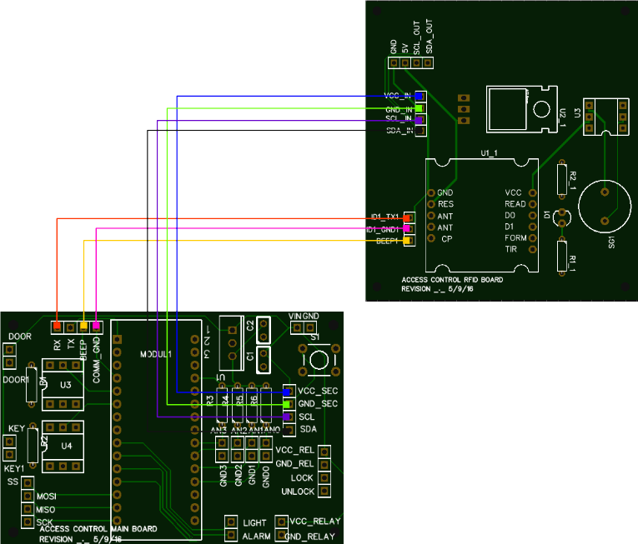

CONTENT

INTRODUCTION 3

SPECIFICATIONS 3

HARDWARE DESCRIPTION 3

Board 1 4

Links with the board 2 5

Digital inputs 6

Digital outputs 7

Mechanical interface 8

Bill of materials 8

Board 2 8

Links with the board 1 9

Mechanical interface 10

Bill of materials 10

Boards interconnection 10

FIRMWARE DESCRIPTION 11

States machine 11

State 0 Idle 12

State 1 Door opened 12

State 10 Identification OK 13

State 11 Master RFID tag identification 13

State 100 Alarm triggered 14

State 200 Manual mode 14

State 250 New code registration 14

Special protections and functions 15

Maximum denied attempts 15

Identification of a new RFID tag code 15

# INTRODUCTION

This device performs an access control by means of 125 kHz RFID tags as the one shown in Figure 1. It consists of a microcontroller and a RFID reader which are communicated by means of a serial link.

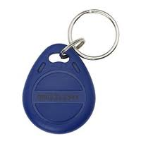

Figure 1 125 kHz RFID tag

When an accepted RFID tag is swiped around the reader, the device grants access to a protected zone by means of switching on a relay that power on the lights. The capabilities of this device can be further increased by integrating an electro-mechanical locking mechanism to the door. This could be locked and unlocked by means of two additional digital outputs.

# SPECIFICATIONS

The following table shows the general specifications for the access control system.

|  |  |  |  |  |
| --- | --- | --- | --- | --- |
| **Parameter** | **Min Value** | **Max Value** | **Unit** | **Comments** |
| Vin | 7 | 25 | V | This voltage is usually the one applied to the output relays coils so it should be chosen accordingly. |
| Iin | 5 | 500 | mA | It depends on the value of the resistors chosen. |
| Operating temperature | 0 | 40 | ºC |  |
| Board1 dimensions | 70x45 | | mm |  |
| Board2 dimensions | 61x67 | | mm |  |

Table 1 Specifications

# HARDWARE DESCRIPTION

The hardware is divided into two boards as can be seen on Figure 2. This architecture increases the safety as the mainboard (board 1) can be safely placed (or even hidden) inside the protected area whereas the human-machine interface (HMI) board (board 2) can be left exposed in the un-protected area.

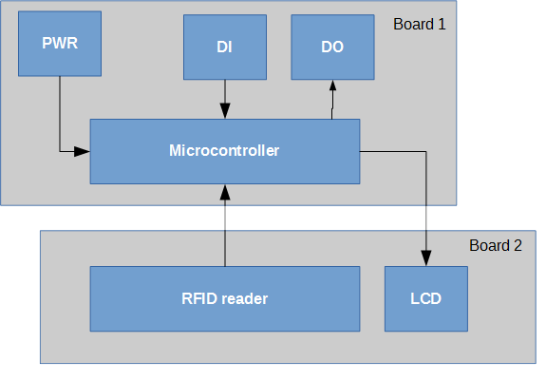

Figure 2

The board 1 acquires all the inputs (such as door opened) and executes the algorithm activating the outputs (alarm) as required; even in the absence of board 2. This guarantees that even in the case of vandalism that may destroy the exposed part (board 2), the alarm will keep on being activated in case required.

## Board 1

The board 1 comprises the microprocessor, the digital inputs (DI) and digital outputs (DO) as well as the communication links with the board 2. This board receives the input voltage (*Vin*) and generates the 5 Vdc required by the microprocessor.

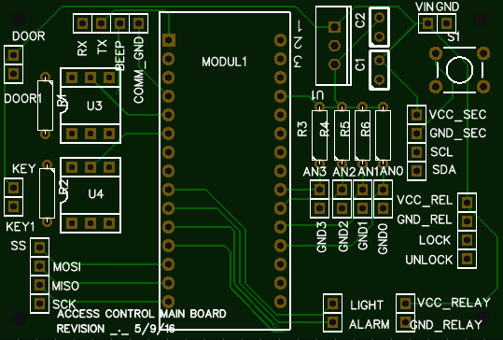

Figure 3

|  |  |
| --- | --- |
| Resultado de imagen de warning signal | In the initial prototypes of this board, there was no onboard 5V voltage regulator so an external one should be used to avoid relying on the microcontroller’s regulator. In this situation, the *Vin* pin in the microcontroller should be cut and left floating and it should be powered from the external voltage regulator at 5V (see Figure 4). |

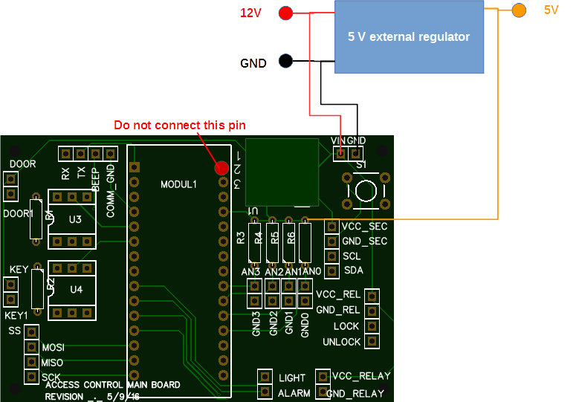

Figure 4 Initial prototype boards

### Links with the board 2

The link with the board 2 is splitted in two connectors for the sake of routing simplicity. These can be highlighted in Figure 5. The connector highlighted in red implements the communication with the RFID module whereas the one in blue sends the power supply to the board 2 and the communication with the LCD display.

Both links can be accommodated using a single UTP8 cable. Lengths up to 2,5 m have been properly tested and validated.

The pin *Tx* in the red connector is not used so it should not be wired.

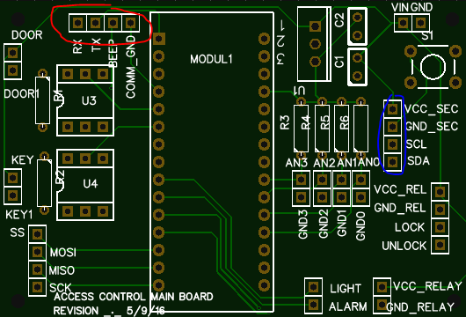

Figure 5 Connectors with board 2

### Digital inputs

The board includes two digital inputs that will gather the information about the status of the door (pins *DOOR* and *DOOR1* in Figure 3) and the status of the manual key that turns the unit into manual mode (pins *KEY* and *KEY1*). The digital inputs are optocoupled as seen on Figure 6.

|  |  |
| --- | --- |
| Resultado de imagen de warning signal | Here, the *Vcc* tag equals *Vin* so the value of the limiting resistors *R1* and *R2* should be chosen according to the actual value of *Vin* (12V usually). |

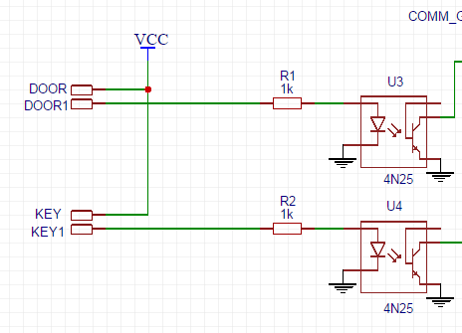

Figure 6

### Digital outputs

The board includes two digital outputs that will control the status of the lights (pin *LIGHT* in Figure 3) and the status of the alarm (*ALARM* pin). Additionally, two more digital outputs are prepared to include an electro-mechanical lock system to the door (pins *LOCK* and *UNLOCK*); but currently these feature has not been implemented in the firmware.

The digital outputs are conceived to be used with standard relay boards as the one shown in Figure 7. These can be sourced from many internet suppliers for very few euros.

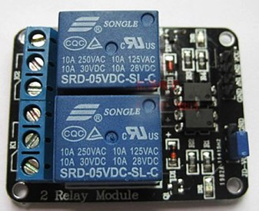

Figure 7

To operate with these relay boards, the following cabling should be performed (Figure 8):

* Digital outputs driving signals (green and blue traces)
* Driving signals voltage (yellow trace)
* Relay coils voltage (red and black traces)

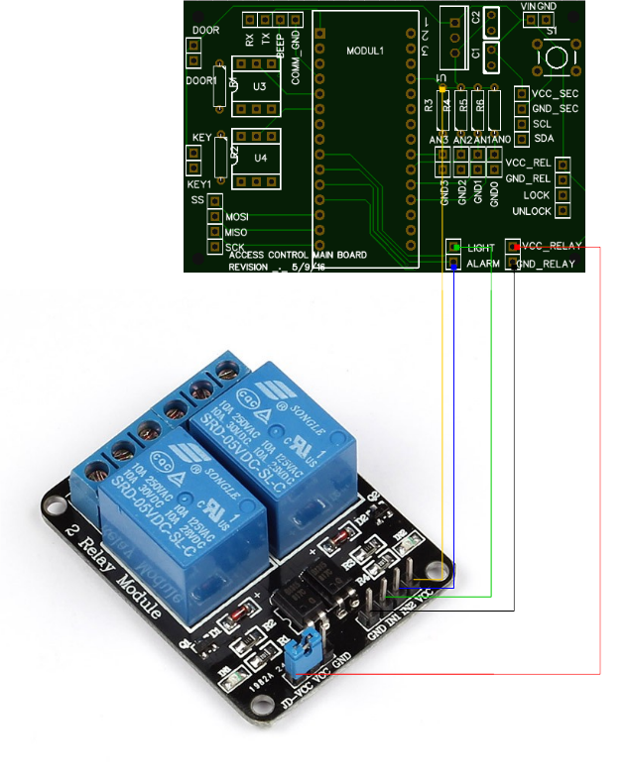

Figure 8 Cabling between the board 1 and a 12V relay board

|  |  |
| --- | --- |
| Resultado de imagen de warning signal | The blue bridge shown in Figure 8 should only be used in case the voltage of the coils of the relays coincides with the driving signals voltage (5V). In any other case, it should be removed. |
| Resultado de imagen de warning signal | Normally these relay boards have inverted input; i.e., to activate the relay, a logic 0 should be applied to the corresponding driving signal. This is how the firmware is programmed as default; in case a non-inverted output is required, the values of the code tags __RELAY_ON__ and __RELAY_OFF__ should be exchanged. |

### Mechanical interface

The board 1 includes four 2 mm diameter holes to be fixed to a frame by means of plastic spacers. The pattern for the holes is shown in Figure 9.

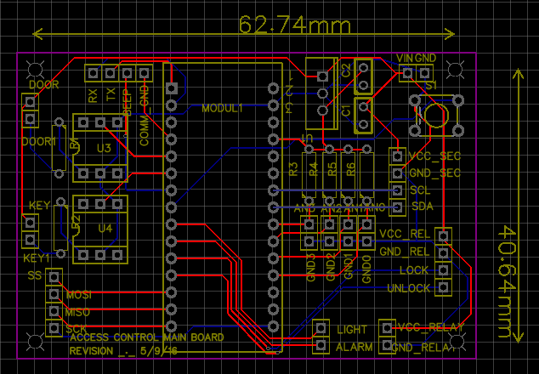

Figure 9 Holes pattern on board 1

### Bill of materials

The following table shows the components required to build up the board 1.

|  |  |  |  |  |
| --- | --- | --- | --- | --- |
| **Units** | **Component code** | **Description** | **Source** | **Cost** |
| 1 | MODUL1 | Arduino nano v3 | Aliexpress | 5,80 € |
| 2 | U3,U4 | 4N25 Optocoupler | Aliexpress | 0,17 € |
| 1 | U1 | LM7805 5V voltage regulator | Aliexpress | 0,09 € |
| 2 | R1,R2 | 1 kOhm resistor |  |  |
| 1 |  | 2 channel 12Vdc relay board | Aliexpress | 1,84 € |

Table 2 Bill of material

## Board 2

The board 2 comprises the RFID reader and an LCD display that shows information about the status of the device. This board is intended to be used with an ID-12LA reader and a breakout board [1] (<https://www.sparkfun.com/products/13030>) but other serial interfaced readers might be used.

This board receives the power supply from the link with the board 1 and converts it to a 5 Vdc stabilized voltage by means of its onboard regulator (*U2_1* in Figure 10).

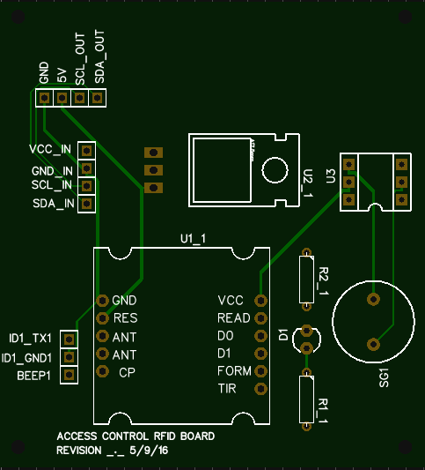

Figure 10

Board 2 also includes a buzzer (*SG1* in Figure 10) that gives a sound feedback when a RFID tag has been read. It is additionally used to give some other information to the user such as a counter that is about to finish.

### Links with the board 1

The links with the board 1 are highlighted in the next figure with corresponding colors to Figure 5. An important remark is that the pin *ID1_TX1* in Figure 11 should be wired to the pin *Rx* in Figure 5.

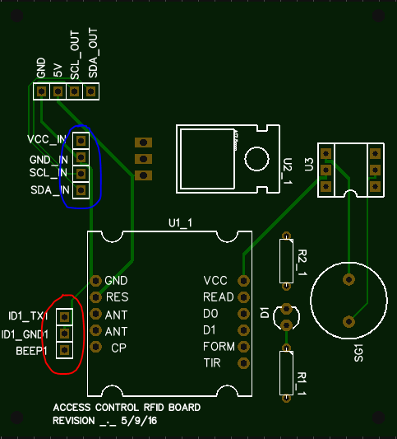

Figure 11 Interfaces with board 1

### Mechanical interface

The board 2 includes four 2 mm diameter holes to be fixed to a frame by means of plastic spacers. The pattern for the holes is shown in Figure 12.

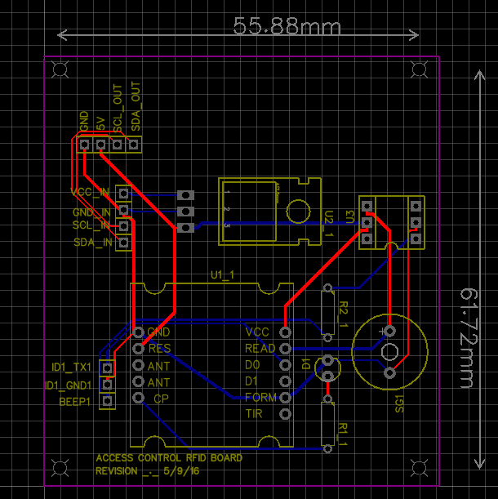

Figure 12 Holes pattern on board 2

### Bill of materials

The following tables cover the minimal components to have an operational board and some additional features.

|  |  |  |  |  |
| --- | --- | --- | --- | --- |
| **Minimal implementation** | | | | |
| **Units** | **Component code** | **Description** | **Source** | **Cost** |
| 1 | U1_1 | ID-12LA | [Sparkfun](https://www.sparkfun.com/products/11827) | 29,95 € |
| 1 | U1_1 | ID-12 breakout board | [Sparkfun](https://www.sparkfun.com/products/13030) | 1,95 € |
| 1 | U2_1 | LM7805 5V voltage regulator | Aliexpress | 0,09 € |

Table 3 Minimal implementation bill of materials

|  |  |  |  |  |
| --- | --- | --- | --- | --- |
| **Add-ons** | | | | |
| **Units** | **Component code** | **Description** | **Source** | **Cost** |
| 1 | SG1 | 5 V buzzer | Aliexpress | 0,14 € |
| 1 | U3 | 4N25 Optocoupler | Aliexpress | 0,17 € |
| 1 | R2_1 | 1 kOhm resistor |  | 0,00 € |
| 1 |  | I2C interfaced LCD | Aliexpress | 1,86 € |
| 1 | D1 | LED |  | 0,00 € |
| 1 | R1_1 | 470 Ohm resistor |  | 0,00 € |

Table 4 Optional components

## Boards interconnection

The following figure summarizes the cabling between both boards.



Figure 13 Boards interconnection

# FIRMWARE DESCRIPTION

Along this section, the firmware loaded in the microcontroller will be described.

## States machine

The Figure 14 schematically describes the sequence of states defined to control the flow of the program.

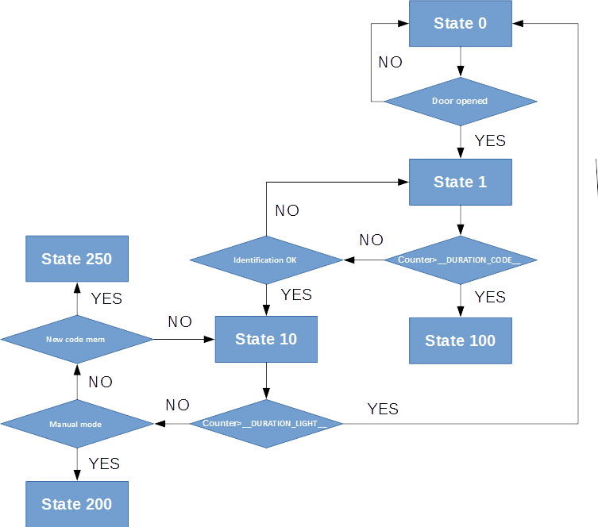

Figure 14 Algorithm flowchart

In what follows, the states of the algorithm are carefully described.

### State 0 Idle

The state 0 is the initial state the program goes once booted. In this state, the digital outputs (DO) and the display (LCD) are turned off. The device is waiting for any of the following events:

* The door is opened (moves to state 1)
* An accepted key is swiped and detected (moves to state 10)

### State 1 Door opened

The state 1 is the state that is activated if the door is opened without a valid identification. The device starts a timer with the duration indicated in the code tag __DURATION_CODE__ [min] after which, if no valid identification is detected, moves to state 100.

The door opened condition is detected by opening the contacts shown in the figure.

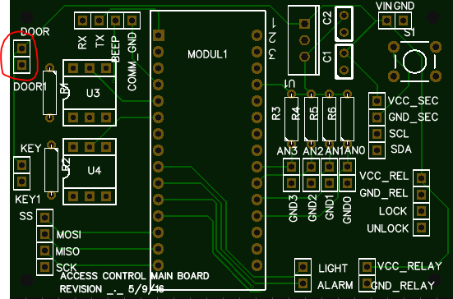

Figure 15

### State 10 Identification OK

The state 10 is the state that is activated once a valid identification is detected. In this state, the lights are switched on. The device will remain in this state for the time indicated in the code tag __DURATION_LIGHT__ [min].

While being in this state, if a valid identification is detected, the device will remain in this state for an additional __DURATION_LIGHT__ period of time; i.e. if __DURATION_LIGHT__ is set to 2 minutes, the device will stay in this state (with the lights on) for the said 2 minutes. Whenever a new valid identification is detected, an additional period of time of 2 minutes will be added to the counter.

Once the counter reaches the final time, the device will move back to state 0, so the door should be closed before this point, otherwise, the alarm counter will be initiated.

### State 11 Master RFID tag identification

The state 11 indicates that a MASTER RFID tag has been detected. In this state, the lights are turned on for the time indicated in the code tag __DURATION_LIGHT__ [min]. This state allows erasing the accepted key codes from the memory thus leaving as a valid key only the MASTER RFID tag.

To erase the codes, the MASTER RFID tag should be swiped around the detector the number of times indicated in the code tag __SWIPES_MASTERKEY__.

It is important to setup the MASTER RFID tag code in the source code before downloading it to the device. This code is stored in the variable *master_code* as a 5 byte array.

### State 100 Alarm triggered

This state indicates that the timeout for a valid identification has been reached and the alarm is triggered. In this state, the lights are switched off and the alarm relay is turned on.

The device will remain in this state until a valid identification is detected (registered RFID tag swiped) or the device is switched to manual state.

### State 200 Manual mode

This state indicates that the device is on manual mode. This state is reached if the contacts indicated in the figure are shorted.

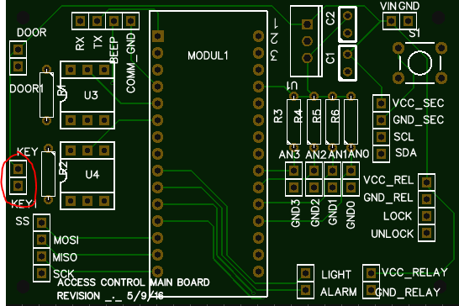

Figure 16

### State 250 New code registration

This state is used to memorize new RFID tags. It is reached from the state 10 or 11 (where a valid identification has been detected) when the leads indicated in the figure are shorted.

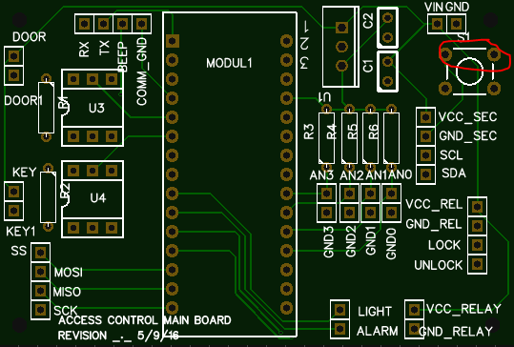

Figure 17

The device waits for the detection of a new key for the time indicated in the code tag __DURATION_CODE__, after which, if no swipe is detected, it moves to state 0.

If a new key is detected, the device stores it in the EEPROM and moves back to state 10.

## Special protections and functions

Some special functions have been included in order to increase the safety of the system.

### Maximum denied attempts

In order to avoid a bulk RFID tag test, a limitation on the number of attempts that can be tried with a non-registered RFID tag has been included. This basically allows for a maximum of the value stored in the code tag __MAX_DENIED_TRIES__ denied attempts after which, the reader blocks not allowing to read any further RFID tag for a period of time indicated in the code tag __DENIED_TRIES_DECRMT_TIME__ [min].

If the device is in blocked state, the only way to unlock it is by waiting for the time indicated in __DENIED_TRIES_DECRMT_TIME__ and swiping a valid RFID tag or by switching the system to manual mode (see State 200 Manual mode).

### Identification of a new RFID tag code

If the code of a new RFID tag is required (for example to set it up as the MASTER RFID tag), a compilation of the firmware uncommenting the flag __DEBUGGING__ can be downloaded to the device. With this compilation, the microcontroller outputs over the serial link the code of any RFID tag swiped around.

1. This strictly applies to the initial prototypes of board 2 (the ones that are currently being used). In further releases, the breakout board will no longer be needed.