Leveraging ICT for Growth, Employment and Governance (LICT)



**A PROJECT REPORT ON**

BINIMOY

|  |  |
| --- | --- |
| Submitted By | Submitted To |
| Tanvir Hasan  Md. Mizanur Rahman  Shakil Saikh  Dept. of Computer Science and Engineering,  Bangabandhu Sheikh Mujibur Rahman Science & Technology University (BSMRSTU) | Mohamed Raffic Rasul  Course Co-ordinator of JAVA,  LICT  Ministry of ICT. |
| Submission Date: 30/03/2017 | |

**PROJECT APPROVAL**

The project titled “BINIMOY” submitted by Tanvir Hasan , Md. Mizanur Rahman, Md.Shakil Shaikh has been accepted as satisfactory in partial fulfillment of the requirements for “LICT Top-Up and Foundation Skill” project.

**Project Approved:**

.........................................

Signature of the Supervisor

Trainer

LICT Top-Up and Foundation Skill

**INDEX**

1. Acknowledgement …………………………………………. 3
2. Abstract …………………………………………. 4
3. Introduction …………………………………………. 5
4. Module Design …………………………………………..6
5. Technology Behind the System ……………………………………... 7
6. User Manual ………………………………………….8
7. Limitation & Future Work …………………………………………. 13
8. Reference ……………………………………………14

**Acknowledgement**

We are grateful to our supervisor and Mohamed Raffic Rasul, who provided us with an opportunity to work under his kind supervision. We dedicate this acknowledgement to all our teachers and members of our department who gave us knowledge. It would not be possible to complete this project without the help of few persons.

**Abstract**

“BINIMOY” is a file sharing software. It is a desktop application. It will help users to messaging with other person. Also we can transfer files using this application. We can share screen with our partner.

The only requirement for this application is both of the user have to connect in same network.

which allows the secure sharing data, file, massaging, screen belong computers .The performance of the software is well that is useful to the user. Finally future directions and improvements are discussed.

**Introduction**

File sharing softwares have been in existence for some time. Familiar softwares or applications such as Share it ,Zipya have large user base. Binimoy is the free software to transfer your files and folders from PC to PC over wireless connection. You can use this free file transfer software to transfer files from one pc to another.

**Here are some features of Folder Transfer software:**

* Transfer files from computer to computer over wireless network .
* Transfer files from one computer to another over wifi.
* Transfer large files and folders between two computers directly
* Share files and folders to let others download anytime over networks

|  |  |  |
| --- | --- | --- |
| **Transfer Files to Another Computer** | **Transfer Files Between Computers** |  |
| Backup to Another Computer  Transfer files from one computer to another | Backup Between Computers  Transfer files between two computers |  |

**Module**

**Server or Client**

**Client**

Responsive control

Receive file

Get shared screen

**Server**

Control pc

Select & send

Share screen

Select

**Request**

**Technology Behind The System**

This system is very helpful for users. User can share their files and share their pc screen also. They can massage also to each other.

* **Eclipse :**

**Eclipse** is an [integrated development environment](https://en.wikipedia.org/wiki/Integrated_development_environment) (IDE) used in [computer programming](https://en.wikipedia.org/wiki/Computer_programming), and is the most widely used Java IDE It contains a base [workspace](https://en.wikipedia.org/wiki/Workspace) and an extensible [plug-in](https://en.wikipedia.org/wiki/Plug-in_%28computing%29) system for customizing the environment. Eclipse is written mostly in [Java](https://en.wikipedia.org/wiki/Java_%28programming_language%29) and its primary use is for developing Java applications, but it may also be used to develop applications in other [programming languages](https://en.wikipedia.org/wiki/Programming_language) via plug-ins, including: [Ada](https://en.wikipedia.org/wiki/Ada_%28programming_language%29), [ABAP](https://en.wikipedia.org/wiki/ABAP), [C](https://en.wikipedia.org/wiki/C_%28programming_language%29), [C++](https://en.wikipedia.org/wiki/C%2B%2B), [COBOL](https://en.wikipedia.org/wiki/COBOL), [D](https://en.wikipedia.org/wiki/D_%28programming_language%29), [Fortran](https://en.wikipedia.org/wiki/Fortran), [Haskell](https://en.wikipedia.org/wiki/Haskell_%28programming_language%29), [JavaScript](https://en.wikipedia.org/wiki/JavaScript), [Julia](https://en.wikipedia.org/wiki/Julia_%28programming_language%29) [Lasso](https://en.wikipedia.org/wiki/Lasso_%28programming_language%29), [Lua](https://en.wikipedia.org/wiki/Lua_%28programming_language%29), NATURAL, [Perl](https://en.wikipedia.org/wiki/Perl), [PHP](https://en.wikipedia.org/wiki/PHP), [Prolog](https://en.wikipedia.org/wiki/Prolog), [Python](https://en.wikipedia.org/wiki/Python_%28programming_language%29), [R](https://en.wikipedia.org/wiki/R_%28programming_language%29), [Ruby](https://en.wikipedia.org/wiki/Ruby_%28programming_language%29) (including [Ruby on Rails](https://en.wikipedia.org/wiki/Ruby_on_Rails) framework), [Rust](https://en.wikipedia.org/wiki/Rust_%28programming_language%29), [Scala](https://en.wikipedia.org/wiki/Scala_%28programming_language%29), [Clojure](https://en.wikipedia.org/wiki/Clojure), [Groovy](https://en.wikipedia.org/wiki/Groovy_%28programming_language%29), [Scheme](https://en.wikipedia.org/wiki/Scheme_%28programming_language%29), and [Erlang](https://en.wikipedia.org/wiki/Erlang_%28programming_language%29). It can also be used to develop documents with [LaTeX](https://en.wikipedia.org/wiki/LaTeX) (via a TeXlipse plug-in) and packages for the software [Mathematica](https://en.wikipedia.org/wiki/Mathematica). Development environments include the Eclipse Java development tools (JDT) for Java and Scala, Eclipse CDT for C/C++, and Eclipse PDT for PHP, among others.

The initial [codebase](https://en.wikipedia.org/wiki/Codebase) originated from [IBM VisualAge](https://en.wikipedia.org/wiki/IBM_VisualAge) The Eclipse [software development kit](https://en.wikipedia.org/wiki/Software_development_kit) (SDK), which includes the Java development tools, is meant for Java developers. Users can extend its abilities by installing plug-ins written for the Eclipse Platform, such as development toolkits for other programming languages, and can write and contribute their own plug-in modules. Since [Equinox, plug-ins can be plugged-stopped dynamically and are termed (OSGI) bundles](https://en.wikipedia.org/wiki/Equinox_%28OSGi%29)

Eclipse [software development kit](https://en.wikipedia.org/wiki/Software_development_kit) (SDK) is [free and open-source software](https://en.wikipedia.org/wiki/Free_and_open-source_software), released under the terms of the [Eclipse Public License](https://en.wikipedia.org/wiki/Eclipse_Public_License), although it is incompatible with the [GNU General Public License](https://en.wikipedia.org/wiki/GNU_General_Public_License). It was one of the first IDEs to run under [GNU Classpath](https://en.wikipedia.org/wiki/GNU_Classpath) and it runs without problems under [IcedTea](https://en.wikipedia.org/wiki/IcedTea).

* **Notepad:**

**Notepad** is a [text editor](https://en.wikipedia.org/wiki/Text_editor) and [source code editor](https://en.wikipedia.org/wiki/Source_code_editor) for use with [Microsoft Windows](https://en.wikipedia.org/wiki/Microsoft_Windows). It supports [tabbed](https://en.wikipedia.org/wiki/Tab_%28GUI%29) editing, which allows working with multiple open files in a single window. The project's name comes from the [C](https://en.wikipedia.org/wiki/C_%28programming_language%29) [increment operator](https://en.wikipedia.org/wiki/Increment_operator).

Notepad is distributed as [free software](https://en.wikipedia.org/wiki/Free_software). At first the project was hosted on [SourceForge.net](https://en.wikipedia.org/wiki/SourceForge.net), from where it has been downloaded over 28 million times, and twice won the SourceForge Community Choice Award for Best Developer Tool. The project was hosted on [TuxFamily](https://en.wikipedia.org/w/index.php?title=TuxFamily&action=edit&redlink=1) ([fr](https://fr.wikipedia.org/wiki/TuxFamily" \o "fr:TuxFamily)) from 2010 to 2015; since 2015 Notepad has been hosted on [GitHub](https://en.wikipedia.org/wiki/GitHub). Notepad uses the [Scintilla editor component](https://en.wikipedia.org/wiki/Scintilla_%28software%29).

.

**User Manual**

1. **Home Page**: This is the home page of this application. It has some buttons. If an user want to send a file then he/she will click on “Send File” button and the other user will click on “Receive File” button.

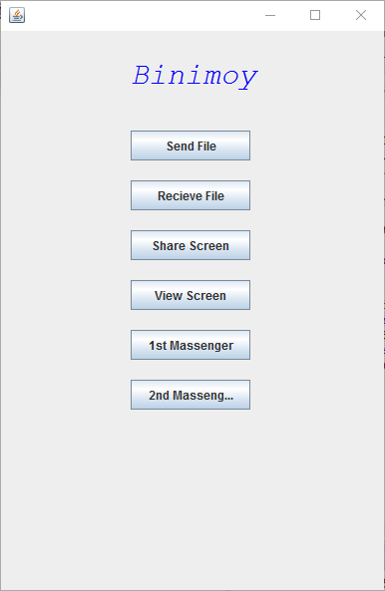

1. **File Selection:** If user click on send button then a file chooser will open then he can select a file from his desired directory.

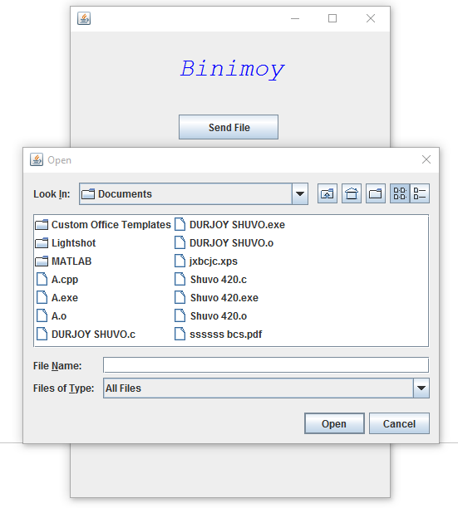

1. **Send:** After selection the file will sending. Then a progress bar will showed to indicate how much of the file has transferred.

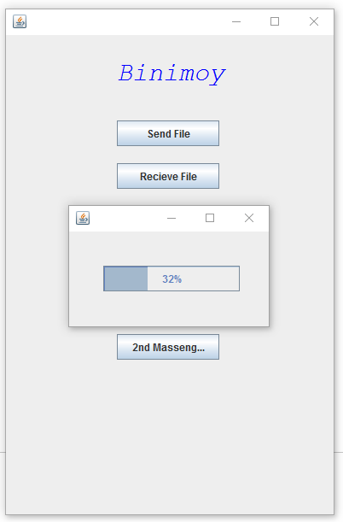

1. **Send successful:** After completely transfer the file a pop up will open showing a massage “File sent successfully”.

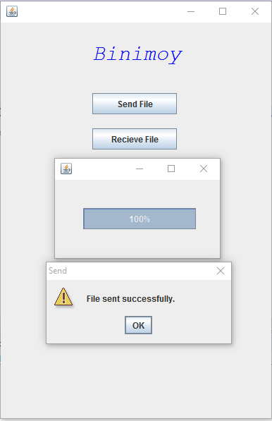

1. **Screen share**: If an user want to share his/her computer screen then click on “Share Screen” button and other user click on “View Screen” button. Then he can see the screen of other person.

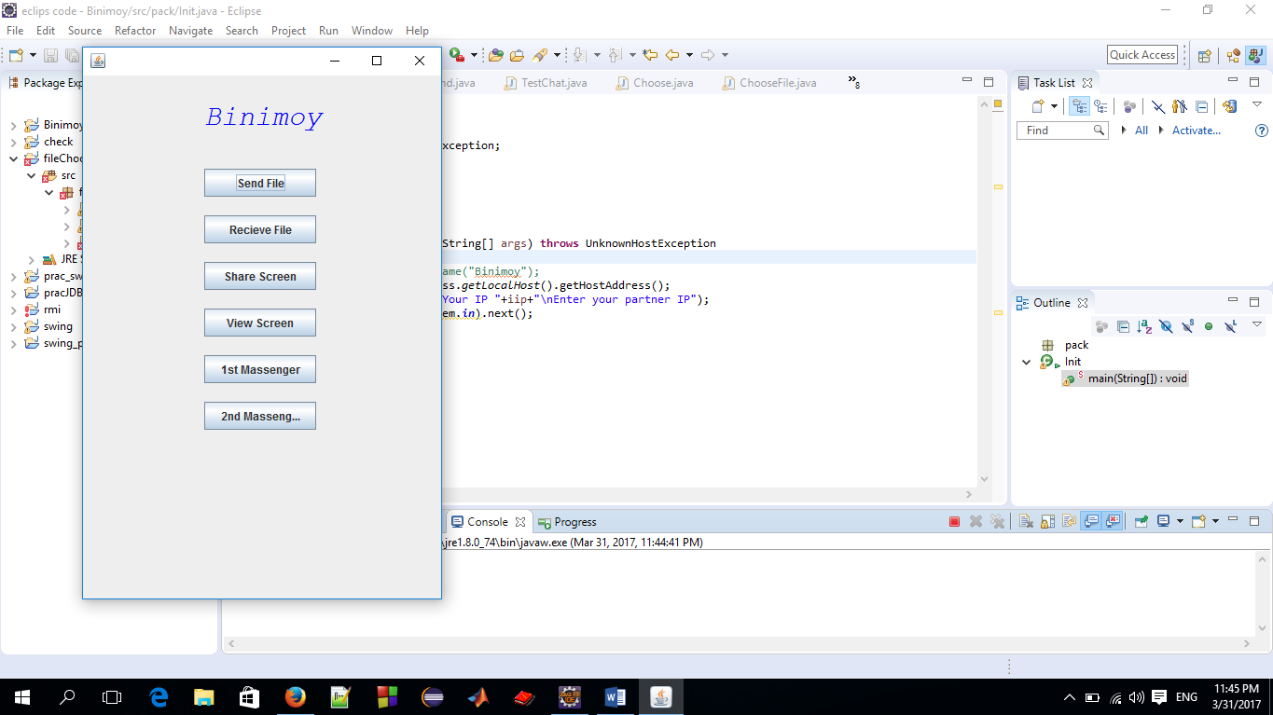

1. Massaging: If a user want to massage with other user then one user click on “1st Massenger” button and other user click on “2nd Massenger ” button. Then they can chat each other.

**Limitation and Future Work**

* 1. **Limitation**
* Need wireless connection.
* Multiple user can’t use the software at a time.
* Security of the software is not strong.
* User interface is not looks beautiful,
  1. **Future Work**

1. I will develop multiple user at a time.
2. This software will be useable for all operating system.
3. Any students(school,college,university) can use it easily.
4. This software will be developed for people.

**6. Discussion**

The Binimoy software is useful for all windows pc user.It is network noiseless

Software. A user can transfer his file between two computers very easily.

Reference

* [www.google.com](http://www.google.com)
* [www.wikipadia.com](http://www.wikipadia.com)
* www.javatpoint.com