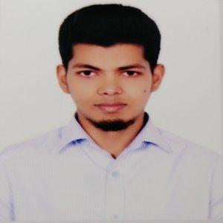
RESUME OF
MIZANUR RAHMAN
Kollyanpur, Alamin Road
House no: 390/1, Mirpur
Dhaka-1216
Email: mrahman5037@gmail.com
Cell Phone: +88-01515-612832

Career Objectives:
I am seeking a position as a web developer where I can work in a challenging environment and gain experience in working in working as a part of a team to research and develop new products.
Working Experience:
Programmer (03/2019 – 12/2019)
On Optima Solution, Gulshan
Responsibilities:
• Wrote maintainable and extensible code in a team environment.
• Stored, retrieved and manipulated data for system capabilities.
• Consulted regularly with customers on project status, proposals.
• Prepared detailed reports.
• Consult with company and clients to determine user needs.
Education Qualifications
Exam Title | Concentration/Major | Institute | Result | Passing Year | Duration
Bachelor of Science (BSc) | Computer Science & Engineering | Jagannath University | CGPA:3.33  out of 4 | 2017 | 4
HSC | Science | Bangladesh Navy College | CGPA:5  out of 5 | 2011 | -
SSC | Science | Model Academy | CGPA:5  out of 5 | 2009 | -

Key skills:
Knowledge of:
- PHP,Laravel framework,HTML5,CSS3,BootStap
- REST API
- JavaScript,AJAX,jQeury

Other Information:
Language Skill:
- Have excellent command in both English and Bengali.
Self Appraisal:
- Self-motivated, hard-working & energetic

Personal Information:
Name : Mizanur Rahman
Father’s Name : Abdur Rahim
Mother’s Name : Amina Begum
Nationality : Bangladeshi
Permanent Address : Village:Gaoyragacha, Post: Anuhola
Sadar: Tangail Sadar, District: Tangail
Religion : Islam
Gender : Male
Marital Status : Married
Blood Group : B+ (positive)

Personal Interest:
- Reading book and online blog, Playing Cricket

Declaration:
I hereby declare that all the above mentioned information given by me is true and correct to the best of my knowledge and belief.

References :
Name :Tanvir Ahammad  Designation: Lecturer, Jagannath University  Email : tanvir@cse.jnu.ac.bd  Mobile : 01872222453 | Abdullah Al Mamun  Orion Group, Sr. Officer, Finance & Accounts  mamun.payroll@orion-group.net  +8801673844360

