MCQ
Chapter 05: Modeling Concepts

[The correct answer for each question is indicated by BOLD FACE]

Question 1: Which of the following is not a reason for using a model?
- A model is quicker and easier to build than the real thing
- We can use a model in simulations to test our ideas
- We can use a model instead of building the real thing

Question 2: Which of the following is not a model?
- An Airbus 380.
- A scale model of an Airbus 380 to use in a wind tunnel.
- An engineer’s drawing of a cross-section through the fuselage of an Airbus 380.

Question 3: Analysts and designers use models that consist of which of the following?
- Diagrams and text
- Only diagrams
- Only text

Question 4: Which of the following do analysts and designers use diagrams for?
- To communicate ideas
- To understand structures and relationships
- Both 1 and 2

Question 5: Which of the following do analysts and designers use diagrams for?
- To ensure that users don’t understand the specification for a system
- To communicate ideas to users and other analysts and designers
- Neither A nor B

Question 6: Why are system analysis and design diagram standards important?
- They promote communication between team members
- They provide work for international standards committees
- They prevent systems analysts’ clothes from shrinking in the wash

Question 7: Which of the following are the rules that modelling techniques should enforce?
- Simplicity of representation, external consistency, completeness and network representation
- Simplicity of representation, internal consistency, completeness and hierarchical representation
- Simplicity, internal consistency, completeness and hierarchical symbols

Question 8: Which of the following is true?
- Icons can contain two-dimensional symbols
- Two-dimensional symbols can contain icons
- An icon contains at least one vertex and one string

Question 9: Which of the following is true?
- A model consists of one and only one diagram
- A diagram contains at least one model
- A model contains diagrams

Question 10: Which of the following is the UML notation for a model?
- 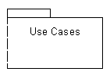
- 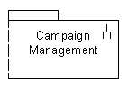
- 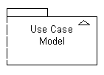
Question 11: Which of the following does the Figure below show?
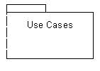
- A model.
- A sub-system
- A package

Question 12: As a model is developed it, which of the following does it become?
- More abstract
- More detailed
- Less formal

Question 13: Which of the following is not a purpose for using activity diagrams?
- To show the sub-systems that make up a system
- To model a task
- To describe the logic of an operation

Question 14: Which of the following does the figure below show?
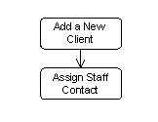
- Two actions joined by a control flow.
- Two control flows joined by an activity.
- Two actors joined by a control flow.

Question 15: A decision node in an activity diagram is represented by which of the following?
- A black circle in a white circle with a black border.
- A diamond.
- A rectangle.

Question 16: Which of the following is shown by a statement in square brackets such as ‘[no staff to assign]’ alongside a control flow?
- An activity.
- An event.
- A guard condition.

Question 17: What is shown by the arrows from the rectangles in the following diagram?
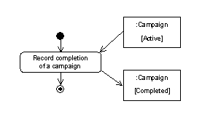
- Object flows.
- Data stores.
- Classes.

Question 18: Which of the following is the name given to the division of an activity diagram into columns that represent where activities take place?
- Tracks.
- Activity zones.
- Activity partitions.

Question 19: How many phases are there in the Unified Software Development Process?
- Three.
- Four.
- Five.

Question 20: Which of the following are the phases of the Unified Software Development Process?
- Inception, elaboration, implementation, test.
- Analysis, design, implementation, test.
- Inception, elaboration, construction, transition.

Question 21: Which of the following is a definition of a workflow in the Unified Software Development Process?
- A series of activities to be carried out and the roles of the people who will carry out those activities.
- A series of stages and the techniques that will be used in those stages.
- A series of products and the roles of the people who will produce those products.

