MCQ
Chapter 07: Requirements Analysis
[The correct answer for each question is indicated by BOLD FACE]

Question 1: Which of the following is not a good reason for constructing a requirements model?
- It can show the business situation in enough detail to check that the requirements have been captured fully and correctly.
- It can demonstrate that all the use cases have been drawn using the correct notation.
- It can be organized in such a way that it will be useful later for designing the software.

Question 2: Which is the correct name for “a possible set of classes, together with an understanding of how those classes might interact to deliver the functionality of a use case”?
- A use case class diagram.
- A realization.
- A collaboration.

Question 3: One of the following is not a difference between a class diagram and a communication diagram. Which one?
- A communication diagram shows object interaction, while a class diagram ignores this.
- A class diagram shows more of the structural details than the communication diagram.
- A class diagram shows the names of the classes, while the communication ignores these.

Question 4: Which of these figures is a communication diagram?
- 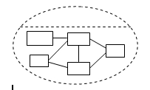
- 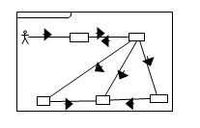
- 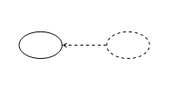

Question 5: Which of these is the correct set of USDP analysis class stereotypes?
- Interface, control and entity.
- Boundary, control and entity.
- Interface, sequence and entity.

Question 6: One of the following is not an advantage of stereotyping analysis classes. Which one?
- The resulting packages can form a basis for the system’s architecture.
- It can be useful to differentiate classes that have broad similarities in the way that they behave.
- Once a class is stereotyped, its behaviour is likely to become more predictable.

Question 7: What do boundary classes represent?
- Customers and suppliers of the business.
- People who will use the system.
- Interfaces between the system and its actors.

Question 8: What is the significance of the double colon in the class name: User Interface::AddAdvertUI?
- The class called AddAdvertUI is in the package called User Interface.
- User Interface is the stereotype of a class called AddAdvertUI.
- User Interface and AddAdvertUI are two alternative names for the same class.

Question 9: Which one of these is not a permitted symbol for a boundary class?
- 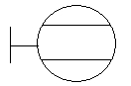
- 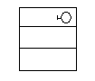
- 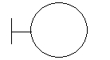
Question 10: What are entity classes?
- Classes that contain data.
- Classes that contain persistent data.
- Classes that represent something or some concept in the application domain.

Question 11: One of these is not a permitted symbol for an entity class. Which one?
- 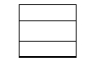
- 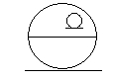
- 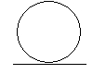

Question 12: What do control classes represent?
- The calculation and scheduling aspects of the logic of the use case.
- Classes that interact with the users of the system.
- Classes that control the storage of persistent data.

Question 13: One of the following cannot directly affect the state of an object. Which one?
- A change in the value of one of its attributes.
- The creation or destruction of another object of the same class.
- The creation or destruction of a link with another object.

Question 14: What is the difference between a link and an association?
- A link connects two instances, while an association connects two classes.
- A link is a transient association.
- A link is an association between two entity classes.

Question 15: What is the significance of the multiplicity of an association?
- It denotes the number of different classes that can be linked together.
- It constrains the number of objects of one participating class that can be linked to an object of the other class.
- It constrains the number of times that an object of one participating class can be linked during its lifetime.

Question 16: Which of the following answers is the correct interpretation of the association multiplicities shown on this diagram?
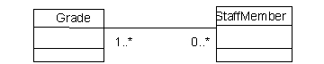
- A staff member need not be associated with any grades, or it can be associated with an indeterminate number of grades; a grade must be associated with one or more staff members.
- A grade cannot be associated with a staff member but a staff member can be associated with a grade.
- A grade need not be associated with any staff members, or it can be associated with an indeterminate number of staff members; a staff member must be associated with one or more grades.

Question 17: How do operations differ from methods?
- A method is a particular implementation of an operation.
- An operation is a particular implementation of a method.
- Some object-oriented programming languages have methods, while others have operations.

Question 18: When do we not need to represent the whole system as a class in the analysis model?
- When the users have not stated that this is a requirement.
- When the system does not need to interact directly with other systems.
- When the system does not need to encapsulate data or behaviour that applies only to the system as a whole.

Question 19: What is a domain class model?
- A class model that does not include either boundary or control classes.
- An analysis class model that is independent of any particular use cases.
- A class model that has been implemented in a particular domain.

Question 20: One of the following is a bad guideline for deciding the class where an operation should be located. Which one?
- The operation represents a service that objects of that class should provide to objects of other classes.
- The operation needs to access or update data that is stored in another class that has an association with that class.
- The operation needs to access or update data that is stored in an attribute of that class.

Question 21: What is the main purpose of the Class–Responsibility–Collaboration technique?
- To decide which team members will be responsible for developing each part of the software.
- To decide which classes of the system should be responsible for each use case.
- To decide how responsibilities should be distributed among the classes of the system.

Question 22: Why is it often difficult to determine the most appropriate choice of responsibilities for each class?
- Because there may be several alternatives that appear equally justified.
- Because the developers may not know enough about how the users want the system to be designed.
- Because members of the development team are often lazy and avoid responsibility as much as they can.

Question 23: The requirements of different use cases may suggest different operations for the same class. How do we resolve this?
- We should split the class so that there is one for each use case, and model each class with the particular operations required for its use case.
- We should include in the class all the operations that are suggested by all the use cases.
- We should model the class with only that subset of operations that applies to all use cases.

Question 24: Which of the following is an advantage of the use of a control class in realizing a use case?
- A control class prevents users from being able to change the way that the entity classes work.
- A control class reduces the need for entity classes to know anything about other entity classes unless this is directly relevant to their own responsibilities.
- A control class allows the system to communicate with other systems on different networks.

