MCQ
Chapter 09: Object Interaction
[The correct answer for each question is indicated by BOLD FACE]

Question 1: Which of the following is true?
- Identifying what messages are passed between objects is a straightforward process.
- Message passing is a metaphor used to describe object interaction.
- Message passing is only concerned with query operations.

Question 2: Which of the following is true about boundary objects?
- The identification and specification of boundary objects is purely a design activity.
- The identification and detailed specification of boundary objects is part of requirements specification.
- The identification and specification of boundary objects is considered in both analysis and design but in different ways.

Question 3: What is meant by the term collaboration in context of interaction modelling?
- A collaboration describes the messages between objects.
- A collaboration describes objects that share functionality.
- A collaboration describes the structure and links between a group of instances playing roles in a behaviour.

Question 4: What is meant by the term interaction?
- An interaction describes any communication between two lifelines.
- An interaction describes a group of lifelines that share functionality.
- An interaction defines the message passing between lifelines (e.g. objects) within the context of a collaboration to achieve a particular behaviour.

Question 5: An interaction sequence diagram drawn during analysis differs from one drawn during design in which of the following ways?
- The former normally does not include design objects or detailed specifications of message signatures.
- The former normally does not include boundary objects.
- The former normally does not include control objects.

Question 6: On the following figure which of the symbols labelled 1, 2 or 3 represents an activation on a sequence diagram?
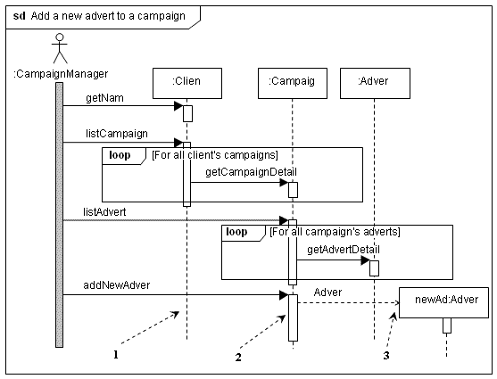
- Symbol 1
- Symbol 2
- Symbol 3

Question 7: Which of the arrows labelled 1, 2 or 3 is pointing to an interaction constraint? 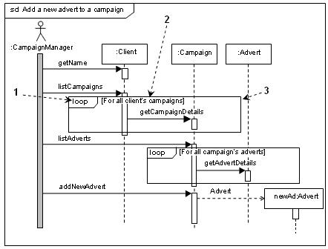
- Arrow 1
- Arrow 2
- Arrow 3

Question 8: Which of the labelled symbols in the following diagram represents a synchronous message? 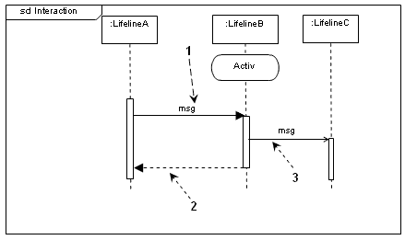
- Symbol 1
- Symbol 2
- Symbol 3

Question 9: What is meant by the term ‘thread of control’ in the context of concurrent behaviour?
- A thread of control is a weak part of the control system.
- A thread of control is the mechanism that controls concurrent behaviour.
- A thread of control is an execution pathway that may occur simultaneously with other execution pathways.

Question 10: Which of the following statements about sequence diagrams is true?
- A sequence diagram containing an interaction fragment may be referenced by only one sequence diagram.
- A sequence diagram containing an interaction fragment may be referenced by one or more sequence diagrams.
- A sequence diagram containing an interaction fragment may never be referenced by another sequence diagram.

Question 11: Which of the following is an appropriate way of hiding complex behaviour in an interaction sequence diagram?
- A group of objects and their interactions can be represented by a single lifeline which references an interaction fragment.
- Some messages are omitted to reduce the complexity.
- Some objects are omitted from the diagram to reduce the complexity.

Question 12: Which of the following is an appropriate way of modelling a part of an interaction that appears in several other interactions?
- Model the common part of the interaction as an ‘alt’ combined fragment.
- Model the common part of the interaction using a communication diagram.
- Model the common part of the interaction as an interaction fragment in a separate sequence diagram.

Question 13: Interaction sequence diagrams should be consistent with other diagrams and models that relate to the same group of objects or subsystems. Which of the following statements is true?
- A sequence diagram must show all the messages that are consistent with the state machines for each of the lifelines in the sequence diagram and be consistent with the class diagram.
- A sequence diagram must be consistent with the class diagram or with the state machines for lifelines in the sequence diagram.
- A sequence diagram must be consistent all other diagrams or models that include or relate to the lifelines in the sequence diagram.

Question 14: Which of the following accurately describes an asynchronous message?
- An asynchronous message does not cause the invoking operation to halt execution while it awaits the return of control.
- An asynchronous message has the same effect as a blocking call.
- An asynchronous message is a reply to a synchronous message.

Question 15: Communication diagrams differ from interaction sequence diagrams in the following way?
- Communication diagrams cannot show the design detail that can be shown on a sequence diagram.
- Communication diagrams only show the collaboration and not the sequence of the messages.
- Communication diagrams show the links between the objects.

Question 16: In a communication diagram one message has the sequence number 5.1.1. Which of the following sequence numbers indicates the message that must be the immediate successor?
- A message with the sequence number 5.1.2.
- A message with the sequence number 5.1.1.1.
- A message with the sequence number 5.2.1.

Question 17: Which of the following is a disadvantage of communication diagrams?
- A communication diagram can only be used during analysis.
- A communication diagram cannot include guard conditions.
- A communication diagram is difficult to read if there are many messages between two objects.

Question 18: An interaction diagram should be consistent with the associated class diagram in various ways. Which of the following statements is true?
- It is always correct to show a message between two objects if there is an association between their classes.
- The sending object must have the object reference of the receiving object before sending a message to that object.
- A message should not be shown between two objects if there is no association between their classes.
Question 19: Which of the following statements is correct about interaction overview diagrams?
- An interaction overview diagram may not have decision nodes.
- An interaction overview diagram may only have interaction occurrences, initial pseudostates and final pseudostates as nodes in the diagram.
- An interaction overview diagram may include in-line sequence diagrams.

Question 20: Timing diagrams are used to show how timing constraints affect interactions between lifelines. Which of the following statements is true?
- A lifeline may only have two alternative states.
- When a state change is being modelled that takes significant (from the application’s perspective) time it is shown by a slanting line.
- Messages are not shown on timing diagrams.

