**A project report on**

Rain Detector Alarm

**Course code: CSE 416**

**Course Title : Mobile and Wireless Communication Sessional Level: 4, Semester :1**

Prepared by

Al Amin ID-1902046 Md Liyon Islam ID- 1902063 Md.Al amin ID-1902066 Rajahul Karim simon ID- 1902072

Mizanur Rahman ID-1902009



## Hajee Mohammad Danesh Science & Technology University

*Department of Computer Science and Engineering*

# Contents

Chapter : 1 2

* 1. Introduction 2
  2. Problem Statement 3
  3. Objective 3

Chapter : 2 4

* 1. Components 4
  2. Working procedure 7

Chapter : 3 8

* 1. Advantages 8
  2. Application 8
  3. Conclusion. 8

References 9

**ABSTRACT**

Rain alarm project is a simple but very useful project which detects the rain and automatically triggers the alarm or buzzer. The sensor acts like a simple switch where the switch closes when it rains and is normally open when the rain stops. As water is basic need in everyone’s life. Saving the water and proper usage is very important. This project will trigger the alarm when it rains so we can make some actions for rain water harvesting and also to save the rain water for using it later for agriculture in fields. It is used in automobiles when the detector detects the rain it will automatically activates the windshield wipers of the vehicles. It can also be used in household for harvesting the rain water and increasing ground water storage instead of flowing it into drainage. This project will help the housewife or other users to alert more quickly when it rains. The sensor is able to detect even the slightest water and will sound an alarm when exposed to rain.It is an easy and simple reliable circuit which can be constructed at a low cost.

# Chapter No : 1 Introduction

## Introduction

Water Management and proper water usage has to be maintained in the recent years. So maintain proper usage of water we need to save the water in every aspect. In agriculture field rain is a basic need but intense rain can affect the crops root growth. Irrigation is enough cover the water need of crop but if intense rainfall occurs it may damage the crops, growth of the crops. when Rain detector detects rain it trigger the alarm. Rain detector alarm efficient way to stop irrigation whenever rain occurs. It is also used in home automation by users to reclaim their belongings, cover windows. In some situations, we can collect some rain water. When rain falls, it will cause a setback to all the reasons for sun-drying enumerated above, especially when the materials being sun dried are not retrieved quickly. Thus, designing and constructing a device which gives one a heads-up the instant it starts to rain hopefully giving you time to retrieve the materials being sun dried, close your windows, and bring in possession is not only apropos but also absolutely imperative. Also, since it can rain at any time without any warning, clothes in a clothes line outside the house that are almost dry may get wet if we do not realize it is raining on time. Thus, this project will also help house wives and other users to be quickly alerted to avoid rain from wetting shirts/ dresses being sun dried at the clothes line outside the house. Collect some rain water.

## Problem Statement

Housewives or other users are not aware of the presence of rain when busy something or sleeping. It may cause the shirt were hanging on the clothesline outside the house may wet again due to slow lift it.

## Objective

The objects of the project are as follows:

* + - The objective to be achieved in this project is to produce an alarm to help users more quickly to avoid the presence of rain from wet shirt at clothesline outside the house.
    - Farmers are pillars of our nation. They have experienced losses due to intense rainfall which damage crops, root growth to overcome this, we have created this project. When the rain detector senses rain, it sounds an alarm. As a result, various aspect has been achieved using Rain detectors to stop irrigation, home automation, electronics.

# Chapter No : 2 Methodology

## Components

### Rain sensor( 2 blade)

Here we use two blade for rain sensing. It is simple sensor and it is an easy to use for detecting rain. When the rain water sensor is completed,it should get connected to the circuit and voltage should be passed through the wires.

### Relay module

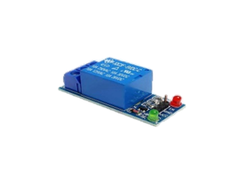The relay module function is mainly to switch electrical devices and systems on or off. It also serves to isolate the control circuit from the device or system being controlled.

### NPN transistor

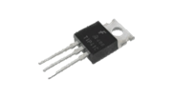NPN transistors work by using the base-emitter voltage to control the current flowing through the collector-emitter path. When the base-emitter voltage is increased, the current flowing through the collector-emitter path will also increase.

### Resistors

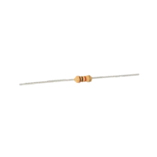A resistor works by restricting the flow of current, it can do this in one of three ways: firstly, by using a less conductive material, secondly by making the conductive material thinner and finally by making the conductive material longer.

### Buzzer

The [buzzer](https://www.quisure.com/blog/faq/what-is-a-buzzer) is a sounding device that can convert audio signals into sound signals. It is usually powered by DC voltage. It is widely used in alarms, computers, printers and other electronic products as sound devices.



### LED light

The positive pin is the ANODE (+) and the negative pin is the CATHODE (-). It is very important that LEDs are connected to a circuit in the right direction. The current flow can flow only from the ANODE (+) terminal to the CATHODE (-) terminal.

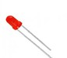

### Battery 9v

To accept and release energy, a battery is coupled to an external circuit. Electrons move through the circuit, while simultaneously ions (atoms or molecules with an electric charge) move through the electrolyte. In a rechargeable battery, electrons and ions can move either direction through the circuit and electrolyte.



### Switch

switch is an electrical device for connecting or disconnecting power supply to a circuit. When we turn on a switch, current flows to the circuit and the devices connected gets electric current supply.



### Breadboard

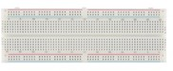A breadboard is used for building temporary circuits. It is useful to designers because it allows components to be removed and replaced easily. It is useful to the person who wants to build a circuit to demonstrate its action, then to reuse the components in another circuit.

### Connecting wires

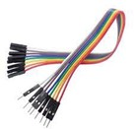Electrical wires operate by offering a path of low resistance to the flow of current through them. When an electric wire comes in contact with a power source, there is a movement or flow of electric charge or electrons in the wire.

## Working procedure

At First, we have connected Resistive rain sensor blade with 5V Relay Module Using Jumper Wires by Soldering. Then We connected Buzzer with Rain sensor and 5V Relay Module Since buzzer used to alert. At last we connected 9V battery using wires.

When the rain drop falls on the sensor, the wires on sensor starts conducting and closes the path between supply and base of transistor T2. Therefore, transistor T1 and T2 will turned ON, and by which the LED will also turn ON. When the transistor T2 is saturated,then the transistor T3 turned ON. As the transistor T3 reaches the saturation mode, the relay switch will get positive. As soon as the relay gets the positive voltage, we can get a pulse signal at the output of relay module. This will turn on the buzzer and make the alarm beep.

### Block diagram:

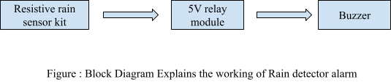

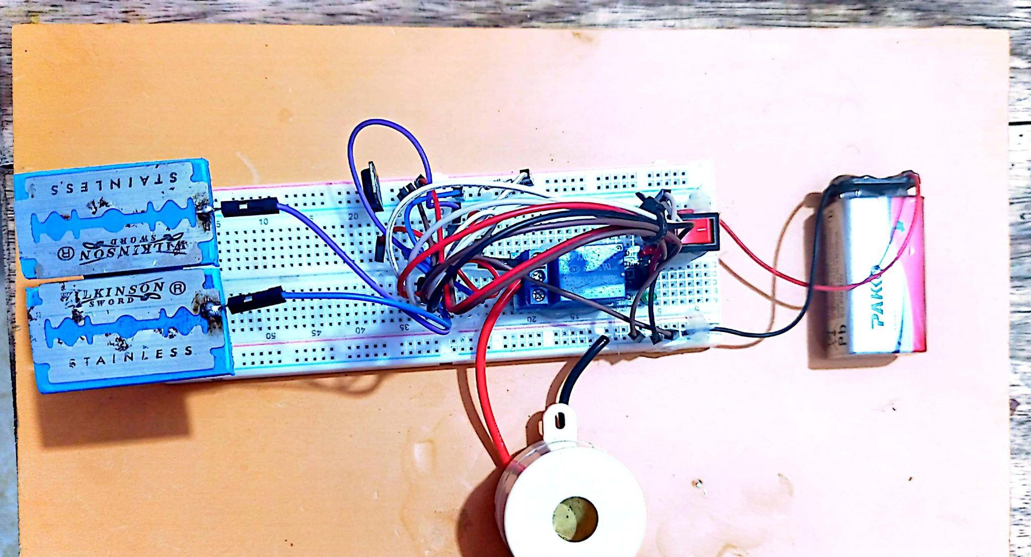

Figure : Photography of Rain Detector Alarm

## Advantages

# Chapter No : 3

* + - Conserves water - prevents watering during and after rain events
    - Save money on fertilizer.
    - Increase the life span of your Irrigation System .
    - Operating principle is very easy.
    - It consumes less power for operation.
    - It is very cheap.
    - No harmful effect.
    - The circuit can be made by everyone.

## Applications

* + - In the irrigation, it will detect the rain and immediately alert the farmer.
    - This project will also help house wives and other users to be quickly alerted to avoid rain from wetting shirts/ dresses being sun dried at the clothes line outside the house.
    - In normal house hold, with the help of rain water detector we can automatically save the rain water.

## Conclusion

The results of our electronic rain alarm system was a success. When we put some water on the circuit board, the rain alarm worked and produced a sound, however, this is as long the electronic devices are not damaged by the water droplets. After testing our project multiple times, we believed that it could be used for a better future.

# References

* [**https://circuitdigest.com/electronic-circuits/laser-security-alarm-circuit-diagram?fb**](https://circuitdigest.com/electronic-circuits/laser-security-alarm-circuit-diagram?fbclid=IwAR0JGm_l4QcbKvOsVBZ3U1yZ0gfev0kmPyYbD0uR6P0VrW05BiDFlJgSExw)[**clid=IwAR0JGm_l4QcbKvOsVBZ3U1yZ0gfev0kmPyYbD0uR6P0VrW05BiDFlJgS**](https://circuitdigest.com/electronic-circuits/laser-security-alarm-circuit-diagram?fbclid=IwAR0JGm_l4QcbKvOsVBZ3U1yZ0gfev0kmPyYbD0uR6P0VrW05BiDFlJgSExw)[**Exw**](https://circuitdigest.com/electronic-circuits/laser-security-alarm-circuit-diagram?fbclid=IwAR0JGm_l4QcbKvOsVBZ3U1yZ0gfev0kmPyYbD0uR6P0VrW05BiDFlJgSExw)
* [**https://youtu.be/WvIS58ISivU?si=ySdwCuvD-3lHmjRI**](https://l.facebook.com/l.php?u=https%3A%2F%2Fyoutu.be%2FWvIS58ISivU%3Fsi%3DySdwCuvD-3lHmjRI%26fbclid%3DIwAR1PABIB7r76ZKCXypTsROUVFvBYD6pLciJFFiMIrxgZ4EbscULLfP5HoxY&h=AT2Ao2f2s6ANwLEZr0Cc63PbBnIytMiNCusnUmezCf-tg3eD02OxlSQq3mnhuKG7F0syUb7LogFWEr5BkUdqT2f1yNbeigimbiDx8YqqKGyUnmrh72qj3wiz0fWtrePHwPAdAQ)

9