
FACULTY OF COMPUTING

BCS2243
WEB ENGINEERING
SEMESTER 2 2025/2026
TITLE : FK Student Club & Event Management System
SECTION : 01
LECTURER : Dr. Noorlin Mohd Ali

Student Detail:
Name | Student ID | Student Photo
MOHAMMAD HELMIZAN BIN SUFFIAN | CA23055 | 
SYAZWAN BIN SUHAILAN | CA23077 | 
RAAED EDDIN SHAH BIN KHAIRUDDIN SHAH | CA23047 | 
AHMAD DANIAL BIN ZAINUDDIN | CA23039 | 

Table of Contents

1. THE IDEA / PRINCIPLE OF THE SOLUTION 4

2. REVIEW OF TWO EXISTING SYSTEMS THAT SIMILAR TO YOUR IDEA 6

2.1. CampusGroups 6

2.2. Anthology Engage 8

2.3. Comparison between CampusGroups and Anthology Engage 10

3. PROJECT MANAGEMENT FRAMEWORK 11

3.1. Gantt Chart (Agile sprints) 11

3.2. Project Tak Allocation 13

4. PROJECT REQUIREMENT 14

4.1. Functional Requirements 14

4.2. Non-Functional requirements 16

5. PROPOSED DESIGN 17

5.1. USE CASE DIAGRAM 17

5.2. USE CASE SCENARIO 18

5.3. ACCESS MODEL 21

6. DATA DESIGN 22

6.1. ENTITY RELATIONSHIP DIAGRAM (ERD) 22

6.1.1. MODULE 1: MOHAMMAD HELMIZAN BIN SUFFIAN (CA23055) 23

6.1.2. MODULE 2: AHMAD DANIAL BIN ZAINUDDIN (CA23039) 24

6.1.3. MODULE 3: SYAZWAN BIN SUHAILAN (CA23077) 25

6.1.4. MODULE 4: RAAED EDDIN SHAH BIN KHAIRUDDIN SHAH (CA23047) 26

6.2. DATA DICTIONARY 27

7. PRESENTATION MODEL FOR EACH MODULE 31

7.1. MODULE 1: MOHAMMAD HELMIZAN BIN SUFFIAN (CA23055) 31

7.2. MODULE 2: AHMAD DANIAL BIN ZAINUDDIN (CA23039) 37

7.3. MODULE 3: SYAZWAN BIN SUHAILAN (CA23077) 47

7.4. MODULE 4: RAAED EDDIN SHAH BIN KHAIRUDDIN SHAH (CA23047) 48

8. TESTING PLAN 50

8.1. Unit Testing 50

8.2. Integration Testing 50

8.3. System Testing 50

9. DEPLOYMENT PLAN 51

- THE IDEA / PRINCIPLE OF THE SOLUTION

The FK Student Club & Event Management System is a web-based platform designed to help the Student Affairs Department at the Faculty of Computing, Universiti Malaysia Pahang Al-Sultan Abdullah (UMPSA) to manage student organizations and campus activities more effectively. Currently, the administration faces significant difficulties in monitoring student clubs, organizing events, and tracking attendance manually. This system fixes those challenges through automation, digital management, and real-time data access.
The following are the proposed solutions:

1. Digital User Registration and Membership Management
- All students must have an active account on the system. The system admin registers through student ID, name, email and role.
- A student can enter (or join) any student club which is already registered in the system. All Club committee members are additionally registered the respective club, and have a role of President / Secretary / Treasurer / Committee Member.
- Users update their personal profiles until now they can see the contact details, profile photo and club membership information, due to this reason user database is maintained in an accurate way as well in up to date.
- Administrator Dashboard: One screen for the administrator where summary data will be shown on a total number of students who registered, total number of clubs that are active, upcoming events and users have recently registered in bar chart, pie chart or line graph.
2. Student Club Management
- The administrator is responsible for managing all student clubs, including creating, updating, deleting, and viewing club details such as club name, description, advisor name, and committee members.
- Each club must have a committee with assigned roles. Committee members have additional privileges such as managing events and viewing participation records related to their club.
- All registered users can browse the list of available clubs and view details about each club including its description, committee members, and past and upcoming events.
- A Club Management Dashboard displays statistics such as total number of clubs, number of active clubs, number of students involved, and distribution of students across clubs.

3. Event Management and Registration
- Club committee members can create, update, delete, and view event details including event title, description, date and time, venue, and maximum participant capacity.
- Students can browse and register for upcoming events. The system supports registration, cancellation, update, and history viewing, and requires confirmation before submission.
- The system automatically checks event capacity to prevent over-registration. If the maximum number of participants is reached, the system notifies students that the event is fully booked and may create a waiting list.
- The Event Management Dashboard shows insights such as number of events per club, number of participants per event, and monthly event activity trends.

4. Attendance Tracking and Participation Reports
- During events, committee members record attendance digitally using QR code scanning or digital check-in. Each attendance record includes student ID, event name, date and time, and attendance status (present, absent, late).
- The system automatically assigns participation points based on attendance status: +10 for on-time attendance, +5 for late arrival, -10 for absent without notice, and +5 for volunteering.
- A comprehensive participation history is maintained for each student, showing total points, history, and ranking. Total points are updated after every event and used to determine student recognition levels such as Active Participant, Highly Active, or Outstanding Participant.
- The system generates dynamic reports including participants per event, attendance rate, points accumulated, and most active clubs. The dashboard presents real-time recognition status and allows filtering by club, semester, or event type.

- REVIEW OF TWO EXISTING SYSTEMS THAT SIMILAR TO YOUR IDEA
  - CampusGroups


CampusGroups (campusgroups.com) is a comprehensive campus engagement platform used by universities worldwide. It includes modules for student organization management, event creation, attendance tracking, and member engagement analytics. CampusGroups offer a wide range of useful features. Students and administrators can browse a directory of all student organizations each with their own committee list and membership details.
When it comes to events, CampusGroups allows committees to create events, open online registration, and set a maximum number of participants. If an event is full, the system can automatically put students on a waiting list.
Furthermore, attendance is recorded using QR codes which makes check-in faster and more accurate. By using QR it solves the problem of manual attendance marking which is slow and prone to errors. In our proposed system we took the idea of using QR codes for attendance for our proposed system.

Students earn points based on how much they participate, and the system displays their recognition level based on those accumulated points. CampusGroups system does a good job of encouraging students to get involved by making their participation visible and rewarding. This feature fit well with what our proposed system are trying to achieve
To conclude, our system is proposed is very similar to this existing system with the difference is that our system is built specifically for FK's needs and does not require any expensive infrastructure to run.

  - Anthology Engage
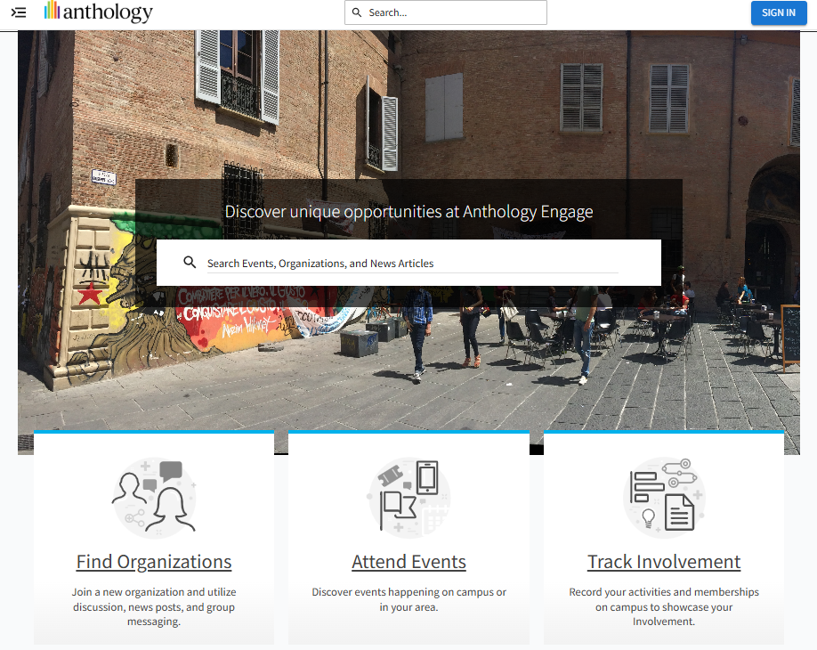
Engage by Anthology is another widely used student engagement platform, mostly in the United States but also by some institutions in Southeast Asia. It was originally developed by Campus Labs and later acquired by Anthology in 2021. The platform is mainly used to manage student organizations, events, and co-curricular records all in one place.
Engage has a complete set of tools for managing student life at a university. Each student organization gets its own portal where they can manage their committee, upload their club constitution, handle re-registration, and get approval from their academic advisor. For events, the system supports registration, ticketing, and even virtual events. The role structure in Engage, which separates students, committee members, advisors, and administrators, is also very close to the three-role system we are building for FK.
Additionally, we found that Engage has already solved a lot of the same problems we are trying to address in our project. The QR code check-in system is something we directly referenced when to design our attendance recording feature. The attendance in Engage is recorded through QR code scanning or swiping a student ID card, and the roster is updated automatically after each check-in.
Furthermore, few other feature that stands out to us is the co-curricular transcript, which keeps a full record of everything a student has joined or attended throughout their time at the university. Also, the administrators get a dashboard that shows how active each organization is, event participation trends and an overall engagement score for each student.
However, the main problem with Engage is that it is an enterprise product, and it shows. The licensing cost is high and is meant to be paid at the university level, not by a single faculty. Since it is designed for large institutions with many faculties and thousands of students, some of its features are simply too broad for what FK needs.
Upon reviewing this system, it has helps us understand what a well-built student engagement system should look like, especially in terms of attendance management and participation tracking.

  - Comparison between CampusGroups and Anthology Engage
Feature | CampusGroups | Anthology Engage
Interface | Modern, centralized campus platform with dashboards for organizations, events, and engagement analytics. Focused on student involvement. | Comprehensive enterprise-level interface with dedicated portals for organizations, advisors, and administrators. More complex but powerful.
User Registration | Students self-register and join organizations. Role-based access for members, committee, and admins. | Structured registration with multiple roles (students, committee members, advisors, administrators). Strong role-based system.
Event Creation | Committees can create events, manage registration, and set participant limits. Supports waitlisting. | Advanced event creation including registration, ticketing, and virtual events. Approval workflows included.
Capacity Control | Yes, with automatic waitlist when event reaches capacity. | Yes, with registration limits and controlled access per role/group.
QR Code Check-In | Yes, built-in QR code system for fast and accurate attendance tracking. | Yes, supports QR code scanning and student ID swiping for attendance.
Attendance Tracking | Automated via QR check-in; reduces manual errors. | Automated attendance tracking with real-time roster updates.
Point System | Yes, includes student engagement points and recognition levels. | No direct point system, but tracks co-curricular activities and engagement records.
Dashboard & Reports | Provides analytics on student participation, engagement levels, and organization activity. | Advanced dashboards with engagement metrics, participation trends, and co-curricular transcripts.
Advantages | 1. Built-in point system for engagement.  2. QR-based attendance tracking.  3. Waitlist feature for full events.  4. Strong organization directory and visibility. | 1. Comprehensive role management.  2. Supports full student lifecycle (clubs, events, records).  3. Co-curricular transcript feature.  4. Advanced analytics and reporting.
Disadvantages | 1. May include unnecessary features for smaller faculty systems.  2. Requires institutional-level setup. | 1. High licensing cost (enterprise-level).  2. Too complex for small-scale faculty use.  3. Overly broad features beyond FK requirements.

- PROJECT MANAGEMENT FRAMEWORK
  - Gantt Chart (Agile sprints)
The project adopts an Agile-based project management framework, Agile is selected because it supports iterative development, rapid feedback cycles, and the ability to accommodate changing requirements all of which are critical given the 14-week project timeline with scheduled progress checkpoints.
1 | Task/ Week | 1 | 2 | 3 | 4 | 5 | 6 | 7 | 8 | 9 | 10 | 11 | 12 | 13
2 | Project kick-off and requirement gathering
3 | Seek for idea and initialize the design, review existing systems
4 | Define project management framework, start with data design
5 | Detail the project requirements, continue designing data
6 | Create use case diagrams
7 | Detail the project designs, use case scenarios, access models
8 | Refine designs, begin to develop system
9 | Initial development, create ERD
10 | Continue to develop, data dictionary, sample data
11 | Create texting plan, initial testing
12 | Plan deployment, review the system code
13 | Final testing, bug fixes, prep for deployment
14 | Deployment, final presentation and report

  - Project Tak Allocation

Task | Module Responsible | Day Allocated
Project kick-off and requirement gathering | All | 5
Seek for idea and initialize the design, review existing systems | All | 5
Define project management framework, start with data design | All | 10
Detail the project requirements, continue designing data | All | 10
Create use case diagrams | All | 5
Detail the project designs, use case scenarios, access model | All | 10
Refine designs, begin to develop system | All | 10
Initial development, create ERD | All | 10
Continue to develop, data dictionary, sample data | All | 10
Create texting plan, initial testing | All | 5
Plan deployment, review the system code | All | 10
Final testing, bug fixes, prep for deployment | All | 10
Deployment, final presentation and report | All | 6

The Gantt chart below outlines the 13 weeks schedule for the development of the FK Student Club & Event Management System. As evident, the timeline has been divided into different stages beginning from project kick-off and requirement collection to the review of currently available systems that will help define the guiding principles for designing the system. It can be observed that detailed design will take place in Weeks 2 to 8, during which various use case diagrams, hypertext structure models, and access models will be created. Responsibilities of each module have been assigned to four required modules, namely Module 1 (Membership and Registration), Module 2 (Club Management), Module 3 (Events and Registration), and Module 4 (Attendance and Participation Reports). Development and ERD construction will take place more intensely in Weeks 7 to 11. Testing will be done during Weeks 10 and 11 to verify the CRUD functionalities of the project. Finally, code review will take place in Week 12 while Week 13 marks the completion stage of the project when the system will be fully implemented.
- PROJECT REQUIREMENT
  - Functional Requirements
The functional requirements describe the specific behaviours and functions the system must support:
Login, Membership & User Management
- The system shall provide login functionality for three user roles: Administrator, Club Committee Member, and Student.
- The system shall authenticate users using username and password with session management.
- The system shall redirect users to role-specific dashboards upon successful authentication.
- The administrator shall be able to create, update, view, and delete user accounts.
- Users shall be able to view and update their own profile information including contact details and profile photo.
Student Club Management
- The administrator shall be able to create, update, delete, and view club records.
- Each club record shall contain club name, description, advisor name, and committee member list.
- The administrator shall be able to activate or deactivate clubs.
- The system shall support assignment of committee roles including President, Vice President, Secretary, and Treasurer.
- All users shall be able to view the club list and individual club details including past and upcoming events.
- The club management dashboard shall display total clubs, active clubs, student involvement statistics, and distribution charts.

Event Management & Registration
- Club committee members shall be able to create, update, delete, and view events.
- Each event record shall contain event title, description, date/time, venue, and maximum participant count.
- Students shall be able to register, cancel, and view their registration history for events.
- The system shall enforce maximum participant limits and notify students when an event is fully booked.
- The event dashboard shall display events per club.
Attendance & Participation Reports
- Committee members shall be able to record attendance using QR code scanning or digital check-in.
- Attendance records shall capture student ID, name, event name, date/time, and attendance status (Present / Late / Absent).
- The system shall automatically calculate participation points based on attendance status.
- Students shall be able to view their total points, participation history, and recognition level.
- Administrators and committees shall be able to view participation reports with filters by club, event, and year.
The participation dashboard shall display total events, student participation rates, points distribution, and most active students/clubs.

  - Non-Functional requirements
Security
- All user passwords shall be stored using secure encryption or hashing techniques to prevent unauthorized access.
- Access to administrative functions shall be restricted to users with the Administrator role.
Performance
- All system pages shall load within 3 seconds under normal network conditions.
- The system shall support at least 50 concurrent users without performance degradation.
Usability
- The system shall provide a responsive web interface accessible on desktop browsers.
- User interface shall follow consistent design conventions with clear navigation and labelled form fields.
- Error messages shall be descriptive and guide users to correct their input.
Reliability
- The system shall maintain at least 99% uptime during the semester.
- Data shall be persisted reliably with daily backup capability.
Compatibility
- The system shall be compatible with modern browsers: Google Chrome, Mozilla Firefox, and Microsoft Edge.

- PROPOSED DESIGN
  - USE CASE DIAGRAM
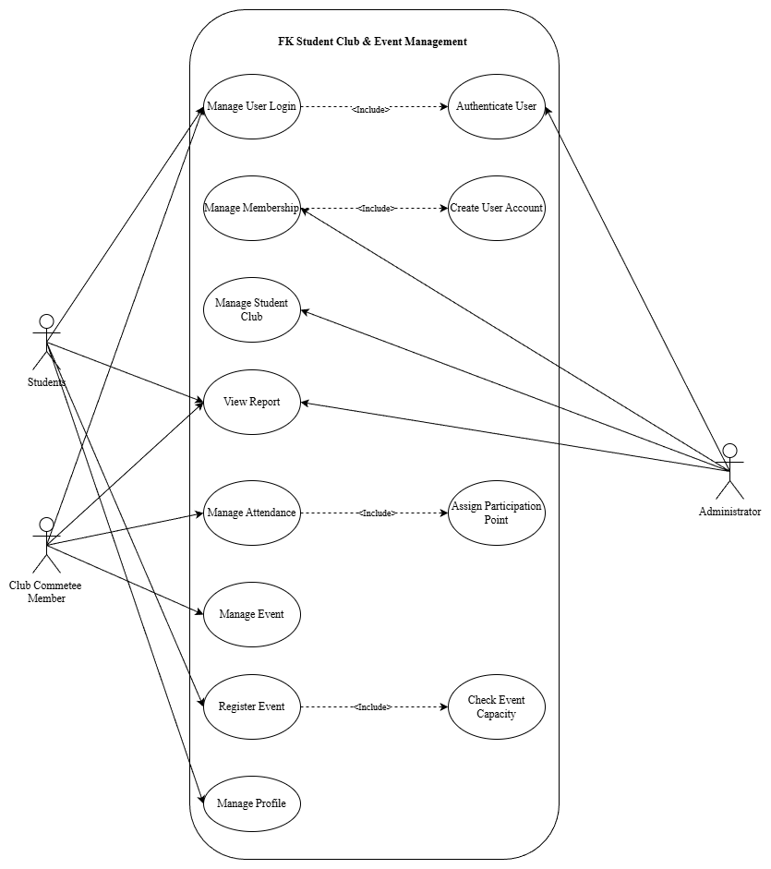

  - USE CASE SCENARIO
Use Case Name | Manage User Login
Brief Description | The user logs into the FK system. The system verifies the credentials (username and password) to authenticate the user.
Actors | Administrator, Club Committee Member, Registered Student
Pre-condition | Users must have valid login credentials (username and password).
Basic Flow | 1. User enters login credentials (username and password).  2. System authenticates the user.  3. If valid, system logs in the user and shows their name together with available options based on their role.
Alternative Flow | [A1: Incorrect login credentials]  1. The system displays an error message and the user re-enters login details and attempts to log in again.
Post-Condition | The user can access the system based on their role.

Use Case Name | Manage Membership
Brief Description | The administrator registers new users and assigns roles. Students can view and update their profiles and join clubs.
Actors | Administrator, Registered Student
Pre-condition | Administrator must be logged into the system with valid credentials.
Basic Flow | 1. Administrator selects 'Manage Membership' from the dashboard. 2. Administrator enters user details (student ID, name, email, role). 3. System validates and stores the new user record. 4. Student logs in and can view or update their profile and join clubs.
Alternative Flow | [A1: Incomplete or duplicate information]  1. System displays an error message.  2. Administrator corrects and resubmits the information.
Post-Condition | New user is registered and can access the system with appropriate role permissions.

Use Case Name | Manage Student Clubs
Brief Description | The administrator manages all student club records, including creating, updating, deleting, activating, or deactivating clubs. Committee roles are assigned by the administrator.
Actors | Administrator
Pre-condition | Administrator is logged into the FK system and the system is connected to the database.
Basic Flow | 1. Administrator selects 'Manage Student Clubs' from the dashboard.  2. System displays list of all clubs.  3. Administrator chooses: Create, Update, Delete, or Activate/Deactivate.  4. System displays relevant form and administrator enters required information.  5. System validates, saves, and displays a confirmation message.
Alternative Flow | [A1: Invalid Input] System displays error and prompts correction.  [A2: Cannot Delete] If club has active members or events, system blocks deletion.  [A3: Deactivate with Active Events] System warns administrator before proceeding.
Post-Condition | Club information is updated in the system and reflected in all relevant views.

Use Case Name | Manage Events
Brief Description | Club committee members create, update, delete, and view events. Students can register, cancel, and view their event history. The system checks for capacity limits.
Actors | Club Committee Member, Registered Student
Pre-condition | Users must be logged in. Events and clubs must exist in the system.
Basic Flow | 1. Committee member selects 'Manage Events' from the menu.  2. Committee creates or updates event details.  3. System validates and saves the event.  4. Student browses events and registers.  5. System checks capacity and confirms registration.  6. System records participant information.
Alternative Flow | [A1: Event Full] System displays 'Event Fully Booked' and may offer waitlist.  [A2: Invalid Input] System shows error and prompts correction.  [A3: Cancel Registration] Student cancels before event; system updates participant list.
Post-Condition | Event details are saved and participant lists are updated accordingly.

Use Case Name | Manage Attendance and Points
Brief Description | Committee members record attendance via QR code scanning or digital check-in during events. The system automatically calculates and updates participation points.
Actors | Club Committee Member, Registered Student
Pre-condition | Event is in progress. Students are registered. Committee member is logged in.
Basic Flow | 1. Committee member selects 'Manage Attendance' for the event.  2. Committee member scans QR code or marks attendance status.  3. System records attendance with timestamp and status.  4. System automatically calculates and updates participation points.  5. System determines student recognition level based on total points.
Alternative Flow | [A1: Invalid QR Code] System displays error and prompts re-scan.  [A2: Manual Override] Committee member can manually update attendance status.
Post-Condition | Attendance records are saved. Points are updated. Recognition levels are recalculated automatically.

  - ACCESS MODEL
Student
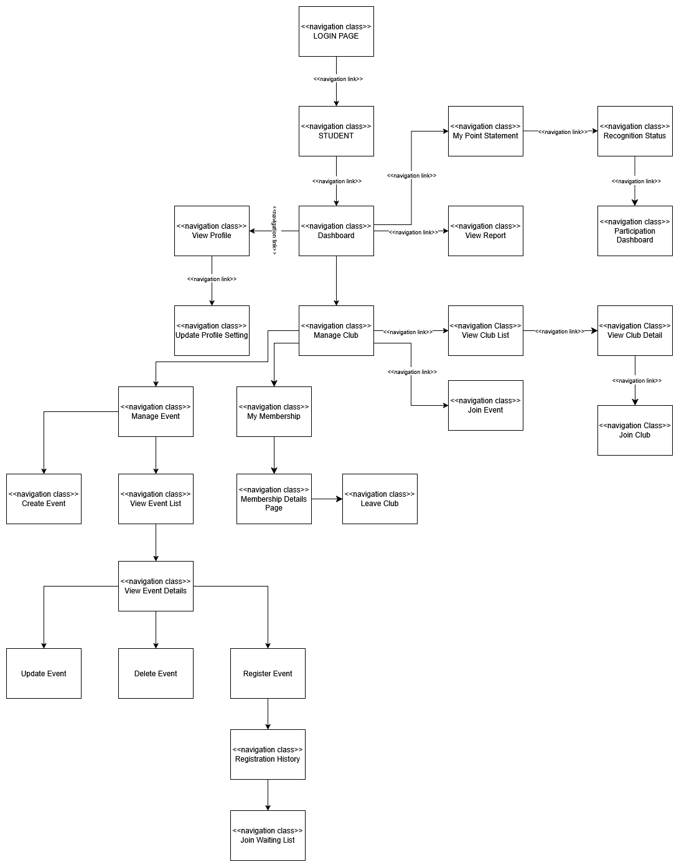

Administrator
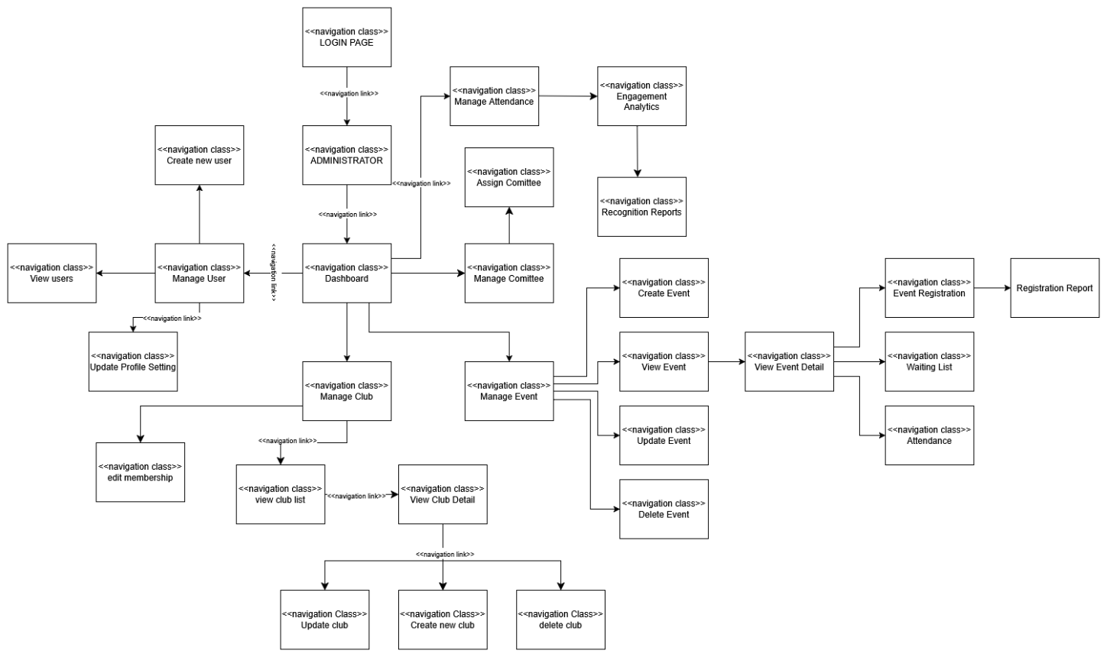

- DATA DESIGN
  - ENTITY RELATIONSHIP DIAGRAM (ERD)

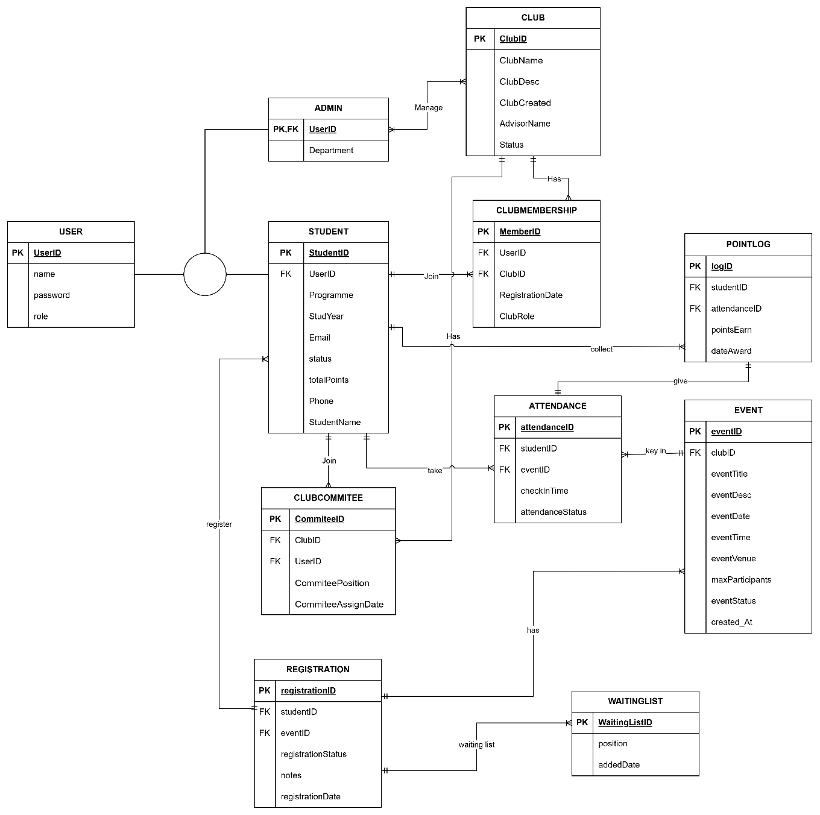

    - MODULE 1: MOHAMMAD HELMIZAN BIN SUFFIAN (CA23055)
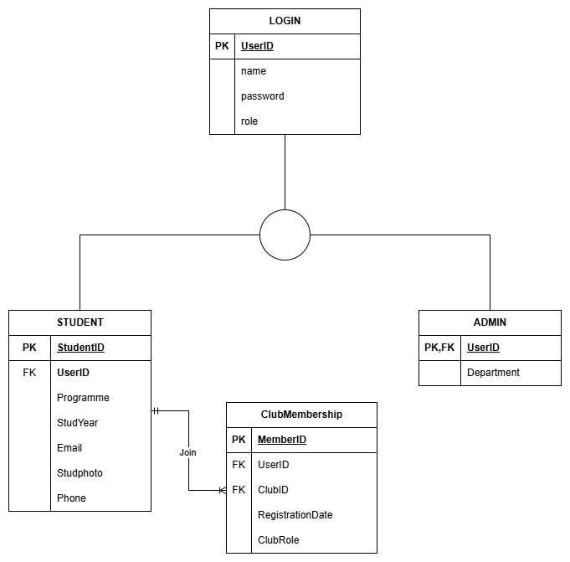

    - MODULE 2: AHMAD DANIAL BIN ZAINUDDIN (CA23039)
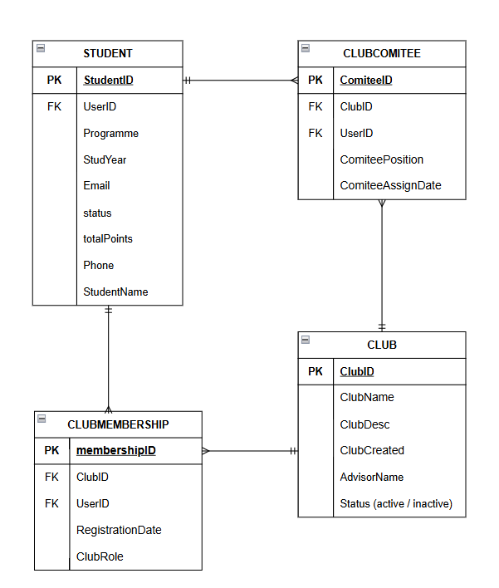

    - MODULE 3: SYAZWAN BIN SUHAILAN (CA23077)

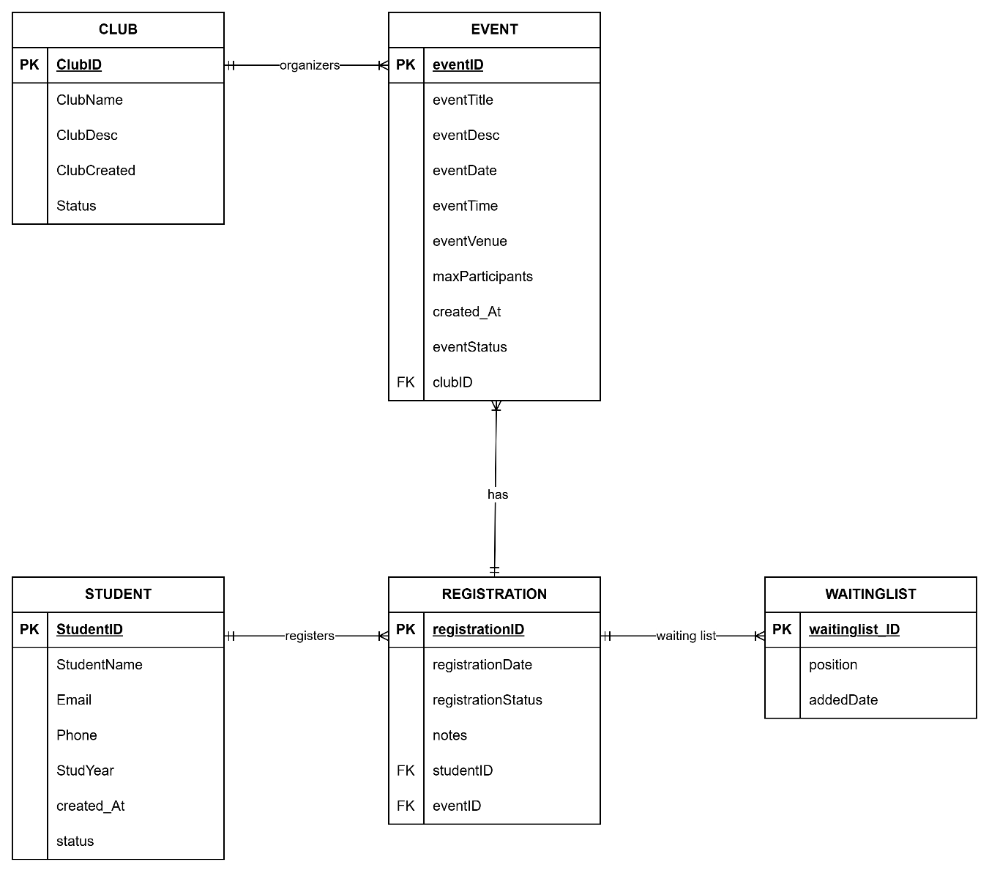

    - MODULE 4: RAAED EDDIN SHAH BIN KHAIRUDDIN SHAH (CA23047)
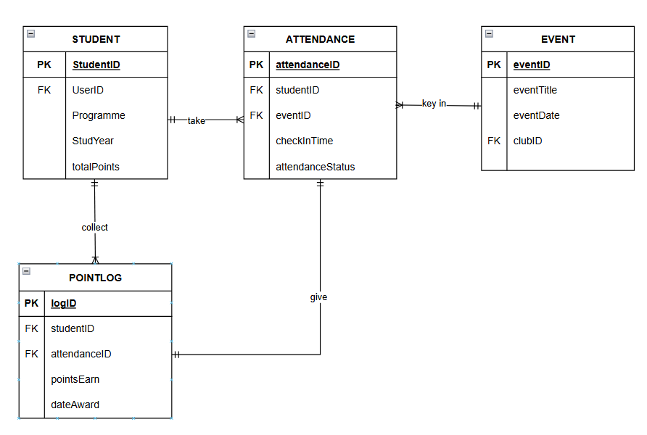

  - DATA DICTIONARY

- Login
Field Name | Description | Data Type | Constraint
UserID | ID for user | VARCHAR | PK
name | Username | VARCHAR | NOT NULL
password | User Password | VARCHAR | NOT NULL
role | Role: admin, student | VARCHAR | NOT NULL

- Student
Field Name | Description | Data Type | Constraint
UserID | ID for user | VARCHAR | FK
programme | Student course | VARCHAR | NOT NULL
StudYear | Year of Study | DATE | NOT NULL
Email | Student Email | VARCHAR | NULL
Studphoto | Picture profile | IMAGE | NULL
Phone | Student Phone Number | INT | NULL
totalPoints | Participation Points | INT | NOT NULL

- Admin
Field Name | Description | Data Type | Constraint
UserID | ID for user | VARCHAR | PK
department | Department of User | VARCHAR | NOT NULL

- Club
Field Name | Description | Data Type | Constraint
ClubID | Unique ID for club | VARCHAR(20) | PK
ClubName | Name of student club | VARCHAR(50) | NOT NULL
ClubDesc | Club description and objectives | TEXT | NULL
ClubCreated | Date of club establishment | DATE | NOT NULL
AdvisorName | Name of club advisor | VARCHAR(50) | NOT NULL
ClubStatus | Active or Inactive | VARCHAR(50) | NOT NULL

- ClubMembership
Field Name | Description | Data Type | Constraint
memberID | Unique ID for member | VARCHAR(20) | PK
userID | References user table | VARCHAR(20) | FK
clubID | References club table | VARCHAR(20) | FK
RegistrationDate | Date member registered club. | DATE | NOT NULL
clubRole | Role in the club | VARCHAR(50) | NOT NULL

- Event
Field Name | Description | Data Type | Constraint
eventID | Unique ID for event | VARCHAR (20) | PK
ClubID | References club table | VARCHAR (20) | FK
eventTitle | Name of event | VARCHAR (100) | NOT NULL
eventDesc | Description of event | TEXT | NOT NULL
eventDate | Date of event | DATE | NOT NULL
eventTime | Time of event | TIME | NOT NULL
eventVenue | Venue of event | VARCHAR (100) | NOT NULL
maxParticipants | Maximum number of participants | INT | NOT NULL
eventStatus | Open, closed or cancelled | VARCHAR (20) | NOT NULL
created_At | Date event was created | DATETIME | NOT NULL

- Registration
Field Name | Description | Data Type | Constraint
registrationID | Unique ID for registration | VARCHAR (20) | PK
studentID | References student table | VARCHAR (20) | FK
eventID | References event table | VARCHAR (20) | FK
registrationStatus | Pending, approved or cancelled | VARCHAR (20) | NOT NULL
notes | Additional registration notes | VARCHAR (200) | NULL
registrationDate | Date of registration | DATETIME | NOT NULL

- WaitingList
Field Name | Description | Data Type | Constraint
WaitingListID | Unique ID for waiting list | VARCHAR (20) | PK
position | Waiting queue number | INT | NOT NULL
addedDate | Date added into waiting list | DATETIME | NOT NULL

- Attendance
Field Name | Description | Data Type | Constraint
attendanceID | To identify attenfance record | VARCHAR (20) | PK
studentID | Reference the student who attended | VARCHAR (20) | FK
eventID | Reference the event attendance belong to | VARCHAR (20) | FK
checkInTime | Timestamp when the student check in | DATETIME | NOT NULL
AttendanceStatus | Status of attendance | VARCHAR (20) | NOT NULL

- Point Log
Field Name | Description | Data Type | Constraint
logID | Unique identifier for each point log entry | VARCHAR (20) | PK
studentID | Reference the student who earned or lost points | VARCHAR (20) | FK
attendanceID | References the attendance record that triggered the points | VARCHAR (20) | FK
pointsEarn | Number of points awarded or deducted for the attendance | INT | NOT NULL
dateAward | Date and time the points were assigned | DATETIME | NOT NULL

- ClubCommitee
Field Name | Description | Data Type | Constraint
committeeID | Unique ID for committee record | VARCHAR(20) | PK
userID | References user table | VARCHAR(20) | FK
clubID | References club table | VARCHAR(20) | FK
commiteePosition | President, Secretary, Treasurer, Member | VARCHAR(50) | NOT NULL
CommiteeAssignDate | The date when a user was assigned to a committee position in a club. | DATE | NOT NULL

- PRESENTATION MODEL FOR EACH MODULE
  - MODULE 1: MOHAMMAD HELMIZAN BIN SUFFIAN (CA23055)

Login Page
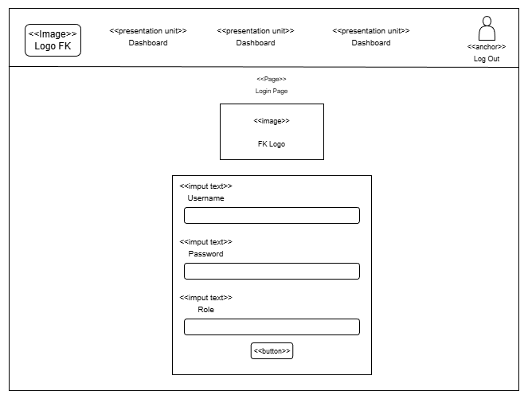

Dashboard (student)
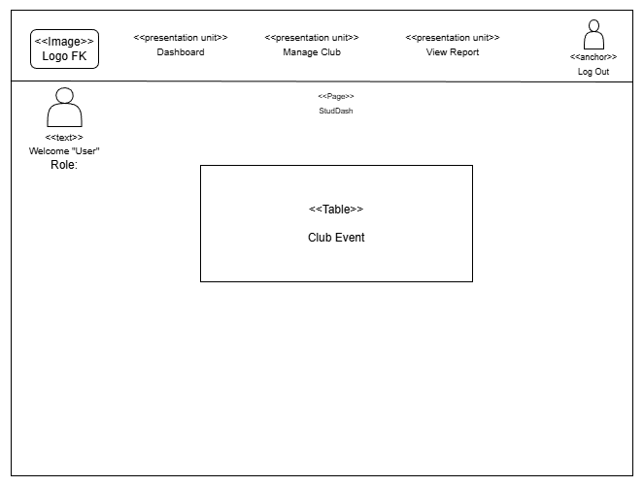
View Profile
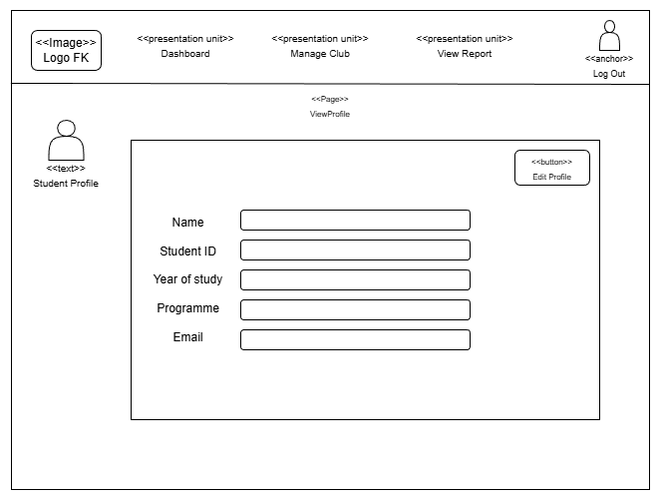

Edit Profile (student)
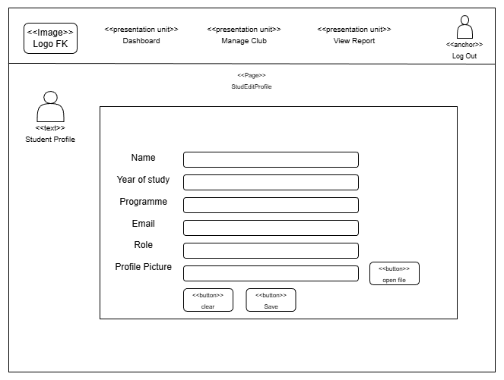
Manage Club (student)
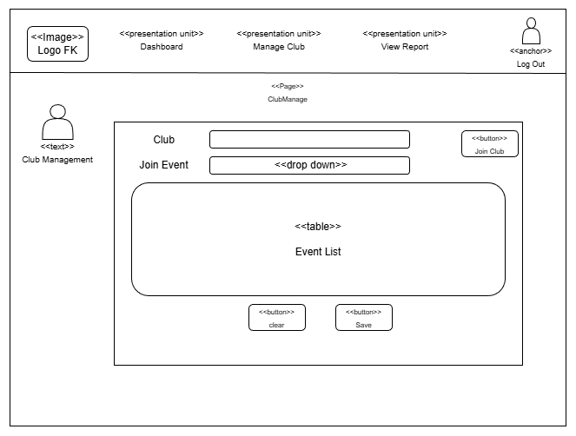
Join Club
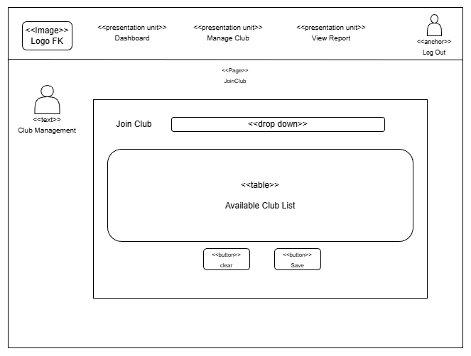
Admin Dashboard
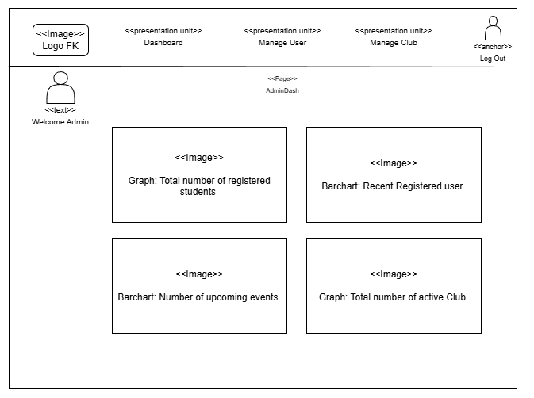
Admin User Registration
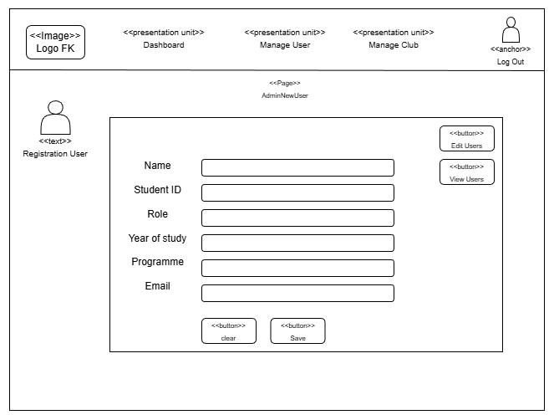
Edit User (Admin)
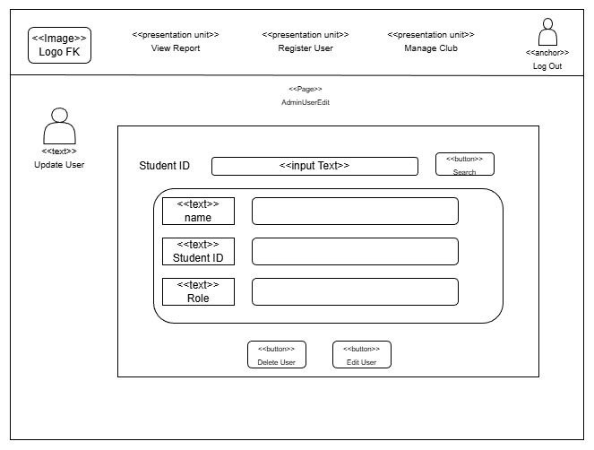
View User (admin)
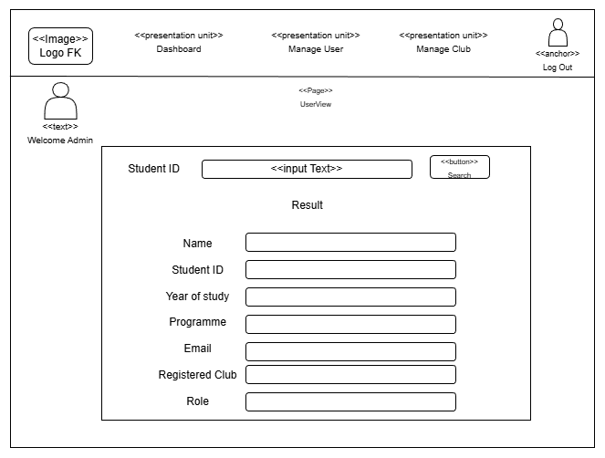

  - MODULE 2: AHMAD DANIAL BIN ZAINUDDIN (CA23039)
Club List Page(admin only)
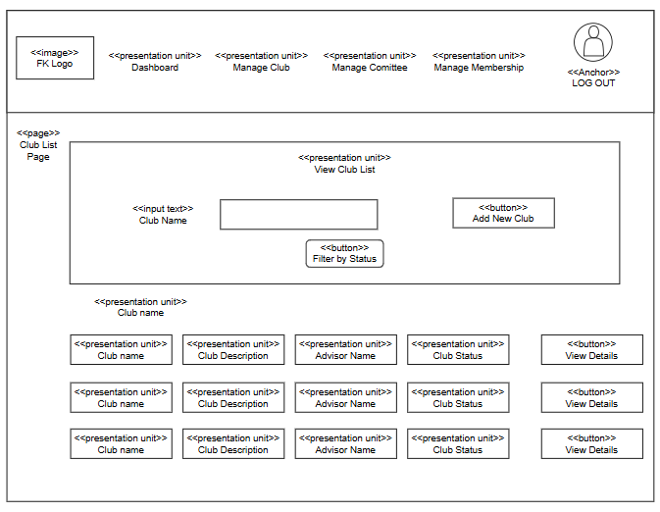

Club List Page(student)
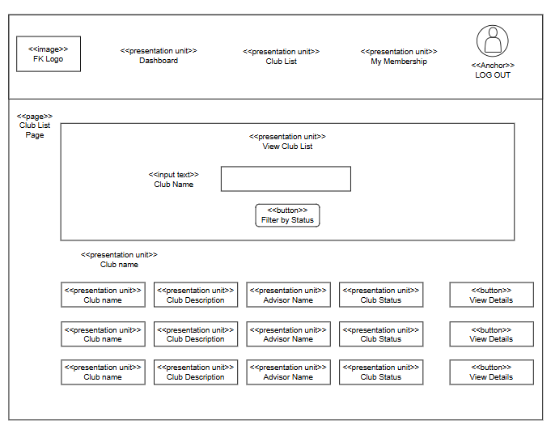

Club Details Page(admin only)
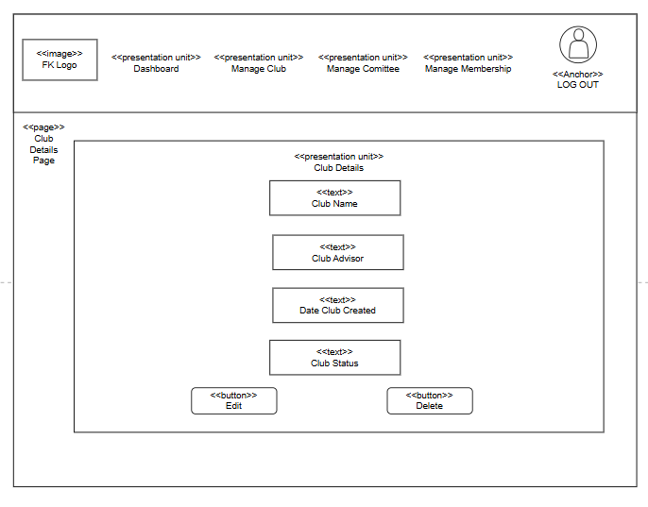

Club Details Page(student)
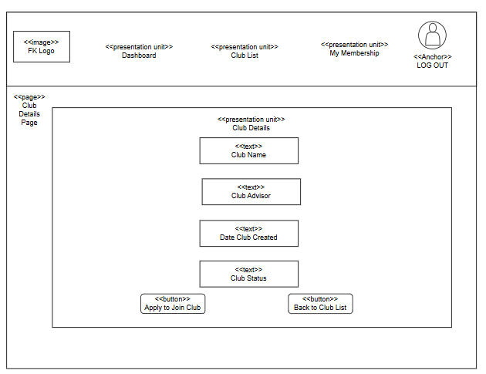

Add/Edit Club Page (Admin only)
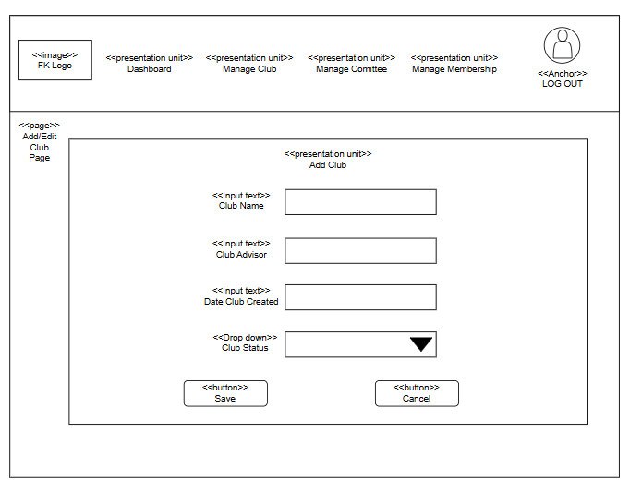

Manage Committee Page (Admin only)
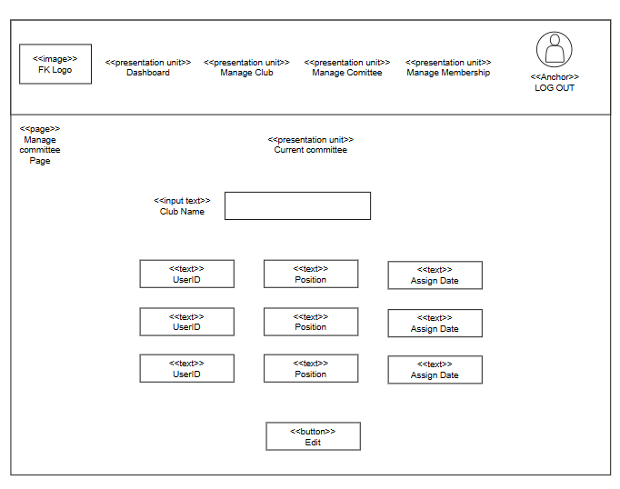

Assign Committee Form (Admin only)
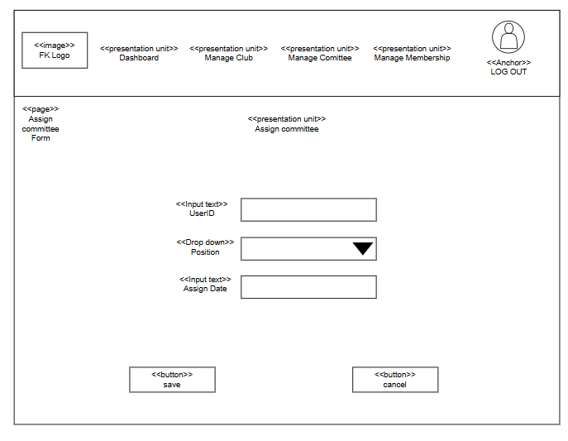

Club Membership Page (student)
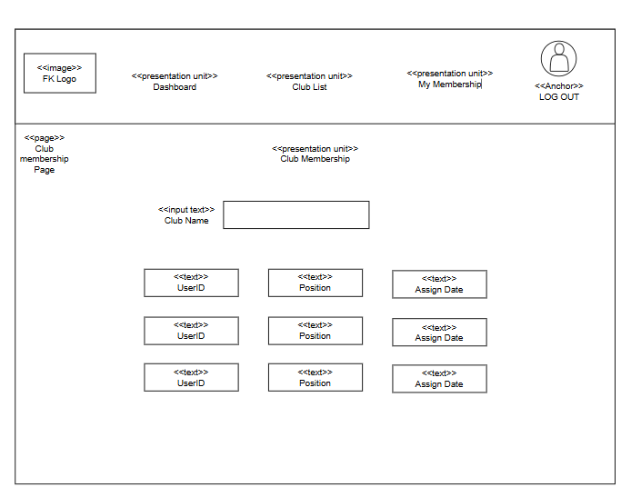

Club Membership Page (admin only)
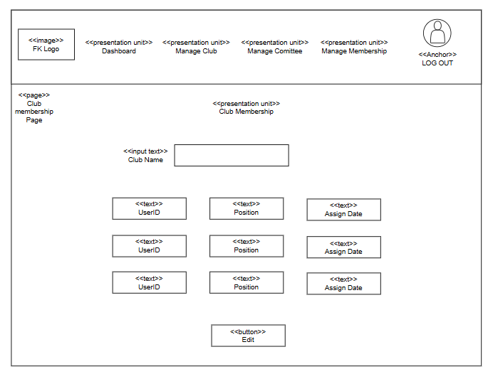

Club Management Dashboard (Admin only)
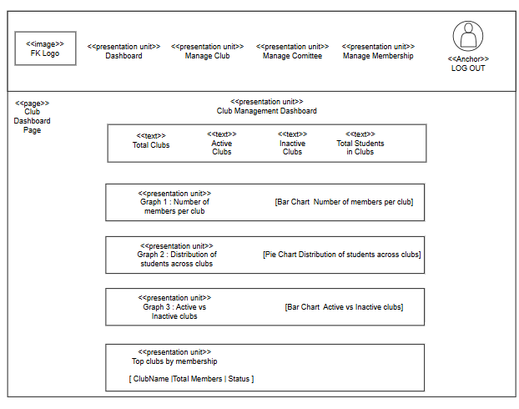

  - MODULE 3: SYAZWAN BIN SUHAILAN (CA23077)
Event Dashboard
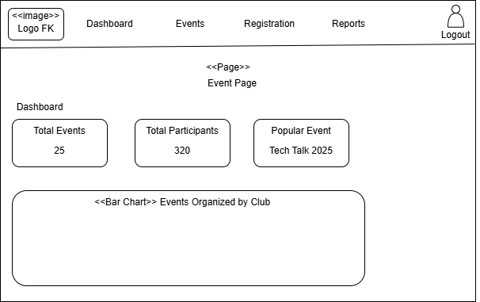

  - MODULE 4: RAAED EDDIN SHAH BIN KHAIRUDDIN SHAH (CA23047)

Attendance dashboards (committee member view)
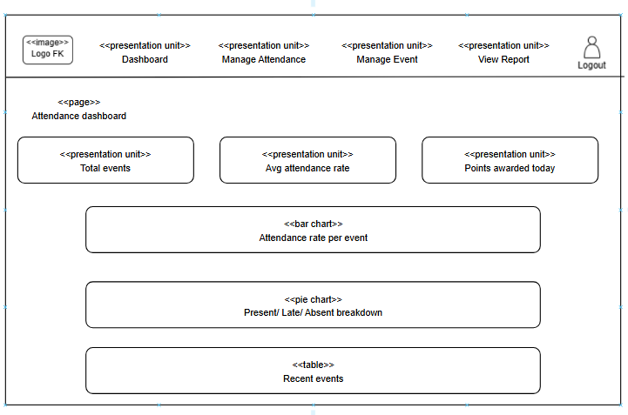

Take attendance page (committee member view)

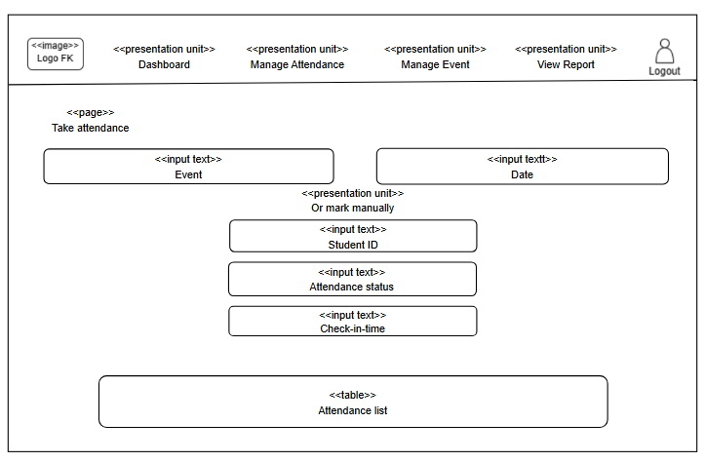

My attendance & points (student view)
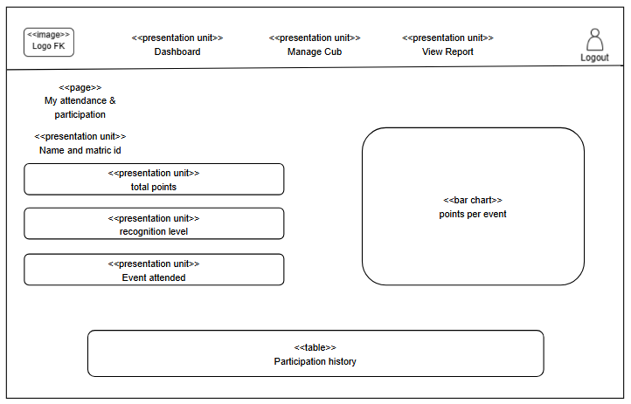

Participation report (admin view)

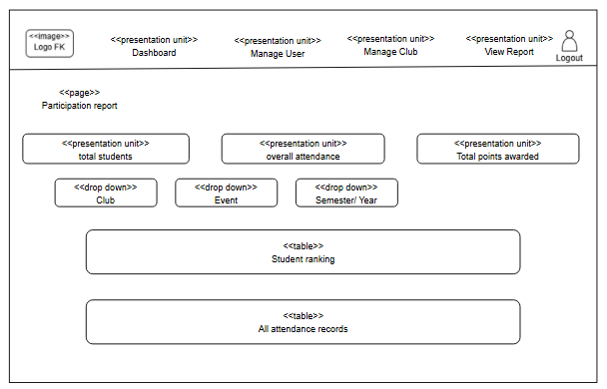

View student attendance detail (admin view)
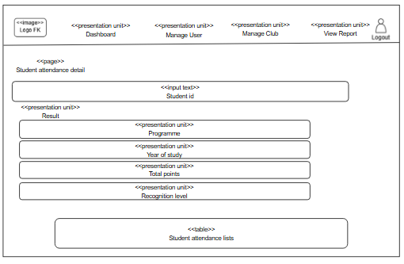

- TESTING PLAN
  - Unit Testing
Tests individual modules for each module assigned to each member, for example Login, Membership, Clubs, Attendance, and Events. This to ensure each module’s core functions like CRUD operations work correctly.
  - Integration Testing
This test applies to modules to test how modules interact with each other and with database, user sessions, data consistency, and point synchronization. This will validate each of the module.
  - System Testing
This test evaluates the complete, integrated application by simulating real world end-to-end scenarios to confirm the system meets all functional requirements. It creates the simulation scenarios with real user for example this project is scenario execution and outcome verification for systems. By applying this testing, it confirms the system meet the functional requirements and deliver good user experience in the workflows.

- DEPLOYMENT PLAN
The FK Student Club & Event Management System will be deployed in three phases: local, staging, and production. After local testing, the system will be migrated to a PHP/MySQL hosting platform. Post-deployment, all core features such as login, joining event and attendance QR scanning, will undergo comprehensive functional testing. To ensure a secure and reliable environment, the system incorporates password encryption, input validation, and role-based access control. Finally, long-term system stability will be maintained through automated cloud backups, continuous performance monitoring, bug fixes, and future feature updates.

