English to Hindi Machine Translation Systems Comparison
FGAI Assignment 3 Experimental Report
Student name | ________________________________________
Registration number | ________________________________________
Developed system | Comparative English to Hindi neural machine translation pipeline
Dataset | IIT Bombay English-Hindi Parallel Corpus
Repository | https://github.com/mizar-0/MachineTranslationSystemsComparison
Report date | 31 October 2026

Executive Summary
This report evaluates four English-to-Hindi machine translation systems on identical fixed data splits: a Transformer trained from scratch, full fine-tuning of mT5-small, and LoRA adaptation of LLaMA 3.2 1B and Gemma 3 270M. Every system was evaluated on the same 2,507-sentence test set with deterministic greedy decoding.
LLaMA 3.2 1B LoRA produced the strongest result, with corpus BLEU 0.845 and chrF 9.680, while updating only 5.64 million parameters. The scratch Transformer was fastest to train and decode. Absolute quality remained low across all systems, and sentence-level inspection exposed repetition, omissions, empty outputs, and fluent hallucinations. The models are suitable for experimental comparison but not for high-stakes deployment.
System | BLEU | chrF | Train hours | Sec per sentence
Scratch Transformer | 0.003 | 7.509 | 0.57 | 0.236
mT5-small | 0.065 | 8.487 | 2.39 | 0.344
LLaMA 3.2 1B LoRA | 0.845 | 9.680 | 4.50 | 1.634
Gemma 3 270M LoRA | 0.394 | 4.575 | 7.71 | 0.571

Report Structure
- Sections 1 to 4 define the task, dataset, systems, and experimental protocol.
- Sections 5 and 6 compare quantitative and qualitative outcomes.
- Sections 7 to 10 address responsible AI, limitations, reproducibility, and conclusions.
- The appendix records run identifiers and core hyperparameters for auditability.

1 Problem and Objective
Machine translation quality depends not only on model size but also on architecture, pretraining, tokenization, and the way a model is adapted. This project controls the dataset and test protocol so those design choices can be compared on English-to-Hindi translation.
The objective is to train or adapt four required model families, measure BLEU, chrF, time, memory, and parameter counts, retain sentence-level predictions, and interpret the results with explicit attention to failure modes and responsible use.

2 Dataset and Split Protocol
The public IIT Bombay English-Hindi Parallel Corpus provides aligned English and Hindi sentences. A reproducible reservoir sample of 30,000 training pairs was selected with seed 1729. The complete official development and test splits were retained. No normalization, deduplication, length filtering, or language identification was applied, which preserves the source distribution but also preserves noise and domain imbalance.
Split | Pairs | Selection
Train | 30,000 | Seeded reservoir sample
Validation | 520 | Complete official development split
Test | 2,507 | Complete official test split

Dataset source: IIT Bombay English-Hindi Parallel Corpus
The generated manifest records split sizes, source files, and checksums. All four runs consumed the same saved data files, preventing accidental test-set drift.

3 Systems and Adaptation
System | Architecture | Tokenizer | Adaptation
Scratch Transformer | 4 encoder and 4 decoder layers; d=256; 4 heads | 8,000-token SentencePiece BPE trained on selected train split | Full training
mT5-small | Multilingual encoder-decoder | Pretrained mT5 SentencePiece vocabulary | Full fine-tuning
LLaMA 3.2 1B | Pretrained decoder-only causal LM | Native pretrained tokenizer | LoRA rank 8 on all linear layers
Gemma 3 270M | Instruction-tuned decoder-only causal LM | Native pretrained tokenizer | LoRA rank 8 on all linear layers

3.1 Scratch Transformer
The scratch baseline uses a standard Transformer encoder-decoder with learned token embeddings and a jointly trained SentencePiece tokenizer. Its 11.51 million parameters are all trainable. Because it receives no multilingual pretraining, the 30,000-pair subset must teach both language representation and translation behavior.

3.2 mT5 Small
mT5-small is a multilingual text-to-text encoder-decoder. All 300.18 million parameters were fine-tuned with BF16, gradient checkpointing, AdamW, and an effective batch size of 16. Its pretrained vocabulary provides Hindi coverage without a new tokenizer.

3.3 LLaMA and Gemma LoRA
The causal language models were adapted with low-rank matrices applied to all linear layers. Only 0.454% of LLaMA parameters and 0.703% of Gemma parameters were trainable. Both used the prompt 'Translate the following English sentence into Hindi' and masked prompt and padding tokens in the loss. The local snapshots came from Unsloth mirrors of the original model families; this avoids gated repository access while preserving the named base architectures.
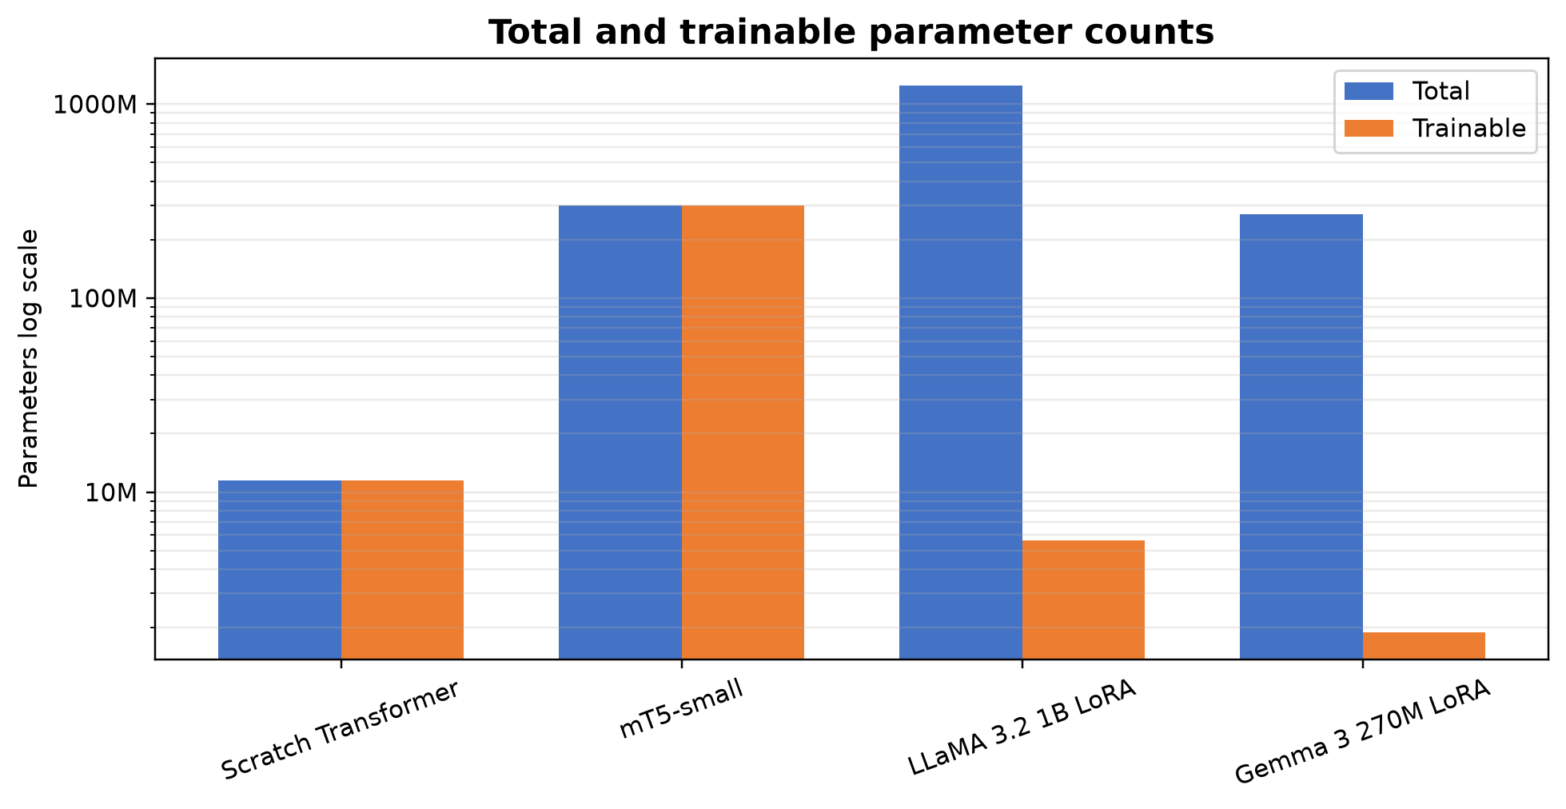
Figure 1. Total and trainable parameter counts on a logarithmic scale.

4 Experimental Setup
Training ran on one NVIDIA GeForce RTX 5060 Laptop GPU with 8 GB VRAM using Python 3.14, PyTorch 2.11.0, CUDA 12.8, Transformers, PEFT, SentencePiece, and SacreBLEU. Seed 1729 was used throughout. Run folders preserve configuration, step logs, epoch logs, status, checkpoints, summaries, and all test predictions.
System | Epochs | Batch / accumulation | Max lengths | Learning rate | Precision
Scratch Transformer | 16 of 30; early stop | 32 / 1 | 128 shared | 3e-4 with reductions | FP32
mT5-small | 5 | 4 / 4 | 128 / 128 | 5e-5 linear | BF16
LLaMA LoRA | 2 | 1 / 16 | 96 / 96 | 2e-4 linear | BF16
Gemma LoRA | 2 | 1 / 16 | 96 / 96 | 2e-4 linear | BF16

Evaluation used greedy decoding with beam size 1 and no temperature sampling. Corpus BLEU measures exact n-gram precision with a brevity penalty; chrF measures character n-gram similarity and is more tolerant of morphology and spelling variation. Both are reported because neither alone captures semantic adequacy.
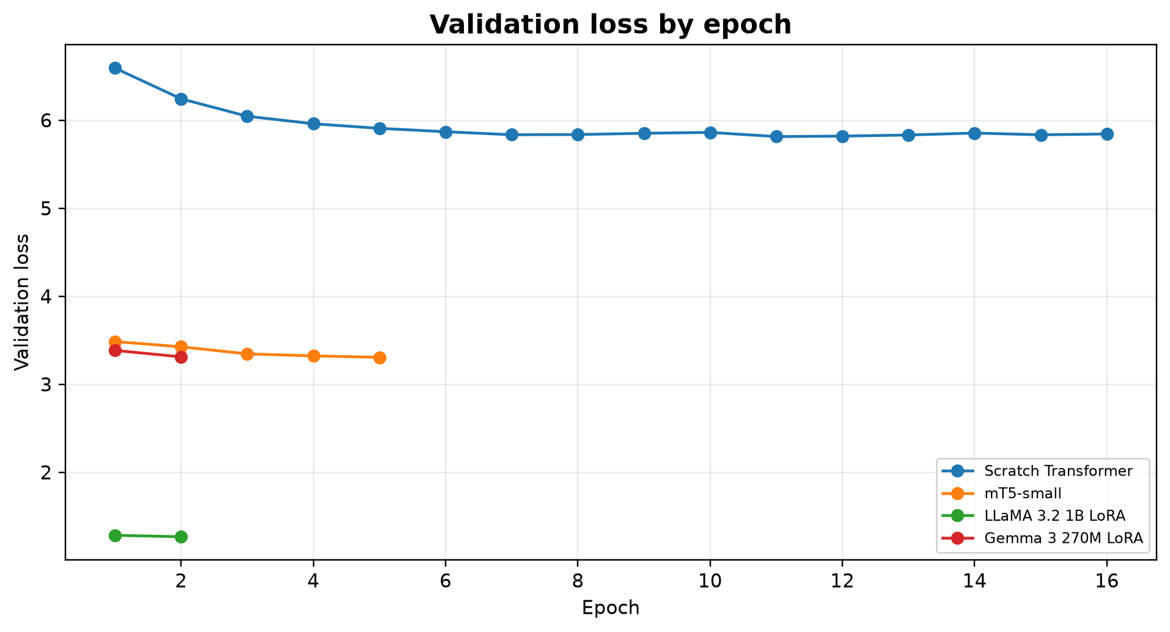
Figure 2. Validation loss by epoch. Loss values are not directly comparable across different tokenizers and objectives.

5 Quantitative Results
Model | BLEU | chrF | Train h | Infer s | s/sent | Peak GiB
Scratch Transformer | 0.003 | 7.509 | 0.57 | 592.4 | 0.236 | 1.38
mT5-small | 0.065 | 8.487 | 2.39 | 863.0 | 0.344 | 5.95
LLaMA 3.2 1B LoRA | 0.845 | 9.680 | 4.50 | 4097.1 | 1.634 | 2.84
Gemma 3 270M LoRA | 0.394 | 4.575 | 7.71 | 1431.7 | 0.571 | 1.38

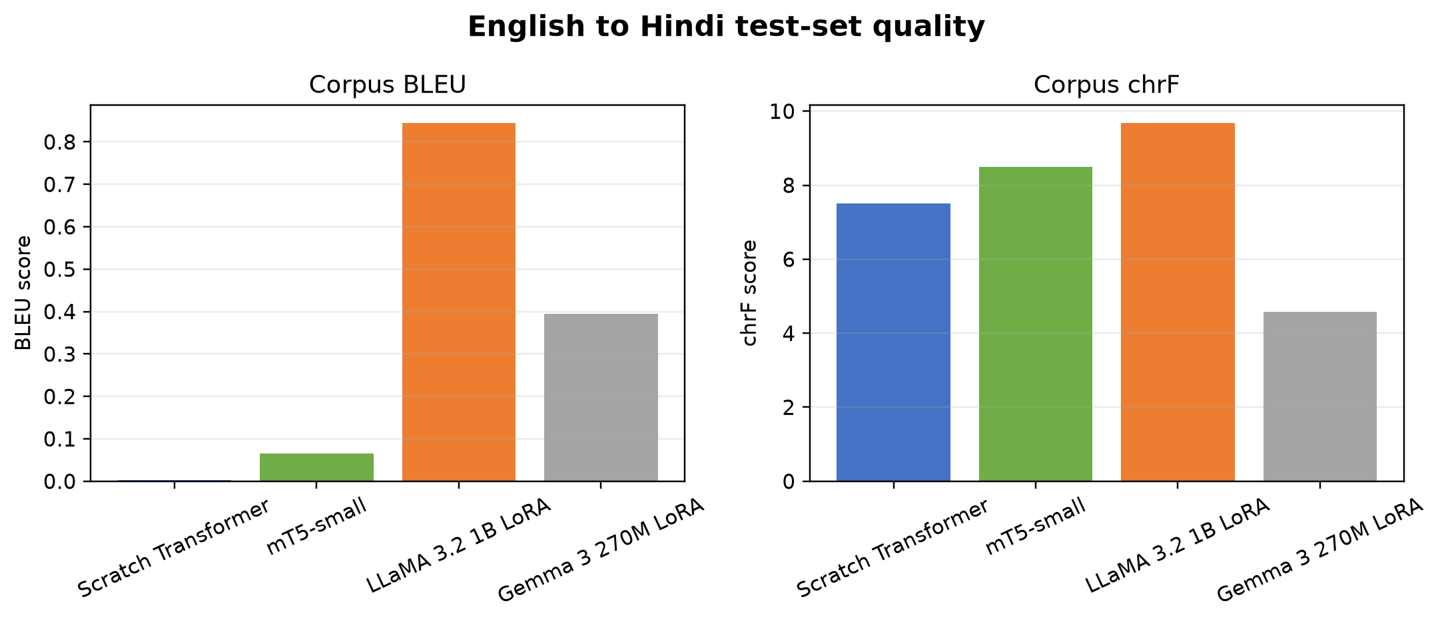
Figure 3. Corpus BLEU and chrF on the common 2,507-sentence test set.
LLaMA ranks first on both metrics, followed by Gemma on BLEU and mT5 on chrF. The gap between BLEU and chrF is important: partial character overlap can remain even when full phrase ordering and adequacy are poor. The low absolute BLEU values align with the visible repetition and hallucination in sentence-level outputs.
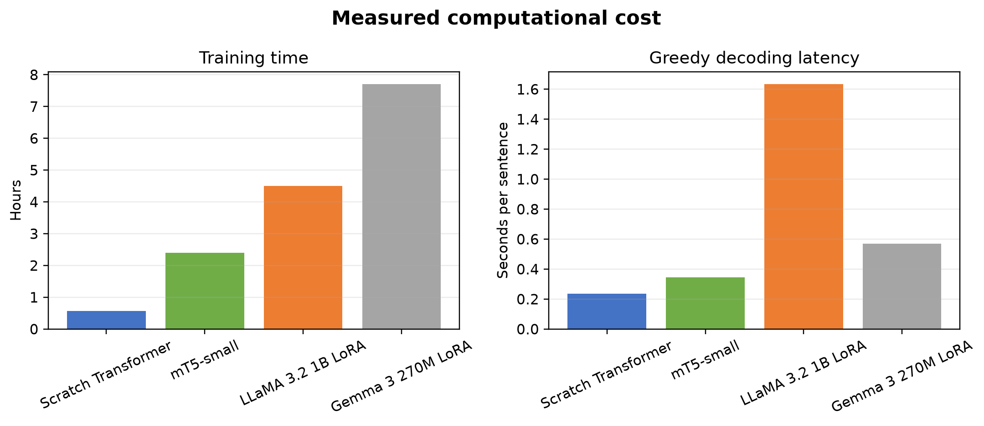
Figure 4. Measured training time and greedy decoding latency.
The scratch Transformer is the fastest system, requiring 0.57 hours to train and 0.236 seconds per test sentence. LLaMA is the strongest but slowest at inference. Gemma trained for 7.71 hours, showing that a smaller total parameter count does not guarantee faster fine-tuning when sequence lengths, architecture, checkpointing, and kernels differ.

6 Qualitative Analysis
Five fixed examples are saved in the repository. The three examples below illustrate a successful short translation, a partially adequate domain sentence, and a sensitive-content failure. Outputs are shown exactly as generated.

6.1 Test Item 0
English: A black box in your car?
Reference: आपकी कार में ब्लैक बॉक्स?
System | Generated Hindi
Scratch Transformer | और (ऐ रसूल) तुम कह दो कि अगर तुम उनसे कह दो कि अगर तुम (अज़ाब से) तुम (अज़ाब से) तुम परसतिश हो तो (अज़ाब से) तो (अज़ाब) से) से (अज़ाब से) से) से (अज़ाब से) से (अज़ाब से) से (अज़ाब से) से) से (अज़ाब से) से (अज़ाब से) से) से (अज़ाब से) से (अज़ाब से) से) से (अज़ाब से) से (अज़ाब से) से (आख़िर) से) से (अज़ाब से)
mT5-small | और हमारे पास यह बात है कि हमारे पास यह बात है कि हमारे पास यह बात है कि हमारे पास यह बात है कि हमारे पास यह बात है कि हमारे पास यह बात है कि हमारे पास यह बात है कि हमारे पास यह बात है कि हमारे पास यह बात है कि हमारे पास यह बात है कि हमारे पास यह बात है कि हमारे पास
LLaMA 3.2 1B LoRA | कार में एक ब्लैक बॉक्स?
Gemma 3 270M LoRA | एक कार में एक काला बॉक्स?

Interpretation: LLaMA and Gemma preserve the core meaning of a short question, while the scratch and mT5 systems collapse into repetition.

6.2 Test Item 147
English: The director of the Mall group made payments to all the financial institutions after deducting the TDS, but did not deposit it in the government treasury.
Reference: मॉल के ग्रुप संचालक ने टीडीएस काटकर संबंधित वित्तीय संस्थानों को भुगतान तो किया, लेकिन सरकारी खजाने में इसका भुगतान नहीं किया।
System | Generated Hindi
Scratch Transformer | और (ऐ रसूल) तुम कह दो कि अगर तुम उनसे कह दो कि अगर तुम (अज़ाब से) तुम (अज़ाब से) तुम परसतिश हो तो (अज़ाब से) तो (अज़ाब) से) से (अज़ाब से) से) से (अज़ाब से) से (अज़ाब से) से (अज़ाब से) से) से (अज़ाब से) से (अज़ाब से) से) से (अज़ाब से) से (अज़ाब से) से) से (अज़ाब से) से (अज़ाब से) से (आख़िर) से) से (अज़ाब से)
mT5-small | और हमने उन्हें उसकी बात और उसकी बात और उसकी बात और उसकी बात और उसकी बात और उसकी बात और उसकी बात और उसकी बात और उसकी बात और उसकी बात और उसकी बात और उसकी बात और उसकी बात और उसकी बात और उसकी बात और उसकी बात और उसकी बात और
LLaMA 3.2 1B LoRA | माल ग्रुप के निदेशक ने सभी वित्तीय संस्थाओं को टीडीएस के बाद निकाले गए धन को निकालने के लिए पूरा पैसा दे दिया है, लेकिन सरकारी खजाने में नहीं जमा किया।
Gemma 3 270M LoRA | और जब वह (उसकी ओर) झुठलाया तो (उसकी ओर) ज़मीन में (उसकी ओर) झुठलाया तो (उसकी ओर) ज़मीन में (उसकी ओर) झुठलाया तो (उसकी ओर) ज़मीन में (उसकी ओर) झुठलाया तो (उसकी ओर) ज़मीन में (उसकी ओर) झुठलाया तो (उसकी ओर) ज़मीन में (उसकी

Interpretation: LLaMA captures the finance and government-treasury content but introduces awkward wording; the other systems are largely unrelated.

6.3 Test Item 179
English: Indian Mujahideen terrorists involved in the bombings had intended to cause a stampede during the rally, so that more people would die and to spread panic in the state.
Reference: विस्फोटों में संलिप्त रहे इंडियन मुजाहिदीन के आतंकियों की मंशा रैली के दौरान भगदड़ मचाने की थी, ताकि अधिकाधिक लोग हताहत हों और प्रदेश में दहशत का माहौल बने।
System | Generated Hindi
Scratch Transformer | और (ऐ रसूल) तुम कह दो कि अगर तुम उनसे कह दो कि अगर तुम (अज़ाब से) तुम (अज़ाब से) तुम परसतिश हो तो (अज़ाब से) तो (अज़ाब) से) से (अज़ाब से) से) से (अज़ाब से) से (अज़ाब से) से (अज़ाब से) से) से (अज़ाब से) से (अज़ाब से) से) से (अज़ाब से) से (अज़ाब से) से) से (अज़ाब से) से (अज़ाब से) से (आख़िर) से) से (अज़ाब से)
mT5-small | और हमने उन्हें न ही न ही न ही न ही न ही न ही न ही न ही न ही न ही न ही न ही न ही न ही न ही न ही न ही न ही न ही न ही न ही न ही न ही न ही न ही न ही न ही न ही न ही न ही
LLaMA 3.2 1B LoRA | क्या आप किसी भी समय किसी भी स्थिति में किसी भी समय किसी भी स्थिति में किसी भी समय किसी भी स्थिति में किसी भी समय किसी भी स्थिति में किसी भी समय किसी भी स्थिति में किसी भी समय
Gemma 3 270M LoRA | [empty output]

Interpretation: On violence-related news, LLaMA hallucinates an interface-like question, Gemma returns an empty string, and the other models repeat unrelated text. This is an unacceptable high-stakes failure.
Across the selected examples, recurring failure modes are degeneration into a repeated phrase, empty output, omission of named entities and numbers, mistranslation of domain terminology, and fluent but unsupported content. LLaMA is comparatively better on some short and medium examples, but its aggregate lead does not remove these risks.

7 Responsible and Ethical AI Analysis

7.1 Bias and Cultural Representation
The corpus inherits the topics, register, geographic focus, gender representation, political language, and religious references of its source material. Models can amplify those imbalances or attach culturally loaded language to neutral inputs. Formal Hindi references may not represent regional varieties or mixed Hindi-English usage.

7.2 Hallucination and Harm
The test outputs demonstrate hallucinated interface questions, unrelated religious-style phrases, repetition, and empty strings. These errors can distort events, identities, quantities, and intent. Harm is highest in medical, legal, financial, government, public-safety, and violence-related translation, where a fluent sentence may be trusted even when it is unsupported.

7.3 Mitigations
- Require fluent human review for consequential translations and retain the source sentence beside every output.
- Detect empty, highly repetitive, excessively long, or low-confidence generations and abstain instead of returning them.
- Evaluate named entities, numbers, negation, gender, caste, religion, region, and domain terminology with targeted test suites.
- Conduct stereotype, toxicity, and cultural-appropriateness review with diverse Hindi speakers.
- Record model, data, decoding, and reviewer metadata so problematic translations remain traceable.
- Do not deploy these four checkpoints for high-stakes translation on the evidence available here.

8 Temperature and Decoding Scope
Temperature experiments were intentionally deferred. Every reported prediction uses deterministic greedy decoding, so temperature is not active in the comparison. This keeps the four systems comparable and avoids presenting unrun sampling results.
A future study should hold the test subset and generation limit fixed, test several nonzero temperatures with multiple random seeds, and report mean and variance for BLEU, chrF, repetition, empty-output rate, hallucination rate, and human adequacy. Greedy decoding should remain the temperature-free baseline.

9 Limitations
- The 30,000-pair training subset is small relative to modern multilingual pretraining and may not cover the test domains adequately.
- Only one data seed and one training seed were used, so run-to-run uncertainty is not measured.
- Different tokenizers and objectives make cross-model loss values descriptive rather than directly comparable.
- BLEU and chrF do not directly assess factual consistency, toxicity, cultural appropriateness, or human preference.
- Greedy decoding controls the comparison but does not establish the best decoding policy for each architecture.
- The causal models used mirrored model repositories; the identifiers and local paths are disclosed for reproducibility.

10 Conclusion
LLaMA 3.2 1B LoRA is the best system in this controlled experiment. It leads BLEU and chrF while training only 0.454% of the base parameters. The scratch Transformer is the most computationally efficient, and mT5 offers a strong multilingual encoder-decoder baseline, but both exhibit severe degeneration in the selected outputs. Gemma is parameter-efficient yet produces the lowest chrF and frequent empty or unrelated outputs.
The practical conclusion is cautious: pretrained capacity and parameter-efficient adaptation improve limited-data translation, but the measured checkpoints remain unreliable. Future work should use more and cleaner parallel data, targeted domain evaluation, sequence-level controls, repeated seeds, and bilingual human assessment before deployment.

11 Reproducibility and Repository
The repository contains dataset preparation, four training implementations, durable queue and checkpoint handling, tracked comparison tables and figures, selected predictions, and this report. Raw checkpoints and full run outputs are kept locally because of their size; aggregate results and examples are tracked in Git.
GitHub repository: mizar-0 MachineTranslationSystemsComparison
Core run identifiers are transformer_full_20261029, mt5_small_20261029_r3, llama_lora_20261030_r2, and gemma_lora_20261030. Each contains a configuration file, epoch history, summary, and exactly 2,507 test predictions.

References
1. Vaswani, A. et al. 2017. Attention Is All You Need. https://arxiv.org/abs/1706.03762
2. Kunchukuttan, A., Mehta, P., and Bhattacharyya, P. 2018. The IIT Bombay English-Hindi Parallel Corpus. https://aclanthology.org/L18-1548/
3. Xue, L. et al. 2021. mT5 A Massively Multilingual Pre-trained Text-to-Text Transformer. https://arxiv.org/abs/2010.11934
4. Meta. Llama 3.2 1B Model Card. https://huggingface.co/meta-llama/Llama-3.2-1B
5. Google. Gemma 3 Model Overview. https://ai.google.dev/gemma/docs/core/model_card_3
6. Post, M. 2018. A Call for Clarity in Reporting BLEU Scores. https://aclanthology.org/W18-6319/

Appendix A Run Configuration Summary
Run | Best epoch | Parameters | Trainable share | Stopping
transformer_full_20261029 | 11 | 11,511,104 | 100.000% | Early stopping
mt5_small_20261029_r3 | 5 | 300,176,768 | 100.000% | Epoch cap
llama_lora_20261030_r2 | 2 | 1,241,450,496 | 0.454% | Epoch cap
gemma_lora_20261030 | 2 | 269,996,672 | 0.703% | Epoch cap

The scratch run selected epoch 11 by validation loss and stopped after epoch 16 following five stale epochs. mT5 selected epoch 5. Both causal LoRA systems selected epoch 2. Checkpoints were saved before final generation so evaluation failures would not discard completed training.

Appendix B Logged Artifacts
- run_config.json: data counts, software and GPU environment, hyperparameters, parameter counts, truncation counts, and decoding configuration.
- steps.jsonl and epochs.jsonl: step losses, learning rate, gradient norm, timing, validation metrics, and peak allocated GPU memory.
- summary.json: selected epoch, stopping reason, total timing, test BLEU, test chrF, and test-set size.
- test_predictions.jsonl: test identifier, English source, Hindi reference, and generated prediction for every sentence.
- Best and last checkpoints or adapters: recoverable model state at training boundaries.

