Word Level Autoregressive Limerick Generation System
  - Foundations of Generative AI ICT4403 Assignment 2
Student name | Pranav Joshi
Registration number | 230953248
Assignment title | Foundations of Generative AI Assignment 2
System title | Word Level Limerick Generation with RNN LSTM and GRU
Dataset | Limerick Dataset OEDILF v3 - https://doi.org/10.5281/zenodo.5722527
GitHub repository | https://github.com/mizar-0/RNN-LSTM-GRU-Comparison

Executive summary
Four word-level autoregressive models were trained on the filtered OEDILF limerick corpus under the same data split and core hyperparameters. GRU produced the lowest held-out perplexity at 45.30 and the highest top-1 and top-5 accuracy. The final generation setting is GRU at temperature 0.5: its strict AABBA rhyme score was 33.67%, close to 34.25% at temperature 0.3, while repeated trigrams fell from 3.85% to 0.78% and distinct-2 rose from 0.241 to 0.415. Generated poems often contained fluent fragments but rarely formed a coherent setup and punchline. The blinded qualitative scores were produced by Claude as an LLM judge, not by a human rater.

1 Problem and objective
The task was to build an autoregressive text-generation system using Simple RNN, Bidirectional RNN, LSTM, and GRU architectures. Each model predicts the next word from its preceding context and generates a poem one token at a time from a seed sequence. The comparison covers predictive performance, computational cost, generated-text quality, and the effect of sampling temperature.

2 Dataset and preprocessing
The Limerick Dataset OEDILF v3 was obtained from Zenodo under the CC BY 3.0 US licence. The source contains 98,454 records. Filtering by the supplied limerick label retained 65,886 five-line poems from 1,296 authors. Poems contain a mean of 29.76 words and a median of 30; the 10th and 90th percentiles are 26 and 34 words. The material is user-submitted and includes some crude, offensive, or adult language.
The poems were shuffled with seed 42 and split by poem into 80% training, 10% validation, and 10% test partitions before sequence construction. Text was lowercased and tokenised into words and punctuation. Each poem received beginning-of-sequence, end-of-line, and end-of-sequence tokens. The 10,000-token training vocabulary retained pad and unknown tokens. About 10.16% of lexical training tokens and 9.92% of lexical test tokens map to the unknown token. The frequency distribution is concentrated in function words; the five most frequent lexical tokens are the, a, and, to, and in.
A 64-token left context was paired with each target token, yielding 2,229,796 training, 279,120 validation, and 278,760 test examples. Splitting before window construction prevents token windows from the same poem appearing in more than one partition.

3 Model architectures
All four models shared the same input representation and output layer. A 128-dimensional embedding maps token indices to dense vectors. The recurrent layer uses 256 hidden units and dropout of 0.3. A linear projection then maps the recurrent representation to the 10,000-token vocabulary.
Model | Recurrent layer | Output width | Sequence representation | Parameters
Simple RNN | RNN 256 | 256 | Final forward hidden state | 3.95M
BiRNN | Bidirectional RNN 256 | 512 | Concatenated forward and backward states | 6.61M
LSTM | LSTM 256 | 256 | Final hidden state | 4.25M
GRU | GRU 256 | 256 | Final hidden state | 4.15M

4 Experimental protocol
The models used Adam with a learning rate of 0.001, batch size 512, context length 64, and random seed 42. Training was capped at 40 epochs. Validation-loss early stopping used a patience of five epochs, and the lowest-validation-loss checkpoint was retained. The final checkpoint for each model was evaluated once on the held-out test set. Because early stopping is part of the protocol, models trained for different numbers of epochs; the comparison uses each model's best validated checkpoint rather than its final epoch.

5 Training behaviour
The learning curves show that LSTM and GRU reached lower validation loss than the two vanilla recurrent models. Simple RNN stopped after 22 epochs with its best checkpoint at epoch 17. BiRNN stopped after 33 epochs with its best checkpoint at epoch 28. LSTM stopped after 26 epochs with its best checkpoint at epoch 21. GRU reached the 40-epoch cap and its best checkpoint was the last epoch, indicating that it had not triggered early stopping.
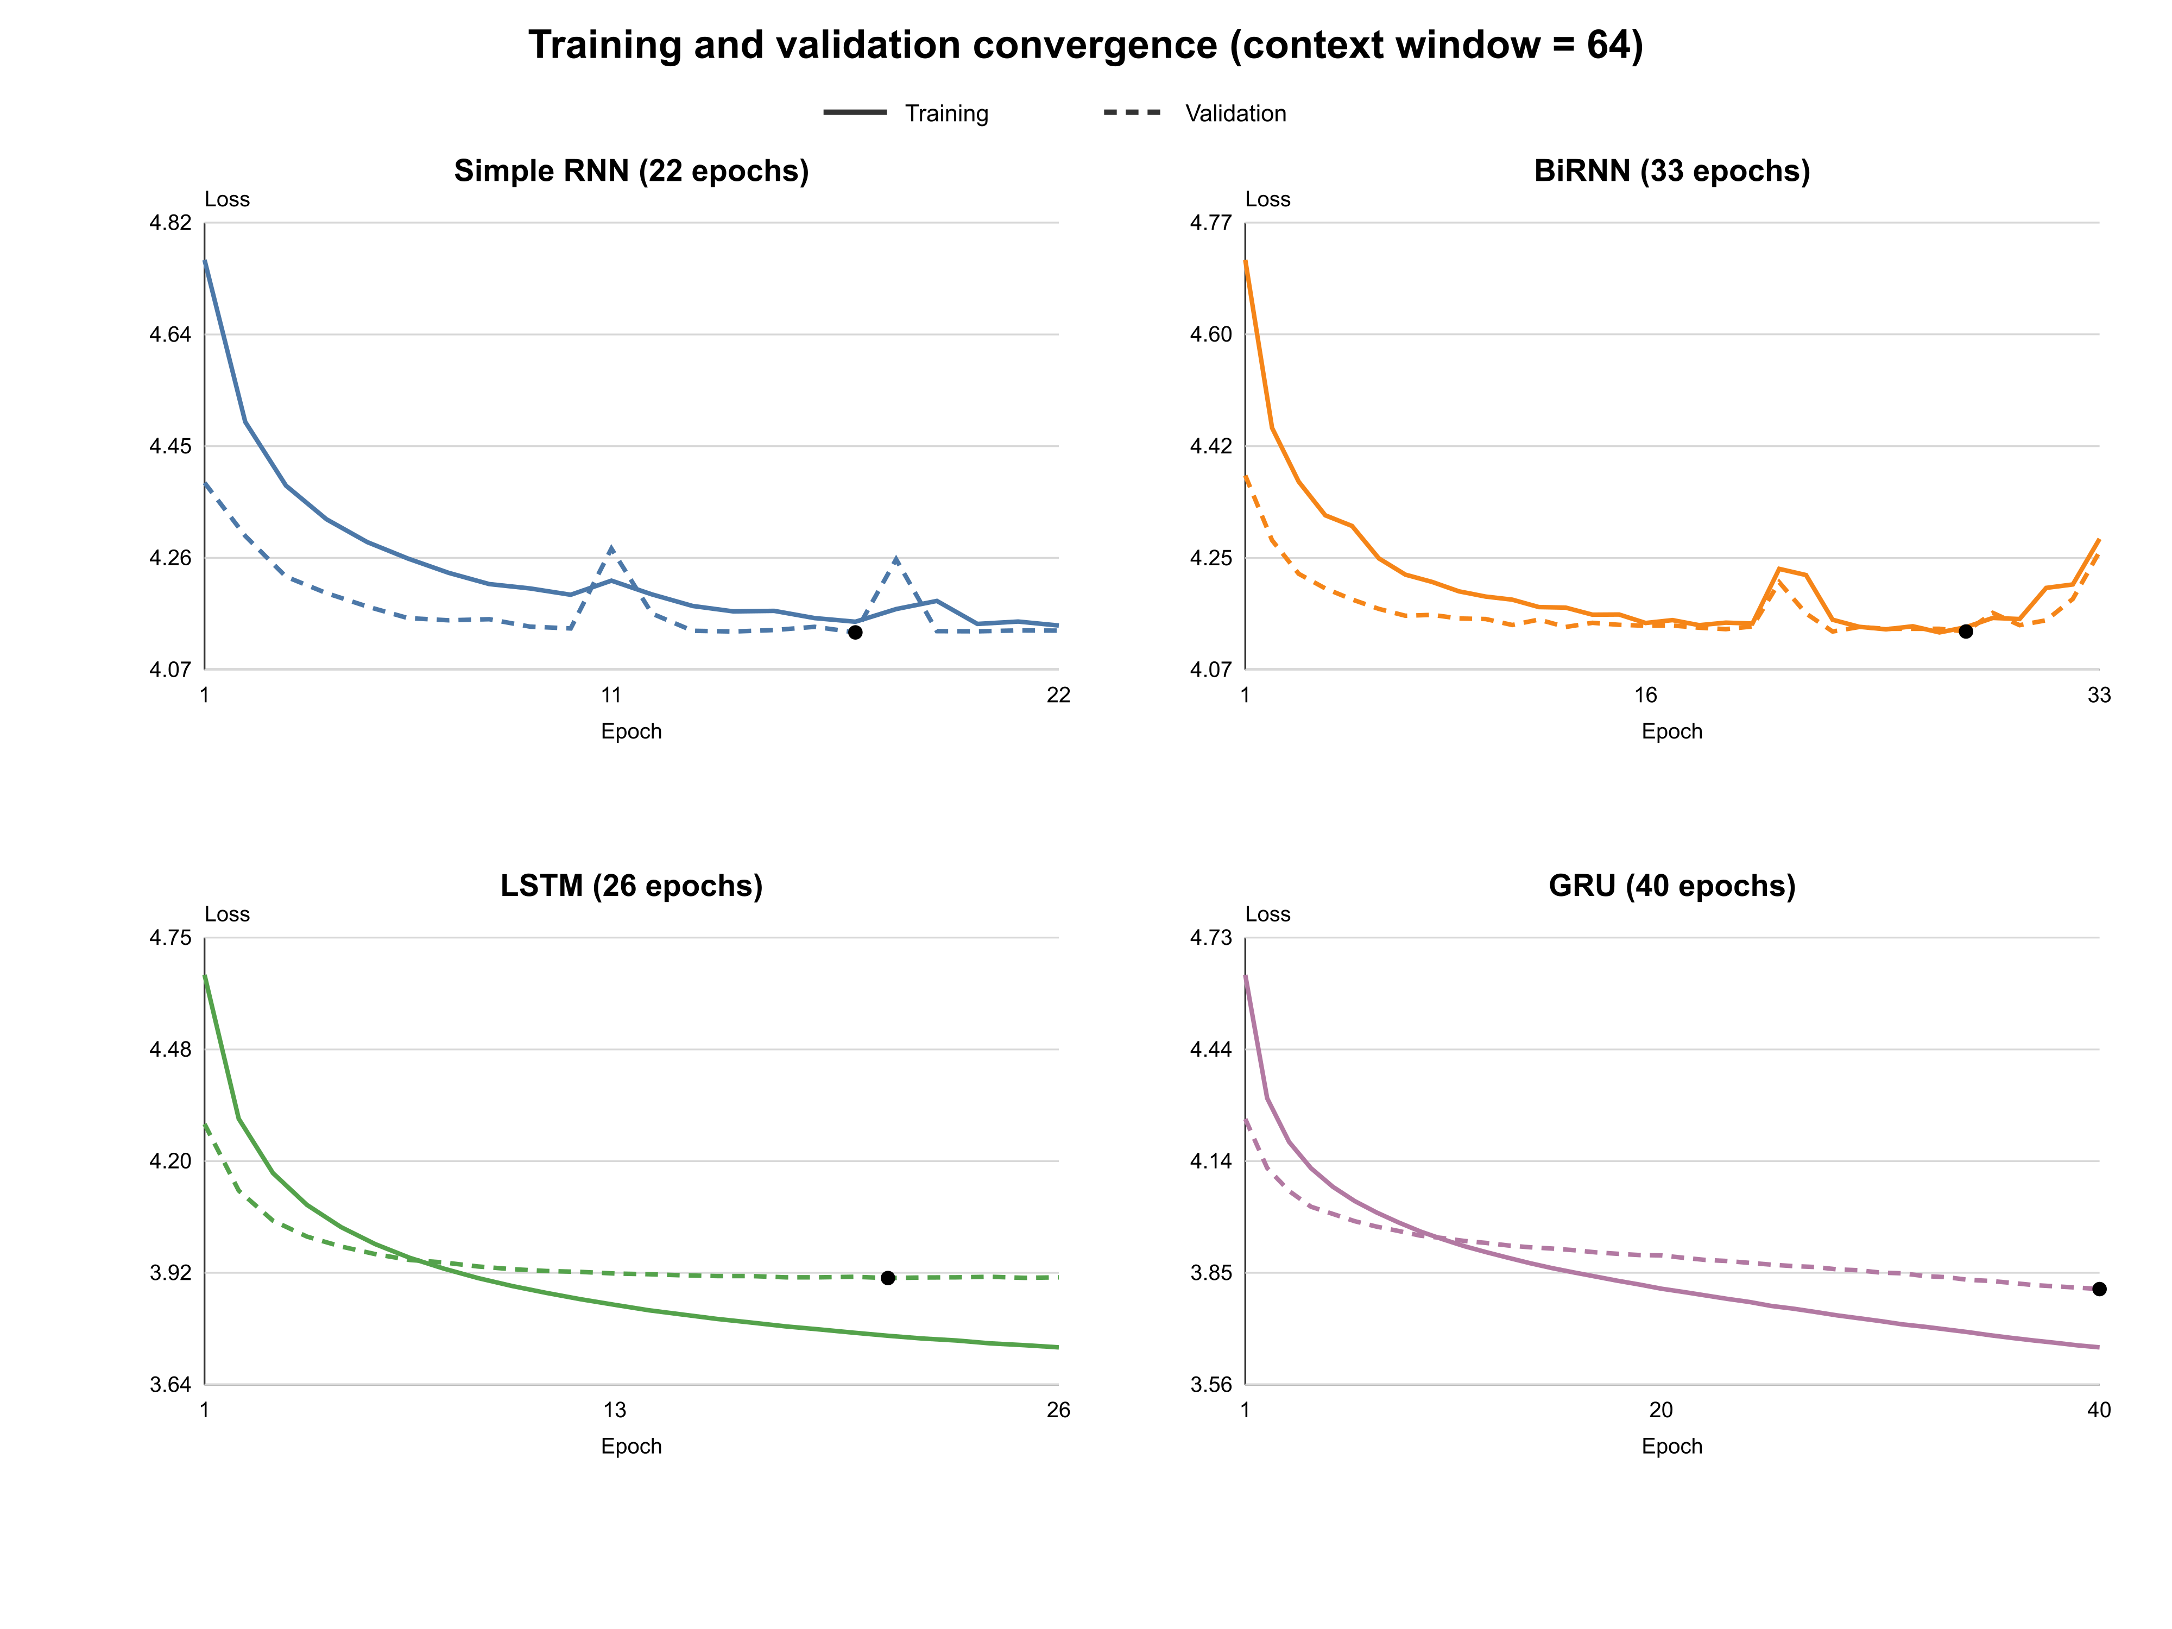
Figure 1 Training and validation loss for the final context length 64 runs

6 Held out test results
Model | Epochs | Loss | PPL | Top 1 | Top 5 | Sec epoch | Total time
Unigram | - | 5.702 | 299.59 | 11.46% | 31.60% | - | -
Simple RNN | 22 | 4.140 | 62.79 | 31.94% | 50.56% | 59.5 | 21.8 min
BiRNN | 33 | 4.140 | 62.81 | 32.00% | 50.61% | 93.9 | 51.7 min
LSTM | 26 | 3.913 | 50.03 | 34.14% | 53.55% | 68.9 | 29.9 min
GRU | 40 | 3.813 | 45.30 | 34.84% | 54.79% | 70.5 | 47.0 min
The add-one-smoothed unigram baseline confirms that all recurrent models learned useful sequence information. GRU achieved the strongest predictive result: its perplexity of 45.30 was 9.5% lower than LSTM and about 27.9% lower than Simple RNN. It also obtained the highest top-1 accuracy at 34.84% and top-5 accuracy at 54.79%. LSTM and GRU required similar compute per epoch at 68.9 and 70.5 seconds. LSTM's 17.1-minute lower total reflects earlier validation-based stopping, not materially faster epochs. BiRNN used the most compute per epoch without improving perplexity over Simple RNN.
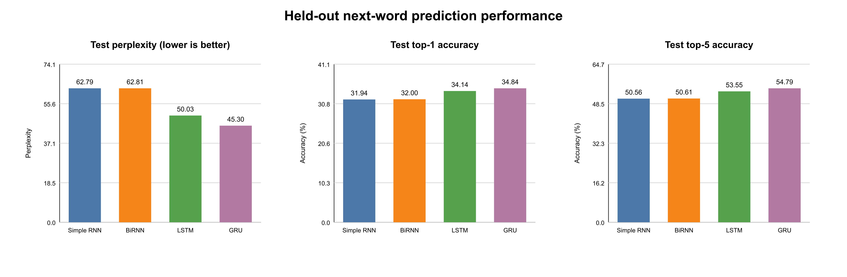
Figure 2 Held-out perplexity and next-word accuracy

7 Generation sweep
The generation sweep produced 7,200 poems from four models, six temperatures, and 300 poems per model-temperature cell. All models used the same five prompts. Automatic metrics covered termination, exact five-line form, pronunciation-dictionary coverage, AABBA rhyme, repeated trigrams, immediate repetitions, copied training lines, distinct n-grams, and unique-poem share. Metric uncertainty was estimated with 2,000 bootstrap resamples.
Strict AABBA rhyme is the mean of four required pair checks: lines 1-2, 3-4, 1-5, and 2-5. A pair scores one only when both end words are distinct, both are covered by the CMU Pronouncing Dictionary, and the dictionary lists them as rhymes. Identical endings, uncovered pairs, and missing five-line structure score zero. Rhyme coverage is the share of the four required pairs containing distinct, dictionary-covered words.
Under this definition, GRU scored 34.25% at temperature 0.3 and 33.67% at 0.5. The held-out human reference scored 94.25% with 94.33% eligible-pair coverage. The earlier permissive calculation counted identical endings as rhymes and conditioned the average on fully covered poems; it is not used in this report.

8 Temperature effects
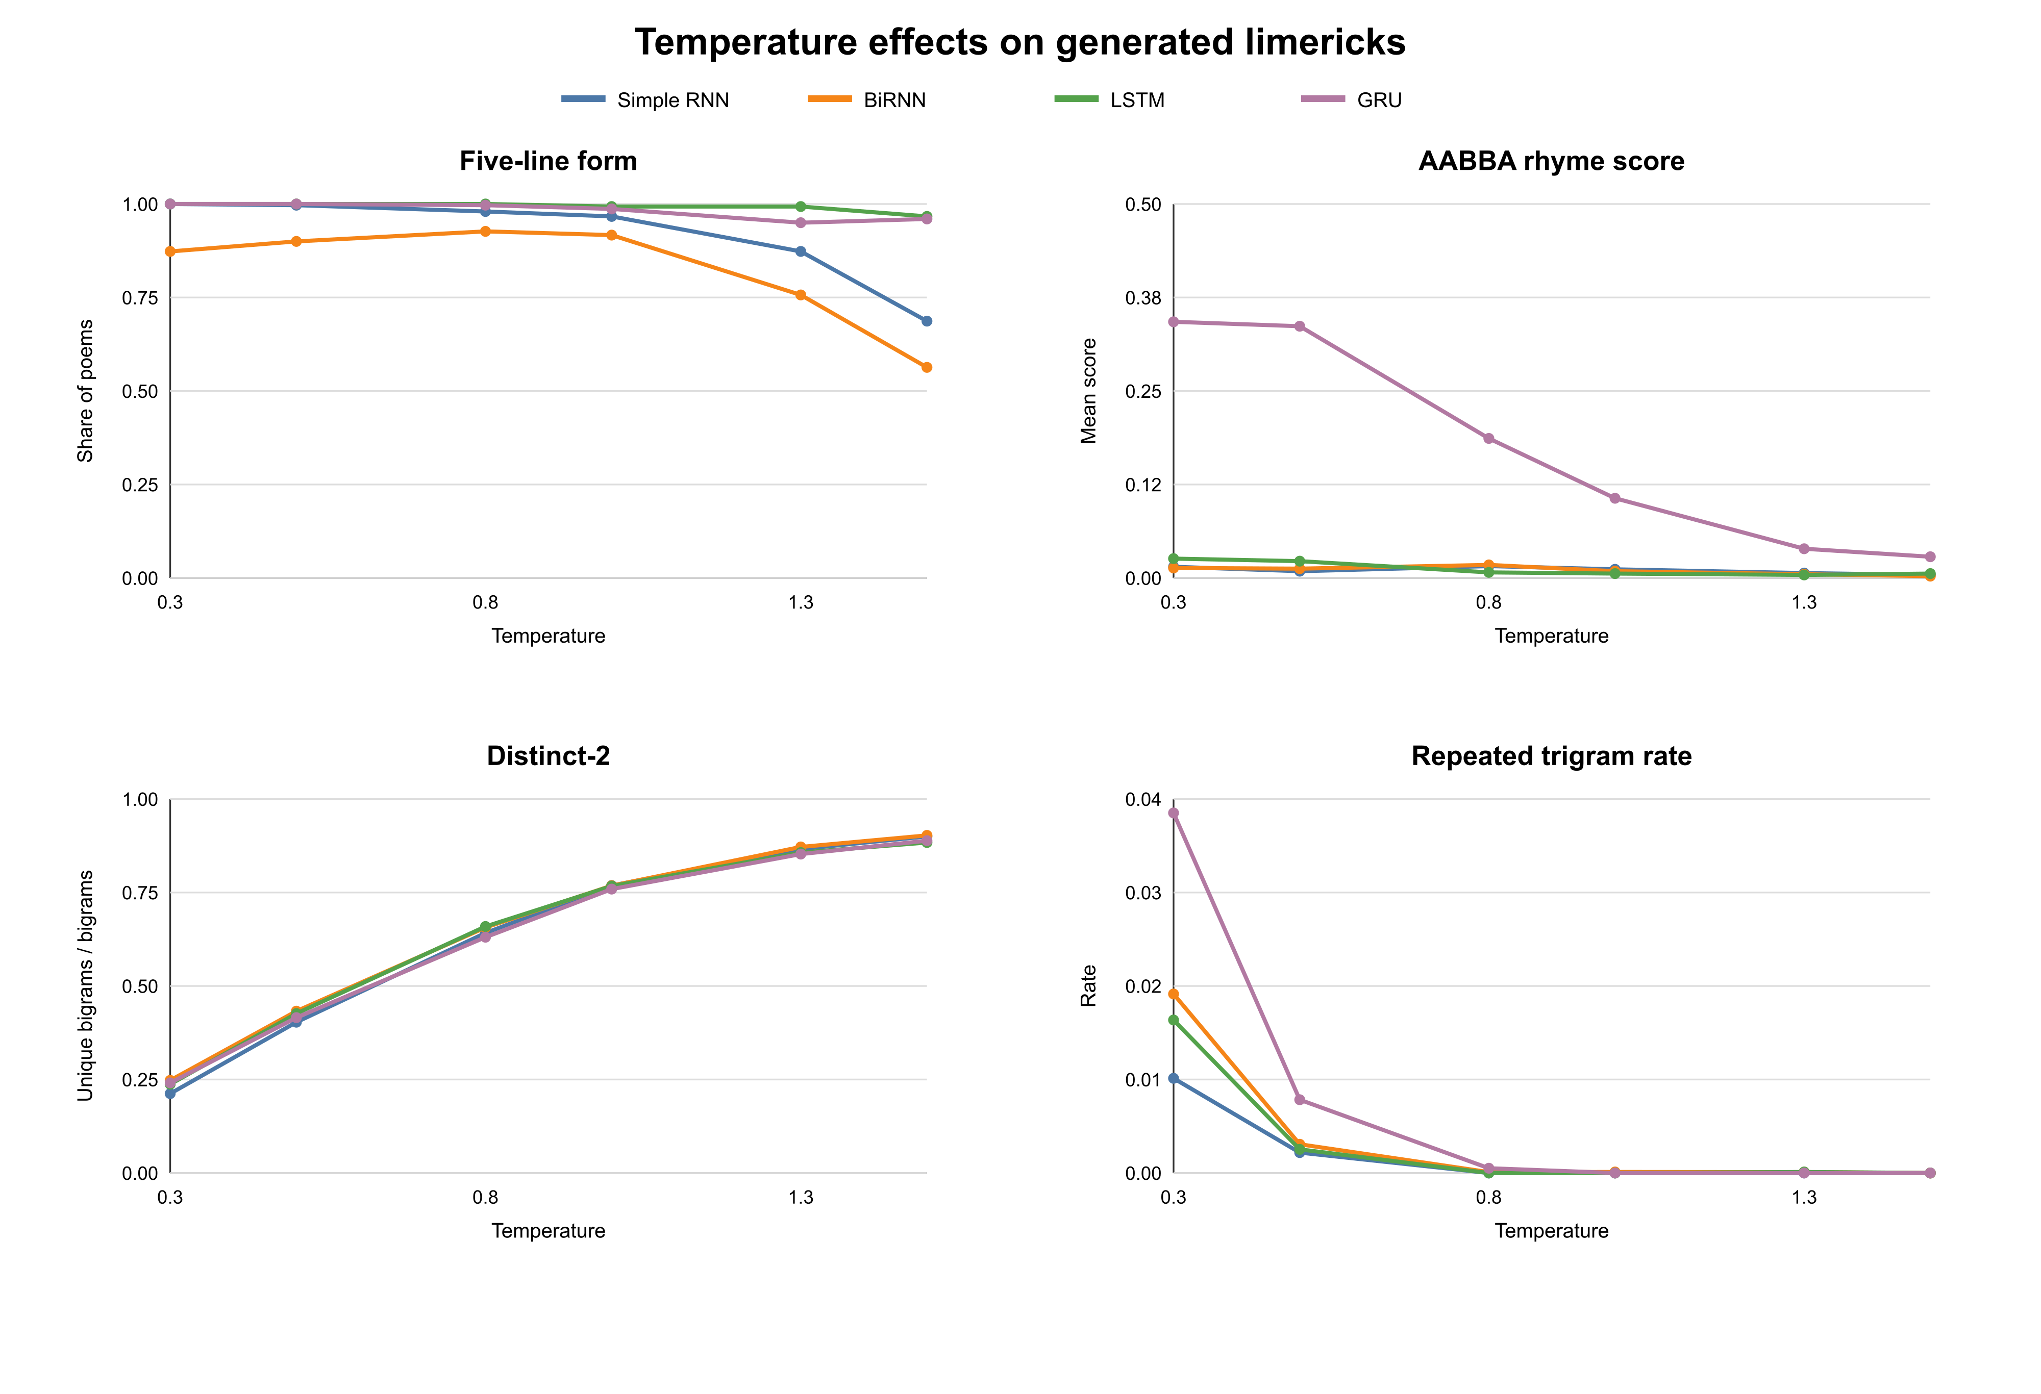
Figure 3 Form quality strict rhyme diversity and repetition across temperatures
Temperature controlled a structure-diversity trade-off. Across the four models, distinct-2 rose from approximately 0.21-0.25 at temperature 0.3 to 0.88-0.90 at 1.5, while rhyme and five-line form generally weakened. For GRU, moving from 0.3 to 0.5 reduced strict rhyme by only 0.58 percentage points, from 34.25% to 33.67%, but repeated trigrams fell from 3.85% to 0.78% and distinct-2 rose from 0.241 to 0.415. The word man appeared as a line ending 85 times among the 1,500 GRU line endings at temperature 0.3, compared with 39 at 0.5. These results favour 0.5 as the better balance.

9 Blinded manual evaluation
The blinded sheet contained 80 poems: four models, four temperatures, and five poems per cell. Claude served as an LLM judge and scored coherence and contextual consistency from 1 to 5 without access to model or temperature labels. GRU at temperature 0.3 received a combined score of 3.0 out of 5 with a 95% bootstrap interval of 2.6 to 3.4, tied in point estimate with LSTM at 0.3. GRU at 0.5 received 2.7 out of 5. No independent human rating or human-LLM agreement check was collected, so these values are supplementary qualitative evidence rather than a human evaluation.
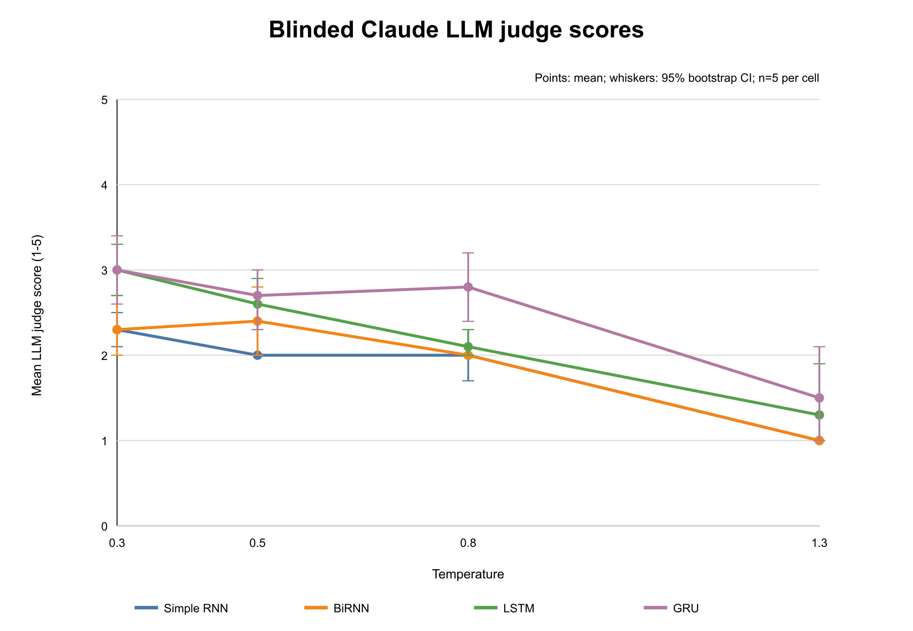
Figure 4 Mean blinded Claude LLM judge scores by model and temperature

10 Generated poem comparison
Table 3 uses the same prompt and sample index for every model at three temperatures. Slashes mark line breaks. The examples show the aggregate pattern: low temperatures preserve recurrent phrasing and form, whereas higher temperatures increase variety but often weaken grammar. Even the strongest outputs are usually fluent fragments rather than complete limericks with a coherent setup and punchline.
Model and temperature | Generated poem from prompt there once was a
Simple RNN 0.3 | there once was a fellow who knew  that he said but she was so i see  i am not in a bind  on the floor then i fear  that i find that it is a great deal
BiRNN 0.3 | there once was a woman named fred  and a rabbit one made winning bred  in the surf and the rest  was a victim of fame  and a tale of the name of the key
LSTM 0.3 | there once was a young lady named  who was caught by the long of the day  she was born for a week  and she said i don't know  i don't care but i'm sure i don't know
GRU 0.3 | there once was a man of a man  and a man who was caught in a pan  he was born with a beard  and his beard was a beard  in a pan when he ran off the pan
Simple RNN 0.5 | there once was a girl and a bit  well i've got a great deal i don't know  i will not have a hunch  that i want to be far  to my mom your dear friend i would say
BiRNN 0.5 | there once was a good to sized  with a gem loving type of up  but this limerick is banned  we've got much more than fun  and the rest of this place is the same
LSTM 0.5 | there once was a woman named booth  who was shot by the moon up named clyde  who was built in the past  but that meant to be brief  he would say as he claimed it i fear
GRU 0.5 | there once was a fellow named andy  who ate his new car and his mother  had a talent to make  and his wife made a man  and the rest of his daughter was sloppy
Simple RNN 1.0 | there once was a top of a thought  when the stage is a genius when he  was an instrument whoa  why that gold is to blame  here's a count and its flag look a bit
BiRNN 1.0 | there once was a kind out of dough  he's a knife and as an affair pace  this good end is i need  to you keeping you nice  these apartment fires so
LSTM 1.0 | there once was a lady named grace  who exclaimed the emotions you rot  if you often can say  eating friction a way  he will help you fall in it will thrive
GRU 1.0 | there once was a number the phrase  that produced with the straight cheese of wine  it's divine and fresh duty  with a chomp and through water  the sole part of the more mouth agape

11 Model selection
Model | Prediction | Seconds epoch | Five-line form | Strict rhyme | Decision
Simple RNN | Weak | 59.5 | 100% at 0.3 | 1.5% at 0.3 | Fast baseline
BiRNN | Weak | 93.9 | 87.3% at 0.3 | 1.3% at 0.3 | Not selected
LSTM | Strong | 68.9 | 100% at 0.3 | 2.6% at 0.3 | Prediction alternative
GRU | Best | 70.5 | 100% at 0.5 | 33.7% at 0.5 | Selected model
The selection rule first chooses the architecture with the best held-out next-word prediction, then chooses its temperature by balancing strict rhyme, diversity, and repetition. GRU is selected because it has the lowest test loss and perplexity and the highest top-1 and top-5 accuracy. Within GRU, temperature 0.5 is selected over 0.3 because its strict rhyme differs by only 0.58 percentage points while diversity improves and repeated trigrams fall sharply. Five-line completion is not used as a deciding advantage because both GRU and LSTM reached 100% at temperature 0.3.

12 Limitations
The study used one random seed, so training variance is unknown. Validation-based early stopping produced different epoch counts: LSTM stopped after 26 epochs, whereas GRU reached the 40-epoch cap. Their per-epoch times were similar, but the unequal number of updates confounds architectural and total-training comparisons. GRU might improve with a longer cap. The strict rhyme metric depends on CMU Pronouncing Dictionary coverage and treats uncovered or identical word pairs as failures. Qualitative scoring used one Claude LLM judge and five poems per cell, with no independent human agreement check. Perplexity does not directly measure humour, narrative coherence, or originality.

13 Reproducibility
The repository contains preprocessing and training code, run metadata, learning curves, test metrics, the 7,200-sample generation sweep, automatic metric outputs, the blinded scoring workbook, and the unblinded LLM-judge score summary. The raw dataset and model checkpoints are excluded because of their size; download and reproduction instructions are provided. The final configuration records seed 42, data split, vocabulary size, context length, optimiser settings, epoch history, and checkpoint selection for each model.

14 Conclusion
LSTM and GRU outperformed Simple RNN and BiRNN on held-out next-word prediction, but only GRU showed substantial strict rhyme adherence. Because GRU also trained for more epochs than LSTM and only one seed was used, the experiment cannot attribute every difference to architecture alone. GRU at temperature 0.5 is the strongest overall configuration under the stated selection rule. Its outputs remain well below human-reference rhyme quality and generally lack a coherent limerick punchline.

References
Limerick Dataset OEDILF v3. Zenodo. https://doi.org/10.5281/zenodo.5722527
CMU Pronouncing Dictionary. Carnegie Mellon University. http://www.speech.cs.cmu.edu/cgi-bin/cmudict
PyTorch. https://pytorch.org

