Even Tree
You are given a tree (a simple connected graph with no cycles).You have to remove as many edges from the tree as possible to obtain a forest with the condition that : Each connected component of the forest contains even number of vertices
Your task is to calculate the number of removed edges in such a forest.

Input:
The first line of input contains two integers N and M. N is the number of vertices and M is the number of edges. 2 <= N <= 100.
Next M lines contains two integers ui and vi which specifies an edge of the tree. (1-based index)

Output:
Print a single integer which is the answer
Sample Input
10 9
2 1
3 1
4 3
5 2
6 1
7 2
8 6
9 8
10 8

Sample Output :
2

Explanation : On removing the edges (1, 3) and (1, 6), we can get the desired result.
Original tree:

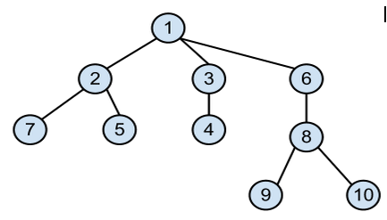
Decomposed tree:

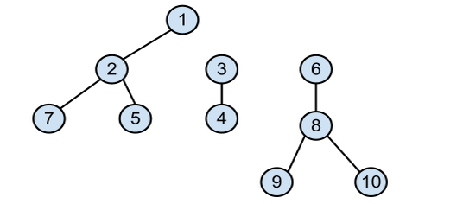
Note: The tree in the input will be such that it can always be decomposed into components containing even number of nodes.

