Initialize the android studio

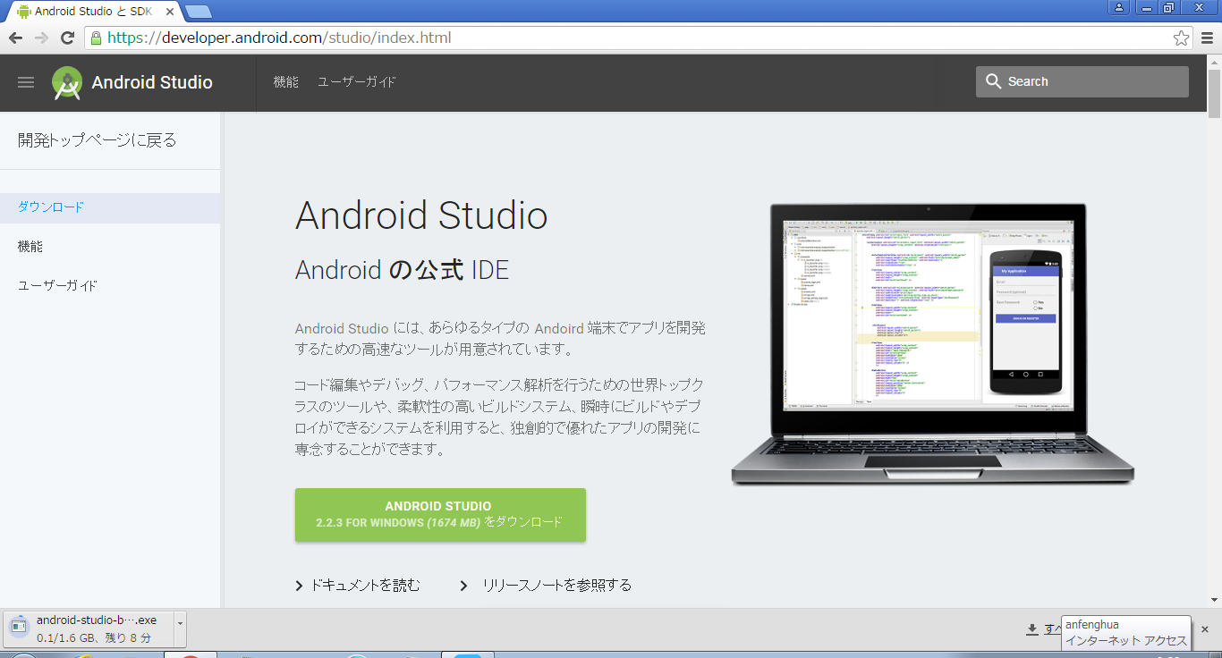

This application is based on IntelliJ IDE. And it has a great useful function of code editor.

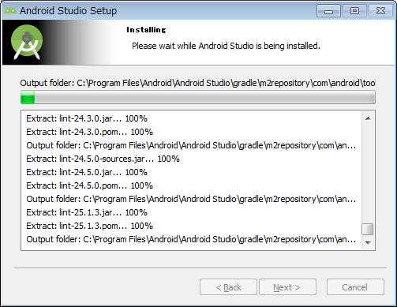

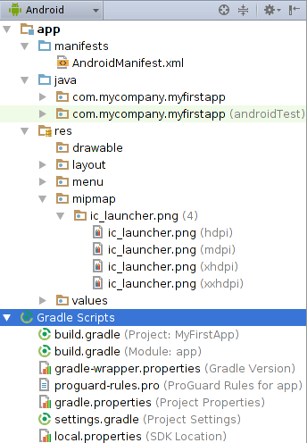

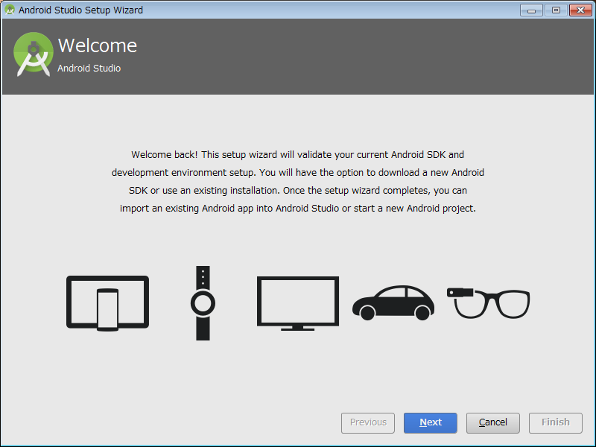
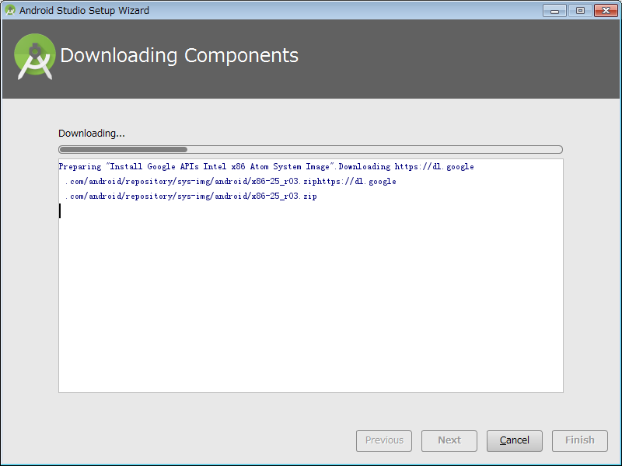

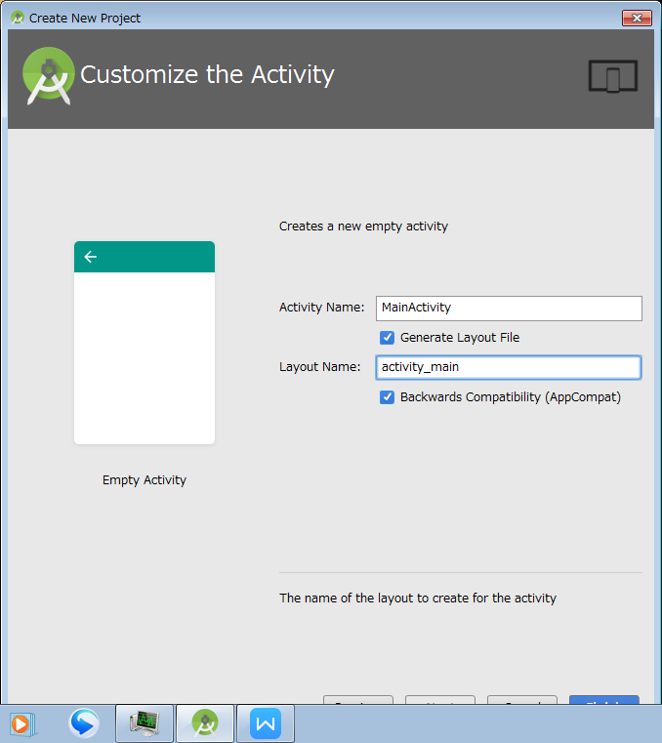

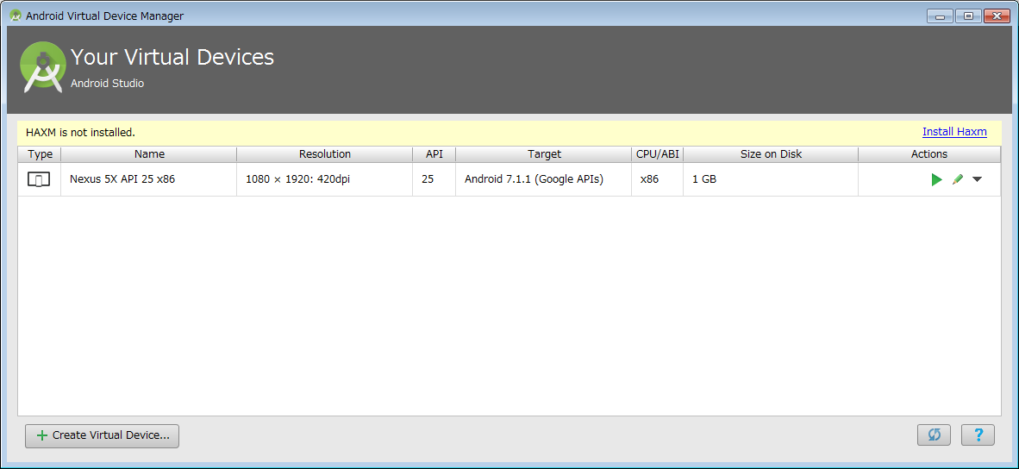
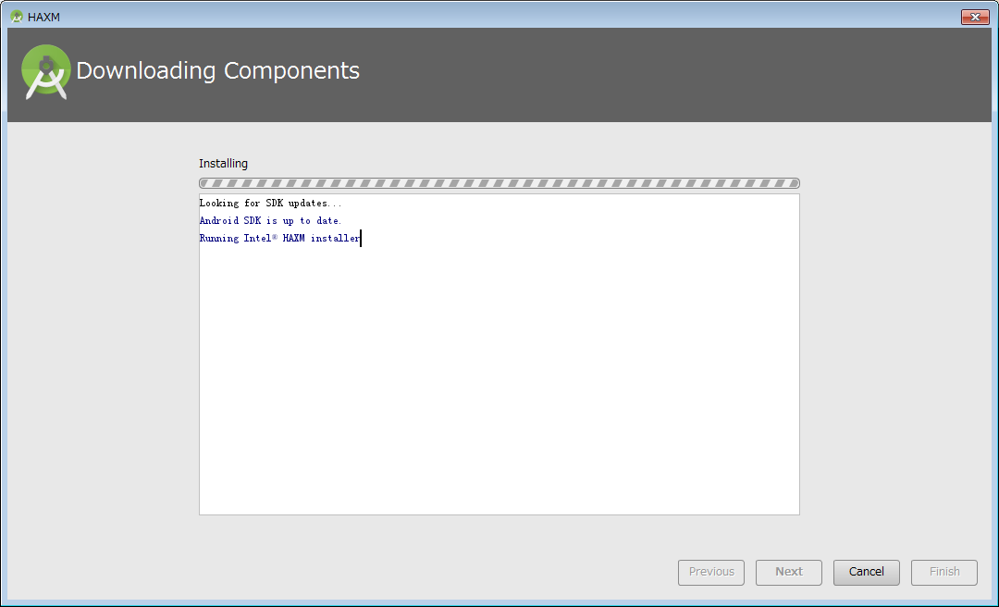
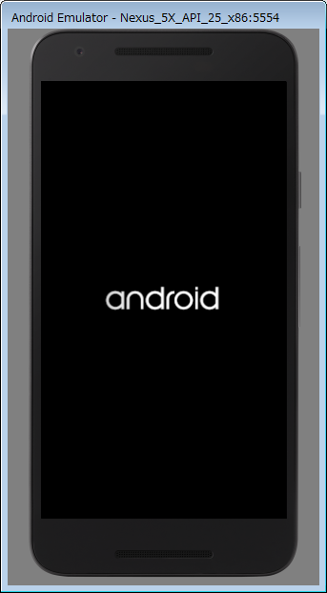
E/AndroidRuntime: FATAL EXCEPTION: main
Process: com.example.user.myapplication, PID: 3342
java.lang.IllegalStateException: Could not find method evet1(View) in a parent or ancestor Context for android:onClick attribute defined on view class android.support.v7.widget.AppCompatButton with id 'button1'
at android.support.v7.app.AppCompatViewInflater$DeclaredOnClickListener.resolveMethod(AppCompatViewInflater.java:327)
at android.support.v7.app.AppCompatViewInflater$DeclaredOnClickListener.onClick(AppCompatViewInflater.java:284)
at android.view.View.performClick(View.java:5610)
at android.view.View$PerformClick.run(View.java:22265)
at android.os.Handler.handleCallback(Handler.java:751)
at android.os.Handler.dispatchMessage(Handler.java:95)
at android.os.Looper.loop(Looper.java:154)
at android.app.ActivityThread.main(ActivityThread.java:6077)
at java.lang.reflect.Method.invoke(Native Method)
at com.android.internal.os.ZygoteInit$MethodAndArgsCaller.run(ZygoteInit.java:865)
at com.android.internal.os.ZygoteInit.main(ZygoteInit.java:755)

