Linux system in android

1.adb root to enter
using adb root to get all permissions of the file system.
if there is no root permission, the follow error will come out:
ls: ./XXXX:Permission denued

- # bash this is the # bash, which
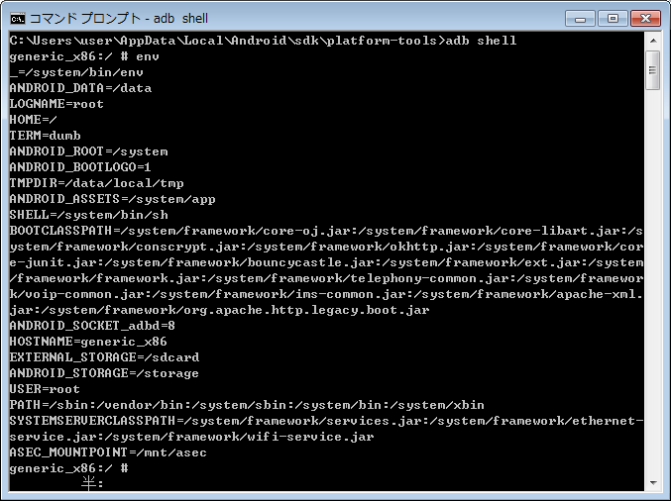
the file system of the linux system
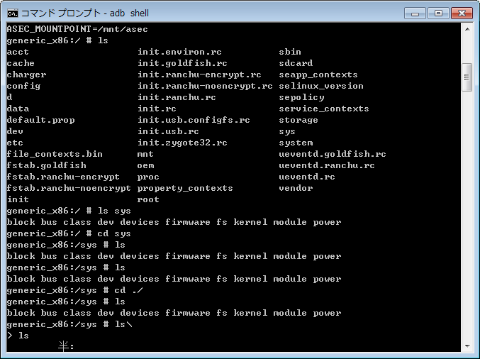
the data/data has most application data of the linux system
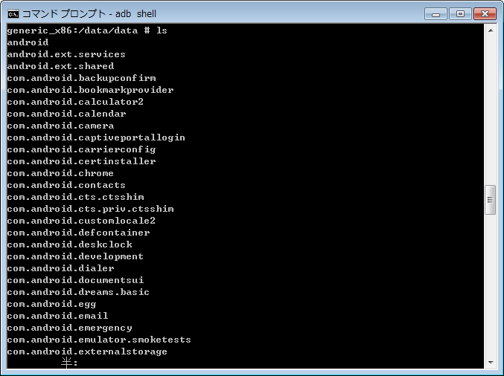
The system/app has most of the system application installed
