Some Other Basics About Power Shell

We can use right-click and property to get the basic setting information of power shell.

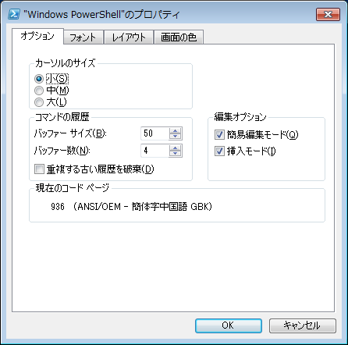

Now I changed the power shell console layout like this.

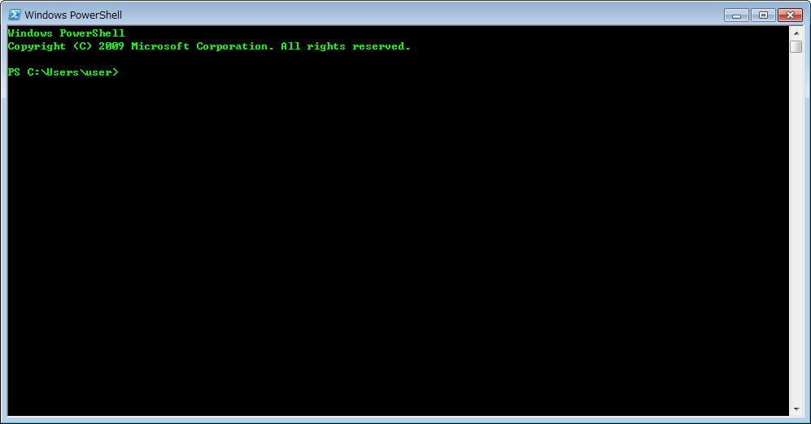

Start-Transcript

This command gives us a history file to be recorded. What we did in power shell console be saved in this history file automatically.

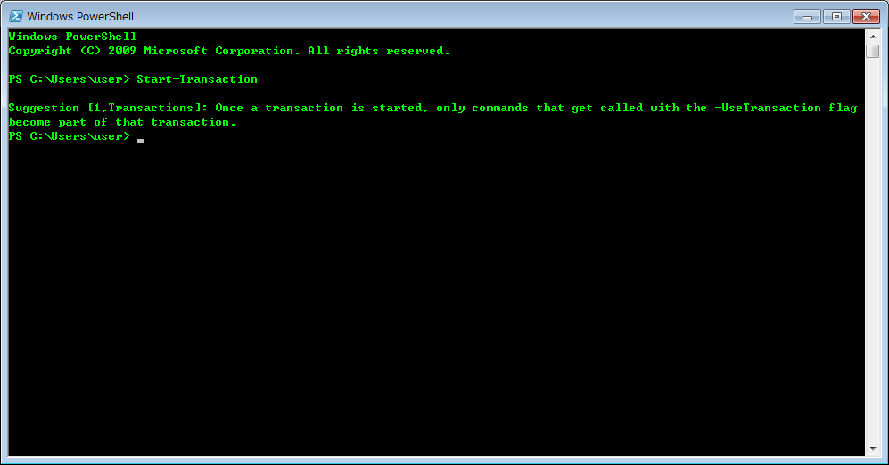

-noun

This command gives us a filter selecting the right part of the command name. In English it means .n

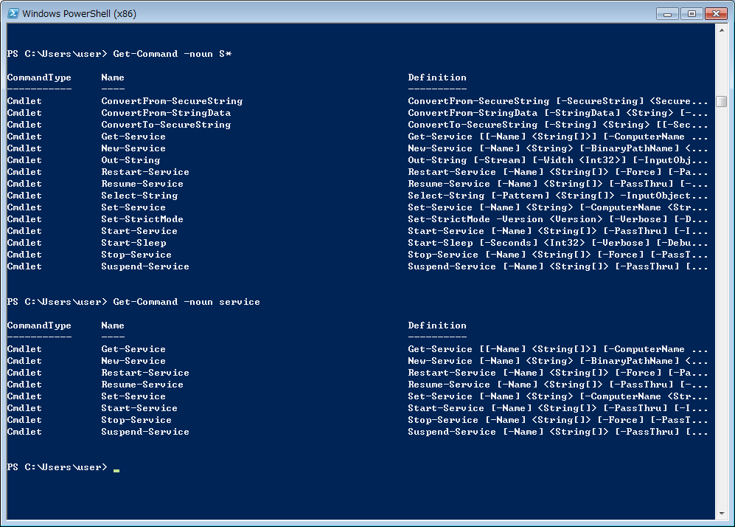

-verb

This command gives us a filter selecting the left part of the command name. In English it means .v

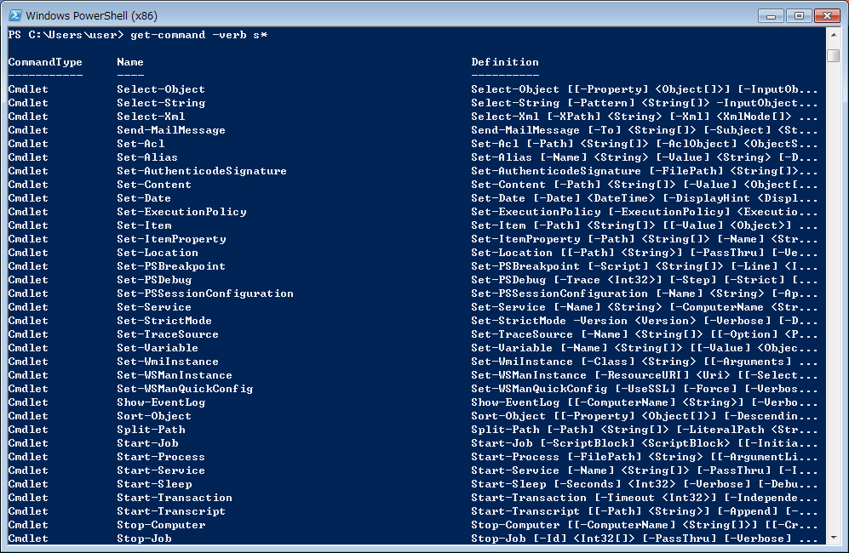

Get-Help

This command gives us a good way to get the help information we want to know about the command.

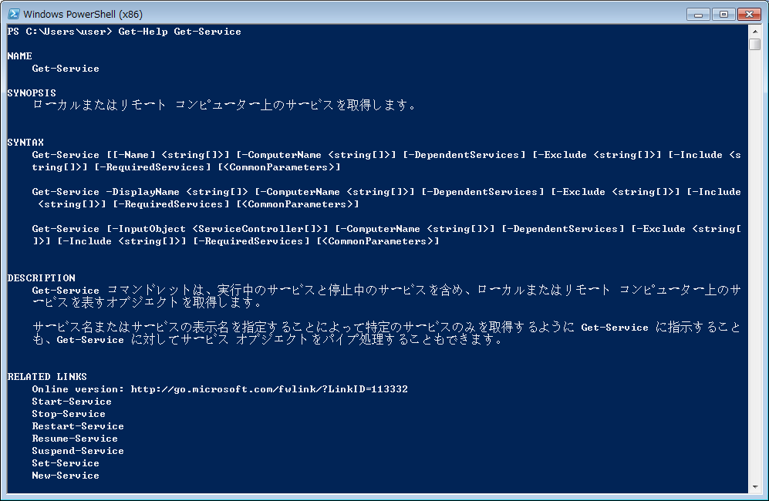

Get-Help -Examples

This command gives us examples testing by human-beings.

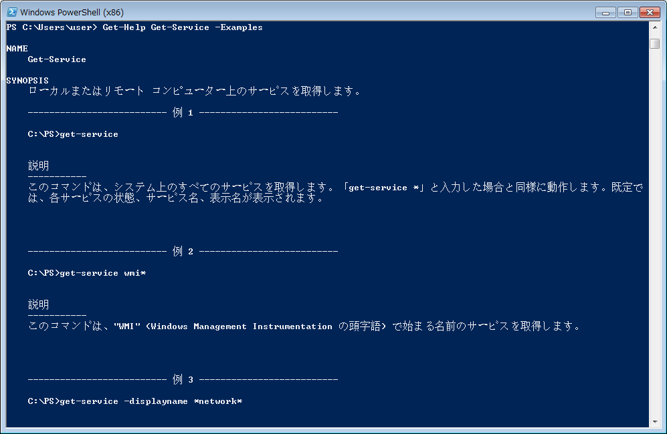

Get-Help -Online

This command gives us a online help by official on the website.

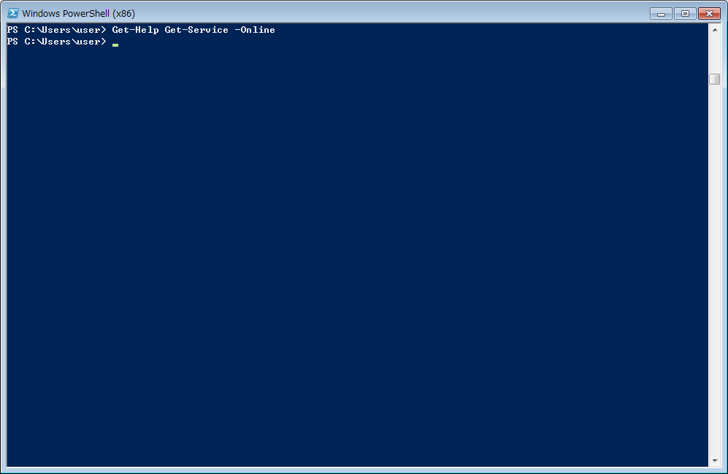

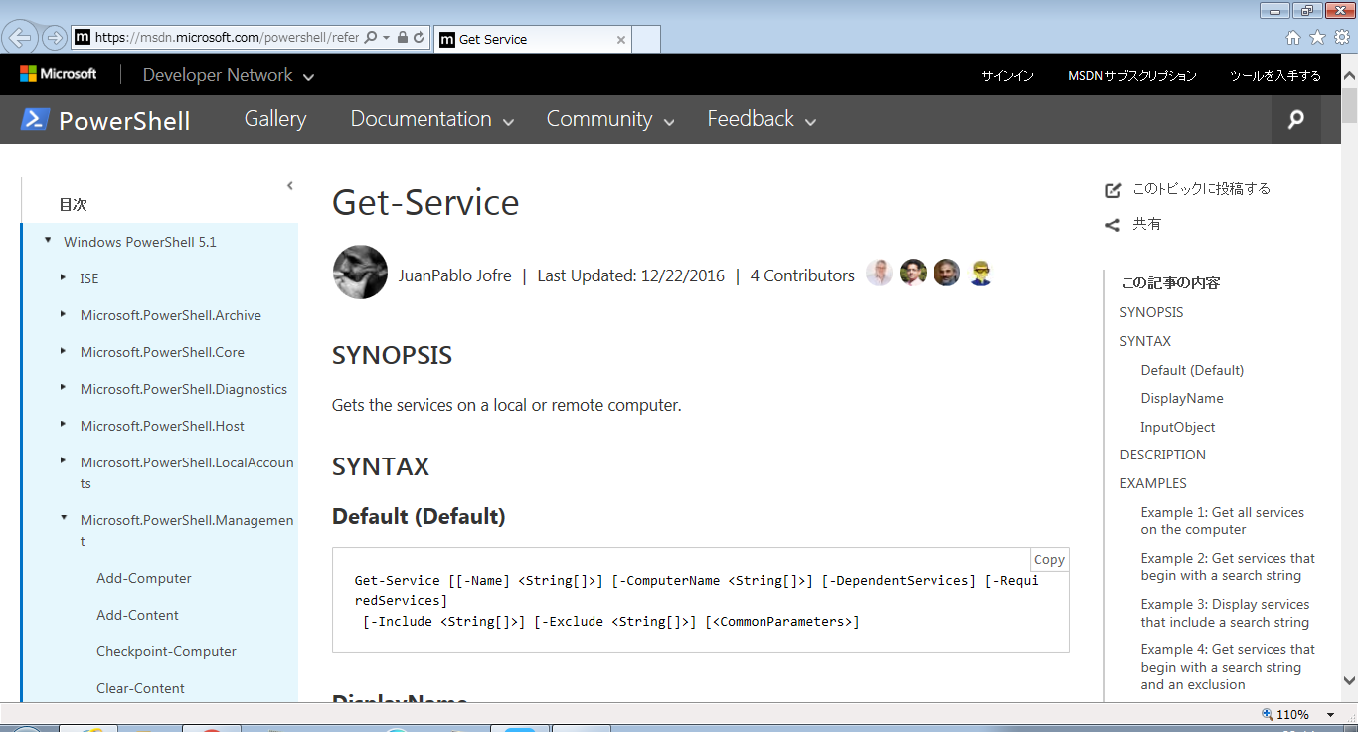

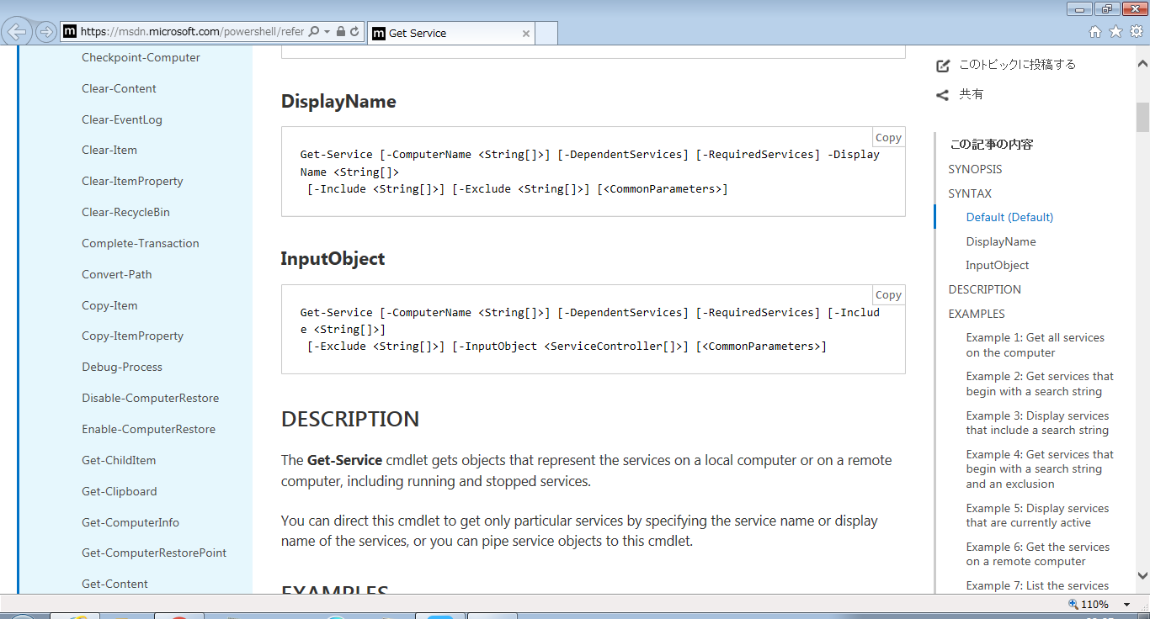

Syntax means the format of this command, and the next level shows the using of these commands. For example we can use get-service -displayname “webclient” to get the service which has the displayname of “webclient”

Get-Process -Name

This command gives us a way to get the process which has the name of something.

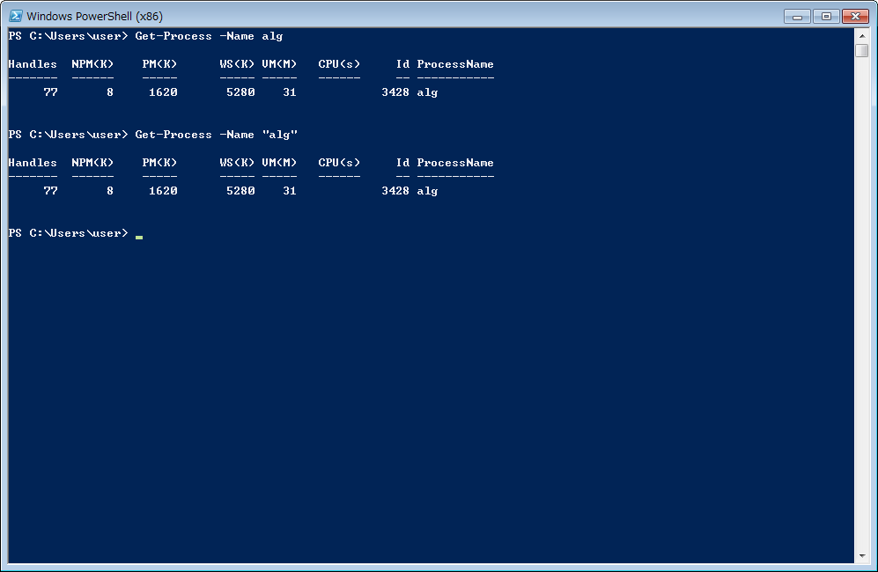

Get-Process -Name XXX | Get-Member
Get-Process -Name XXX | Select-Object *

The most import commands in power shell. Remember it. This gives us a way to know the information of a process and control the process by what the method it provides.

We can control it like this:

- Create a process object by using get-process.
- Get the property or execute the method of the process object by using “.”.
(All the methods and properties about the current process, we can see them in the Get-Process -Name XXX | Get-Member).

