Error Handling In Power Shell

$lastexitcode

shows the last return code in bat process.

Example:

C:\Users\user\Desktop\aa.bat
echo $lastexitcode

Running result:

PS C:\Users\user> C:\Users\user\Desktop\aa.bat
echo $lastexitcode
14

Ecidence

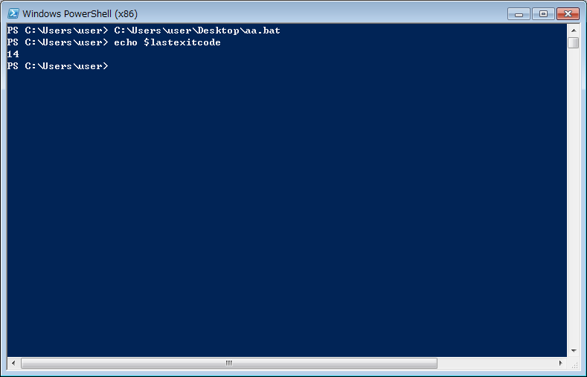

$ErrorActionPreference

Give a handling method when error happens

Values:
1.”stop”
2.”continue”

Default=”continue”

Examples:

Get-Content "not exists"

echo "hoge"

Running result:

Get-Content : Cannot find path 'C:\Users\user\not exists' because it does not exist.
At line:1 char:12
+ Get-Content <<<< "not exists"
+ CategoryInfo : ObjectNotFound: (C:\Users\user\not exists:String) [Get-Co
ntent], ItemNotFoundException
+ FullyQualifiedErrorId : PathNotFound,Microsoft.PowerShell.Commands.GetContentComm
and

hoge

Examples:

$ErrorActionPreference = "stop"
Get-Content "not exists"
echo "hoge"

Running result:

Get-Content "not exists"

echo "hoge"
Cannot find path 'C:\Users\user\not exists' because it does not exist.
At line:3 char:12
+ Get-Content <<<< "not exists"
+ CategoryInfo : ObjectNotFound: (C:\Users\user\not exists:String) [Get-Cont
ent], ItemNotFoundException
+ FullyQualifiedErrorId : PathNotFound,Microsoft.PowerShell.Commands.GetContentComman
D

Examples:

$ErrorActionPreference = "stop" #in order to make the catch block work, you have to value this

try {
Get-Content "not exists"
} catch {
echo "catch!!"
}

echo "hoge"

Running result:

PS C:\Users\user> $ErrorActionPreference = "stop"

try {
Get-Content "not exists"
} catch {
echo "catch!!"
}

echo "hoge"
catch!!
Hoge

Evidence:

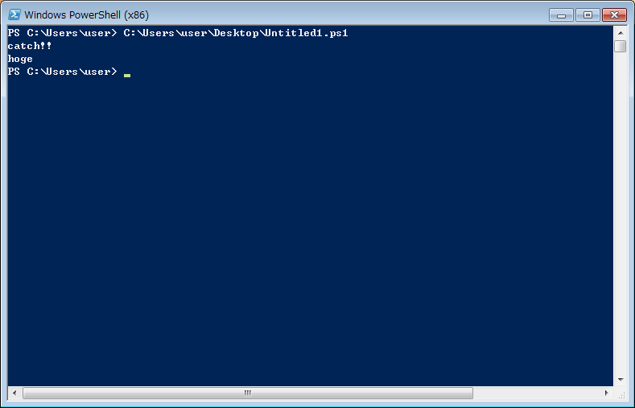

trap

Gives the execution block when error happens.Will only be active in the smallest block of the whole script.And do not need the $erorActionPreference announcing.

Examples:

function Hoge {
throw "test error"

trap {
echo "Hoge trap"
}
}

Hoge
echo "hoge"

trap {
echo "trap"
}

Running Result:

PS C:\Users\user> C:\Users\user\Desktop\Untitled1.ps1
File C:\Users\user\Desktop\Untitled1.ps1 cannot be loaded because the execution of script
s is disabled on this system. Please see "get-help about_signing" for more details.
At line:0 char:0

Evidence:
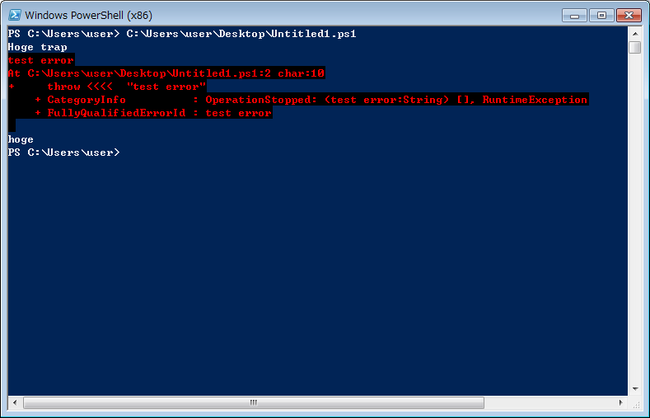

throw

Throw the exception to the stack.And gives a value to the array $error instantly only one time.

Example:

try {
throw "hoge"
} catch {
echo $error[0]
}

Running result:

PS C:\Users\user> try {
throw "hoge"
} catch {
echo $error[0]
}
hoge
At line:2 char:10
+ throw <<<< "hoge"
+ CategoryInfo : OperationStopped: (hoge:String) [], RuntimeException
+ FullyQualifiedErrorId : hoge

Evidence:
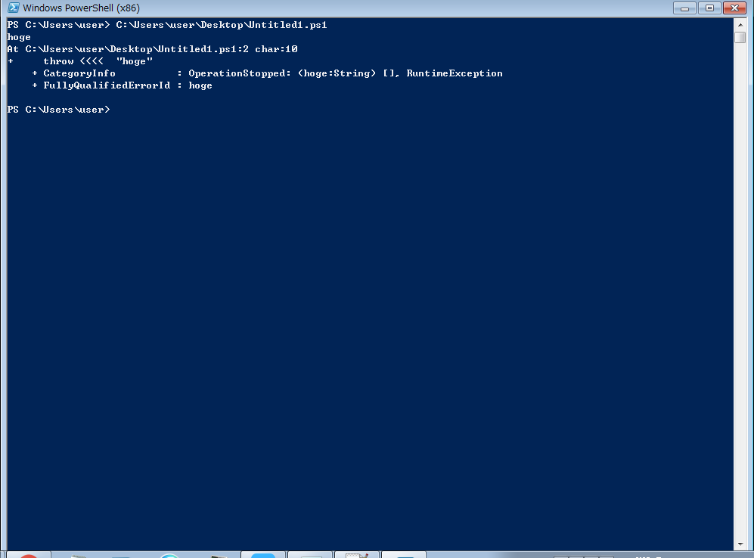

I will update the next blog tomorrow to show the pipe command.This is the most powerful command in Power Shell.

