Powel Shell version 1.0
location:
%SystemRoot%\system32\WindowsPowerShell\v1.0\powershell.exe

Logic Calculation

-and in java the same meaning as &&
-or in java the same meaning as ||
-not / -! in java the same meaning as !

Command Parameter and Param()

Param([Type]args1,[Type]args2..[Type]argsN)

To get parameter from command.
To access a ps1 script file, use command parameter to give the script process a parameter.

examples:
first you have to change the security policy of your os.Use Set-ExecutionPolicy RemoteSigned command:
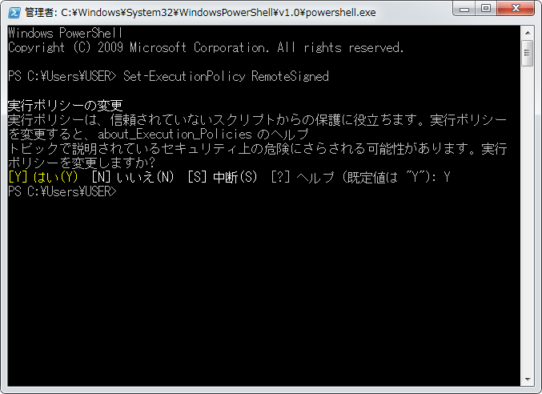

write a power Shell script called test.ps1

+1 Param([string] $one, $two)
+2
+3 echo ($one + ", " + $two)

save it and F5 it in windows power shell ISE. If the running is passed, run it in power shell.exe (version 1.0), the picture below shows the running result of the script:
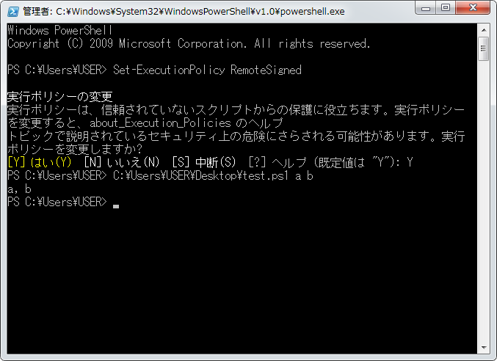

Default Command Parameter

$args used for getting default command parameter in ps1 scripts.

examples:

write a power Shell script called test.ps1
+1 echo ("Type : " + $args.GetType().Name)
+2 echo ("Length : " + $args.Length)
+3 echo ('$args : ' + $args)

save it and F5 it in windows power shell ISE. If the running is passed, run it in power shell.exe (version 1.0), the picture below shows the running result of the script:

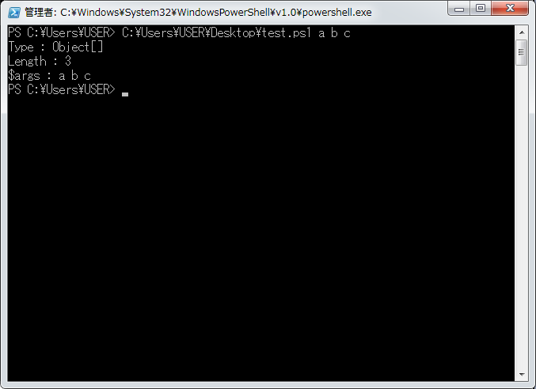

Function Define and Usage

function functionname{
doSomeThing;
}

use this king of format to define a function in power shell, which can be used any times in work space.

examples:

write a power Shell script called test.ps1
+1 function Hoge($a, $b) {
+2 echo ('$a = ' + $a + ", $b = " + $b)
+3 }
+4
+5 Hoge 'aaa' 'bbb'

save it and F5 it in windows power shell ISE. If the running is passed, run it in power shell.exe (version 1.0), the picture below shows the running result of the script:

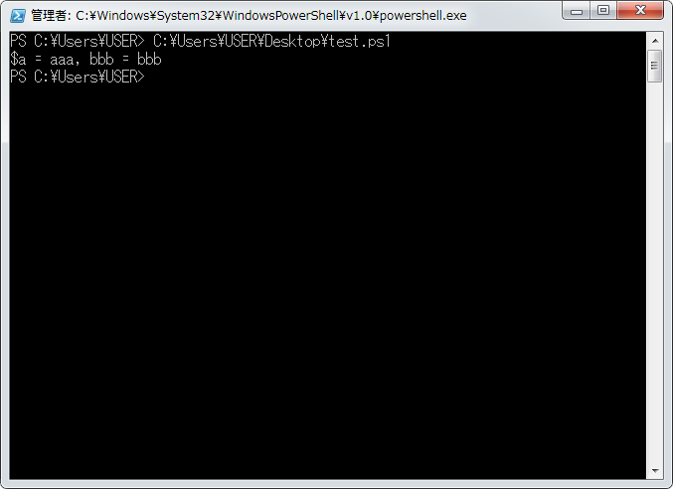

CAUTION:
When using function defined, remember to separate the parameters by space(" ").
Do not use comma(",") because it will become a array.

example:
write a power Shell script called test.ps1
+1 function Hoge($a, $b) {
+2 echo ('$a = ' + $a + ", $b = " + $b)
+3 }
+4
+5 Hoge 'aaa', 'bbb'

save it and F5 it in windows power shell ISE. If the running is passed, run it in power shell.exe (version 1.0), the picture below shows the running result of the script:

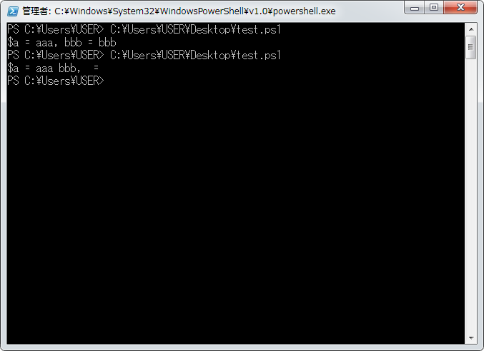

as we see in the running result, it became a array because of using conma.

-param1, param1 -param2, param2 -paramN paramN

use bar mark to educate the parameter name and value mapping relationship.

examples:

write a power Shell script called test.ps1
+1 function TestFunction($a, $b) {
+2 echo ('$a = ' + $a + ', $b = ' + $b)
+3 }
+4
+5 TestFunction -a "hoge" -b "fuga"

save it and F5 it in windows power shell ISE. If the running is passed, run it in power shell.exe (version 1.0), the picture below shows the running result of the script:
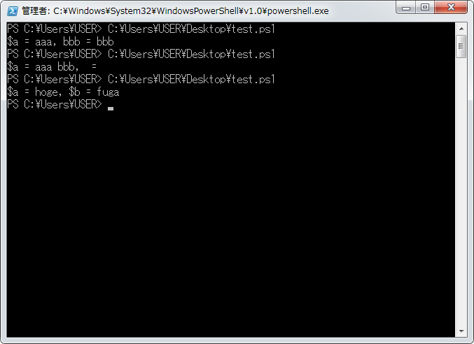

This shows the charactor of this langage. The name of the function parameter has a effect on the running of the command script.

But in the java langage,the args parameter is a array of string like this "String[] args".
In order to get the mapping relationship you have to make a circulation for it to get the parameter, or force user to enter parameters one by one. If you do not know what the user enters, you have to check them one by one or even cut them.

But the same in both powerShell and java is that they all separate by space.

Set the default value of parameters like this.
+1 function Hoge($a, $b=10) {
+2 echo ('$a = ' + $a + ', $b = ' + $b)
+3 }
+4
+5 Hoge
+6 Hoge "aaa"

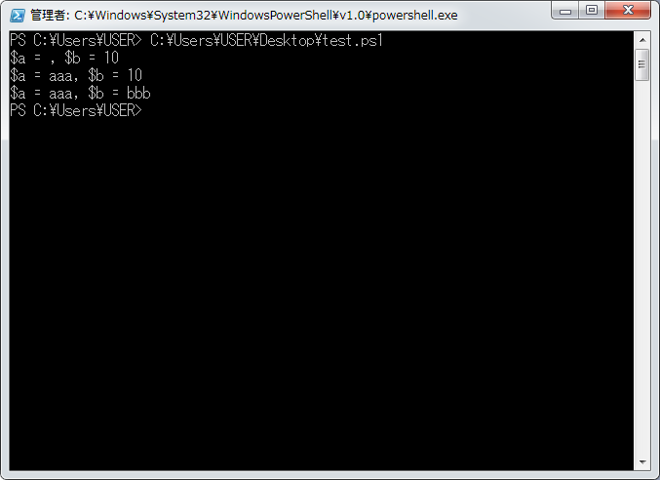

return use "return" to give a return value to the defined function.

examples:

write a power Shell script called test.ps1

- function Hoge {
  - echo "HOGE"
  - return "hoge"
- }

- $result = Hoge

- echo "=================="
- echo $result
- echo "=================="

save it and F5 it in windows power shell ISE. If the running is passed, run it in power shell.exe (version 1.0), the picture below shows the running result of the script:

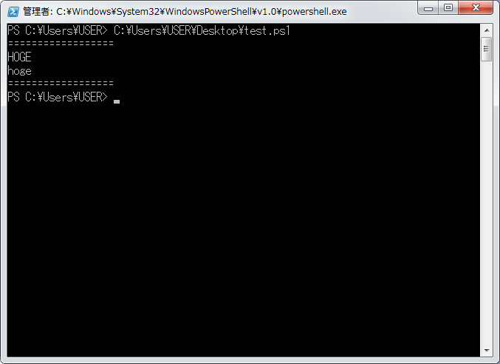
CAUTION
Variables announced in the inner of a function will not be treated as a object which has a memory cost. And it is the same as other languages.

Create a Constant and Use It

set CONSTANT_VALUE [paramname] -option constant
set $CONSTANT_VALUE [paramname] -option constant

while creating a constant value, use "set CONSTANT_VALUE [paramname] -option "("set CONSTANT_VALUE [paramname] -option " is also right)constant.

- set CONSTANT_VALUE "hoge" -option constant
- echo $CONSTANT_VALUE
- $CONSTANT_VALUE = "fuga"

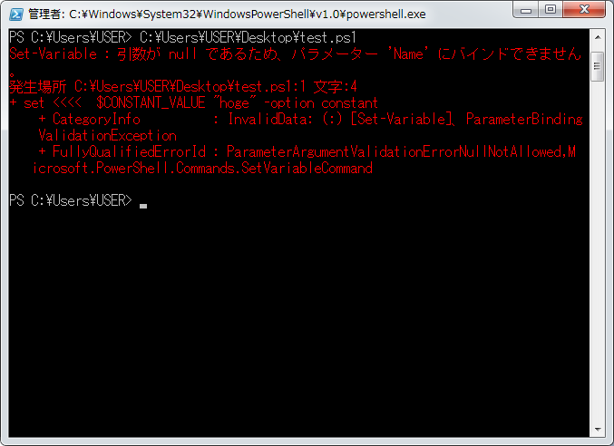

while trying to change the value of a constant, an error will come out because of the value of a constant will never be changed anytime in any situation.

even you want to give the same value to it, this will also cause a problem.
- set CONSTANT_VALUE "hoge" -option constant
- echo $CONSTANT_VALUE
- $CONSTANT_VALUE = "hoge"

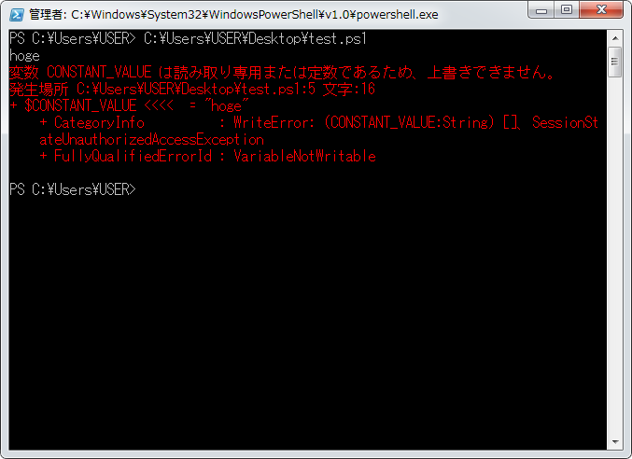
I am sorry for having some personal emotion but I am really poor and I am from the poor place of China. It is very hard for me to be a very excellent engineer and I am so ashamed of this. Now it is Saturday in Tokyo and I worked for 5 days without resting. Even through what I want to do is resting. I have to do some king of no-money-costing entertainment now. Or may be I want to kill myself for some reason.

