What I read in maruzen bookshop in in the nearby of Tokyo station

After a long time of the searching, I finally found the position of the bookshop of Maruzen(Nihonbashi). And I think it is one of the best book shops I ever see in this city. Much better than Bookoff, Takaya or some other shops in Tokyo. Also even better than those I saw in China. Just like Beijing or some places else. This is a great shop for people working in IT field in Tokyo. Here is the map I captured:
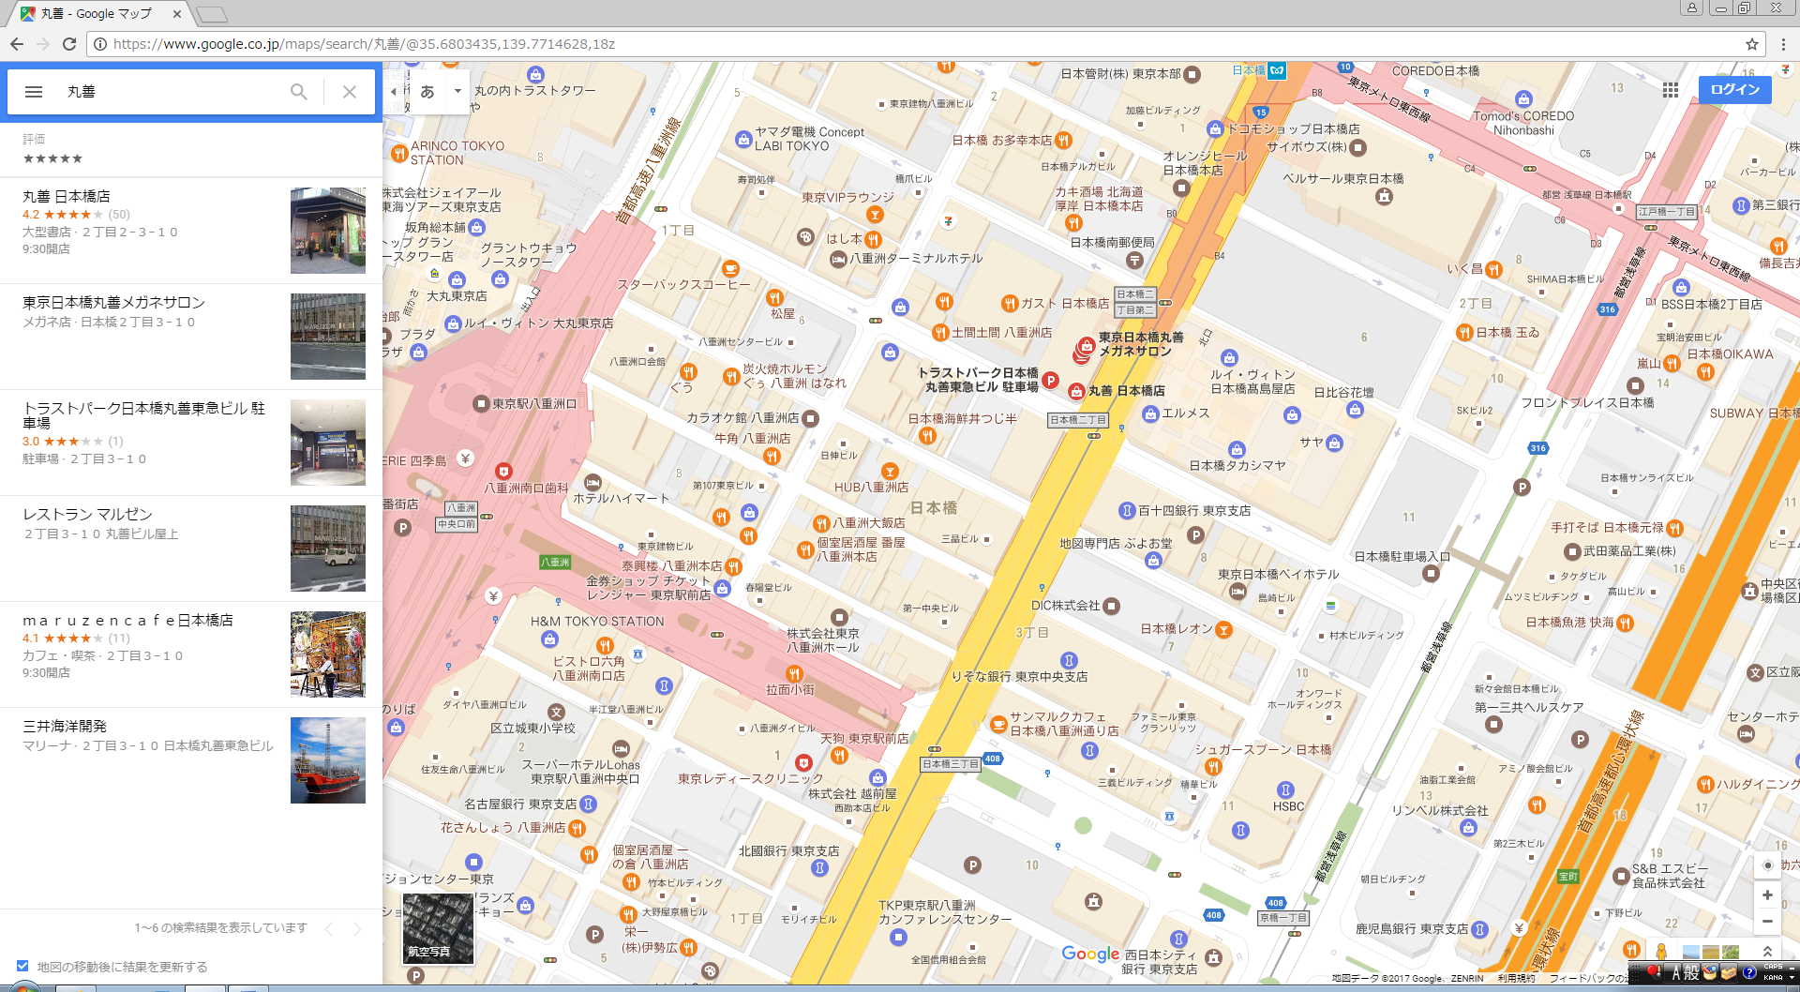

In the bookshop I read a book of writing AI program in python. And it looks great for me because recently I am just studying python. As I am so interested in it, I read caption 1 and learned something more about Python AI.

Input ()(raw_input() in 3.x)

This gives user a chance to input message for computer to read. And the same time shows what is wrote in the program itself. What the user enters will be treated as different kind by judging the “もったいない! last be string!” law.

type():

This shows the data type of the program.

():
This is how python transfer different kinds of input into the type program processing needs. str() means transferring some kinds of int into string As well int() means transfer some other kinds of data into string type in python.

If…elif…else

The if/else in python.

In/ not in

Judge the element is in the collection or not.

Is/is not

Judge the same object or not.
Here is the example of the difference between “= =”.

Example1:

>>> a = "a"
>>> b = "a"
>>> a is b
True
Example2:
>>> [1,2,3] is [1,2,3]
False
>>> (1,2,3) is (1,2,3)
False
Example3:
>>> 1 == True
True
>>> 1 is True
False
Example4:
>>> class NoneisTrue:
... def __eq__(self,other):
... return True
...
>>> none = NoneisTrue()
>>> none == None
True

