A small research on python 2.7.10 running on linux.

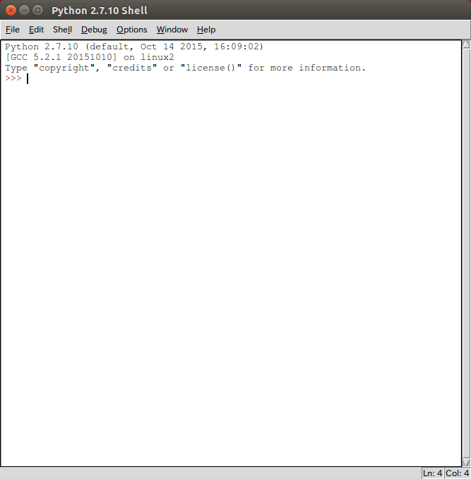
In the right down of this software it shows the line and column. This is greater than SQL-developer or some other softwares.

Here shows some interesting things about this language, it can be used like this.

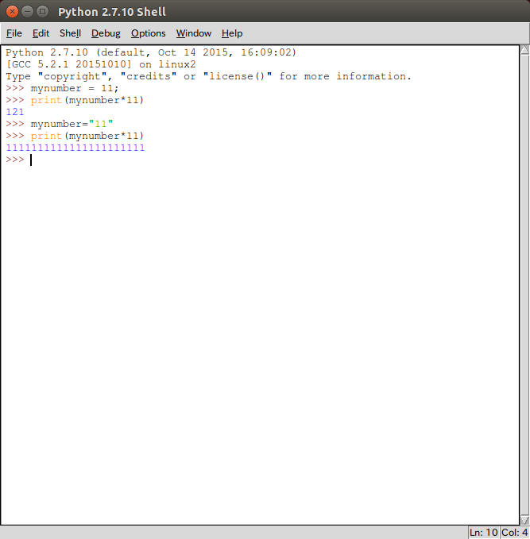
That seems great because it shows what python can do. It is much more stronger than java.

How to debug python

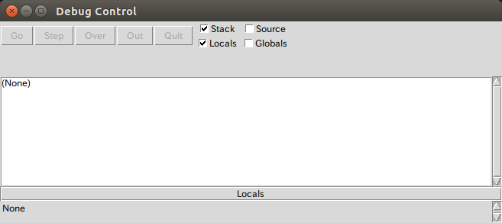
After opening the debug mode we can easily see the properties in this window. After this window appears, we can do the debugs in main window.

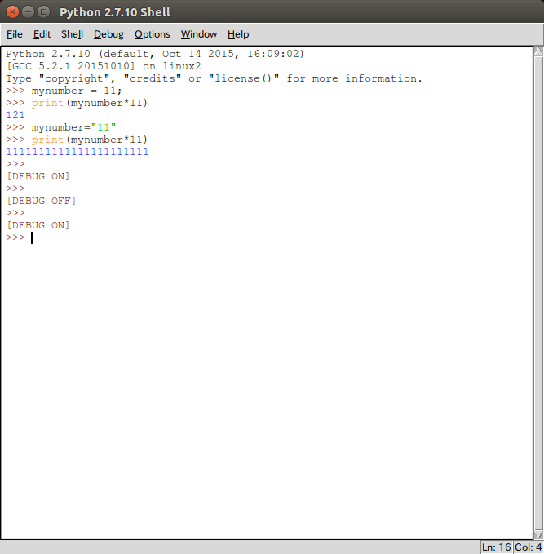

OK, now we entered the debug mode successfully. Let us go on with our next working. Another good way for us to quickly use the methods in this is the ctrl+space. This will show all the methods we can use in a class or something.

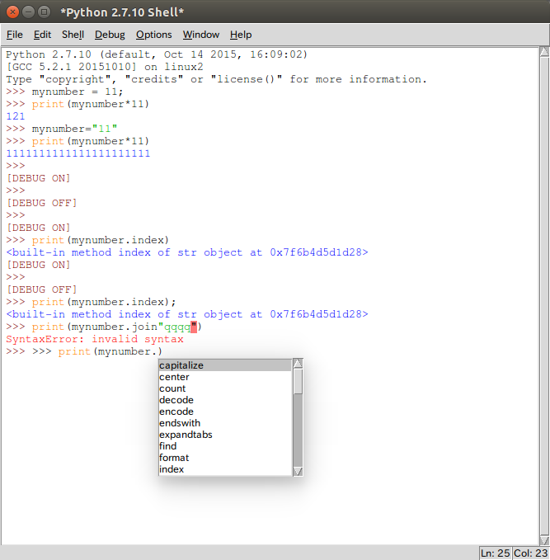
This seems great. Is not it? In fact in a lot of other places we can also use Ctrl+space to get all the methods. Just like HTML , JavaScript and so on.

Good job. This will really make us work faster than ever.

And many other hot buttons are almost the same. And Ctrl+P means printing the text using the default printer.
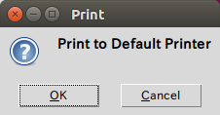

While Ctrl + G and Ctrl+H has the same function of searching something.
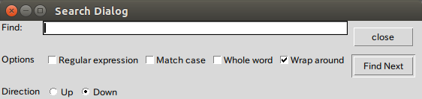

And Ctrl+I means moving award for a long distance while Ctrl+B means moving backward for a long distance.

Good tool. Nice coding.

