The Newest Tkinter Games Made By Shin

It is almost the same boring as what I made before. But any way it works. And this time I am sure I have learned the event binding of <Button-1>, <A>, <a> or some other things like this. What the user inputted will be responded one by one the function binds. Also the create functions of canvas create a id for us to use in the function of canvas’s coords() function to change the position of the objects in canvas.

Also by the canvas.delete(“tagname”), we can delete the name by the tag named when creating widgets while using the create function of canvas. Also we can use canvas.delete(“all”) to delete all objects in canvas. Canvas.update() also gives us a good way to fresh the canvas widget.

Tag_binding seems to be another way to bind events.

Here are the source code and I also uploaded to the sources branch on git-hub.

createBlockAndClear.py

#coding:utf-8
import time
from Tkinter import *

def callback(event):
print "clicked at", event.x, event.y

def handler(event, a, b, c, ob):
'''''事件处理函数'''
print "clicked at", event.x, event.y
print ("creatBox")
points = [event.x - 2.5,event.y - 5,event.x + 2.5,event.y - 5,event.x - 2.5,event.y + 5,event.x + 2.5,event.y + 5]
color= "#476042"
ob.create_polygon(points, outline=color,
fill='yellow', width=3)

def creatBox(event, ob):
'''''事件处理函数'''
print "clicked at", event.x, event.y
print ("creatBox")
points = [event.x - 2.5,event.y - 2.5,event.x + 2.5,event.y - 2.5,event.x - 2.5,event.y + 2.5,event.x + 2.5,event.y + 2.5]
color= "#476042"
ob.create_polygon(points, outline=color,
fill='yellow', width=3)

# it seems that this function does not work very well without any reason
def dance(event, ob):
'''''事件处理函数'''
xPosition = 0
yPosition = 0
#img = PhotoImage(file="/home/shin/デスクトップ/rocks.ppm")
#canvas.create_image(20,20, anchor=NW, image=img)
filename = PhotoImage(file = "C:\Users\user\Desktop\lll.gif")
#while(True):
time.sleep(3)
image = ob.create_image(xPosition, yPosition, anchor=NW, image=filename)
#xPosition += 10
#yPosition += 10

def clr(event, ob):
'''''事件处理函数'''
ob.delete("all")

def handleradaptor(fun, **kwds):
'''''事件处理函数的适配器，相当于中介'''
return lambda event,fun=fun,kwds=kwds: fun(event, **kwds)

class App(object):

def __init__(self,master):
self.com3= Canvas(master,bg="white",width=500,height=500)
self.com3.bind("<Button-1>", handleradaptor(handler, a=1, b=2, c=3, ob=self.com3))
self.com3.bind("<Button-3>", handleradaptor(creatBox, ob=self.com3))
self.com3.bind("<Button-2>", handleradaptor(dance, ob=self.com3))
self.com3.bind("<a>", handleradaptor(clr, ob=self.com3))
self.com3.pack(side=BOTTOM)
self.com3.focus_set()
self.com2=Label(master,text="Life Game")
self.com2.pack(side = BOTTOM)
self.wd=200
root=Tk()
root.title('life game')
app=App(root)
root.mainloop()

tagBind.py

#coding:utf-8
from Tkinter import *

root = Tk()
c0 = Canvas(root, width = 200, height = 150)
c0.pack()
id = c0.create_rectangle(10, 10, 20, 20, fill = 'brown')

def move_rect(event):
x = event.x
y = event.y
c0.coords(id, x - 5, y - 5, x + 5, y + 5)

c0.tag_bind(id, '<Button1-Motion>', move_rect)

root.mainloop()

MySpaceShip.py

#coding:utf-8
import time
from Tkinter import *

def callback(event):
print "clicked at", event.x, event.y

def handler(event, a, b, c, ob):
'''''事件处理函数'''
print "clicked at", event.x, event.y
print ("creatBox")
points = [event.x - 2.5,event.y - 5,event.x + 2.5,event.y - 5,event.x - 2.5,event.y + 5,event.x + 2.5,event.y + 5]
color= "#476042"
ob.create_polygon(points, outline=color,
fill='yellow', width=3)

def creatBox(event, ob):
'''''事件处理函数'''
print "clicked at", event.x, event.y
print ("creatBox")
points = [event.x - 2.5,event.y - 2.5,event.x + 2.5,event.y - 2.5,event.x - 2.5,event.y + 2.5,event.x + 2.5,event.y + 2.5]
ob.update()
color= "#476042"
ob.create_polygon(points, outline=color,
fill='yellow', width=3)

# it seems that this function does not work very well without any reason
def dance(event, ob):
'''''事件处理函数'''
xPosition = 0
yPosition = 0
#img = PhotoImage(file="/home/shin/デスクトップ/rocks.ppm")
#canvas.create_image(20,20, anchor=NW, image=img)
filename = PhotoImage(file = "C:\Users\user\Desktop\lll.gif")
#while(True):
time.sleep(3)
image = ob.create_image(xPosition, yPosition, anchor=NW, image=filename)
#xPosition += 10
#yPosition += 10

def clr(event, ob):
'''''事件处理函数'''
ob.delete("all")

def handleradaptor(fun, **kwds):
'''''事件处理函数的适配器，相当于中介'''
return lambda event,fun=fun,kwds=kwds: fun(event, **kwds)

def myship(event, ob):
ob.delete("all")
'''''事件处理函数'''
points = [event.x - 2.5,event.y - 2.5,event.x + 2.5,event.y - 2.5,event.x - 2.5,event.y + 2.5,event.x + 2.5,event.y + 2.5]
color= "#476042"
ob.create_polygon(points, outline=color,
fill='yellow', width=3, tag="ship")

def leftmoving(event, ob):
ob.delete("ship")
'''''事件处理函数'''
points = [event.x - 3.5,event.y - 3.5,event.x + 1.5,event.y - 3.5,event.x - 3.5,event.y + 1.5,event.x + 1.5,event.y + 1.5]
ob.update()
color= "#476042"
ob.create_polygon(points, outline=color,
fill='yellow', width=3, tag="ship")

class App(object):

def __init__(self,master):
self.com3= Canvas(master,bg="white",width=500,height=500)
#self.com3.bind("<Button-1>", handleradaptor(handler, a=1, b=2, c=3, ob=self.com3))
#self.com3.bind("<Button-3>", handleradaptor(creatBox, ob=self.com3))
self.com3.bind("<Button-1>", handleradaptor(myship, ob=self.com3))
#self.com3.bind("<a>", handleradaptor(clr, ob=self.com3))
self.com3.bind("<a>", handleradaptor(leftmoving, ob=self.com3))
self.com3.pack(side=BOTTOM)
self.com3.focus_set()
self.com2=Label(master,text="Life Game")
self.com2.pack(side = BOTTOM)
self.wd=200
root=Tk()
root.title('life game')
app=App(root)
root.mainloop()

MySpaceShipVersion2.py

#coding:utf-8
import time
from Tkinter import *

shipId = ""

def callback(event):
print "clicked at", event.x, event.y

def handler(event, a, b, c, ob):
'''''事件处理函数'''
print "clicked at", event.x, event.y
print ("creatBox")
points = [event.x - 2.5,event.y - 5,event.x + 2.5,event.y - 5,event.x - 2.5,event.y + 5,event.x + 2.5,event.y + 5]
color= "#476042"
ob.create_polygon(points, outline=color,
fill='yellow', width=3)

def creatBox(event, ob):
'''''事件处理函数'''
print "clicked at", event.x, event.y
print ("creatBox")
points = [event.x - 2.5,event.y - 2.5,event.x + 2.5,event.y - 2.5,event.x - 2.5,event.y + 2.5,event.x + 2.5,event.y + 2.5]
ob.update()
color= "#476042"
ob.create_polygon(points, outline=color,
fill='yellow', width=3)

# it seems that this function does not work very well without any reason
def dance(event, ob):
'''''事件处理函数'''
xPosition = 0
yPosition = 0
#img = PhotoImage(file="/home/shin/デスクトップ/rocks.ppm")
#canvas.create_image(20,20, anchor=NW, image=img)
filename = PhotoImage(file = "C:\Users\user\Desktop\lll.gif")
#while(True):
time.sleep(3)
image = ob.create_image(xPosition, yPosition, anchor=NW, image=filename)
#xPosition += 10
#yPosition += 10

def clr(event, ob):
'''''事件处理函数'''
ob.delete("all")

def handleradaptor(fun, **kwds):
'''''事件处理函数的适配器，相当于中介'''
return lambda event,fun=fun,kwds=kwds: fun(event, **kwds)

def myship(event, ob):
ob.delete("all")
shipId = ob.create_rectangle(10, 10, 20, 20, fill = 'brown')

def leftmoving(event,ob,idd):
ob.coords(idd, 200, 200, 210, 210)

class App(object):

def __init__(self,master):
self.com3= Canvas(master,bg="white",width=500,height=500)
#self.com3.bind("<Button-1>", handleradaptor(handler, a=1, b=2, c=3, ob=self.com3))
#self.com3.bind("<Button-3>", handleradaptor(creatBox, ob=self.com3))
#self.com3.bind("<Button-1>", handleradaptor(myship, ob=self.com3))
#self.com3.bind("<a>", handleradaptor(clr, ob=self.com3))
id = self.com3.create_rectangle(10, 10, 20, 20, fill = 'brown')
self.com3.bind("<a>", handleradaptor(leftmoving, ob=self.com3,idd=id))
self.com3.pack(side=BOTTOM)
self.com3.focus_set()
self.com2=Label(master,text="Life Game")
self.com2.pack(side = BOTTOM)
self.wd=200
root=Tk()
root.title('life game')
app=App(root)
root.mainloop()

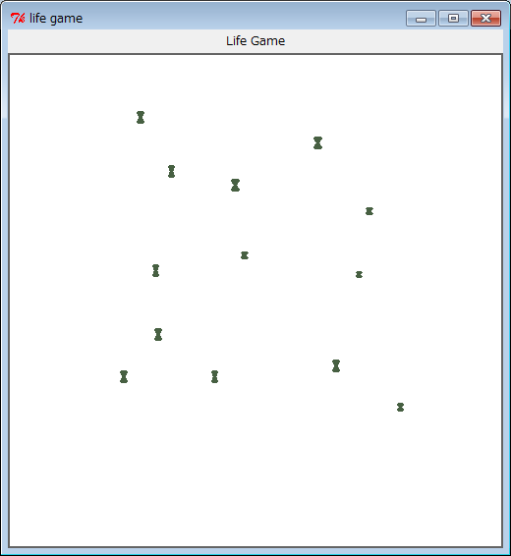

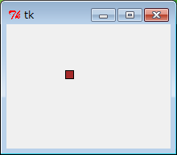

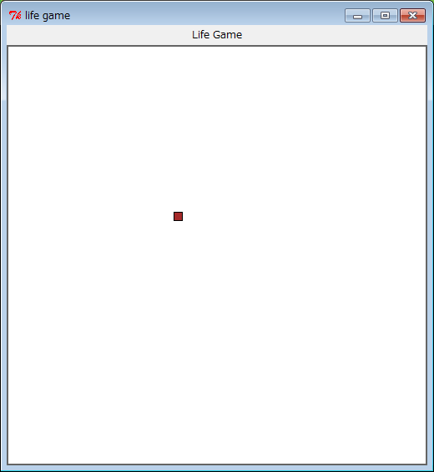

Looks ugly but any way they work and move.

