Tkinter in Python

For monthes I learned Python in many book shops in the street of tokyo. Day after day I try to get a best way to learn more about this popular language and at last I found a very interesting package in Python called Tkinter.

The Tk and Python are mixed in it. Tk is a kind of GUI interface , also used in Ruby or Perl. This is a very popular GUI package. And in Python it is named Tkinter.

To use the Tkinter, you have to use the import command to use the module in IDEL

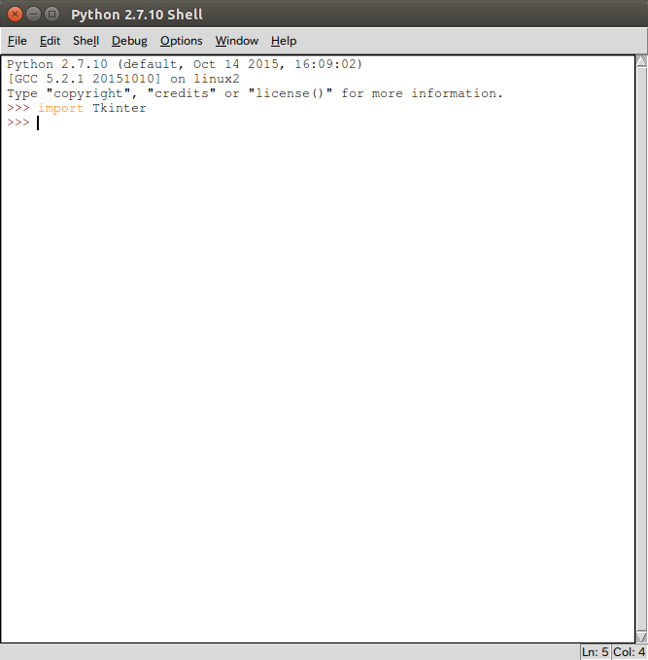

Here are the main objects in Tkinter below;

Button
Canvas
Checkbutton
Entry
Frame
Label
Listbox
Menubotton
Menu
Message
Radiobutton
Scale
Scrollbar
Text
Toplevel
Spinbox

I wrote some kind of sources to show the display of this dialog.

from Tkinter import *

class App(object):
def __init__(self,master):
self.com3= Canvas(master,bg="white",width=200,height=200)
self.com3.create_oval(50,50,150,150,tags="oval")
self.com3.pack(side=BOTTOM)
#self.com3.focus_set()
self.com2=Label(master,text="NicoNico")
self.com2.pack(side = BOTTOM)
self.com=Button(master,text='create a circle', command=self.sayHi())
self.com.pack(side=BOTTOM)
def sayHi(self):
pass
root=Tk()
root.title('window with command')
app=App(root)
root.mainloop()

Because it is written in python. In order to do not destroy any index, I try to make them together because python uses index and changing row as a judgment of blocks.

This shows the result in the window.
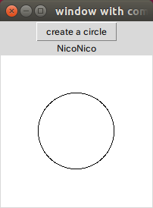

All these properties above shows a good example of how we make this window. We use initial method as a constructor. We use self as the pointer of this object. Also we use something like oval to
make a circle or something.

What I think about this Tkinter package is to have a good thinking of all these belong:
1. Components and the attributes or parameters of them.

2. The position of the components in the windows, also the relationship between them and different windows.

3. The actions of all these components added.

4.The main loop, which is a thread of python and can have a keep-going status for develop OS on line programs just like a game or something.

5.Keep thing all of them as objects.

In the next few blogs I will write some other things about this package and also I will keep on writing new blogs of the power shell commands.

