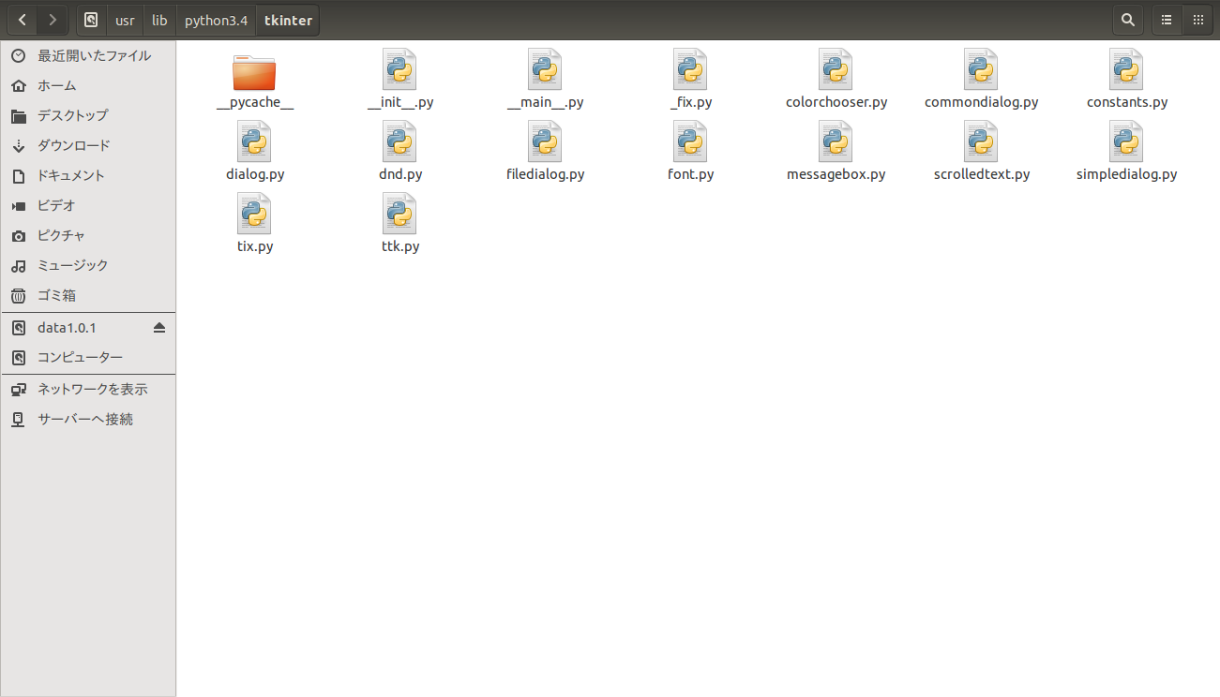
Main Source Codes Of Tkinter

pycache The package of tkinter seems to give a function of cache function to make the effective processing.

Init .py

The introduction of widgets in tkinter:

"""Wrapper functions for Tcl/Tk.

Tkinter provides classes which allow the display, positioning and
control of widgets. Toplevel widgets are Tk and Toplevel. Other
widgets are Frame, Label, Entry, Text, Canvas, Button, Radiobutton,
Checkbutton, Scale, Listbox, Scrollbar, OptionMenu, Spinbox
LabelFrame and PanedWindow.

Properties of the widgets are specified with keyword arguments.
Keyword arguments have the same name as the corresponding resource
under Tk.

Widgets are positioned with one of the geometry managers Place, Pack
or Grid. These managers can be called with methods place, pack, grid
available in every Widget.

Actions are bound to events by resources (e.g. keyword argument
command) or with the method bind.

Example (Hello, World):
import tkinter
from tkinter.constants import *
tk = tkinter.Tk()
frame = tkinter.Frame(tk, relief=RIDGE, borderwidth=2)
frame.pack(fill=BOTH,expand=1)
label = tkinter.Label(frame, text="Hello, World")
label.pack(fill=X, expand=1)
button = tkinter.Button(frame,text="Exit",command=tk.destroy)
button.pack(side=BOTTOM)
tk.mainloop()

I wrote some source codes of the example, it shows the helloworld of tkinter.
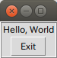

By using import tkinter, it does not work well so I changed the way of using it. Here is the source code.

from Tkinter import *
tk = Tk()
frame = Frame(tk, relief=RIDGE, borderwidth=2)
frame.pack(fill=BOTH,expand=1)
label = Label(frame, text="Hello, World")
label.pack(fill=X, expand=1)
button = Button(frame,text="Exit",command=tk.destroy)
button.pack(side=BOTTOM)
tk.mainloop()

Introductions of the event parts:

"""Container for the properties of an event.

Instances of this type are generated if one of the following events occurs:

KeyPress, KeyRelease - for keyboard events
ButtonPress, ButtonRelease, Motion, Enter, Leave, MouseWheel - for mouse events
Visibility, Unmap, Map, Expose, FocusIn, FocusOut, Circulate,
Colormap, Gravity, Reparent, Property, Destroy, Activate,
Deactivate - for window events.

If a callback function for one of these events is registered
using bind, bind_all, bind_class, or tag_bind, the callback is
called with an Event as first argument. It will have the
following attributes (in braces are the event types for which
the attribute is valid):

serial - serial number of event
num - mouse button pressed (ButtonPress, ButtonRelease)
focus - whether the window has the focus (Enter, Leave)
height - height of the exposed window (Configure, Expose)
width - width of the exposed window (Configure, Expose)
keycode - keycode of the pressed key (KeyPress, KeyRelease)
state - state of the event as a number (ButtonPress, ButtonRelease,
Enter, KeyPress, KeyRelease,
Leave, Motion)
state - state as a string (Visibility)
time - when the event occurred
x - x-position of the mouse
y - y-position of the mouse
x_root - x-position of the mouse on the screen
(ButtonPress, ButtonRelease, KeyPress, KeyRelease, Motion)
y_root - y-position of the mouse on the screen
(ButtonPress, ButtonRelease, KeyPress, KeyRelease, Motion)
char - pressed character (KeyPress, KeyRelease)
send_event - see X/Windows documentation
keysym - keysym of the event as a string (KeyPress, KeyRelease)
keysym_num - keysym of the event as a number (KeyPress, KeyRelease)
type - type of the event as a number
widget - widget in which the event occurred
delta - delta of wheel movement (MouseWheel)

In the design of this package, it alse used call back just like javascript or other kinds of programming languages.

Introduction of event sequence of tkinter:

"""Bind to this widget at event SEQUENCE a call to function FUNC.

SEQUENCE is a string of concatenated event
patterns. An event pattern is of the form
<MODIFIER-MODIFIER-TYPE-DETAIL> where MODIFIER is one
of Control, Mod2, M2, Shift, Mod3, M3, Lock, Mod4, M4,
Button1, B1, Mod5, M5 Button2, B2, Meta, M, Button3,
B3, Alt, Button4, B4, Double, Button5, B5 Triple,
Mod1, M1. TYPE is one of Activate, Enter, Map,
ButtonPress, Button, Expose, Motion, ButtonRelease
FocusIn, MouseWheel, Circulate, FocusOut, Property,
Colormap, Gravity Reparent, Configure, KeyPress, Key,
Unmap, Deactivate, KeyRelease Visibility, Destroy,
Leave and DETAIL is the button number for ButtonPress,
ButtonRelease and DETAIL is the Keysym for KeyPress and
KeyRelease. Examples are
<Control-Button-1> for pressing Control and mouse button 1 or
<Alt-A> for pressing A and the Alt key (KeyPress can be omitted).
An event pattern can also be a virtual event of the form
<<AString>> where AString can be arbitrary. This
event can be generated by event_generate.
If events are concatenated they must appear shortly
after each other.

FUNC will be called if the event sequence occurs with an
instance of Event as argument. If the return value of FUNC is
"break" no further bound function is invoked.

An additional boolean parameter ADD specifies whether FUNC will
be called additionally to the other bound function or whether
it will replace the previous function.

Bind will return an identifier to allow deletion of the bound function with
unbind without memory leak.

If FUNC or SEQUENCE is omitted the bound function or list
of bound events are returned."""

The left parts of the files in Tkinter are not too much and we can see they are all-most above the ideas above. And the dnd meams drop-and-down. And tix means expanding of python it self. Ttk means the expanding of tk it self. And what is about tk? We know tkinter is a mix of tk and python, tk is a very old gui package and in the file of tix and ttk it shows this very well.

