More Functions About Using Canvas Tkinter Of Python

It is 3:00 am in the middle night and I am using python to create some GUI functions by canvas.

These are the sources below.

Window.py

#coding:utf-8
from Tkinter import *

class App(object):

def __init__(self,master):
self.canvas_width=200
self.canvas_height=200
self.python_green = "#476042"
self.name1 = 'create a mass'
self.name2 = 'create a polygon'
self.name3 = 'create bitmap group'
self.name4 = 'create a star'
self.name5 = 'create a img'
self.com3= Canvas(master,bg="white",width=200,height=200)
self.com3.create_oval(50,50,150,150,tags="oval")
#self.com3.create_rectangle(10,10,30,30,fill="#234134")
self.com3.pack(side=BOTTOM)
self.com3.focus_set()
self.com2=Label(master,text="NicoNico")
self.com2.pack(side = BOTTOM)
self.com=Button(master,text=self.name1, command=self.sayHi)
self.com.pack(side=BOTTOM)
self.com4=Button(master,text=self.name2, command=self.makepolygon)
self.com4.pack(side=BOTTOM)
self.com5=Button(master,text=self.name3, command=self.createBitmapgroup)
self.com5.pack(side=BOTTOM)
self.com6=Button(master,text=self.name4, command=self.createStar)
self.com6.pack(side=BOTTOM)
self.com7=Button(master,text=self.name5, command=self.createImg)
self.com7.pack(side=BOTTOM)
self.wd=200
def sayHi(self):
self.com3.create_rectangle(11,11,40,40,fill="#674567")
self.com3.create_line(1,1,15,15)
def makepolygon(self):
width = 200
height = 200
color= "#476042"
points = [0,0,width,width/2, 0, height]
self.com3.create_polygon(points, outline=color,
fill='yellow', width=3)
def createBitmapgroup(self):
#create bitmap in canvas,listting all the bitmaps
bitmaps = ["error", "gray75", "gray50", "gray25", "gray12", "hourglass", "info", "questhead", "question", "warning"]
nsteps = len(bitmaps)
step_x = int(200 / nsteps)
for i in range(0, nsteps):
self.com3.create_bitmap((i+1)*step_x - step_x/2,50, bitmap=bitmaps[i])
def createStar(self):
color= "#476042"
points = [100, 140, 110, 110, 140, 100, 110, 90, 100, 60, 90, 90, 60, 100, 90, 110]
self.com3.create_polygon(points, outline=color,
fill='yellow', width=3)
def createImg(self):
photo = PhotoImage(file = '/home/shin/デスクトップ/32847b7bd7a1adbdf1e72e41784b6427(1).gif')
self.com3.create_image(100,100, image=photo)

root=Tk()
root.title('window with command')
app=App(root)
root.mainloop()

It is great because it always keeps the index in python.
Using the script in terminal, and this is what appears in the window.

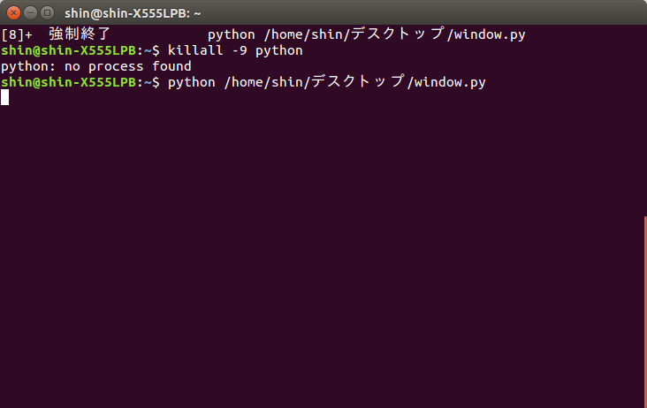

It looks simple and only has a circle in the middle. And after we click some kind of buttons below, it will become more interesting.
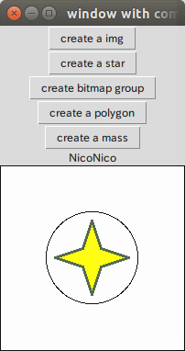
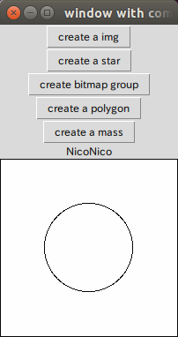
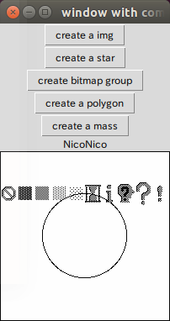

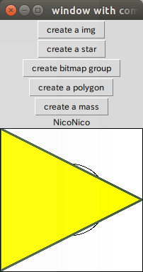
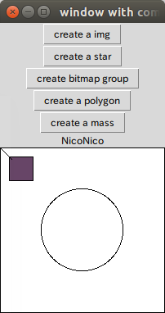

here are the main methods I used in this canvas.

Canvas.create_rectangle
Canvas.create_rectangle
Canvas.create_line
Canvas.create_polygon
Canvas.create_bitmap
Canvas.create_image

All there methods above shows a good display. And when using polygon we have to make a array of points to around a area. So we can fill some color. All these points are defined as a array of points like “points = [100, 140, 110, 110, 140, 100, 110, 90, 100, 60, 90, 90, 60, 100, 90, 110]”.

windows2.py

#coding:utf-8
from Tkinter import *

canvas_width = 300
canvas_height =300

master = Tk()

canvas = Canvas(master,
width=canvas_width,
height=canvas_height)
canvas.pack()

img = PhotoImage(file="/home/shin/デスクトップ/rocks.ppm")
canvas.create_image(20,20, anchor=NW, image=img)

mainloop()

Open it in terminal:
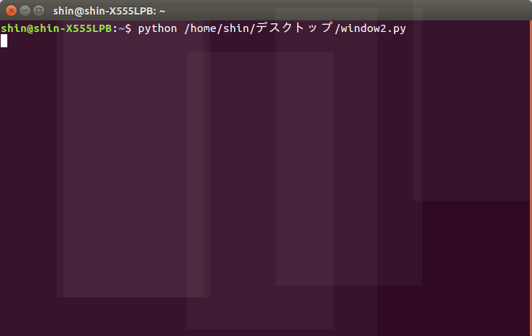
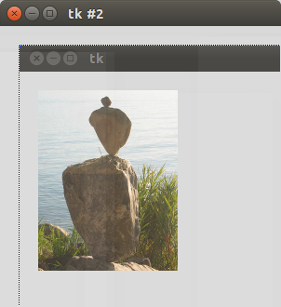

Ok,good job. Canvas can analysis pmm picture as well.

