Using chmod To Solve Github File Up-loadable Problem

Today I found a small bug while using github to upload a file from local. When I try to know the reason I found I changed the accessibility of the file.So the github cannot receive it.

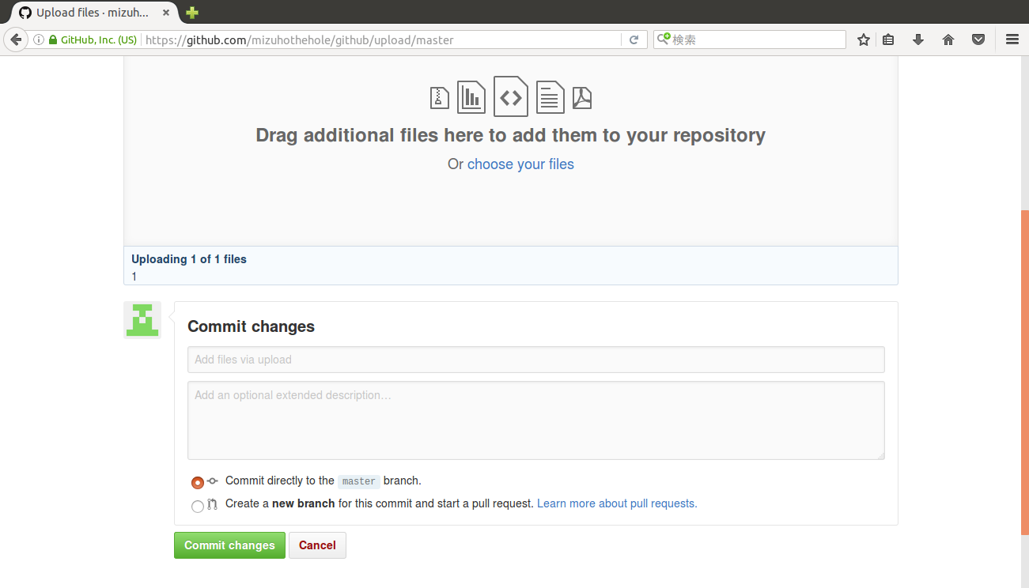

So I did this to complete what I want to do.

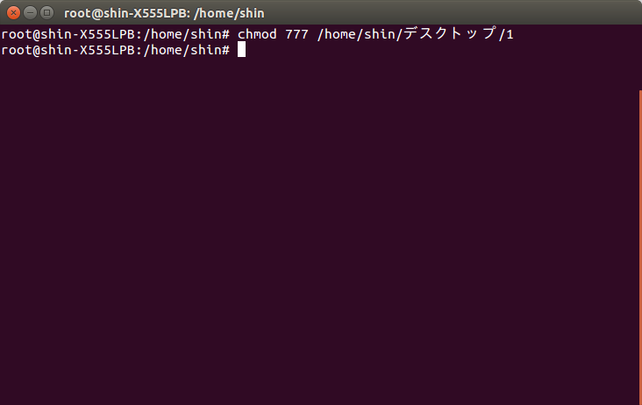
And as we see below it is uploaded successfully. The reason of why it can not be uploaded is that the accessibility of this file is not enough. And we can easily use the chmod 777 to resolve this problem. The command means a lot. First the 7 means 4+2+1, which is the meaning of 4-read,2-write,1-execute. And the 777 means the different users. The first 7 is the user it self. The second 7 is the user group the user is in. And the third is the other users. In Linux it uses user group as well.

Do not use chmod xxx -777 because it may cause dangerous result.

