CrewAI Patient-Centric Healthcare Booking System

High-Level Design (HLD):

1. System Overview
This document describes the High-Level Design (HLD) of a CrewAI-based healthcare platform focused on patient ease, affordability, hospital choice, and optimized doctor booking. The system uses a multi-agent architecture where each agent is responsible for a distinct decision domain, orchestrated sequentially using CrewAI.

2. System Architecture

Overall Architecture Diagram
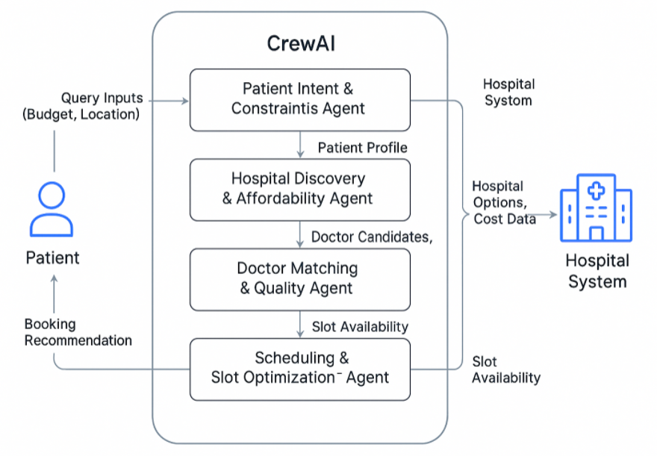

3. Architectural Components

Patient Context Agent
Captures patient intent, constraints, budget, insurance, and urgency.

Hospital Affordability Agent
Ranks hospitals based on cost, distance, insurance acceptance, and ratings.

Doctor Matching Agent
Matches doctors by specialty, experience, quality, and consultation fees.

Scheduling & Slot Optimization Agent
Optimizes appointment slots to minimize wait time and congestion.

Recommendation & Booking Agent
Explains trade-offs, finalizes selection, and triggers booking workflows.

4. Data Flow
1. User submits a natural language query.
2. Patient Context Agent extracts structured constraints.
3. Hospital Affordability Agent filters and ranks hospitals.
4. Doctor Matching Agent identifies suitable doctors.
5. Slot Optimization Agent selects optimal appointment slots.
6. Recommendation Agent explains options and completes booking.

5. External Integrations
- Hospital Information Systems (HIS)
- Doctor Scheduling & Availability APIs
- Payment Gateways
- Notification Services (SMS, Email, WhatsApp)
- Insurance & Government Scheme Databases

6. Non-Functional Requirements
Category | Requirement
Performance | < 2 seconds response time for recommendations
Scalability | Horizontal scaling of agents and services
Availability | 99.9% uptime
Security | Encryption in transit and at rest
Compliance | HIPAA / India DPDP alignment

7. Security & Compliance
The system enforces strict access controls, audit logging, encrypted data storage, and consent-based data sharing. Personally identifiable health information is processed only by authorized agents and services.

8. Deployment Overview
The platform is deployed using containerized microservices. CrewAI agents run as stateless services, with centralized orchestration, shared data stores, and API gateways. The system supports cloud-native deployment on AWS, Azure, or GCP.

9. Error Handling & Logging
- Structured logs (JSON)
- Correlation ID per request
- Retry logic for external APIs

10. Security Design
- JWT-based authentication
- Role-based access (Patient, Admin)
- Encryption at rest and in transit

11. Deployment Details
- Each agent as stateless service
- Horizontal Pod Autoscaling
- API Gateway in front of FastAPI

12. Technology Stack:
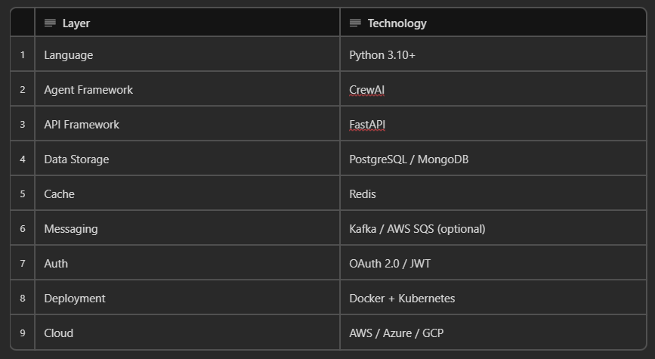
Low-Level Design (LLD)

1.1 Purpose
This Low-Level Design (LLD) document provides detailed technical specifications for implementing the CrewAI Patient-Centric Healthcare Booking System. It translates the High-Level Design (HLD) into concrete modules, classes, APIs, data structures, and execution flows required for development.
1.2 Scope
The LLD covers:
- Agent-level design (CrewAI agents)
- Task orchestration
- Tool and service interfaces
- Data models and schemas
- API contracts
- Error handling, logging, and observability
- Deployment-level technical considerations

2. Technology Stack
Layer | Technology
Language | Python 3.10+
Agent Framework | CrewAI
API Framework | FastAPI
Data Storage | PostgreSQL / MongoDB
Cache | Redis
Messaging | Kafka / AWS SQS (optional)
Auth | OAuth 2.0 / JWT
Deployment | Docker + Kubernetes
Cloud | AWS / Azure / GCP

3. Module-Level Design
3.1 Project Structure
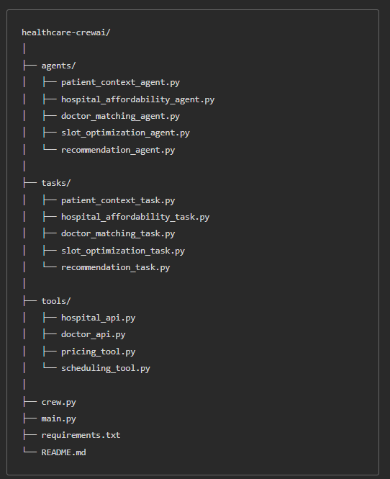

4. Agent-Level Design
4.1 Patient Context & Ease Agent
File: agents/patient_context_agent.py
Responsibilities
- Parse natural language input
- Extract structured patient constraints
Input
{ "query": "string" }
Output
{
"condition": "string",
"specialty": "string",
"location": "string",
"budget_min": number,
"budget_max": number,
"insurance_type": "string",
"urgency": "Routine | Urgent"
}
Failure Handling
- Missing fields → apply defaults
- Ambiguous symptoms → ask clarification

4.2 Hospital Choice & Affordability Agent
File: agents/hospital_affordability_agent.py
Responsibilities
- Query hospital registry
- Compute affordability score
Affordability Formula (Example)$Score = w_1 \cdot cost + w_2 \cdot distance + w_3 \cdot rating$
Output
[
{
"hospital_id": "uuid",
"cost": number,
"distance_km": number,
"insurance_supported": true,
"affordability_score": number
}
]

4.3 Doctor Matching & Quality Agent
File: agents/doctor_matching_agent.py
Responsibilities
- Fetch doctors per hospital
- Rank by experience, rating, and fee
Doctor Ranking Logic$Rank = 0.4 \cdot experience + 0.4 \cdot rating - 0.2 \cdot fee$
Output
[
{
"doctor_id": "uuid",
"hospital_id": "uuid",
"experience_years": number,
"rating": number,
"fee": number
}
]

4.4 Scheduling & Slot Optimization Agent
File: agents/slot_optimization_agent.py
Responsibilities
- Fetch real-time slots
- Predict congestion
Slot Selection Rules
- Prefer earliest slot
- Avoid peak congestion
Output
{
"doctor_id": "uuid",
"recommended_slot": "datetime",
"alternate_slots": ["datetime"]
}

4.5 Recommendation & Booking Agent
File: agents/recommendation_agent.py
Responsibilities
- Compare final options
- Generate explanation
- Trigger booking service
Output
{
"selected_option": "doctor_id",
"reason": "string",
"booking_status": "CONFIRMED"
}

5. Task Design
Each agent is wrapped by a CrewAI Task.
Example:
Task(
description="Extract structured patient context",
agent=PatientContextAgent,
expected_output="JSON"
)
Tasks are executed sequentially.

6. Tool & Service Design
6.1 Hospital API Tool
File: tools/hospital_api.py
Methods
- get_hospitals(location)
- get_pricing(hospital_id, specialty)

6.2 Doctor API Tool
File: tools/doctor_api.py
Methods
- get_doctors(hospital_id, specialty)
- get_ratings(doctor_id)

6.3 Scheduling Tool
File: tools/scheduling_tool.py
Methods
- get_slots(doctor_id)
- book_slot(slot_id)

7. Data Model Design
7.1 Hospital Table
Field | Type
hospital_id | UUID
name | String
location | Geo
avg_cost | Integer
rating | Float

7.2 Doctor Table
Field | Type
doctor_id | UUID
hospital_id | UUID
specialty | String
experience_years | Integer
fee | Integer

8. API Design (FastAPI)
8.1 Book Appointment
Endpoint: POST /appointments
Request
{ "query": "string" }
Response
{ "booking_id": "uuid", "status": "CONFIRMED" }

9. Error Handling & Logging
- Structured logs (JSON)
- Correlation ID per request
- Retry logic for external APIs

10. Security Design
- JWT-based authentication
- Role-based access (Patient, Admin)
- Encryption at rest and in transit

11. Deployment Details
- Each agent as stateless service
- Horizontal Pod Autoscaling
- API Gateway in front of FastAPI

12. Non-Functional Mapping
Requirement | Implementation
Scalability | Kubernetes + HPA
Performance | Redis caching
Availability | Multi-zone deployment

13. Assumptions & Constraints
- External hospital systems provide APIs
- Pricing data is approximate
- Human override supported for edge cases
Sequence Diagram

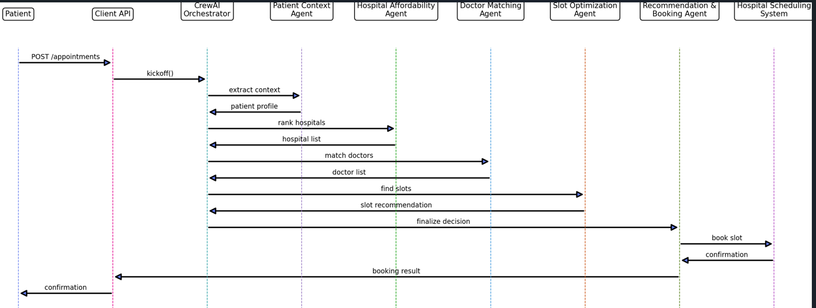

Deployment Guide

Core AWS Architecture (Recommended Baseline)
Compute
EKS (Elastic Kubernetes Service) – preferred
OR
ECS + Fargate – simpler, if you want less ops
Why EKS fits your design
- Each CrewAI agent = stateless microservice
- Horizontal Pod Autoscaling works well
- Clean separation between API, orchestration, agents
✅ Note down
- One Kubernetes namespace per environment (dev / qa / prod)
- Separate deployments for:
  - FastAPI backend
  - CrewAI Orchestrator
  - Each Agent (optional but recommended for scale)

2️⃣ Networking (Very Important for Healthcare)
VPC Design
- Private subnets for:
  - EKS worker nodes
  - Databases
- Public subnets only for:
  - ALB / NLB
✅ Note down
- No direct internet access to agents or DB
- NAT Gateway for outbound calls (hospital APIs)

3️⃣ API Entry Layer
API Gateway vs ALB
Recommended:
- ALB → FastAPI
- API Gateway only if you need throttling + auth at edge
✅ Note down
- ALB Ingress Controller for EKS
- Path-based routing:
  - /appointments
  - /health
  - /admin

4️⃣ Authentication & Authorization
Auth
- Amazon Cognito (patients, admins)
- JWT passed to FastAPI
✅ Note down
- Token validated at API layer
- Agent services are not publicly accessible
- IAM roles for service-to-service calls (IRSA)

5️⃣ Data Layer
Databases
- RDS (PostgreSQL) → transactional data
- DynamoDB → fast lookups, metadata
- Redis (ElastiCache) → caching, slot availability
✅ Note down
- Multi-AZ RDS
- Read replicas if traffic grows
- TTL on cache entries (slots, pricing)

6️⃣ Secrets & Configuration (Critical)
Secrets
- AWS Secrets Manager
  - DB credentials
  - API keys (hospital systems)
Config
- SSM Parameter Store
✅ Note down
- Never bake secrets into containers
- Inject via environment variables
- Rotate secrets automatically

7️⃣ Observability (LLD Must-Have)
Logging
- CloudWatch Logs
- JSON structured logs
Tracing
- AWS X-Ray (or OpenTelemetry)
✅ Note down
- Correlation ID propagated:
  - API → CrewAI → Agents → External APIs
- Per-agent latency metrics

8️⃣ Scaling Rules (Agent-Specific)
✅ Note down concrete rules
- FastAPI: scale on RPS
- CrewAI Orchestrator: scale on CPU
- Agent pods:
  - Scale on execution latency
  - Upper bounds to avoid cost spikes
Example:
minPods: 2
maxPods: 10
targetCPUUtilization: 65%

9️⃣ External Hospital API Access
✅ Note down
- Circuit breaker per hospital API
- Retry with exponential backoff
- Fallback to cached data
- Timeout limits (e.g. 2–3 seconds)
This is mandatory in healthcare systems.

🔐 10️⃣ Security & Compliance (AWS-Specific)
✅ Explicitly note
- Encryption at rest:
  - RDS
  - S3
  - Secrets Manager
- Encryption in transit:
  - TLS everywhere
- IAM least-privilege roles
- CloudTrail enabled (audit logs)
For India:
- Align with DPDP Act
- Data residency: ap-south-1

11️⃣ CI/CD (Production-Grade)
✅ Recommended
- GitHub Actions / CodePipeline
- Steps:
  - Lint + test
  - Build Docker images
  - Push to ECR
  - Deploy via Helm
✅ Note down
- One Helm chart per service
- Versioned deployments
- Blue/Green or Canary for API

12️⃣ Cost & Safety Controls (Often Missed)
✅ Note down
- Pod resource limits
- API rate limits
- Budget alarms
- Separate AWS accounts per env

AWS Deployment Details
15.1 Target AWS Region
- Primary Region: ap-south-1 (Mumbai) for India data residency
- Multi-AZ enabled for all stateful services

15.2 Compute & Orchestration
Preferred Option: Amazon EKS
- FastAPI Backend → Kubernetes Deployment
- CrewAI Orchestrator → Kubernetes Deployment
- Each CrewAI Agent → Independent Kubernetes Deployment (recommended for scale)
Node Strategy
- Managed Node Groups
- Separate node groups for:
  - API + Orchestrator
  - Agent workloads

15.3 Networking
- Dedicated VPC
- Public Subnets:
  - Application Load Balancer (ALB)
- Private Subnets:
  - EKS worker nodes
  - RDS / ElastiCache
- NAT Gateway for outbound hospital API access

15.4 Ingress & Traffic Management
- ALB Ingress Controller for EKS
- Path-based routing:
  - /appointments
  - /health
  - /admin

15.5 Authentication & Authorization
- Amazon Cognito for patient and admin identities
- JWT validation at FastAPI layer
- IAM Roles for Service Accounts (IRSA) for agent-to-AWS access

15.6 Data Layer
- Amazon RDS (PostgreSQL)
  - Multi-AZ
  - Automated backups
- Amazon ElastiCache (Redis)
  - Slot availability caching
  - Pricing cache with TTL
- Optional: DynamoDB for metadata lookups

15.7 Secrets & Configuration
- AWS Secrets Manager:
  - DB credentials
  - Hospital API keys
- AWS Systems Manager Parameter Store:
  - Non-secret configuration

15.8 Observability
- CloudWatch Logs (structured JSON)
- CloudWatch Metrics per service
- AWS X-Ray or OpenTelemetry for tracing
- Correlation ID propagated across API → Orchestrator → Agents

15.9 Auto Scaling
- Horizontal Pod Autoscaler (HPA)
- Scaling signals:
  - FastAPI: Request rate
  - Orchestrator: CPU
  - Agents: Execution latency

15.10 External Hospital API Resilience
- Circuit breakers per hospital API
- Retry with exponential backoff
- Hard timeouts (2–3 seconds)
- Cache-based fallback

15.11 Security & Compliance
- TLS everywhere (in-transit encryption)
- Encryption at rest for RDS, Redis, Secrets
- IAM least-privilege policies
- CloudTrail enabled for audit logs
- Alignment with India DPDP Act

15.12 CI/CD
- GitHub Actions or AWS CodePipeline
- Steps:
  - Lint & test
  - Build Docker images
  - Push to Amazon ECR
  - Deploy via Helm

15.13 Cost & Safety Controls
- Pod CPU/memory limits
- API rate limiting
- AWS Budgets + alerts
- Separate AWS accounts per environment

