Title Heading Level 01[Author]

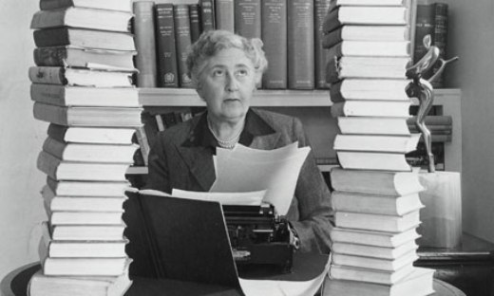

Title Heading Level 2 [Series]
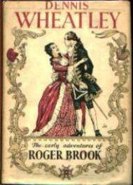

Title Heading Level 03 [Book]
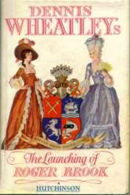

Title Heading Level 04 [Book Part or Chapter]

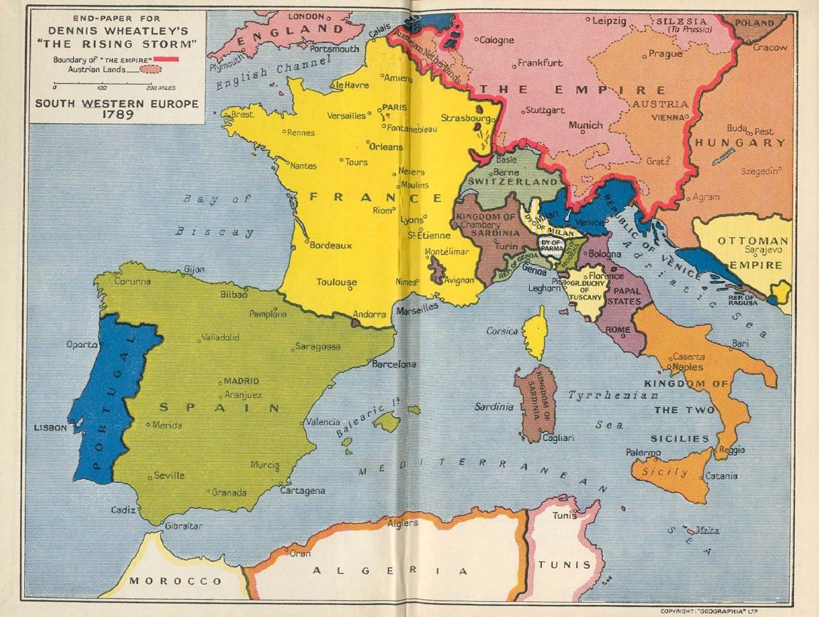

Title Heading Level 05 [Chapter of Book-Part or Sub-Chapter]

Title Heading Level 06 [Sub-Chapter of Chapter of Book-Part]

Agatha Christie was very fond of these ...

Agatha Christie
Hercule Poirot
Death on the Nile (1937)
Chapter One
XII

Agatha Christie
Hercule Poirot
Murder on the Orient Express (1934)
The Facts
An Important Passenger on the Taurus Express
I
The Evidence

Agatha Christie
Hercule Poirot
Sad Cypress (1940)
Part III
Chapter Three
IX

Chapters with special Charaters

Ashfield
O! ma chère maison; mon nid, mon gîte
Le passé Vhabite…O ma chère maison

I
One of the luckiest things that can happen to you in life is to have a happy childhood. I had a very happy childhood. I had a home and a garden that I loved; a wise and patient Nanny; as father and mother two people who loved each other dearly and made a success of their marriage and of parenthood.
Looking back I feel that our house was truly a happy house. That was largely due to my father, for my father was a very agreeable man. The quality of agreeableness Is not much stressed nowadays. People tend to ask if a man is clever, industrious, if he contributes to the well-being of the community, if he ‘counts’ in the scheme of things. But Charles Dickens puts the matter delightfully in David Copperfield:
‘Is your brother an agreeable man, Peggotty?’ I enquired cautiously.
‘Oh what an agreeable man he is!’ exclaimed Peggotty.
Ask yourself that question about most of your friends and acquaintances, and you will perhaps be surprised at how seldom your answer will be the same as Peggotty’s.
By modern standards my father would probably not be approved of.
He was a lazy man. It was the days of independent incomes, and if you had an independent income you didn’t work. You weren’t expected to. I strongly suspect that my father would not have been particularly good at working anyway.
He left our house in Torquay every morning and went to his club.
He returned, in a cab, for lunch, and in the afternoon went back to the club, played whist all afternoon, and returned to the house in time to dress for dinner. During the season, he spent his days at the Cricket Club, of which he was President. He also occasionally got up amateur theatricals. He had an enormous number of friends and loved entertaining them. There was one big dinner party at our home every week, and he and my mother went out to dinner usually another two or three times a week.
It was only later that I realized what a much loved man he was. After his death, letters came from all over the world. And locally tradesmen, cabmen, old employees–again and again some old man would come up to me and say: ‘Ah! I remember Mr Miller well. I’ll never forget him.
Not many like him nowadays.’
Yet he had no outstanding characteristics. He was not particularly intelligent. I think that he had a simple and loving heart, and he really cared for his fellow men. He had a great sense of humour and he easily made people laugh. There was no meanness in him, no jealousy, and he was almost fantastically generous. And he had a natural happiness and serenity.
My mother was entirely different. She was an enigmatic and arresting personality–more forceful than my father–startlingly original in her ideas, shy and miserably diffident about herself, and at bottom, I think, with a natural melancholy.
Servants and children were devoted to her, and her lightest word was always promptly obeyed. She would have made a first class educator.
Anything she told you immediately became exciting and significant.
Sameness bored her and she would jump from one subject to another in a way that sometimes made her conversation bewildering. As my father used to tell her, she had no sense of humour. To that accusation she would protest in an injured voice: ‘Just because I don’t think certain stories of yours are funny, Fred…’ and my father would roar with laughter.
She was about ten years younger than my father and she had loved him devotedly ever since she was a child often. All the time that he was a gay young man, flitting about between New York and the South of France, my mother, a shy quiet girl, sat at home, thinking about him, writing an occasional poem in her ‘album,’ embroidering a pocket-book for him.
That pocket-book, incidentally, my father kept all his life.

