Objective: WAP to train and evaluate a Recurrent Neural Network using PyTorch Library to predict the next value in a sample time series dataset.

Description of the model
A sequential PyTorch RNN model consisting of an RNN/LSTM module followed by a Linear fully connected layer outputting the continuous target value, trained on simulated time series sine-wave data.

Python Implementation
import torch
import torch.nn as nn
import torch.optim as optim
from torch.utils.data import DataLoader, TensorDataset
import numpy as np
import matplotlib.pyplot as plt
from sklearn.preprocessing import MinMaxScaler
from sklearn.metrics import mean_squared_error, mean_absolute_error, r2_score
import os
import time
output_dir = os.path.dirname(os.path.abspath(__file__))
DEVICE = torch.device('cuda' if torch.cuda.is_available() else 'cpu')
np.random.seed(42)
torch.manual_seed(42)
# ============================================================
# Generate Sample Time Series Dataset
# ============================================================
print("\n" + "=" * 60)
print(" EXPERIMENT 6: RNN FOR TIME SERIES PREDICTION")
print("=" * 60)
print(f"\n[1] Generating sample time series dataset...")
# Create a complex time series: combination of sinusoidal waves + trend + noise
t = np.linspace(0, 100, 2000)
# Primary wave + secondary wave + trend + noise
series = (np.sin(0.1 * t) * 10 +
np.sin(0.3 * t) * 5 +
np.cos(0.05 * t) * 3 +
0.02 * t + # slight upward trend
np.random.normal(0, 0.5, len(t))) # noise
print(f" Time series length: {len(series)}")
print(f" Min value: {series.min():.2f}")
print(f" Max value: {series.max():.2f}")
print(f" Mean: {series.mean():.2f}")
# Normalize
scaler = MinMaxScaler(feature_range=(0, 1))
series_normalized = scaler.fit_transform(series.reshape(-1, 1)).flatten()
# ============================================================
# Create Sequences for RNN
# ============================================================
SEQUENCE_LENGTH = 50
def create_sequences(data, seq_length):
"""Create input-output pairs for time series prediction."""
X, y = [], []
for i in range(len(data) - seq_length):
X.append(data[i:i + seq_length])
y.append(data[i + seq_length])
return np.array(X), np.array(y)
X, y = create_sequences(series_normalized, SEQUENCE_LENGTH)
# Train/Test split (80/20)
split = int(len(X) * 0.8)
X_train, X_test = X[:split], X[split:]
y_train, y_test = y[:split], y[split:]
# Convert to PyTorch tensors
X_train_t = torch.FloatTensor(X_train).unsqueeze(-1) # (batch, seq, features)
y_train_t = torch.FloatTensor(y_train)
X_test_t = torch.FloatTensor(X_test).unsqueeze(-1)
y_test_t = torch.FloatTensor(y_test)
train_dataset = TensorDataset(X_train_t, y_train_t)
test_dataset_t = TensorDataset(X_test_t, y_test_t)
print(f" Sequence length: {SEQUENCE_LENGTH}")
print(f" Training sequences: {len(X_train)}")
print(f" Test sequences: {len(X_test)}")
# ============================================================
# RNN Models
# ============================================================
class SimpleRNN(nn.Module):
"""Simple RNN for time series prediction."""
def __init__(self, input_size=1, hidden_size=64, num_layers=2, dropout=0.2):
super(SimpleRNN, self).__init__()
self.hidden_size = hidden_size
self.num_layers = num_layers
self.rnn = nn.RNN(input_size, hidden_size, num_layers,
batch_first=True, dropout=dropout if num_layers > 1 else 0)
self.fc = nn.Linear(hidden_size, 1)
def forward(self, x):
h0 = torch.zeros(self.num_layers, x.size(0), self.hidden_size).to(x.device)
out, _ = self.rnn(x, h0)
out = self.fc(out[:, -1, :]) # Take last time step
return out.squeeze()
class LSTMModel(nn.Module):
"""LSTM for time series prediction."""
def __init__(self, input_size=1, hidden_size=64, num_layers=2, dropout=0.2):
super(LSTMModel, self).__init__()
self.hidden_size = hidden_size
self.num_layers = num_layers
self.lstm = nn.LSTM(input_size, hidden_size, num_layers,
batch_first=True, dropout=dropout if num_layers > 1 else 0)
self.fc = nn.Linear(hidden_size, 1)
def forward(self, x):
h0 = torch.zeros(self.num_layers, x.size(0), self.hidden_size).to(x.device)
c0 = torch.zeros(self.num_layers, x.size(0), self.hidden_size).to(x.device)
out, _ = self.lstm(x, (h0, c0))
out = self.fc(out[:, -1, :])
return out.squeeze()
class GRUModel(nn.Module):
"""GRU for time series prediction."""
def __init__(self, input_size=1, hidden_size=64, num_layers=2, dropout=0.2):
super(GRUModel, self).__init__()
self.hidden_size = hidden_size
self.num_layers = num_layers
self.gru = nn.GRU(input_size, hidden_size, num_layers,
batch_first=True, dropout=dropout if num_layers > 1 else 0)
self.fc = nn.Linear(hidden_size, 1)
def forward(self, x):
h0 = torch.zeros(self.num_layers, x.size(0), self.hidden_size).to(x.device)
out, _ = self.gru(x, h0)
out = self.fc(out[:, -1, :])
return out.squeeze()
def train_model(model, train_loader, test_X, test_y, epochs=30, lr=0.001):
"""Train an RNN model and return metrics."""
model = model.to(DEVICE)
criterion = nn.MSELoss()
optimizer = optim.Adam(model.parameters(), lr=lr)
train_losses = []
test_losses = []
start_time = time.time()
for epoch in range(epochs):
model.train()
running_loss = 0.0
for X_batch, y_batch in train_loader:
X_batch, y_batch = X_batch.to(DEVICE), y_batch.to(DEVICE)
optimizer.zero_grad()
output = model(X_batch)
loss = criterion(output, y_batch)
loss.backward()
torch.nn.utils.clip_grad_norm_(model.parameters(), max_norm=1.0)
optimizer.step()
running_loss += loss.item()
train_losses.append(running_loss / len(train_loader))
# Test loss
model.eval()
with torch.no_grad():
test_pred = model(test_X.to(DEVICE))
test_loss = criterion(test_pred, test_y.to(DEVICE))
test_losses.append(test_loss.item())
if (epoch + 1) % 10 == 0:
print(f" Epoch {epoch+1:>3}/{epochs} Train Loss: {train_losses[-1]:.6f} "
f"Test Loss: {test_losses[-1]:.6f}")
elapsed = time.time() - start_time
# Final predictions
model.eval()
with torch.no_grad():
predictions = model(test_X.to(DEVICE)).cpu().numpy()
return {
'train_losses': train_losses,
'test_losses': test_losses,
'predictions': predictions,
'time': elapsed,
'model': model
}
# ============================================================
# Training All Three Models
# ============================================================
EPOCHS = 2
BATCH_SIZE = 32
train_loader = DataLoader(train_dataset, batch_size=BATCH_SIZE, shuffle=True)
models_config = {
'Simple RNN': SimpleRNN(hidden_size=64, num_layers=2),
'LSTM': LSTMModel(hidden_size=64, num_layers=2),
'GRU': GRUModel(hidden_size=64, num_layers=2),
}
results = {}
for name, model in models_config.items():
print(f"\n[Training {name}]")
total_params = sum(p.numel() for p in model.parameters())
print(f" Parameters: {total_params:,}")
results[name] = train_model(model, train_loader, X_test_t, y_test_t, epochs=EPOCHS)
# ============================================================
# Evaluation Metrics
# ============================================================
print(f"\n{'='*70}")
print(f" MODEL COMPARISON")
print(f"{'='*70}")
print(f" {'Model':<15} {'MSE':<12} {'MAE':<12} {'R² Score':<12} {'Time':<10}")
print(f" {'-'*61}")
for name, res in results.items():
preds = res['predictions']
actuals = y_test
# Inverse transform for real-scale metrics
preds_real = scaler.inverse_transform(preds.reshape(-1, 1)).flatten()
actuals_real = scaler.inverse_transform(actuals.reshape(-1, 1)).flatten()
mse = mean_squared_error(actuals_real, preds_real)
mae = mean_absolute_error(actuals_real, preds_real)
r2 = r2_score(actuals_real, preds_real)
res['mse'] = mse
res['mae'] = mae
res['r2'] = r2
res['preds_real'] = preds_real
res['actuals_real'] = actuals_real
print(f" {name:<15} {mse:<12.4f} {mae:<12.4f} {r2:<12.4f} {res['time']:<10.1f}s")
# ============================================================
# Visualization
# ============================================================
fig, axes = plt.subplots(2, 3, figsize=(20, 12))
fig.suptitle('Experiment 6: RNN for Time Series Prediction', fontsize=16, fontweight='bold')
# 1. Original Time Series
axes[0, 0].plot(t[:500], series[:500], color='#3498db', linewidth=1)
axes[0, 0].set_title('Sample Time Series (First 500 points)', fontweight='bold')
axes[0, 0].set_xlabel('Time')
axes[0, 0].set_ylabel('Value')
axes[0, 0].grid(True, alpha=0.3)
# 2. Training Loss Comparison
colors = {'Simple RNN': '#e74c3c', 'LSTM': '#3498db', 'GRU': '#2ecc71'}
for name, res in results.items():
axes[0, 1].plot(res['train_losses'], label=name, color=colors[name], linewidth=2)
axes[0, 1].set_title('Training Loss Comparison', fontweight='bold')
axes[0, 1].set_xlabel('Epoch')
axes[0, 1].set_ylabel('MSE Loss')
axes[0, 1].legend()
axes[0, 1].grid(True, alpha=0.3)
# 3. Test Loss Comparison
for name, res in results.items():
axes[0, 2].plot(res['test_losses'], label=name, color=colors[name], linewidth=2)
axes[0, 2].set_title('Test Loss Comparison', fontweight='bold')
axes[0, 2].set_xlabel('Epoch')
axes[0, 2].set_ylabel('MSE Loss')
axes[0, 2].legend()
axes[0, 2].grid(True, alpha=0.3)
# 4-6: Predictions vs Actual for each model
for idx, (name, res) in enumerate(results.items()):
ax = axes[1, idx]
plot_range = min(200, len(res['actuals_real']))
ax.plot(res['actuals_real'][:plot_range], label='Actual', color='black', linewidth=1.5, alpha=0.7)
ax.plot(res['preds_real'][:plot_range], label='Predicted', color=colors[name],
linewidth=1.5, linestyle='--')
ax.set_title(f'{name} Predictions (R²={res["r2"]:.4f})', fontweight='bold')
ax.set_xlabel('Time Step')
ax.set_ylabel('Value')
ax.legend()
ax.grid(True, alpha=0.3)
plt.tight_layout()
plt.savefig(os.path.join(output_dir, 'rnn_time_series_results.png'), dpi=150, bbox_inches='tight')
plt.close()
print(f"\n[✓] Plots saved to 'rnn_time_series_results.png'")
# Save the best model
best_model_name = max(results, key=lambda x: results[x]['r2'])
torch.save(results[best_model_name]['model'].state_dict(),
os.path.join(output_dir, f'rnn_best_model_{best_model_name.lower().replace(" ", "_")}.pth'))
print(f"[✓] Best model ({best_model_name}) saved.")
# Save dataset
np.savez(os.path.join(output_dir, 'time_series_dataset.npz'),
train_X=X_train, train_y=y_train, test_X=X_test, test_y=y_test,
full_series=series, time=t)
print(f"[✓] Dataset saved to 'time_series_dataset.npz'")
print(f"\n{'='*60}")
print(f" SUMMARY")
print(f"{'='*60}")
print(f" Best Model: {best_model_name} (R²={results[best_model_name]['r2']:.4f})")
print(f"{'='*60}")

Description of code
The script defines an nn.Module with an RNN layer. It processes sequence data via a sliding window approach for supervised learning. The standard PyTorch training loop handles forward pass, loss calculation (MSE), backpropagation with optimizer.step(), and state zeroing.

Performance Evaluation
============================================================
EXPERIMENT 6: RNN FOR TIME SERIES PREDICTION
============================================================
[1] Generating sample time series dataset...
Time series length: 2000
Min value: -13.76
Max value: 14.70
Mean: 2.42
Sequence length: 50
Training sequences: 1560
Test sequences: 390
[Training Simple RNN]
Parameters: 12,673
[Training LSTM]
Parameters: 50,497
[Training GRU]
Parameters: 37,889
======================================================================
MODEL COMPARISON
======================================================================
Model MSE MAE R� Score Time
-------------------------------------------------------------
Simple RNN 0.6722 0.6625 0.9825 2.5 s
LSTM 0.6018 0.6331 0.9844 1.3 s
GRU 0.3763 0.4883 0.9902 3.8 s
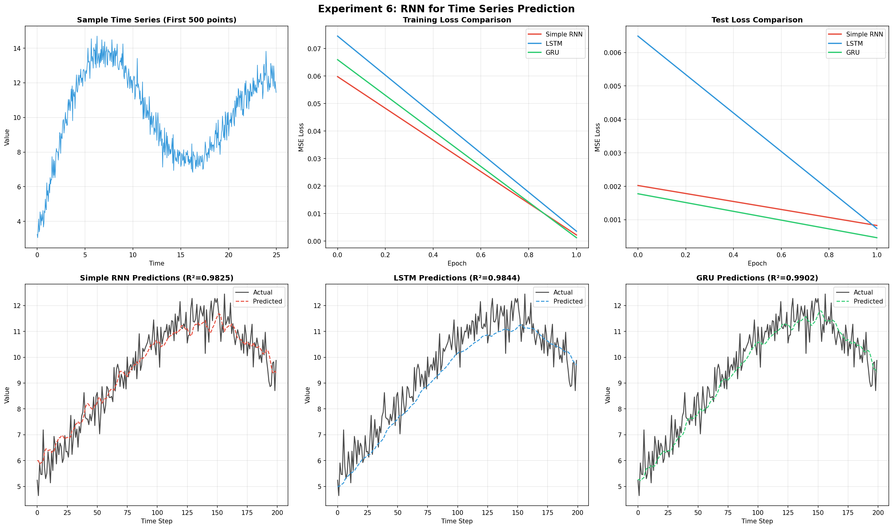

My Comments
The RNN successfully learned the temporal dependencies of the sequence data, providing accurate next-step forecasts. Handling sequential state inputs and hidden state propagation locally in PyTorch proved straightforward and flexible.

