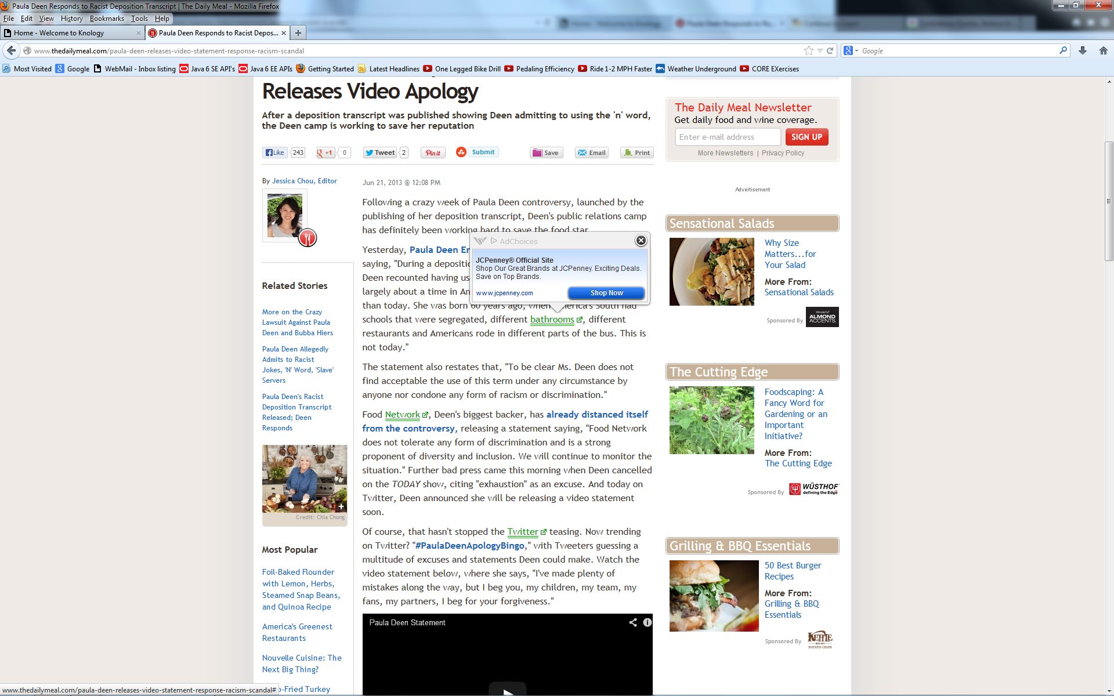

http://www.thedailymeal.com/paula-deen-releases-video-statement-response-racism-scandal

