Lab One Answer with Screenshot
Name: Mohammed Alom- R00144214
Email: Mohammed.alom@mycit.ie
Module: Computer Security Principle
Lecturer: Mr. Dylan Smyth

Task 1: – At first, I saved ISO copy Windows 7 on my personal laptop then installed it on virtual computer through VMWare Player and started the windows 7.

Task 2: I have Installed Google Chrome using Internet Explorer on the Virtual Machine.

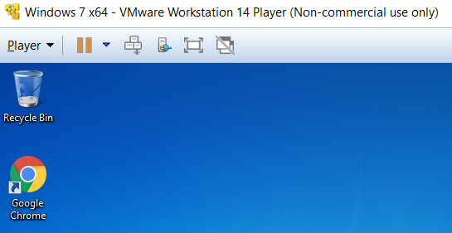

Task 3: ​​I Checked the Operating system for updates.
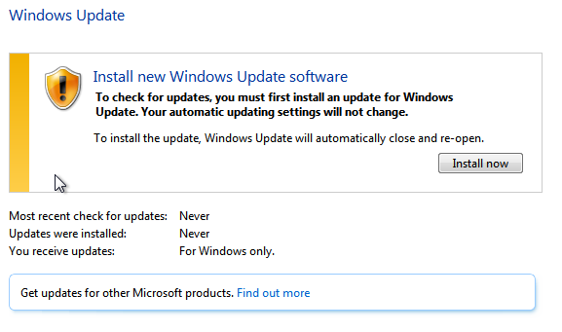

Checking Update Windows
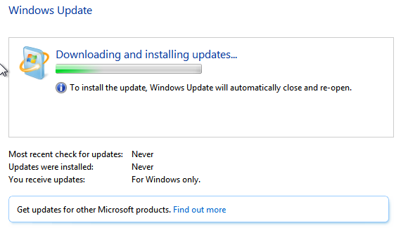
Update found for the windows
Task 4:​​ In the task 4 I Secured the administrator login with the password “CSPismyfavouritemodule!”
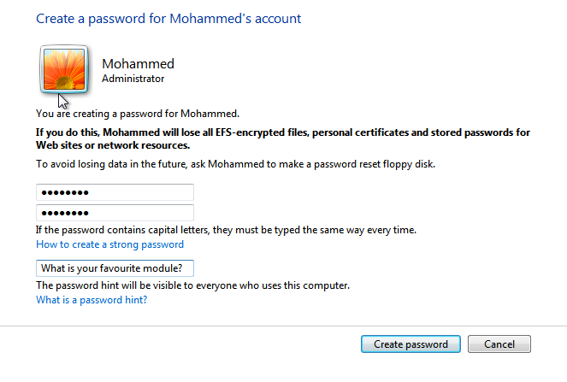
Now Administrator is password protected
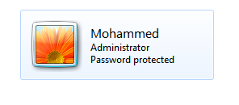

Task 5:​​ I have created and added a non-privileged user josh with password “+CITistheBestIoT”

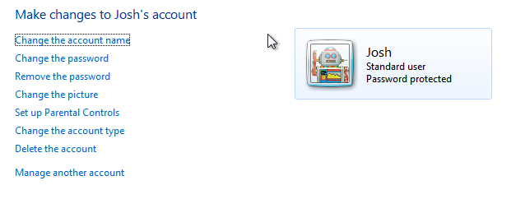

Task 6:​​ I have Installed Microsoft Security Essentials (32 bit version)
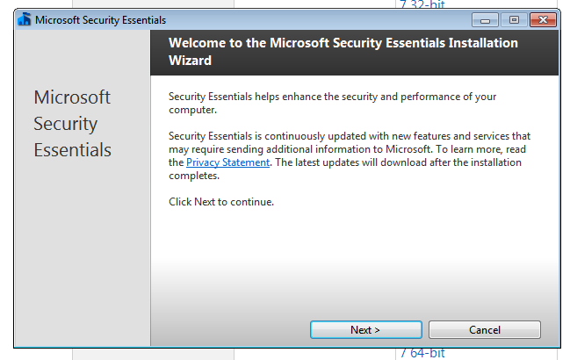

Install in progress
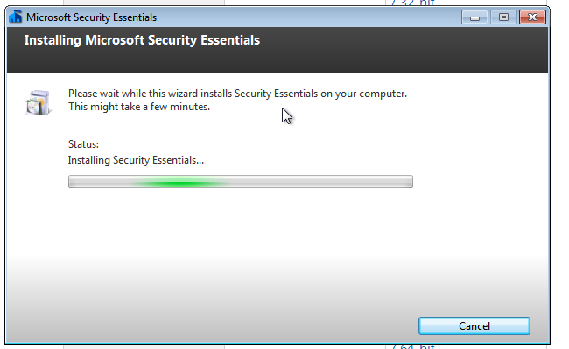

Task 7:​​ I have Installed free version of Malwarebytes anti-malware software.

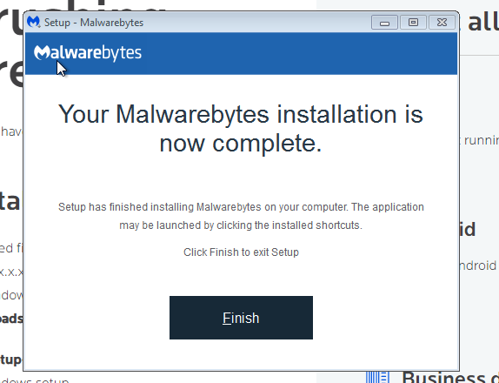

Task 8: Got the eicar virus from the internet and saved on the desktop

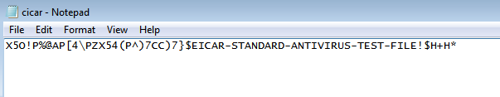

Task 9: Turning on all the firewell on

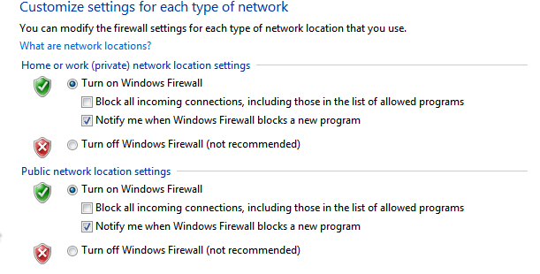

Here is the eicar file

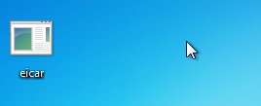
I notice that once it is in the desktop windows security service detected that file and clear it straightway within few minutes from the desktop.

Scanning the laptop with anti-malwarebytes and its clear the cicar.com text file from the desktop
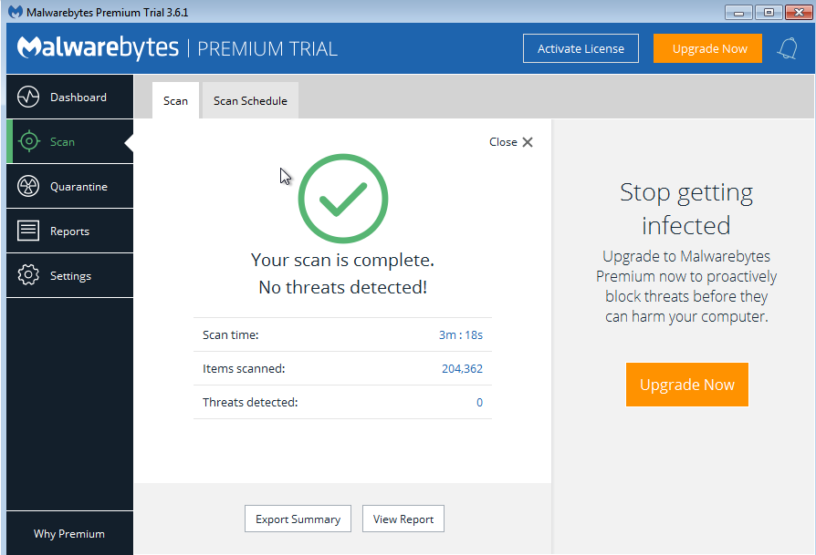

Task 10​​: Create a new rule that will block all outgoing http traffic (destination port 80 –perfect for those paranoid about unencrypted web traffic). Test to see that it works. Reset when done.
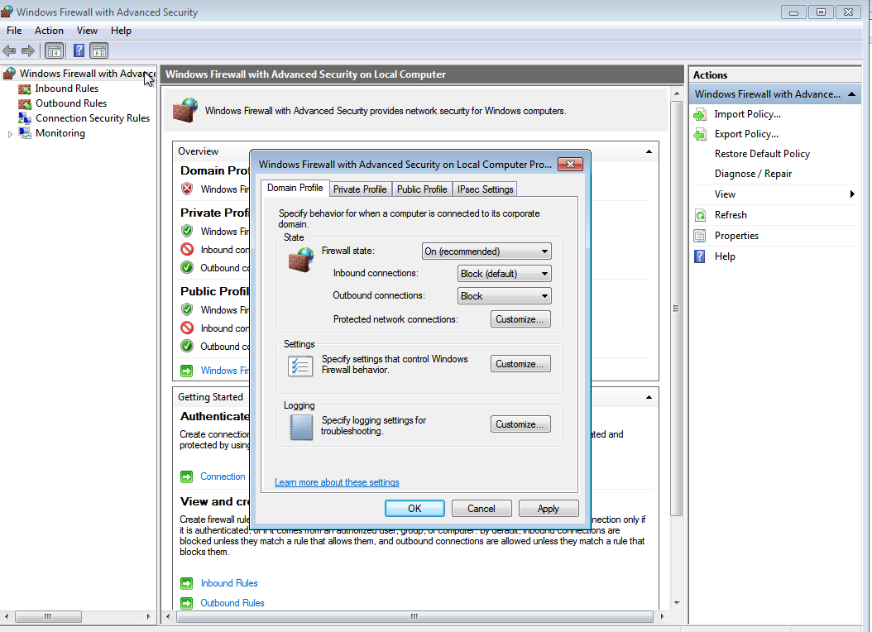

Task 11 : I have Installed the Zonealarm third part firewell program
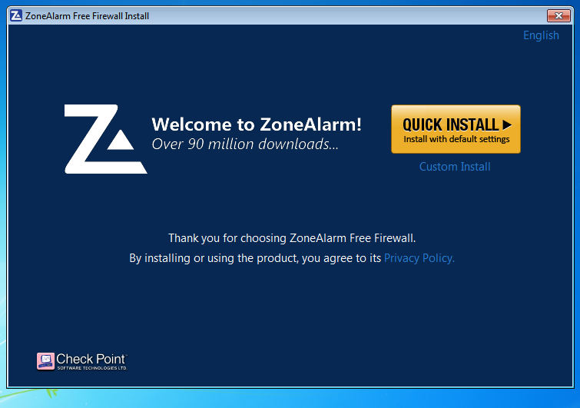

Configuring the Zonealarm
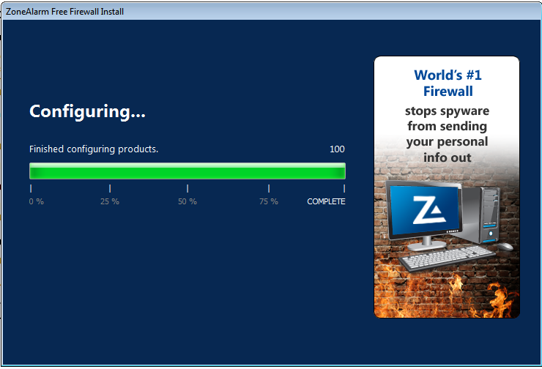
Report of the computer by Zonealarm
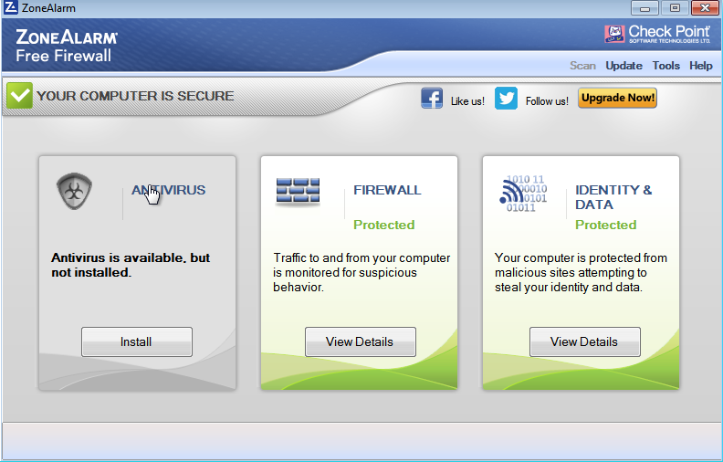

Task 12: Download and Installed KeePassX password manager
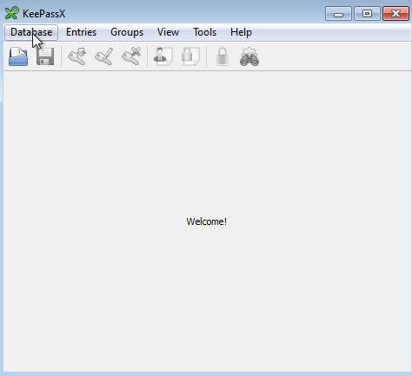

Task 13​​: I have Installed and test CCleaner software
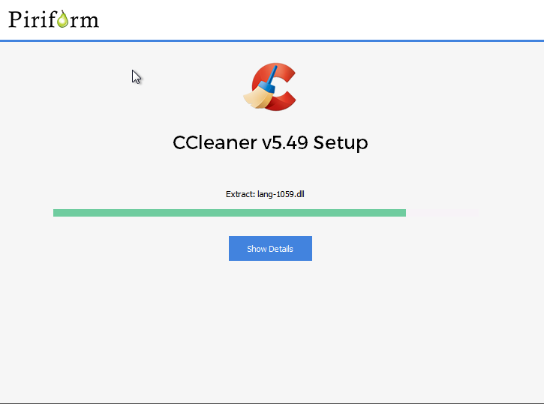

Set up completed
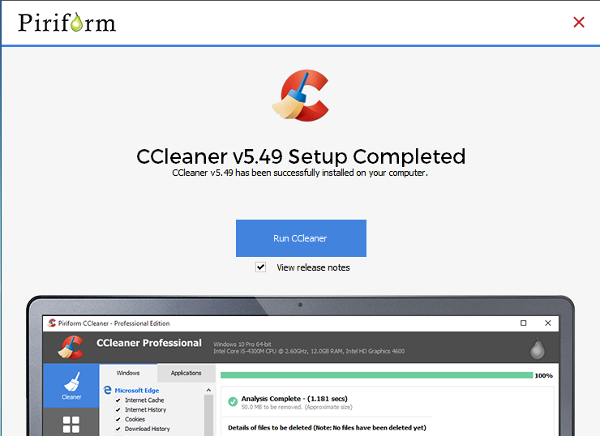
Cleaning status windows
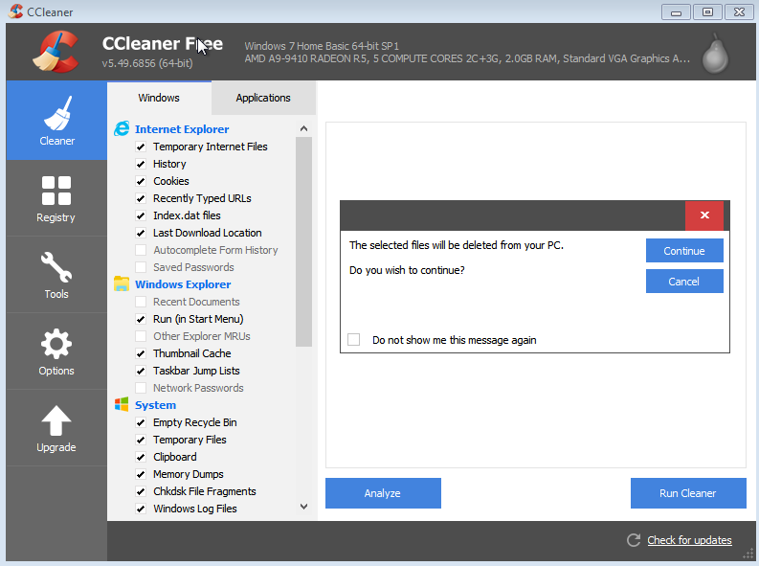

Part 2:
About the WOT
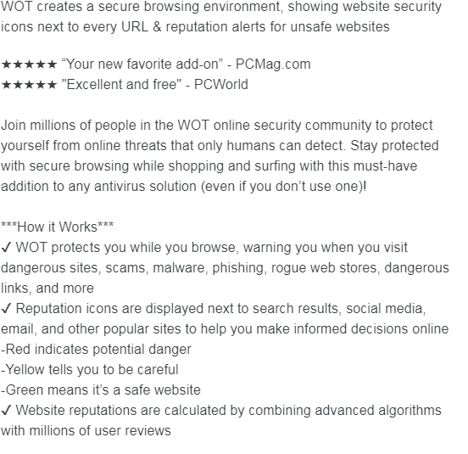

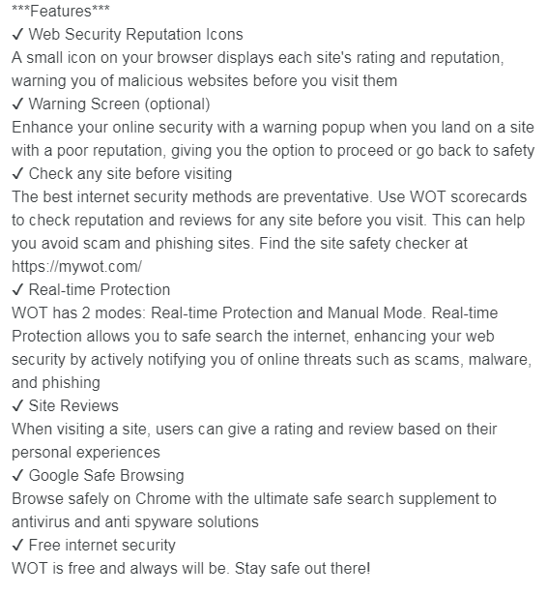
Added the WOT with the chrome browser

Task 2: Investigate, install and test ScriptSafe browser extension

Overview
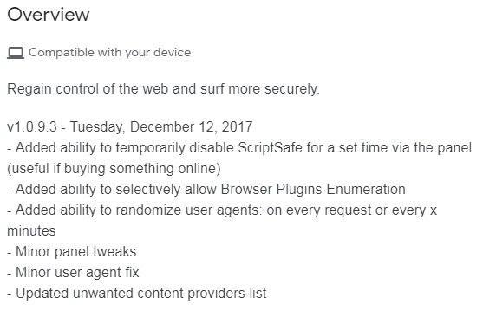
Installed and Added with Chrome browser
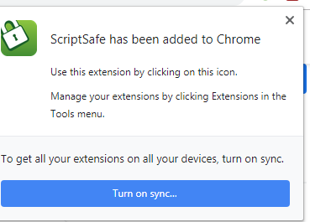

Task 3:​​ Investigate, install and test AdblockPlus browser extension
Overview
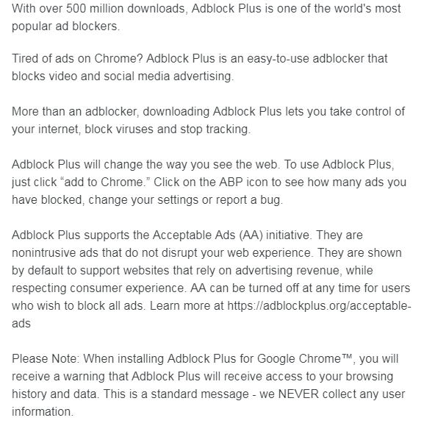
Installed and added with the Chrome browser
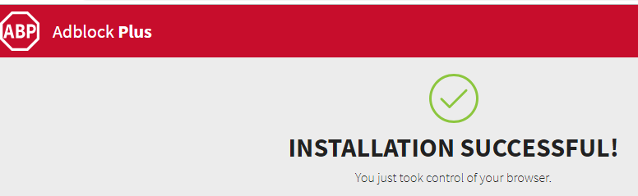

Task 4:​​ Investigate, install and test Ghostery browser extension
Overview
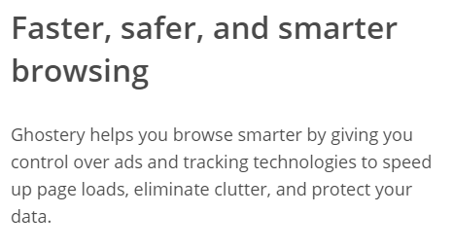

Install and added with the Chrome browser
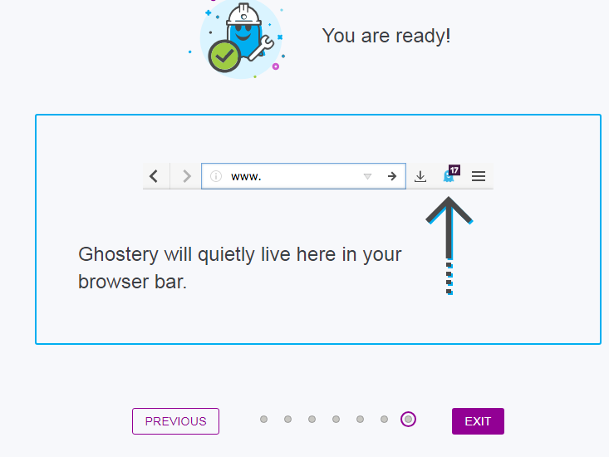

I tried to test rte.ie and its blocked few of the add and I attached screen shot of those
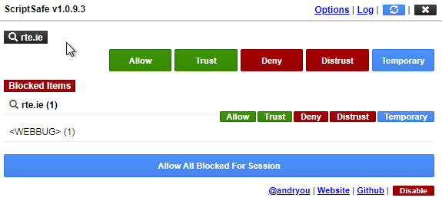
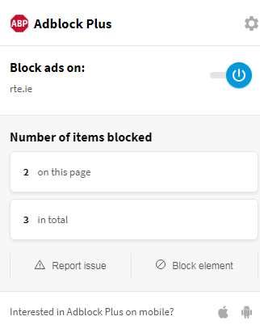

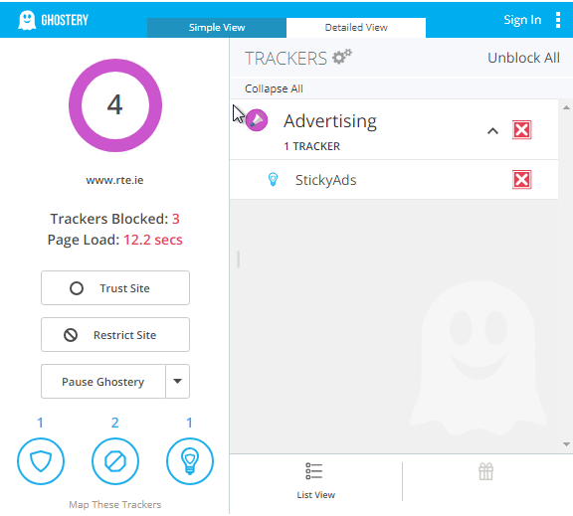

I tried with youtube.com but the page did not load properly.
NB: Task 10--- I was not quite sure how to do

