
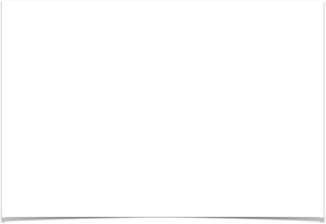

“Git Assignment_October_26_2018”

Student Declaration

I can confirm the following details:

Student ID/Registration Number : R00144214

Name : Mohammed Alom
Email : mohammed.alom@mycit.ie
Module Name : Agile Processes
Module Lecturer: Mr. John OBrien

I confirm that this is my own work.

Due Date: October 26, 2018, on/before 13:00

Student Signature:

Signed: Mohammed Jahangir Alom

___________________

Cork Institute of Technology

Individual Skill Assessment

Module Title: Agile Processes

Module Code: COMP7039

Programme Title: B.Sc. Hons in Software Development –

Stage 3

Programme Code: SDH3

Date Given: October 15, 2018.

Date Due: October 26, 2018, on/before 13:00.

Value: 20% of Module total-score.

<Mohammed Alom/SDH3/mohammed.alom@mycit.iel> <-- fill in please & then pages 5+ then submit this edited document>

- Sam’s Safe Storage, a new startup in Bishopstown, Cork, wishes to create a web page but is unsure of the specification so wishes to have it developed in stages. Create an initial web page and subsequently update it in stages, using git to manage the changes.

  - Create a very basic HTML home page document for the business. The page only contains the name of the business and address. Create a GIT repository and commit the initial version of the page.

  - Add items to the web page create and commit 5 variations, each time committing to the repository.

  - Add a second file to the repository e.g. a css file to change the look of the page and commit that css file also with two revisions of the css file. Also revise the html code to use the css file. Thus, there are 7 versions of the web page.

  - Demonstrate rolling back to version 4. Branch version 6 into a new web page to demonstrate a new variation for the customer.

  - Demonstrate merging, versioning and stashing.

(4 marks each, 20 marks total)

NB:
“By submitting this electronically, using an account & password only I have access to, I hereby certify that this material which I now submit for assessment is entirely my own work and has not been taken from the work of others, save and to the extent, that such work has been cited and acknowledged within the text of my work.”

CIT has access to plagiarism tools and these may be used on submitted assignments. The use of ‘rent a coder’ type services in preparing your assignment is forbidden.

Demo
You may be asked to demo your assignment in the lab.

Screenshots
See below example of screenshots to use when submitting this assignment – please ensure the command prompt uses your login id or student ID.

Submitting.
Please submit THIS edited document with screenshots on page 5+ AND a zip/7z archive file of your git folder including the hidden .git folder.

Submissions to be made as an e-mail attachment to:

John.obrien@cit.ie

Your e-mail must contain the following Subject content only:

“Git Assignment_October_26_2018”

Additionally, a hardcopy of THIS edited document must be handed in by the due-date. Please ensure that your hardcopy-submission top-page displays:

your CIT student number,

name,

mycit e-mail address,

date,

signed originality-declaration, and

assignment title, (i.e. “Git Assignment_October_26_2018”).

Place each item of the assignment on a separate page stating if completed or not and showing screen shot(s) of how you achieved the task item and a description of what you’ve done..
Git set up with user name and password
Completed? Yes

Screenshot

- Git init command screenshot

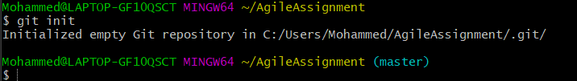

- Git user name and email setup screenshot

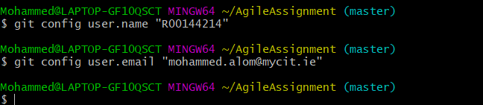

- Git config – list screenshot

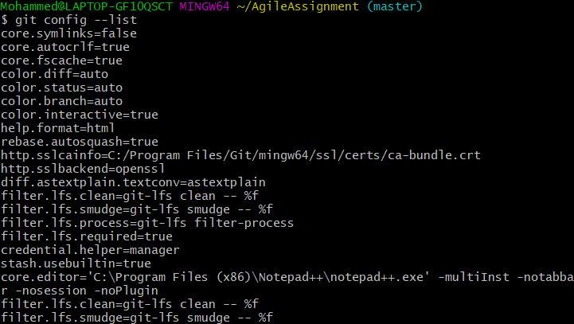

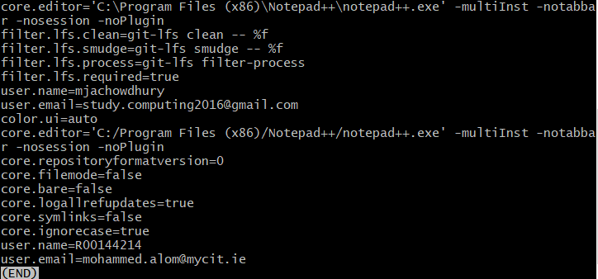

-

Pre-Condition

1 (a) < Create a very basic HTML home page document for the business. The page only contains the name of the business and address. Create a GIT repository and commit the initial version of the page.>
Completed? Yes

Post-Condition

- First git status screenshot

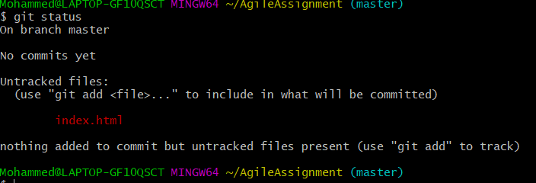

Pre-Condition
1 (b) < Add items to the web page create and commit 5 variations, each time committing to the repository. >
Completed? Yes

Post-Condition

- First git commit status

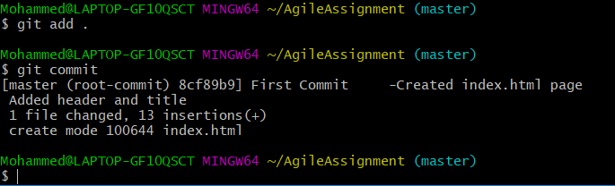

- Second git commit status screenshot

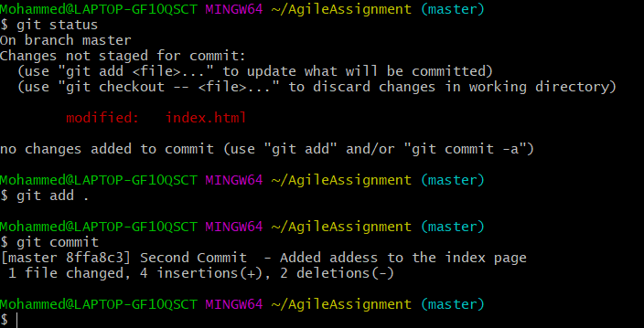

- Third commit status screenshot

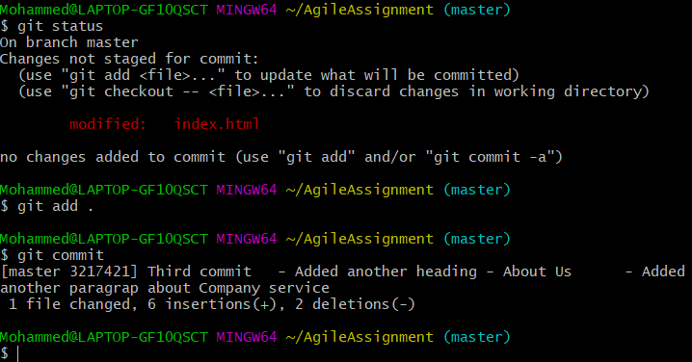

- Forth commit status screenshot

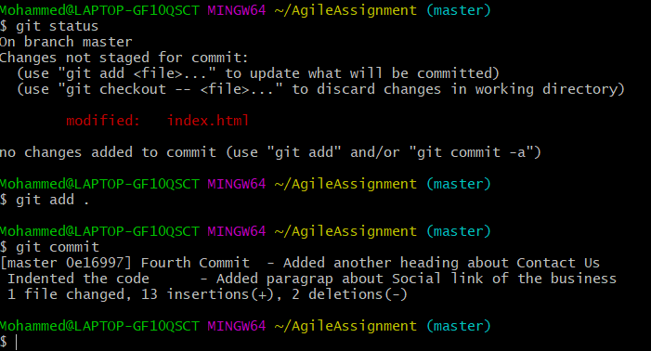

- Fifth commit screenshot status

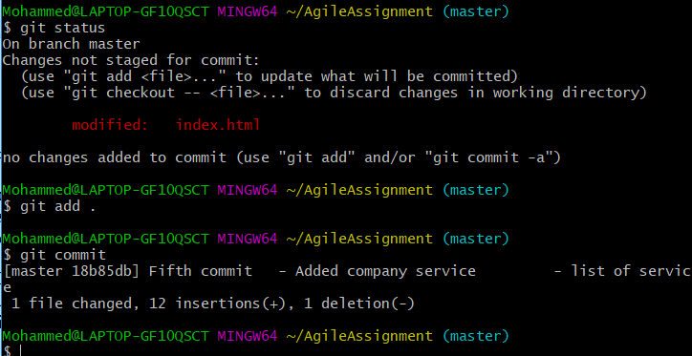

- After fifth commit git status log screen shot

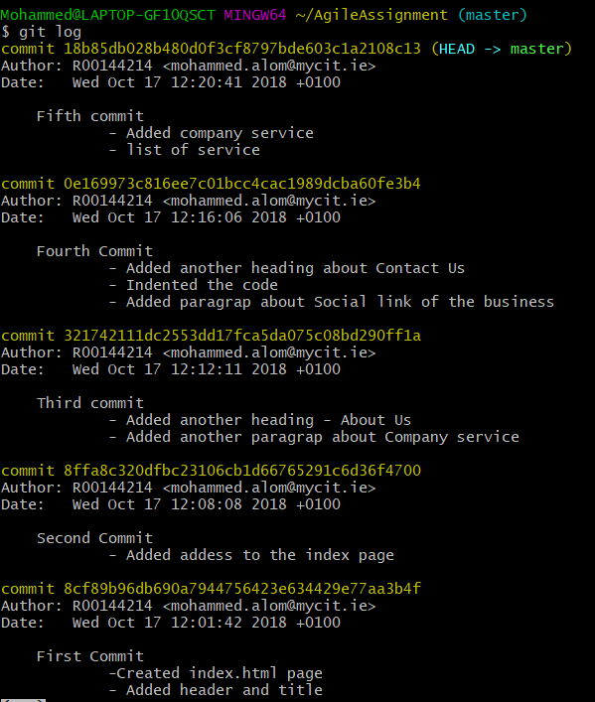

- After fifth commit screenshot of the webpage

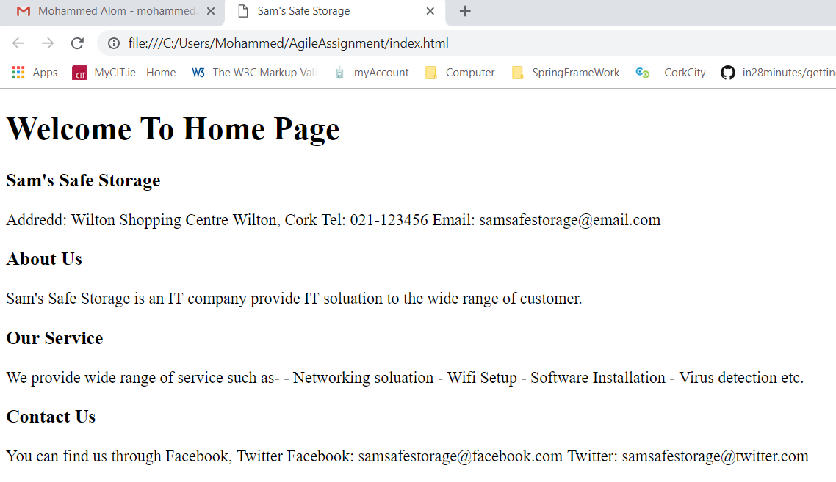

- Screenshot of the HTML Code

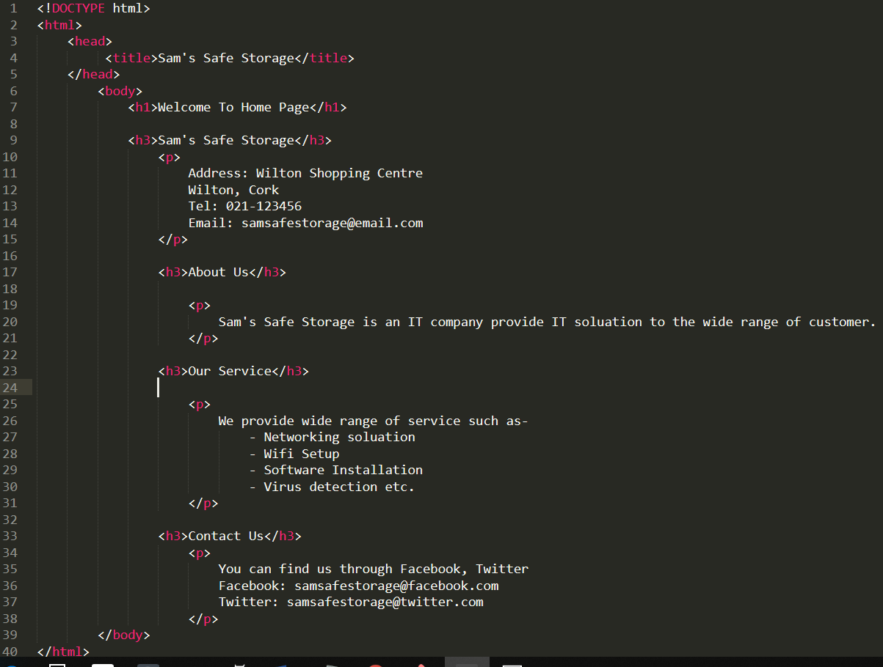

Pre-Condition

1(c) <Add a second file to the repository e.g. a css file to change the look of the page and commit that css file also with two revisions of the css file. Also revise the html code to use the css file. Thus, there are 7 versions of the web page.>
Completed? Yes|No
Completed? Yes
Post-Condition
- Added style.css file screenshot

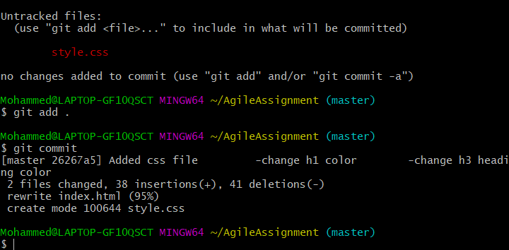

- Style.css file code screenshot

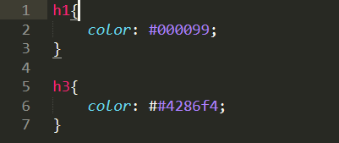

- After adding css style web page look screenshot

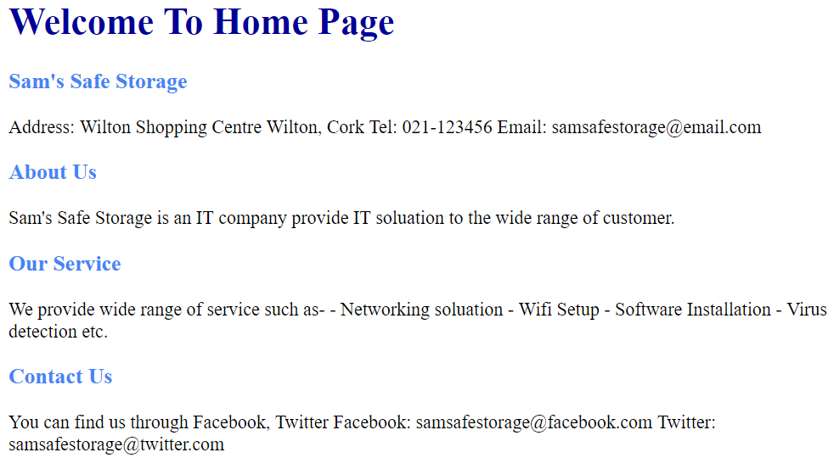

- Second changed css file screenshot

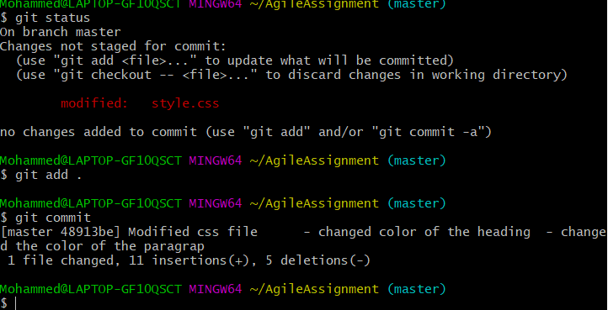

- css code changed screenshot

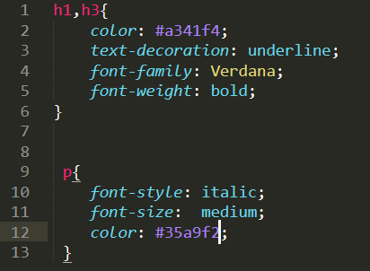

- After changed css file webpage screenshot

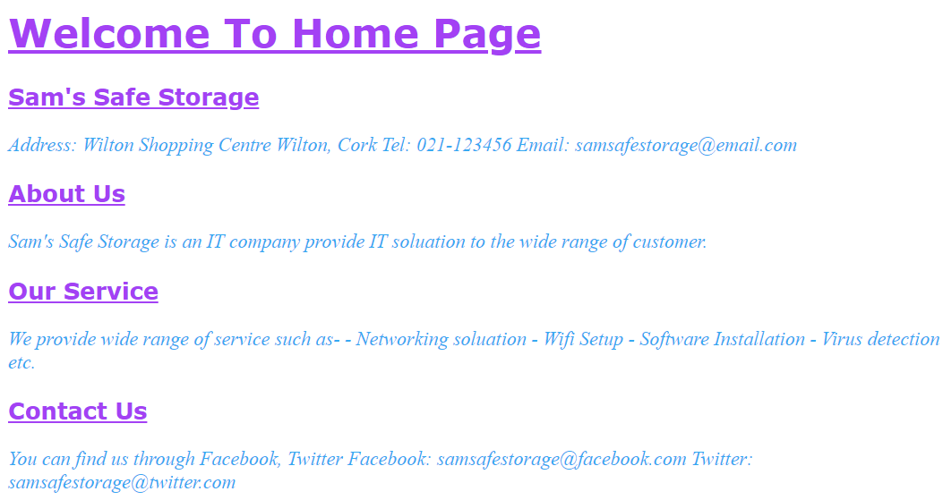

Pre-Condition

1(d) <Demonstrate rolling back to version 4. Branch version 6 into a new web page to demonstrate a new variation for the customer.>
Completed? Yes

Post-Condition

- Created first branch screenshot

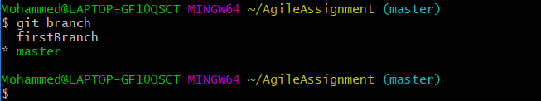

- Going back version screenshot

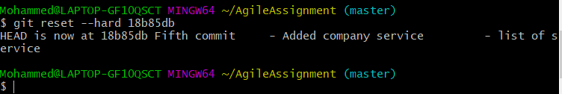

- After going back previous version webpage looks like now screenshot

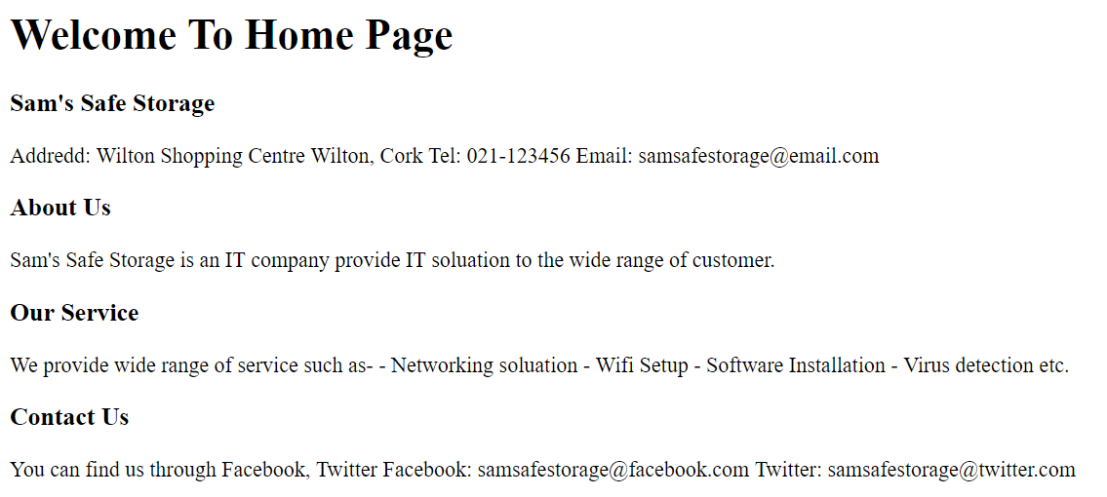

Showing New variation to the customer

- Updated firstBranch screenshot

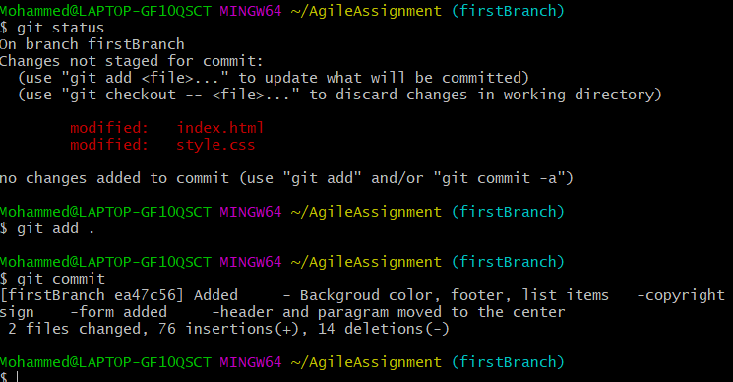

- After updating firstBranch webpage look screenshot

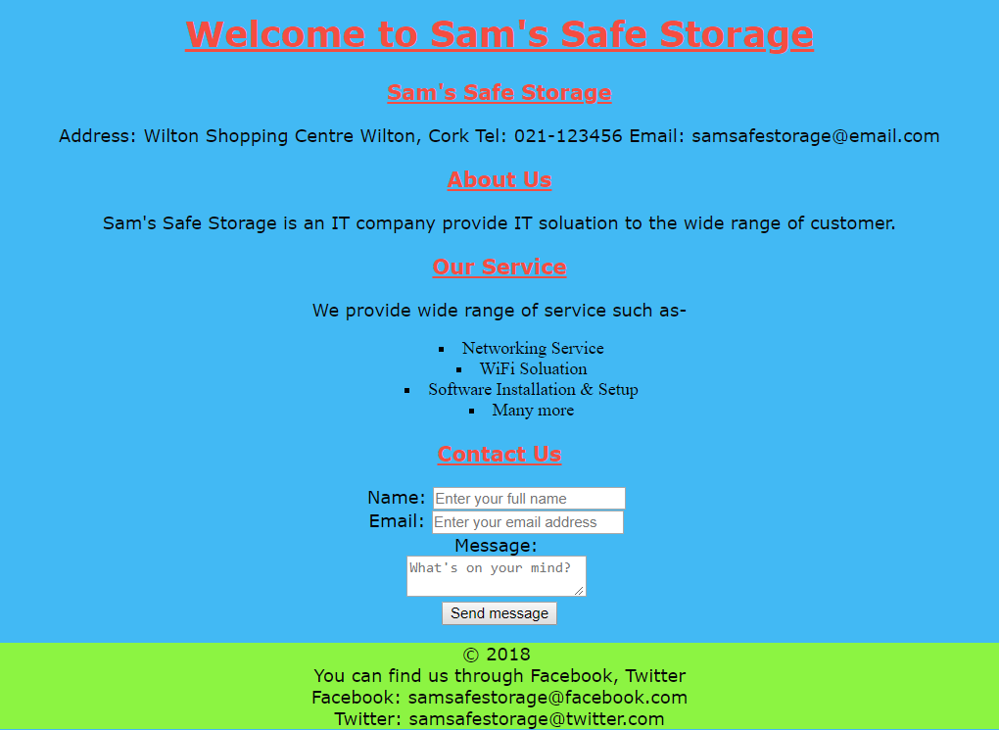

-Code in the css file screenshot

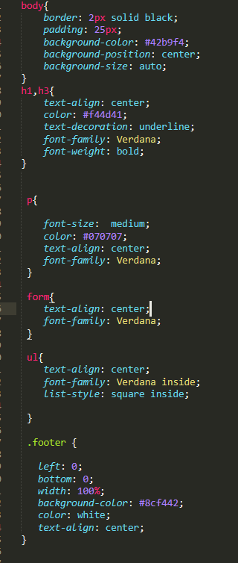

- firstBranch HTML code screenshot

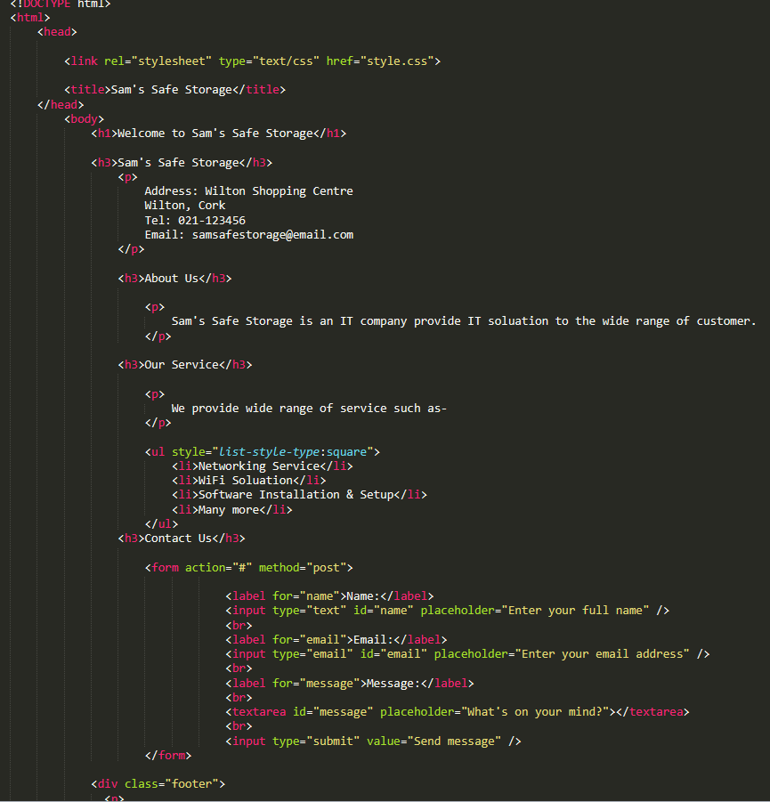

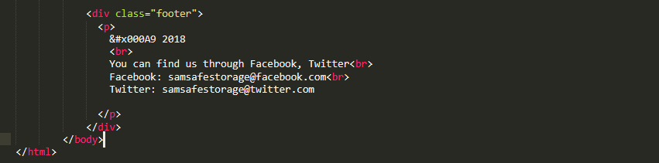

Pre-Condition
1 (e) <Demonstrate merging, versioning and stashing>
Completed? Yes
Post-Condition - merging
- merging screenshot

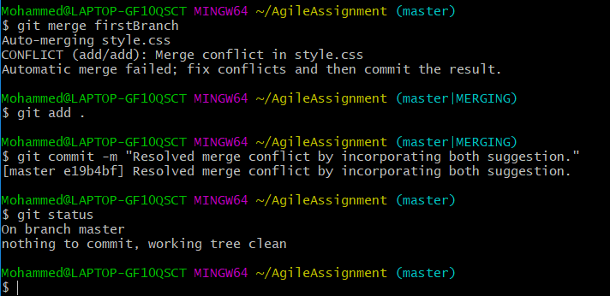

- After merging css file screen shot
- There was conflict issue with css file fixed that issue and merge with master

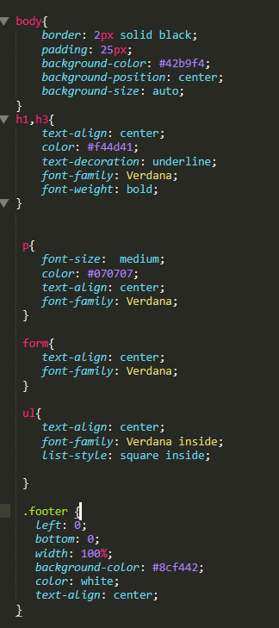

- After merging firstBranch with master now webpage look

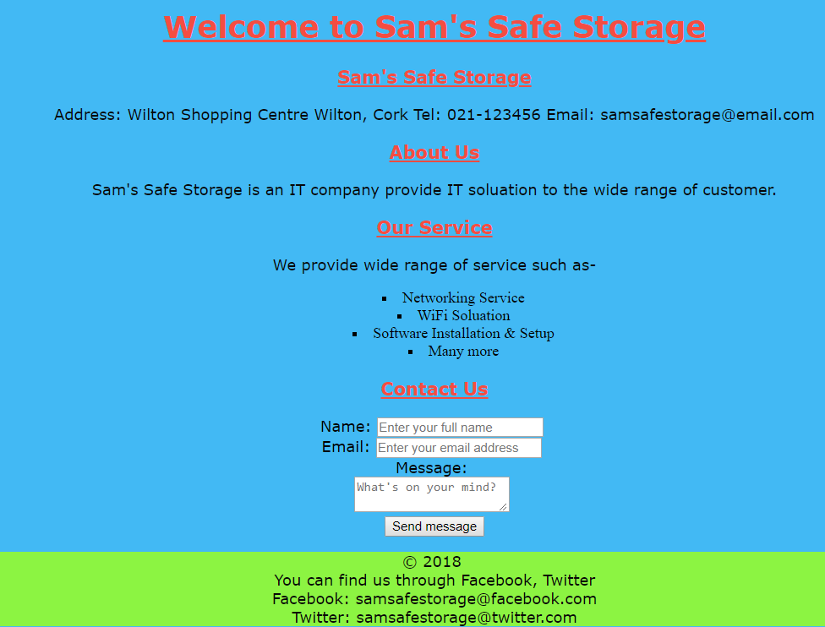

Versioning

- Both branch status and diff screenshot

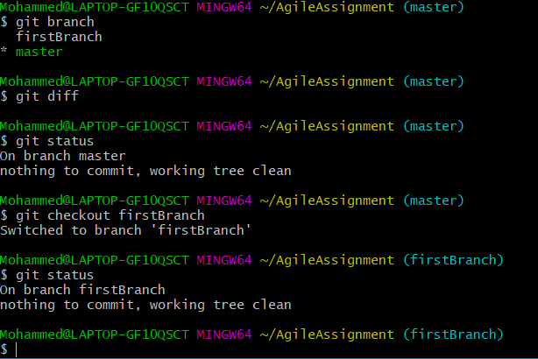
- Git log showing all the commit and version

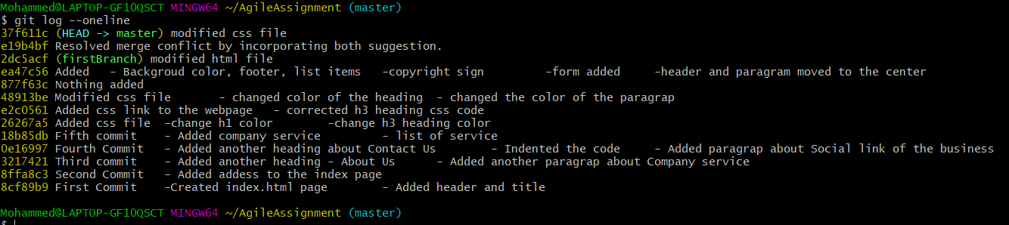

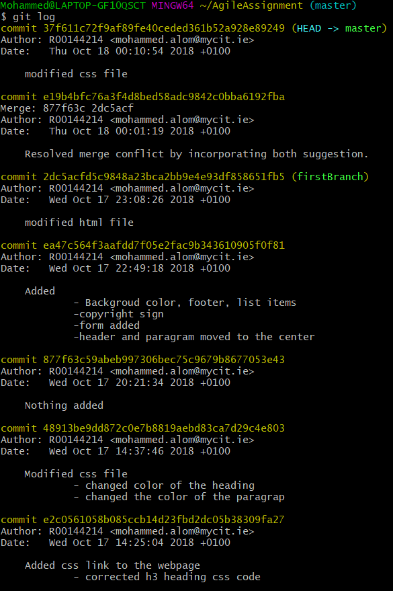
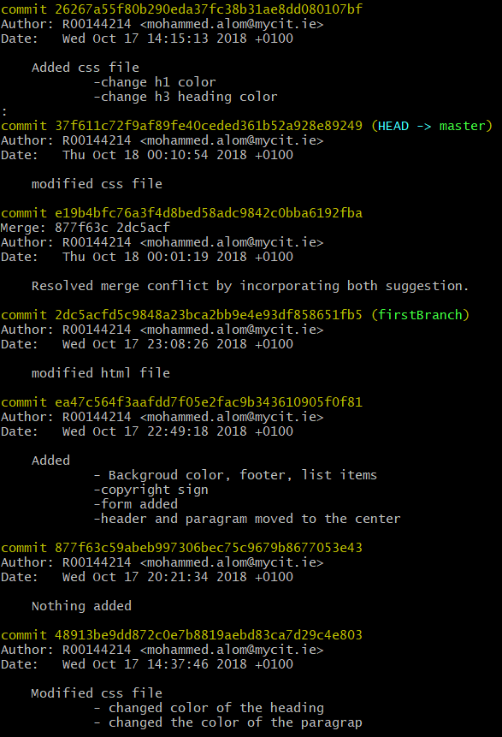

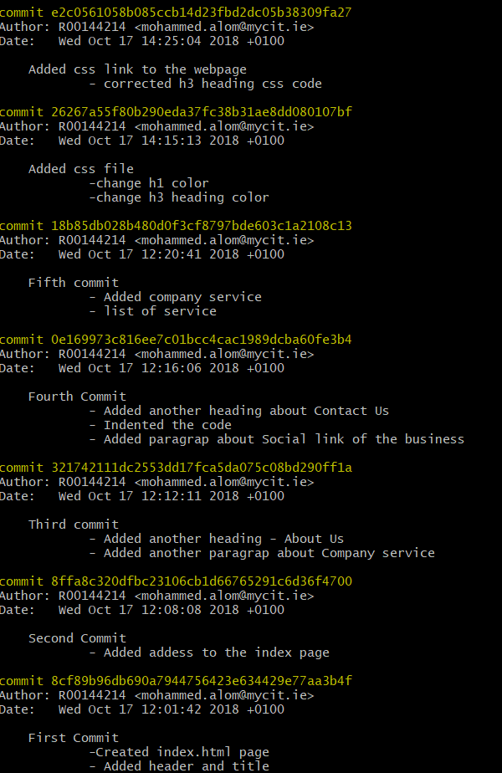

Stashing screenshot

- Adding work in the stash
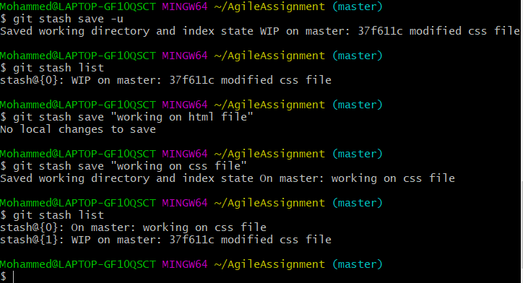

- Removing the stash from the working directory without the git add . and got commit

