How Mail casting Project Works?

Welcome Page
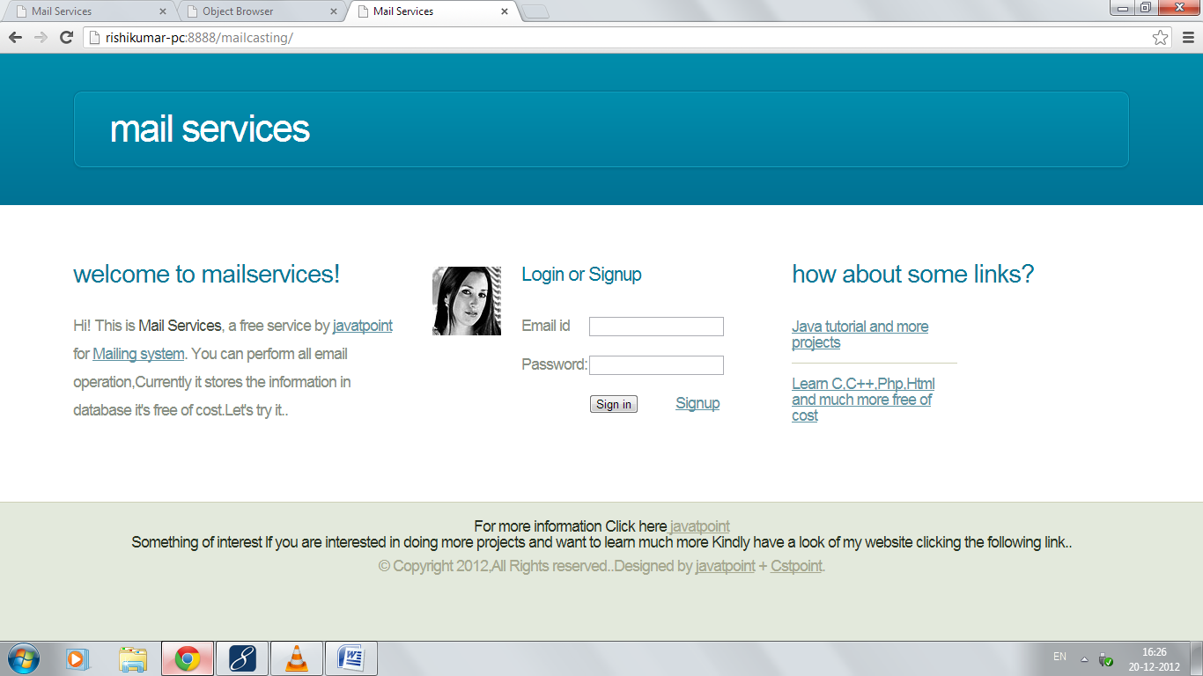
Steps:
- If you are a registered user kindly log in, if you aren’t please signup first.
- Signup:
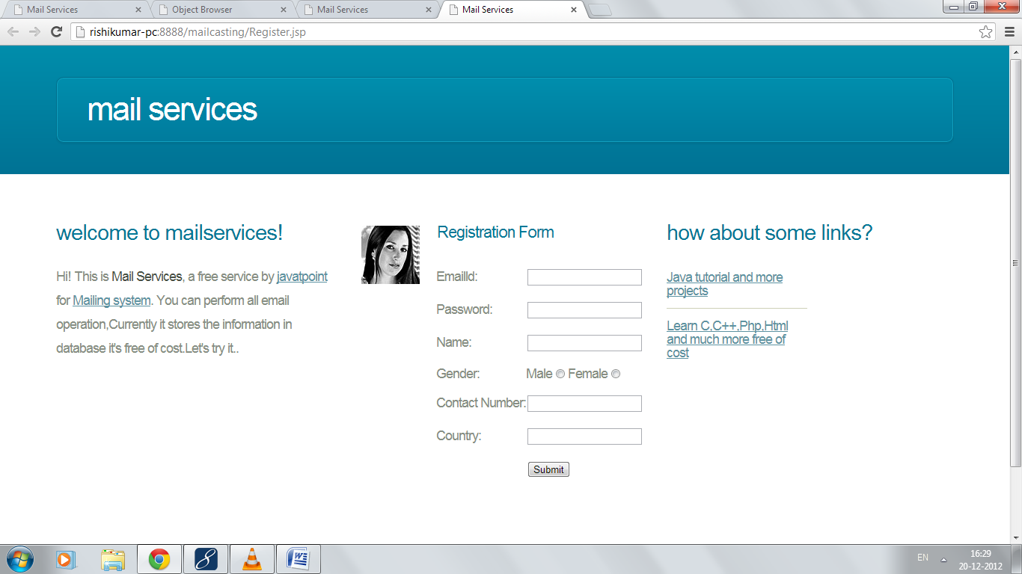
On successful registration:
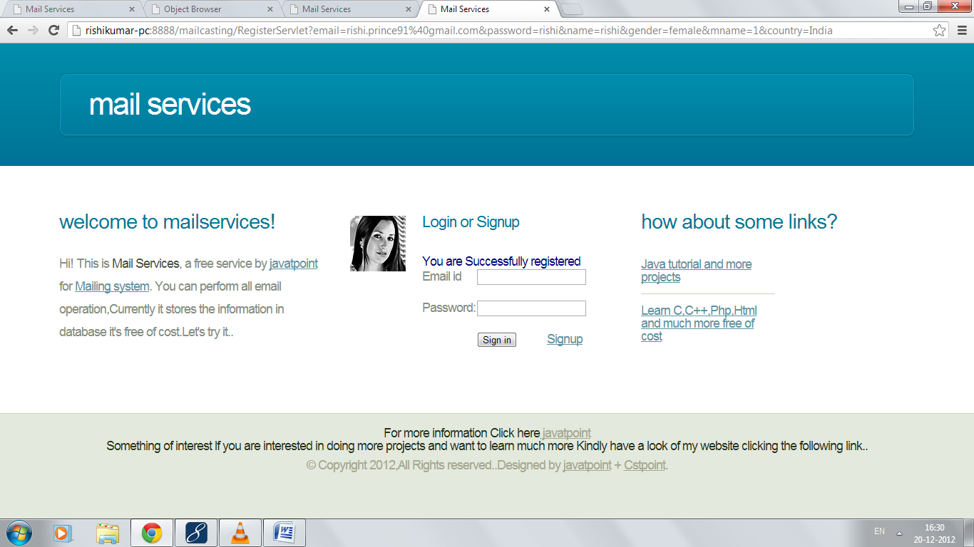
- Login:
Login through above page or welcome page.
On filling Incorrect Detail:
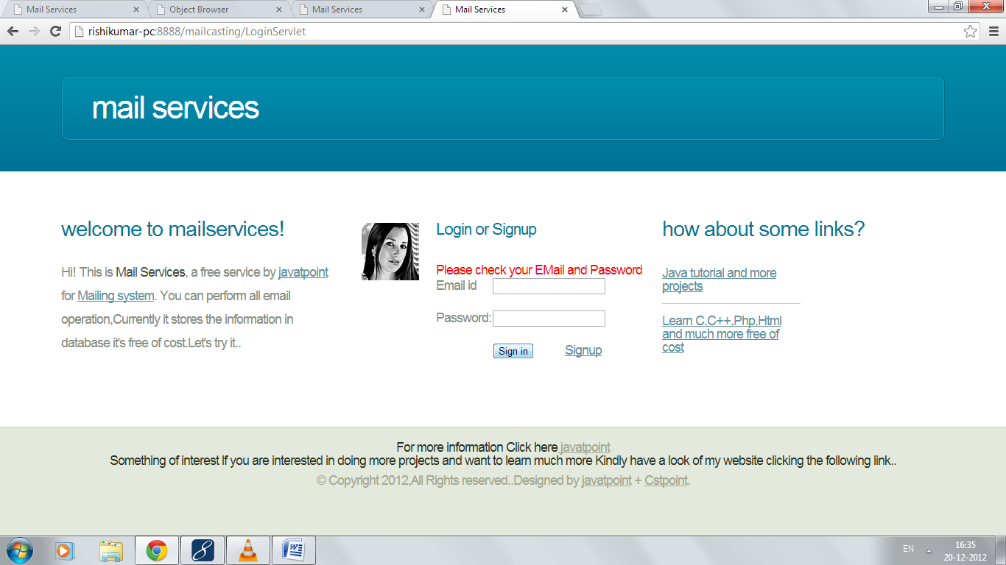
On filling Correct Detail:
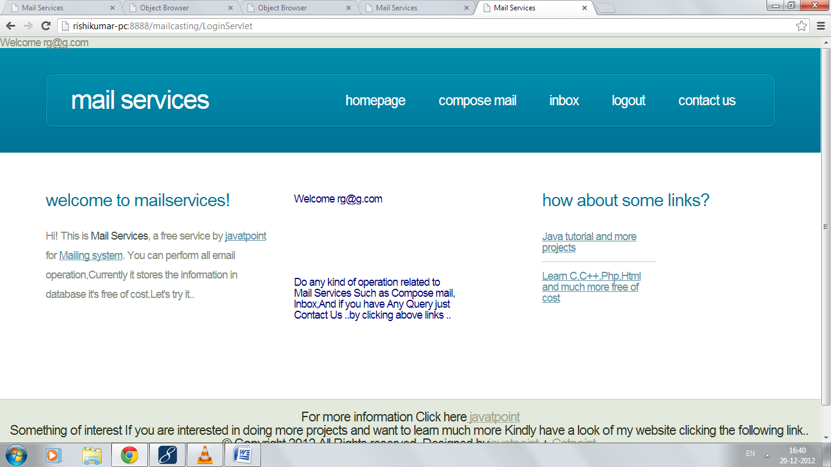

- Authorized user can compose mail, can check received mail and can contact to us.
- Composing mail:
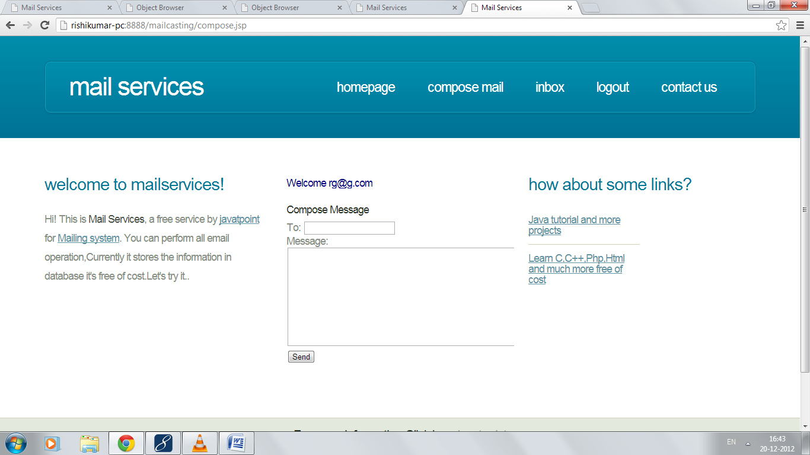
After sending mail:
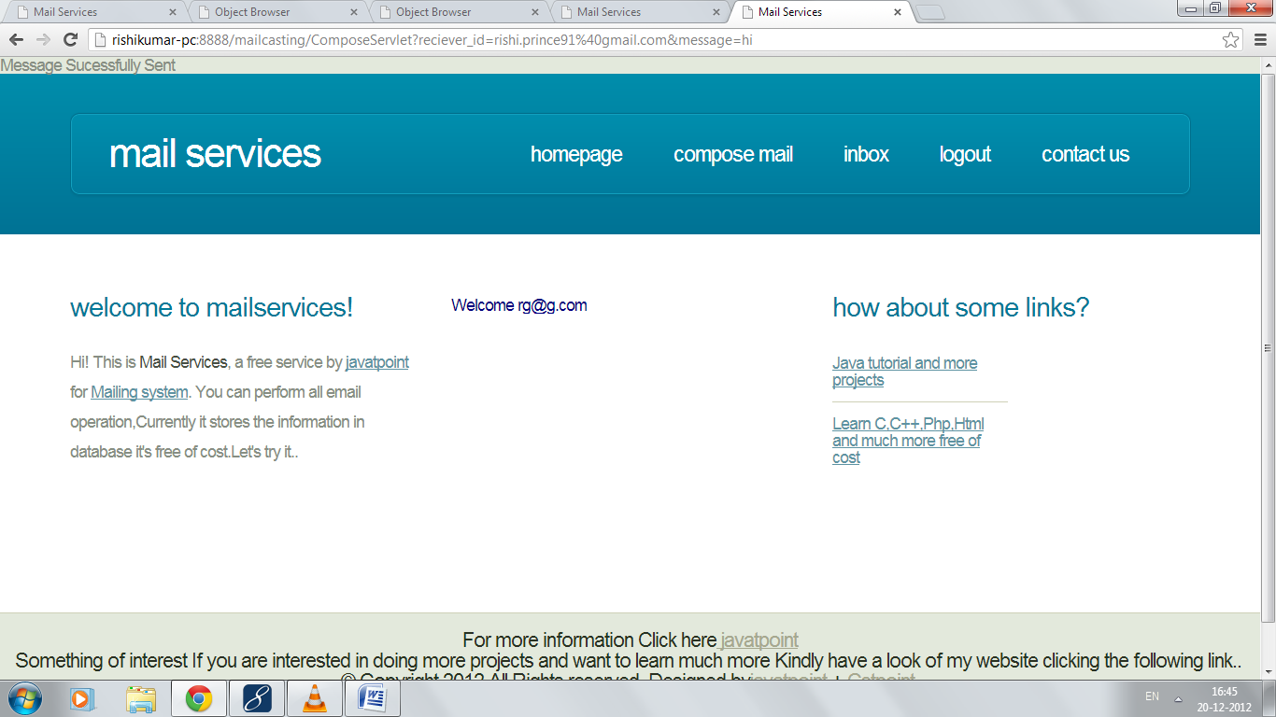
- Inbox:
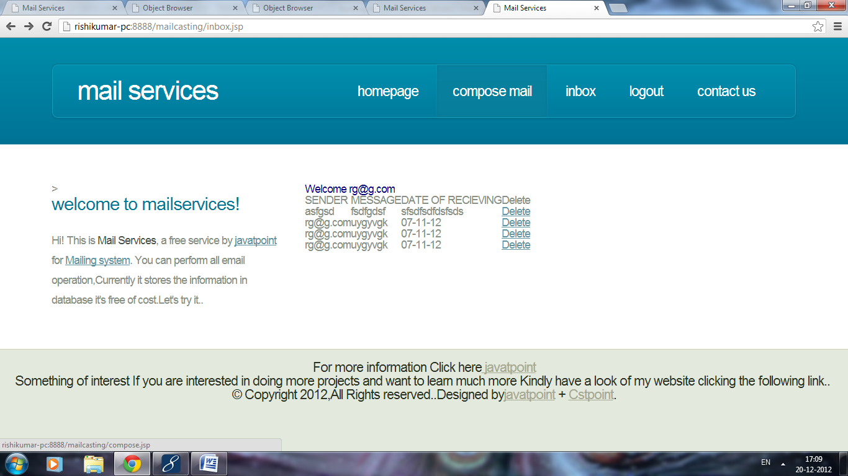
- Logging out:
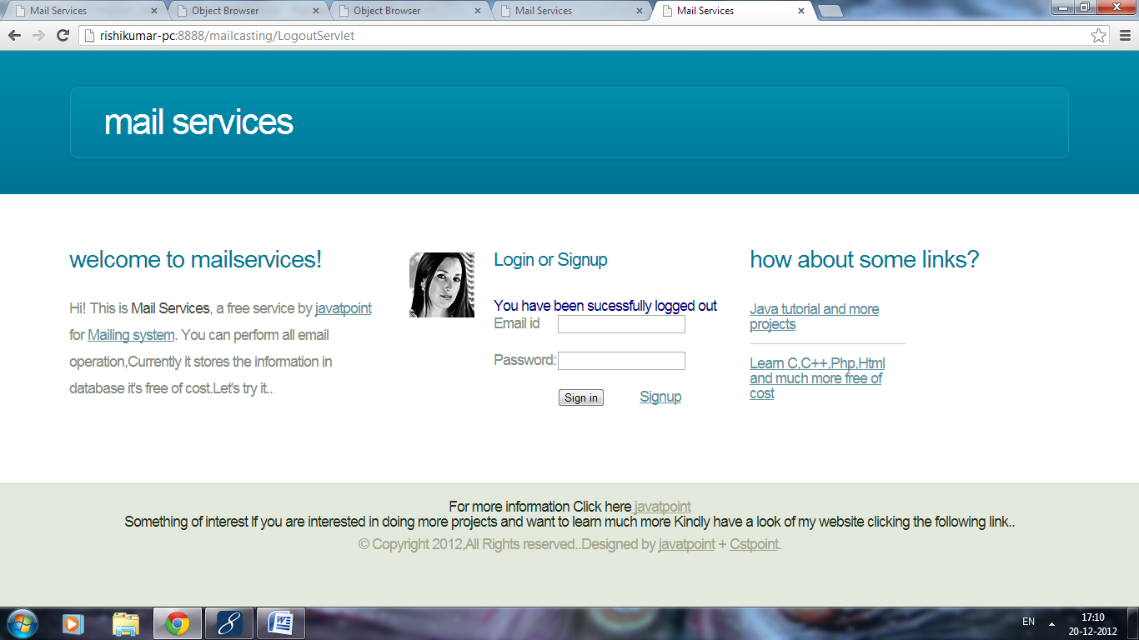

- Contact us:
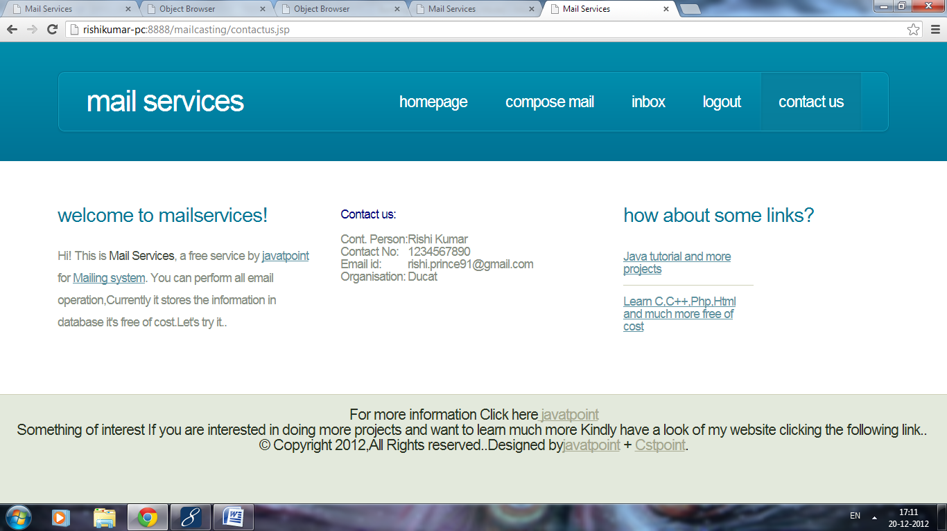
This is all about mail casting project……

Good Luck

