**Online Library**

1. Introduction

1.2 Purpose

1.3 Scope

1.4 Definitions, Acronyms and Abbreviations

1.5 Tools Used

1.6 References

1.7 Technologies to be used

1.8 Overview

2. Overall Description

2.1 Product Perspective

2.2 Software Interface

2.3 Hardware Interface

2.4 Communication Interface

2.5 Constraints

2.6 ER Diagram

2.7 Use - Case Model Survey

2.8 Architecture Design

2.9 Database Design

3. Specific Requirements

3.1 Use-Case Reports

3.2 Activity Diagrams

3.3 Sequence Diagrams

**1. Introduction**

**1.1 Purpose**

The objective of the project is to develop a system that provide help for those students who want to take the services of Library. The purpose is to design a system that allows to check the book details which are available in library and perform various operations such as searching the books and reserving the books etc.

**1.2 Scope**

* The system is proposed to have the following modules:
* 1-***Administrator module***
* ***2-user module***
* ***3-Staff Module***
* **Administrator module:**
* Administrator manages the entire application. Administrator can add the books in database and can delete the book details and also he can update the orders.
* **User module:**
* In this module we are providing the new registration and after registration user can easily search the books details in our library database.
* ***Staff Module*:**
* In this module staff, those who are created by the admin will insert new books into the library and they will update the no of books in the library

**1.3 Definitions, Acronyms and Abbreviations**

**Admin**

**Administrator:**. He has the authority to add/delete users,Books Details

**Apache Tomcat Server**

**Apache Tomcat Server:** It is a Web server that runs and supports J2EE and web applications.

**Oracle**

**Oracle** A database management system that provides a flexible and efficient database platform to maintain records of students, teachers, admin and dm.

**JSP**

**Java Server Pages:** It is used to create dynamic web content.

**J2EE**

**Java 2 Enterprise Edition:** A programming platform which is a part of java platform for developing and running distributed java.

**UML**

**Unified Modeling Language:** is a standard language for writing software blueprints. The

UML may be used to visualize, specify, construct and document

**XML**

**Extensible Markup Language:** is a text based format that let developers describe, deliver and exchange structured data between a range of applications to client for display and manipulation.

**HTTP**

**Hypertext Transfer Protocol:** It’s a service protocol.

**1.4 Tools Used**

**Application architecture – JAVA, J2EE**

**JAVA**

Java is an object-oriented programming language developed by Sun Microsystems a company best known for its high end UNIX workstations. Java language was designed to be small, simple, and portable across platforms, operating systems, both at the source and at the binary level, which means that Java programs (applet and application) can run on any machine that has the Java virtual machine (JVM) installed.

**J2EE**

**Java Platform, Enterprise Edition** or **Java EE** is a widely used platform for server programming in the Java programming language. The Java platform (Enterprise Edition) differs from the Java Standard Edition Platform (Java SE) in that it adds libraries which provide functionality to deploy fault-tolerant, distributed, multi-tier Java software, based largely on modular components running on a Web server.

**Apache Tomcat web Server** is a free, certified Java EE 5 server for building and managing Java applications

It is Apache supported distribution

**Database platform – Oracle**

Oracle Database is the database management system that delivers a flexible and cost effective Database platform to build robust on demand business applications and supports the J2EE and web services standards.

**1.5 References**

* Object Oriented Modeling and Design with UML-Michael Blaha, James Rambaugh.
* Software Engineering, Seventh Edition, Ian Sommerville.
* IBM Red Books.
* IBM TGMC Sample Synopsis.
* IBM – www.ibm.in/developerworks.

**1.6 Technologies to be used**

* Oracle: Relational Database Management System.
* Tomcat:Apache Tomcat web Server**.**
* J2EE

**1.7 Overview**

**Existing System:**

* In the present system all the things were being done manually like going to library and searching the books. It’s time taking process. Manually searching the book is very difficult as there will be so many books. And also more number of employees wanted to maintain the library.

**Drawbacks:**

It’s time taking process. Manually searching the book is very difficult as there will be so many books

**Our Plan (Proposed System):**

The proposed system is a web based application and maintains a centralized repository of all information. In which we can maintain the all the information in our data base which will be given to the web clients to search for their required books in our library. So in our system time taking for reserving and searching the books is very less.

2. Overall Description

**2. Overall Description**

**2.1 Product Perspective**

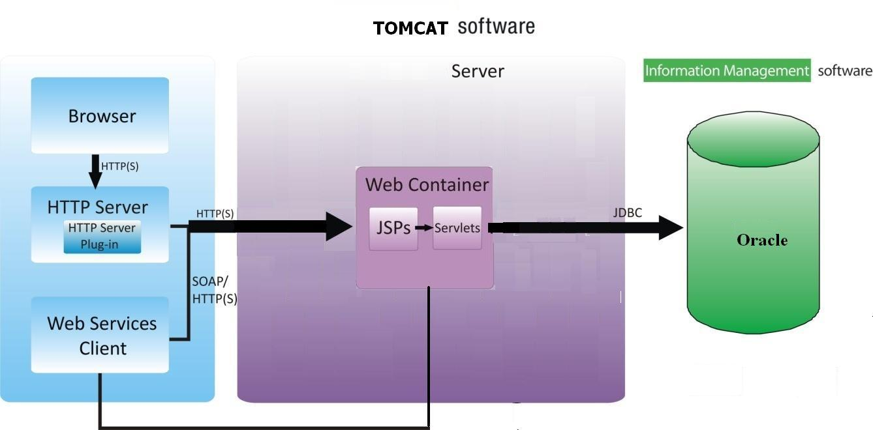

**2.2 Software Interface**

**Client on Internet**

Web Browser, Operating System (any)

**Data Base Server**

Oracle 10g

**Development End**

J2EE, Java, jsp, Servlets, HTML, XML, javaScript, Oracle 10g, OS (Windows XP),

Tomcat 6.0(Web Server)

**2.3 Hardware Interface**

**Minimum Requirements:**

**Client Side**

|  |  |  |  |
| --- | --- | --- | --- |
|  | **Processor** | **RAM** | **Disk Space** |
| Internet Explorer - 6 | Intel Pentium III 800 MHz | 128 MB | 100 MB |

* 1. **Communication Interface**

􀁸

* Client (customer) on Internet will be using HTTP/HTTPS protocol.

**2.5 Constraints**

* GUI is only in English.
* Login and password is used for the identification of users.
* Limited to HTTP/HTTPS.
* This system is working for single server.
  1. **ER Diagram**

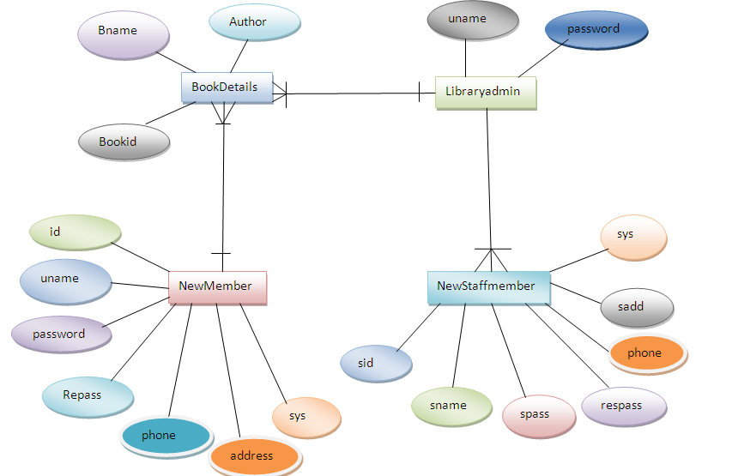

* 1. **Use Case Model Survey**

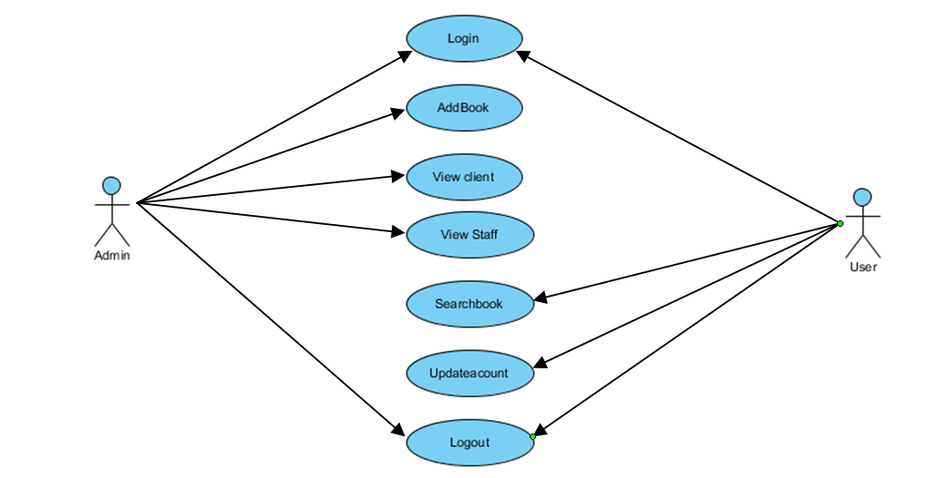

**Fig2.2: Use Case Model Survey**

* **Admin:** Administrator manages the entire application. Administrator can add the books in database and can delete the book details and also he can update the orders.

**User:** In this module we are providing the new registration and after registration user can easily search the books details in our library database.

***Staff Module*:**

In this module staff, those who are created by the admin will insert new books into the library and they will update the no of books in the library

**Deployment 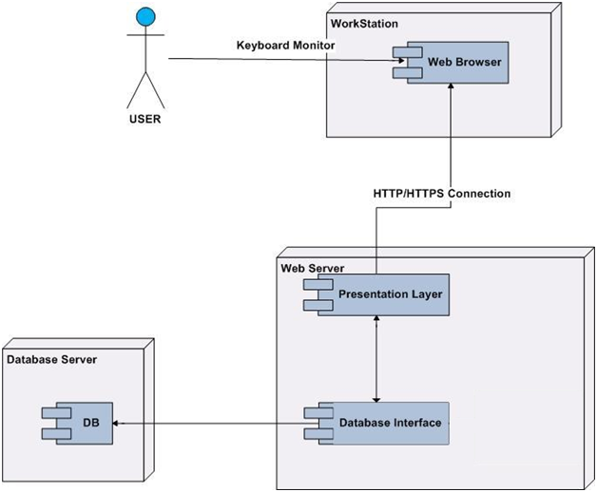State Diagram**

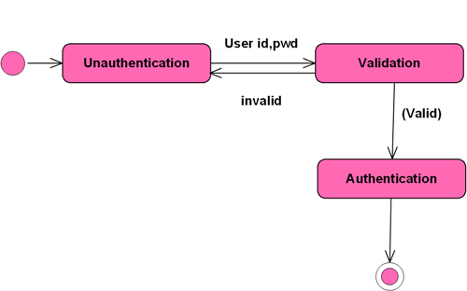

**Class Diagram**

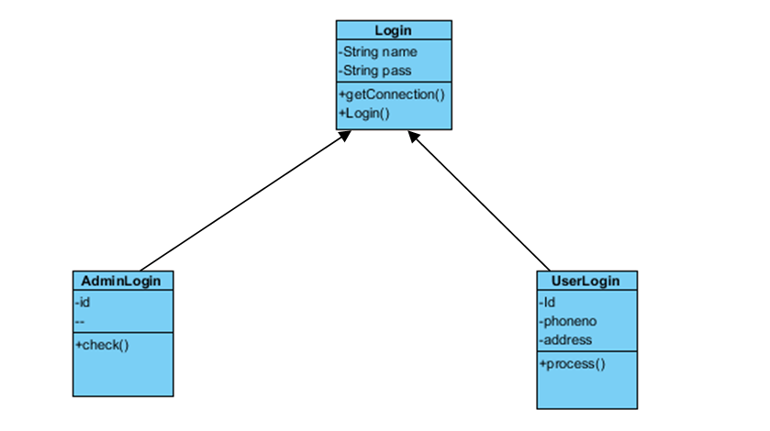

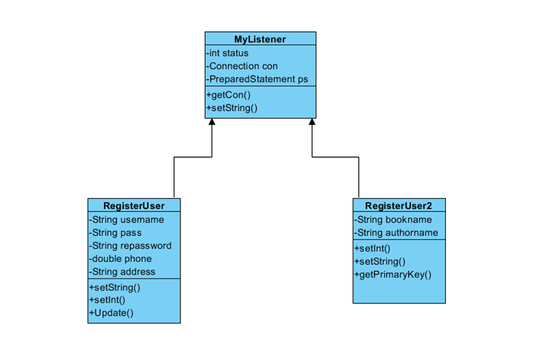**Sequence Diagram**

