**Connect Globe Project**

1. Introduction

1.2 Purpose

1.3 Scope

1.4 Definitions, Acronyms and Abbreviations

1.5 Tools Used

1.6 References

1.7 Technologies to be used

1.8 Overview

2. Overall Description

2.1 Product Perspective

2.2 Software Interface

2.3 Hardware Interface

2.4 Communication Interface

2.5 Constraints

2.6 ER Diagram

2.7 Use - Case Model Survey

2.8 Architecture Design

2.9 Database Design

3. Specific Requirements

3.1 Use-Case Reports

3.2 Activity Diagrams

3.3 Sequence Diagrams

**1. Introduction**

**1.1 Purpose**

* It provides a common platform to share the common people experiences, informations and harrashments all over the world and people can discuss on any topic created by only registered user. Moreover, he/she can give the advice on any topic or report.

**1.2 Scope**

1. There are two basic users **Admin, Common People**

* **Admin:** Can create and post the topic to be discussed and report respectively after getting logged in. Can delete any report which looks like abusive matters. Can view all reports and topics to be discussed and can search reports for each police station. Can help in any report to proceed it further and can give it to the media. Can view the previously posted comments and post a comment on each report or topic
* **Common People:** Can view all reports posted by others after getting logged in!. Can search the report of each police station. Can view the previously posted comments.And post a comment on each report or topic.

**1.3 Definitions, Acronyms and Abbreviations**

**Admin**

**Administrator:**. He has the authority to add/delete reports,topics Details

**Apache Tomcat Server**

**Apache Tomcat Server:** It is a Web server that runs and supports J2EE and web applications.

**Oracle**

**Oracle** A database management system that provides a flexible and efficient database platform to maintain records of students, teachers, admin and dm.

**JSP**

**Java Server Pages:** It is used to create dynamic web content.

**J2EE**

**Java 2 Enterprise Edition:** A programming platform which is a part of java platform for developing and running distributed java.

**UML**

**Unified Modeling Language:** is a standard language for writing software blueprints. The

UML may be used to visualize, specify, construct and document

**XML**

**Extensible Markup Language:** is a text based format that let developers describe, deliver and exchange structured data between a range of applications to client for display and manipulation.

**HTTP**

**Hypertext Transfer Protocol:** It’s a service protocol.

**1.4 Tools Used**

**Application architecture – JAVA, J2EE**

**JAVA**

Java is an object-oriented programming language developed by Sun Microsystems a company best known for its high end UNIX workstations. Java language was designed to be small, simple, and portable across platforms, operating systems, both at the source and at the binary level, which means that Java programs (applet and application) can run on any machine that has the Java virtual machine (JVM) installed.

**J2EE**

**Java Platform, Enterprise Edition** or **Java EE** is a widely used platform for server programming in the Java programming language. The Java platform (Enterprise Edition) differs from the Java Standard Edition Platform (Java SE) in that it adds libraries which provide functionality to deploy fault-tolerant, distributed, multi-tier Java software, based largely on modular components running on a Web server.

**Apache Tomcat web Server** is a free, certified Java EE 5 server for building and managing Java applications

It is Apache supported distribution

**Database platform – Oracle**

Oracle Database is the database management system that delivers a flexible and cost effective Database platform to build robust on demand business applications and supports the J2EE and web services standards.

**1.5 References**

* Object Oriented Modeling and Design with UML-Michael Blaha, James Rambaugh.
* Software Engineering, Seventh Edition, Ian Sommerville.
* IBM Red Books.
* IBM TGMC Sample Synopsis.
* IBM – www.ibm.in/developerworks.

**1.6 Technologies to be used**

* Oracle: Relational Database Management System.
* Tomcat:Apache Tomcat web Server**.**
* J2EE

**1.7 Overview**

**Existing System:**

* The existing system uses Microsoft Excel Sheets for storing data. When a manager needs information of an employee Voucher, one has to search for the specified file in the file system.
* Report generation is done manually by copying the content of the different files into another file. Information retrieval is a very complex process. Lack of organization of the files may lead to information loss due to accidental deletion of files.

**Drawbacks:**

* Searching voucher for particular employee is very lengthy and time consuming process.

**Our Plan (Proposed System):**

* To create Website using which one can maintain all details in an effective and efficient manner.
* The system allows maintaining a centralized database with facilities to insert, edit and delete data as necessary.
* It helps in proper maintenance of data and information. One can easily browse through the various details using the well defined interfaces provided by the system

2. Overall Description

**2. Overall Description**

**2.1 Product Perspective**

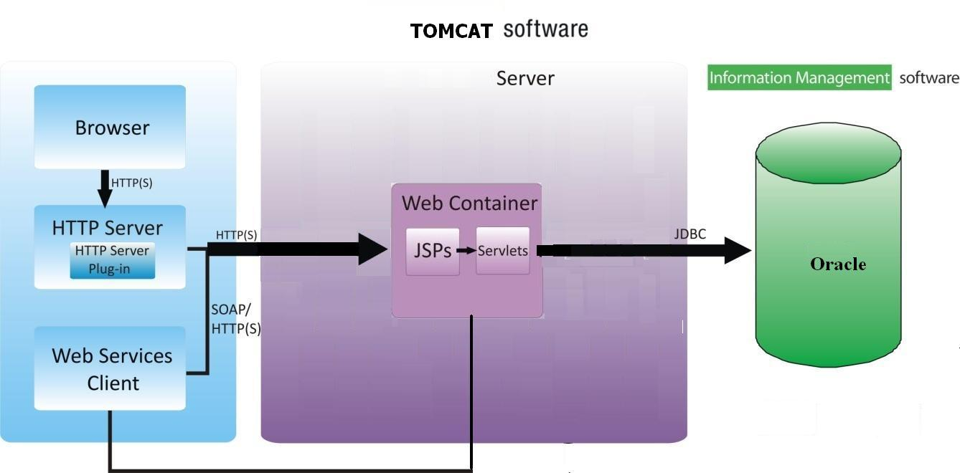

**2.2 Software Interface**

**Client on Internet**

Web Browser, Operating System (any)

**Data Base Server**

Oracle 10g

**Development End**

J2EE, Java, jsp, Servlets, HTML, XML, javaScript, Oracle 10g, OS (Windows XP),

Tomcat 6.0(Web Server)

**2.3 Hardware Interface**

**Minimum Requirements:**

**Client Side**

|  |  |  |  |
| --- | --- | --- | --- |
|  | **Processor** | **RAM** | **Disk Space** |
| Internet Explorer - 6 | Intel Pentium III 800 MHz | 128 MB | 100 MB |

* 1. **Communication Interface**

􀁸

* Client (customer) on Internet will be using HTTP/HTTPS protocol.

**2.5 Constraints**

* GUI is only in English.
* Login and password is used for the identification of users.
* Limited to HTTP/HTTPS.
* This system is working for single server.

**2.6 ER Diagram**

FORUMTPC

FORUMTADVC

FORUMREP

FORUMADVC

FORUMREG

**2.7 Use Case Model Survey**



**Fig2.2: Use Case Model Survey**

* **Admin:** Administrator manages the entire application and manages all the customer details. Administrator is authorized to add, delete and edit all vegetable details, price details and user details.
* **User:** user can register in to the system. also user can get all the information about the vegetables and its price. User also sees the actual price of the vegetable. Also give the complain.
* **Visitor:** Visitors also see all the information about vegetables’ and its price and no need to register. Visitors can view vegetables reports without register into the system.

Use Case Diagram:-



**Deployment 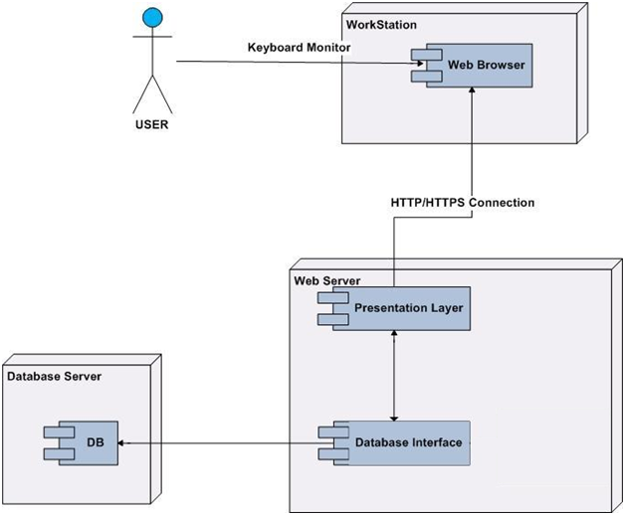State Diagram**

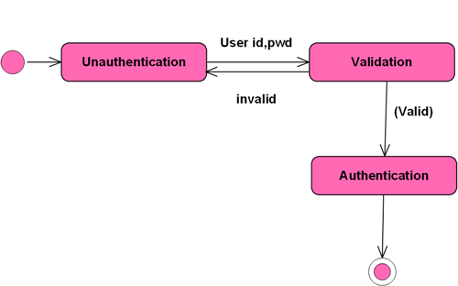

**Class Diagram**



**Sequence Diagram**



**Activity Diagram**

