1. **An actor who is not authenticated must be able to:**
2. **Register to the system as a manager or a user.**

**ERROR**

1. **Browse the catalogue of raffles and navigate to the corresponding prizes.**

Realizamos el test con 10 usuarios

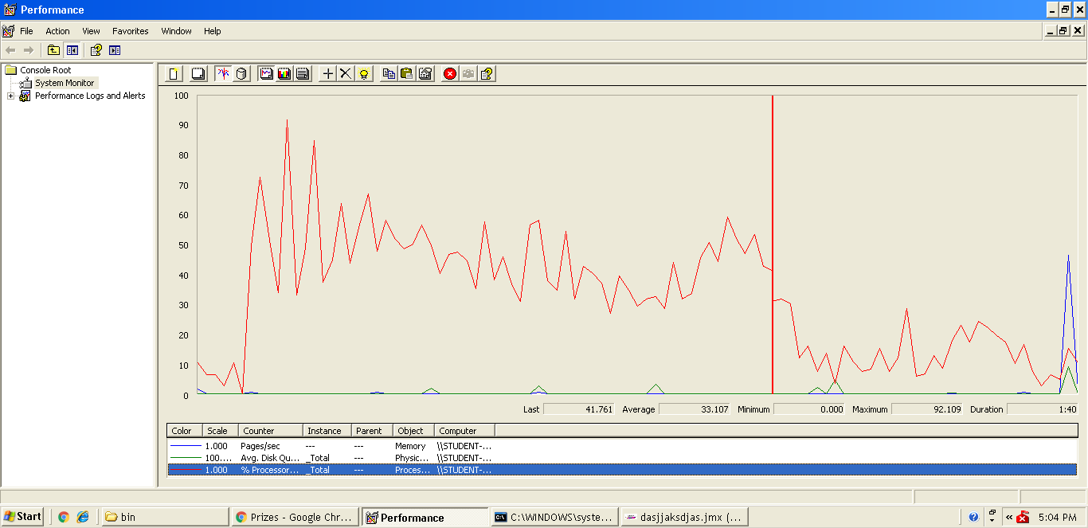

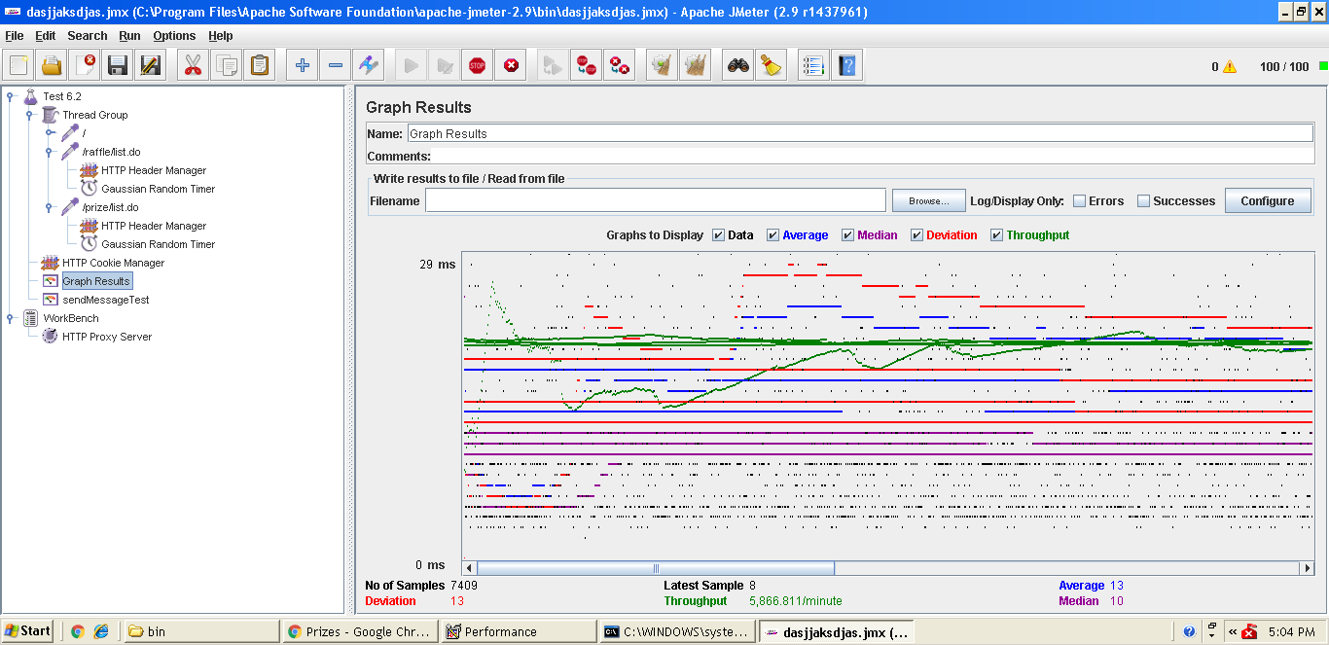

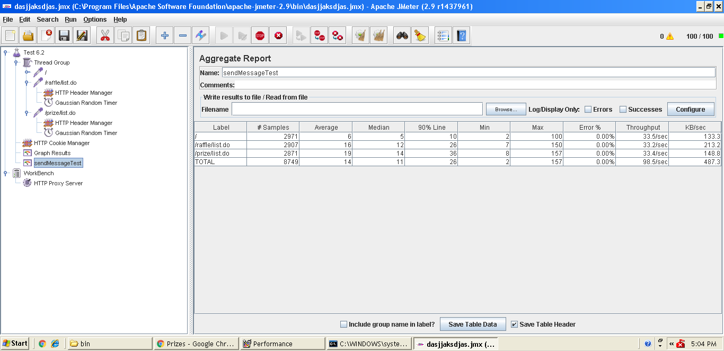

1. **Search for raffles using a single key word that must appear in their titles or their de-scriptions.**

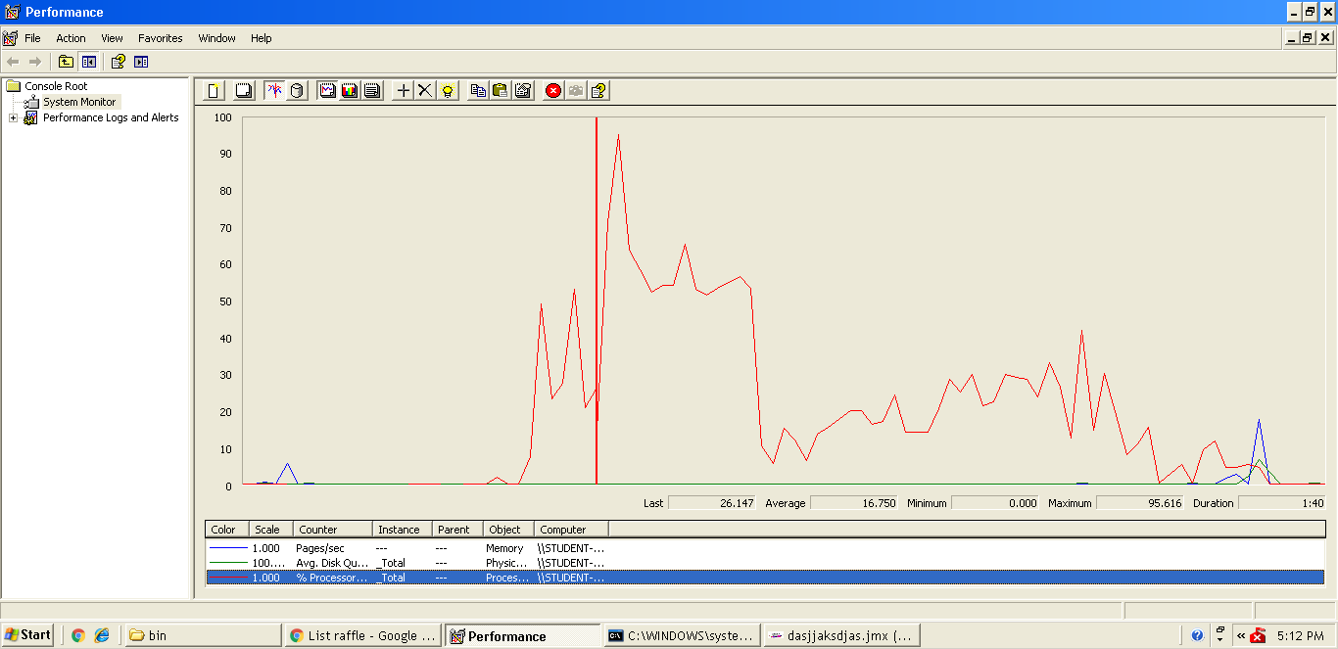

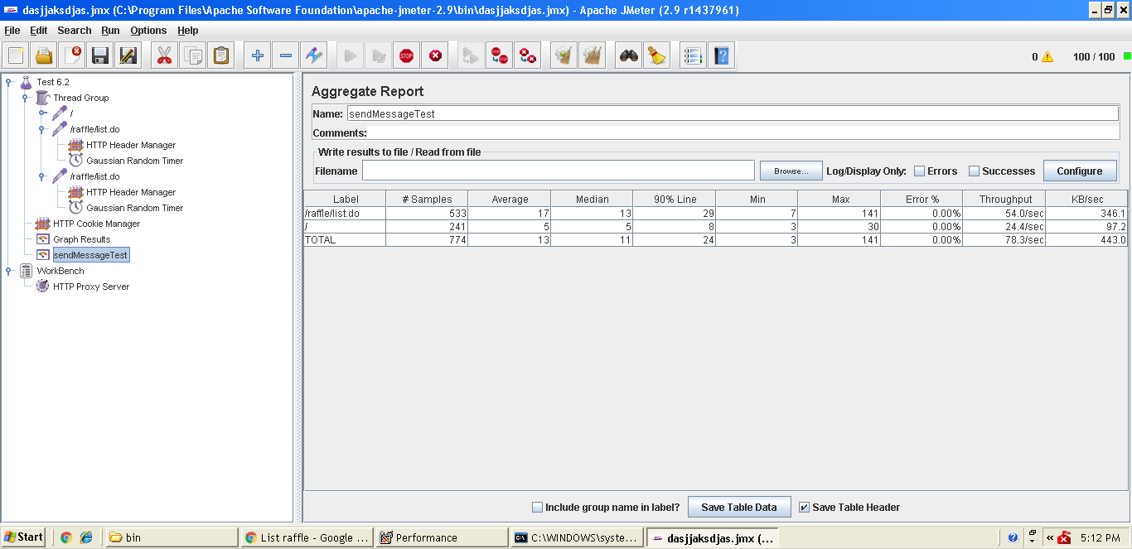

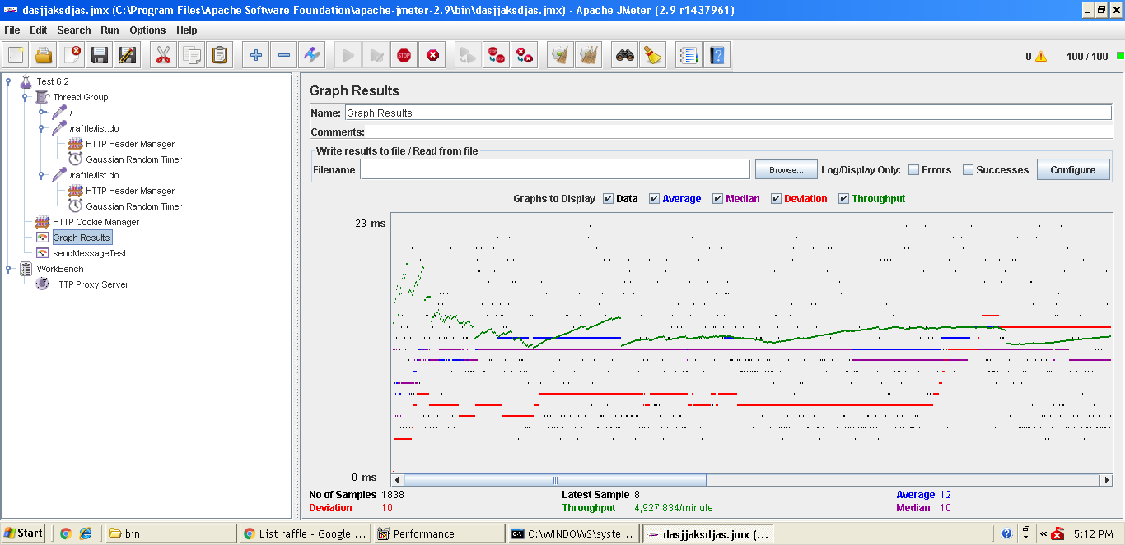

1. **An actor who is authenticated must be able to:**
2. **Do the same as an actor who is not authenticated, except for registering to the sys-tem.**

Jmeter nos devuelve resultados similares al anterior caso. No se produce cuello de botella ni detectamos ningún tipo de error al realizar un test con 10 usuarios (más adelante aumentaremos progresivamente el número de interacciones simultáneas con el sistema)

1. **Edit his or her personal data.**

**ERROR -** Invalid property 'userAccount.socialIdentities' of bean class [domain.User]

1. **An actor who is authenticated as a manager must be able to:**
2. **Manage his or her raffles, which includes listing, creating, editing, and deleting them. Note that a raffle can be edited and deleted as long as its publication time has not passed; once the publication time passes, no raffle can be edited or deleted.**

**ERROR -** Table 'acme-raffle.comment' doesn't exist

1. **Manage the prizes that are associated with any of his or her raffles, which includes listing, creating, editing, deleting them, or re-generating its codes. Editing, deleting, or re-generating the codes of a prize is allowed as long as the corresponding raffle has not started.**

**ERROR -** crear, editar, no se puede puede borrar, no se puede regenerar códigos

1. **An actor who is authenticated as a user must be able to:**
2. **Enter a code for a prize in a given raffle. The system must inform the user on whether: a) the code is a winner code and then he or she’s won the corresponding price; b) the code is invalid, that is, it’s not registered in the database; c) the code was entered before by him- or herself; d) the code was entered by another user.**
3. **List the raffles in which he or she’s participated, then navigating to the prizes for which they’ve entered at least a valid code, and then displaying the codes and the moment when they were entered.**