INTRODUCTION

**What is Angular ?**

Angular is a Javascript Framework which allow you to create Single-Page-Applications (SPAs). Allows to have page apps which look and feel like mobile apps very fast, and loads instantly.

JS changes the DOM during runtime, we won’t see a refresh icon, cuz we are only changing the currently loaded page.

**Understanding Angular Versioning :**

It started with AngularJS(Angular 1), completely rewrote to Angular 2, Angular 3 was skipped, and we have Angular 4, … , Angular 12, … A new version is created every 6 months. Angular 2 and higher is referred to as Angular

**Project Setup :**

npm install -g @anguar/cli

ng new my-dream-app

cd my-dream-app

ng serve

**Course structure :**

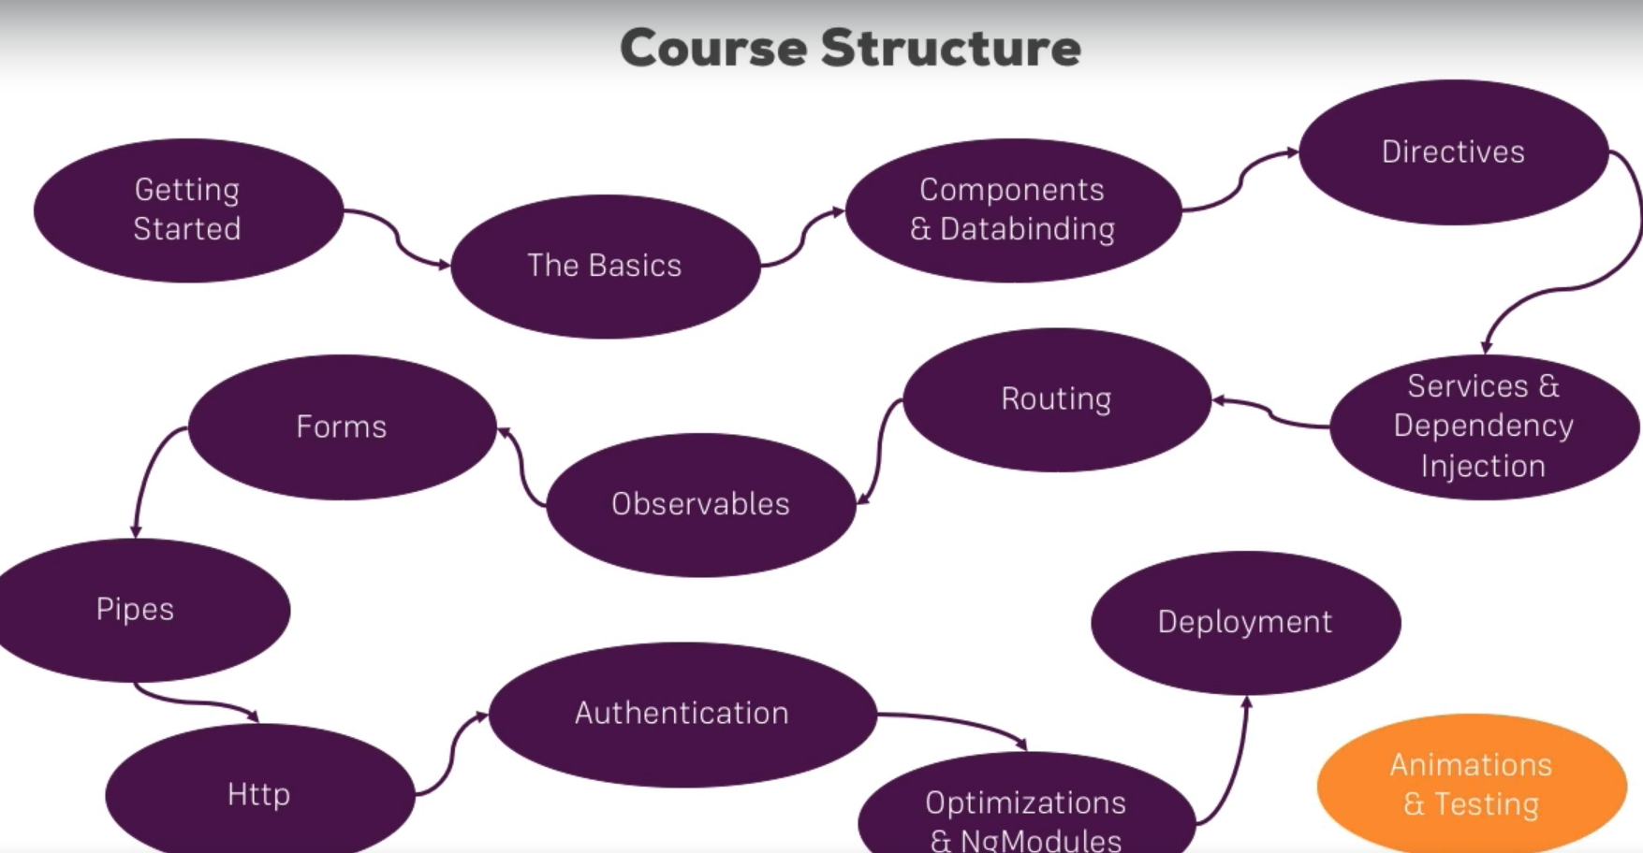

**What is TypeScript ?**

Give more features than Vanilla Javascript (e.g. Types, Classes, Interfaces, …). It is compiled to Javascript.

**Project Setup :**

* I want to use Bootstrap, so i have to install it with the command, i twill install it locally :
  + npm install –save bootstrap@3
  + in Angular.json, i have to notify that i use bootstrap, so i have to add the path of bootstrap Une image contenant texte

    Description générée automatiquement